Figure 2: Patients reporting current and/or hypothetical pain
Group 2 (n=265):
Current pain patients only
Group 1 (n=507):
Current and hypothetical pain patients


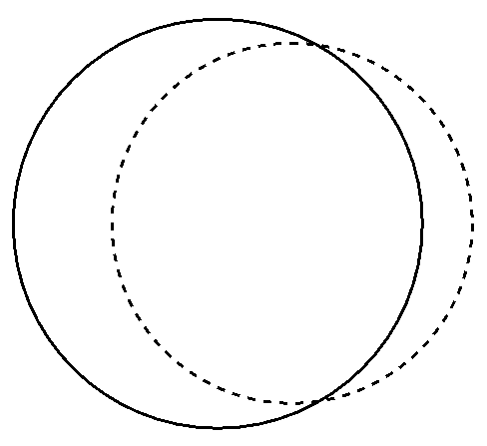
Group 3 (n=91):
Hypothetical pain patients only
Current pain patients (n=797)
Hypothetical pain patients (n=598)
Group 1+2+3 = “All pain” (n=888)* **(n=888)

* 25 patients with current pain did not answer the question on hypothetical pain

