A Framework for Reliability Assessment of an In-service Bridge
Using Structural Health Monitoring Data
Xinghua Chen¹ and Piotr Omenzetter ²
Department of Civil and Environmental Engineering, The University of Auckland, Private Bag 92019, Auckland 1142, New Zealand
¹xche210@aucklanduni.ac.nz
²p.omenzetter@auckland.ac.nz
Keywords: in-service bridges; reliability assessment; structural health monitoring; finite element modeling; model updating, Bayesian updating
Abstract: Because of the critical role that bridges play in land transport networks and broader economy, the assessment of existing bridges is gradually becoming a global concern. Structural health monitoring (SHM) systems have been installed on many bridges to provide data for the evaluation of bridge performance and safety. The challenge for bridge engineers is now to make use of the data and convert them into usable information and knowledge. Integrating SHM data with reliability analysis procedures offers a useful and practical methodology for bridge assessment since reliability is an important performance index and reliability-based procedures have the capability of accommodating uncertainties in structural models, responses, loads and monitoring data. In this paper, an approach for integrating SHM data in a reliability assessment framework is proposed. The reliability of the bridge is quantified by incorporating SHM information in the resistance, load and structural models. Advanced modeling tools and techniques, such as finite element analysis, finite model updating and Bayesian updating, are used for the reliability computations. Data from the SHM system installed on the Newmarket Viaduct, a newly constructed, 12-span, post-tensioned box girder bridge erected by the balanced cantilever method in Auckland, New Zealand, are also presented in this paper and used to explain the proposed framework.
Introduction
Because of their critical importance in transportation networks and, indeed, wider economy, bridge structures are expected to function well for a long term. However, in realistic scenarios in-service bridge structures are at risk from structural degradation, service demands of increasing traffic flow and heavier truck loads, natural or man-made disasters, or deferred maintenance. Consequently, the structural capacity of an existing bridge is typically less than the structural capacity of a new structure. Even if the deterioration does not lead to the direct failure of a bridge, it may weaken the structure, making it more vulnerable to hazards and decreasing its load bearing capacity. Failures of some major bridges, arising from such issues as lack of inspection and maintenance, or natural and man-made disasters, have been widely reported [1, 2]. A notable most recent example is the collapse of the Kutai Kartanegara Bridge in Indonesia on 26 November 2011, while workers were performing maintenance on the bridge. About 20 deaths were caused. By such bitter experiences, people learnt that it is of vital importance to assess in-service bridges throughout their life cycle.
To avoid the tragic disasters, reliability assessment (RA) of in-service bridges [3] arises as an important but challenging task for their owners and engineers. Theoretical reliability analysis based on sophisticated stochastic modeling of structural capacities and demands is a mature field. Although the theory of reliability analysis has been well-established [4, 5], there are only limited successful real-life examples of the use of structural performance defined in reliability theory terms for decision-making. The reliability estimation is greatly impacted not only by the reliability method used, but also by the uncertainties in estimating probability models for random variables. To obtain accurate estimates of the residual reliability of an in-service bridge, it is important to accurately estimate the actual properties of the bridge and properly account for all prevailing uncertainties, arising from variations in loads, material properties, dimensions, magnitude of natural and manmade hazards, insufficient knowledge, and human errors in design and construction, which require a great deal of high quality input data. However, data for traditional bridge assessment is typically collected only via visual inspections and simple non-destructive testing, which suffers from being highly subjective [6].
Structural health monitoring (SHM) systems can make an important positive contribution to both infrastructure asset management and reliability analysis. Such systems automatically measure various loads and other actions acting on a structure, its responses and condition (e.g. corrosion). In the past few decades, significant progress in sensing technology and SHM data analysis method made it possible to measure loads and structural responses much more accurately, conveniently and cheaply and interpret the data to make them useful. Although it is premature to assume that SHM will soon, if ever, completely replace visual inspections, those technologies provide a way to alleviate the subjectivity of visual-inspection-based asset management and some other problems such as high manpower demands, insufficient frequency, inaccessibility of critical structural elements and lack of information on actual loading and responses. From the point of view of the aforementioned limitations of reliability analysis, SHM can provide indispensable data for calibration of any analytical or numerical models for realistic outcomes.
However, while it is often emphasized (see e.g. [7]) that the ultimate goal of SHM is the objective quantification of structural reliability, currently there is a gap between health monitoring technology and RA [8]. The highway administrations cannot determine whether the load capacity or the resistance changed or not from the monitoring data directly. Furthermore, they cannot estimate failure probability of the entire structural system or its main components. Answers are urgently needed to the assessment of the various serviceability and safety issues by RA which would use SHM data to help allocate resources towards bridge inspection, maintenance, and rehabilitation. As a result, evaluating the failure probability for main components and for the entire structural system based on long-term monitoring data becomes a key and urgent scientific research subject, with the challenge of accommodating the uncertainties in response and resistance related parameters and in long-term monitoring data. Research that has developing such RA methods as an explicit objective has only recently started and remains rare [9-14]. Furthermore, virtually all such previous efforts focused on steel bridges, used only dynamic strain monitoring data, and did not incorporate finite element analysis and calibration of finite element models using field data.
In this paper, a comprehensive framework for systematic integration of SHM data into RA methods, which are based on analytical and/or numerical simulations of loads, their effects on structures and structural resistance, is proposed. The models for materials, structures, loads and other actions, and responses, calibrated and refined using the various types of monitoring data will finally be used in structural reliability simulations, yielding more realistic results.
The outline of the paper is as follows. The proposed general framework for integration of SHM data into RA is first described. Then the case study bridge, Newmarket Viaduct (NV), is introduced. This part also provides a description of the bridge monitoring system, initial FE model and an overview of available data and results of dynamic testing and laboratory investigations on material properties. Based on these data, in the third section the comprehensive framework for integration of SHM data into RA is described in detail together with its constituent parts (including probabilistic models for materials, structures, loads and other actions, and their effects), their interactions, and data processing and information flow. Finally, conclusions are given in the fourth section.
General framework for integration of SHM into RA
Figure 1 shows the framework for RA of in-service bridges using various types of SHM data, such as from long-term, continuous monitoring, one-off or periodic testing and monitoring, and laboratory tests. Also, FE analysis and updating is included, which provides a powerful tool for enhanced RA. For a given bridge structure, to perform its advanced RA, an initial FE model, constructed according to design drawings and specifications, is required at first. The various types of SHM data are used to calibrate, or update, the initial FE model. Then based on the monitoring data and the updated model, the load effects of the various structural components can be assessed via simulations. Furthermore, the load effects for structural components with sensors can be statistically evaluated directly using the monitoring data. Structural resistance models can be calibrated using laboratory data, but the updated FE model will also be used here to take into account effects of creep and shrinkage on resistance. Extensive use of Bayesian updating concepts will be made for incorporating information from SHM into analytical models. Finally, reliability assessment of main components or the entire bridge at any time will be conducted, which will aid the bridge maintenance decision-making process. This framework is explained in detail later using a case study bridge.
Figure 1 Framework for RA using SHM data
Reliability analysis
The general reliability analysis includes three steps:
- Defining the limit state function concerning the capacity of a bridge.
- Determining the basic random variables which are the main parameters of the limit state function, such as the mechanical properties of materials and magnitudes of loads.
- Computing failure probability using a reliability method.
The outcome of structural RA can be succinctly presented as a probability of limit state (ultimate or serviceability) violation. In general terms, this corresponds to the probability of an event when at a given time the effects of loads are larger than structural resistance against these loads. Let R and S be random variables representing the stochastic processes of resistance and load effects, respectively. Structural resistance can typically be expressed as a function of material strength and cross-sectional geometry, with strength showing considerable variability. The effects of loads, on the other hand, can be obtained through structural analysis, where both the loads and the structural model also have inherent uncertainties. The adequate performance corresponds to the situation when the performance function, g, defined as [15]:
(1)
takes negative values only with a suitably low probability. A performance function with the right hand side equal to zero is called the limit state function. The performance function with a value lower than zero implies the occurrence of failure. The probability of failure is thus [15]:
(2)
where P(E) is the probability of occurrence of the event E, and P_{f} is the probability of failure. For in-service bridges, the resistance and load effects would be changing during the service life. The minimum resistance method [16] can be employed to estimate the structural reliability:
(3)
where min(R) and max(S) denote the minimum distribution of resistance and maximum distribution of load effects. Then, the failure probability can be calculated by the following formula:
(4)
The corresponding performance function is:
(5)
In the reliability theory, two basic methods, first-order reliability method (FORM) and second-order reliability method (SORM), are available to estimate structural reliability. For bridges, FORM is commonly applied [17]. It was verified that reliability analysis by FORM for linear and some nonlinear problems provides very good approximations. Compared to FORM, SORM is more computational expensive. The Monte Carlo Simulation (MCS) method is a traditional approach which can generate accurate results, but it can be extremely time-consuming [18]. The response surface method (RSM) is a useful and efficient technique to solve the problem of the implicit limit state equation [18, 19]. In this study, simple, computationally cheap methods, such as FORM probability assessment, will be used first. Next step will involve more computationally intensive simulations such as Monte Carlo and RSM. The use of importance and Latin hypercube sampling [20] will be made to lessen the computational burden, as will be truncations of the finite element model to retain only several spans [21].
Monitoring of NV
While the general framework and method above are applicable to different types of loads, structures and limit states, the need for real-life data requires specifying the proposed framework in that respect. In what follows, this section provides the entire description and monitoring program of the instrumented bridge, NV, including the bridge description and FE model.
Description of NV
NV, recently constructed in Auckland is one of the major and most important bridges within the New Zealand road network. It is a horizontally and vertically curved, post-tensioned concrete structure, comprising two parallel, twin bridges. The bridge was built using the balanced cantilever method and contains a total of 468 precast box-girder segments. The Southbound Bridge was constructed first and opened to traffic at the end of 2010; this was followed by the construction of the Northbound Bridge completed in January 2012. The Northbound and Southbound Bridges are joined together via a cast in-situ concrete ‘stitch’. At the time of writing this paper, both bridges have been opened to traffic. The total length of the bridge is nearly 700m, with twelve different spans ranging in length from 38.67m to 62.65m, and average length of approximately 60m. Two photographs of the bridge, during construction and when completed, respectively, are shown in Figure 2.


Figure 2 Newmarket Viaduct: a) new bridge during construction, and b) completed bridge [22]
SHM system
SHM can be beneficial for bridge management in various aspects, and many load and response-related quantities can be measured by various sensors. The following quantities are being monitored on NV and will be used in the proposed framework:
- Strains and deflections in selected critical sections and spans of the girder.
- Accelerations of key sections for structural natural frequency and mode shape estimation.
- Environment data (temperature and humidity) and structural temperature.
Moreover, in addition to the long-term, continuous monitoring, short-term dynamic tests and laboratory test should also be done to provide additional, complementary data.
The long term SHM system installed in NV comprises 20 vibrating wire strain gauges (VWSG) that also measure temperature, 42 embedded temperature sensors, four baseline systems measuring deflections, and two external temperature and humidity sensors, one inside and another outside the girder. Four strain gauges are embedded in concrete in each of the following five cross-sections where sagging or hogging moments have the largest values: in the middle of Span 8 and 9, close to their common pier and at both ends of the two spans. 42 temperature sensors are located in the middle of Span 9 and are spread evenly in both webs along their height; additional sensors are installed across the webs and in the top and bottom slab. In Span 8 and 9 spans, baseline systems [23, 24] for measuring deflections are also installed. Data from these sensors is sampled at 10min intervals with the intention to measure static and slowly-varying responses due to creep, shrinkage and temperature variations. Communication with the data logger for data download in the University of Auckland is via a wireless modem over a cellular telephone network. SHM data collection on NV started in 2010 and it is planned to be continued for the foreseeable future. Installation of six uniaxial accelerometers is planned in near future to complement the aforementioned measurements with dynamic responses in the vertical and horizontal directions due to traffic.
Initial FE model of NV
A 3D FE model of NV (Figure 3) was developed in the SAP2000 software using the design drawings and assumptions. The superstructure was represented using solid elements, piers and pier caps were modeled using beam elements, and expansion joints and bearings using link elements. Fixed boundary conditions were specified at the base of the piers. The material properties used in the FE model came directly from the laboratory tests described later.
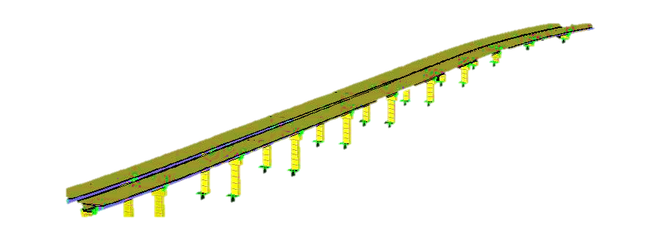
Figure 3 3D FE model of NV
Data analysis
Long term strain monitoring data
The monitoring data that is shown below covers the period from November 2010 to March 2012. However, due to a loss of power, a nearly four month gap from late January 2011 to early May 2011 and another two week gap in June 2011 and July 2011 are present in the data. As an example, Figures 4 present the concrete strain responses from four sensors located in the section close to a pier of Span 8 and ambient temperatures. It can be seen that the concrete strain increases rapidly during posttensioning and during the first year, with smaller strain changes as the concrete age increases. Comparing the strains to the related ambient temperature, it can be seen that concrete strains fluctuate largely as dictated by the ambient temperature. The concrete compressive strain (negative values in the figure) increases during the summer seasons and decreases during the winter seasons.
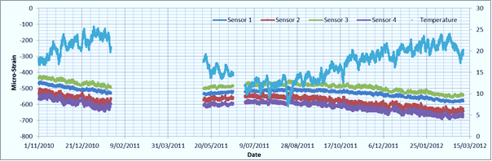

Figure 4 Time histories of concrete strains in an instrumented cross-section and the ambient temperature
Laboratory tests
In order to model the bridge and perform RA, it is necessary to measure a number of material properties of the concrete used at the instrumented bridge. The guidelines of the American Society for Testing of Materials (ASTM) [25] were generally followed in setting up the tests. Twenty concrete 100×200mm cylinders specimens were secured during construction. Six of these were cast for the purpose of measuring compressive strength and elastic modulus but authors’ own results were amply supplemented by the analogous tests conducted by the contractor. The mean 28 days compressive strength and elastic modulus using data from these two sources were found to be 50.2MPa and 38.9GPa, respectively. The remaining cylinders were used for creep and shrinkage tests.
Six concrete cylinders were made to evaluate its shrinkage behaviour, the cylinders were cured under the two different conditions. Three cylinders were cured for 7 days in moist room. Another three cylinders were cured for 28 days in moist condition. Three pairs of gauge points, which were spaced 100mm apart, were placed on each of concrete cylinder (Figure 5a). The preparation of specimens for creep test was the same as that for the shrinkage test specimens. However, each creep test specimen only contained two pairs of gauge points, which were place 100cm apart from each other. For 7 days and 28 days moist curing, four concrete cylinders each were made to evaluate its creep behaviour respectively. The two curing conditions were also the same as those used on the specimens for the shrinkage test, the load level are all 40% of the ultimate compressive strength of concrete at the loading age. Four replicate specimens were loaded in one creep frame using hydraulic jacks (Figure 5b).
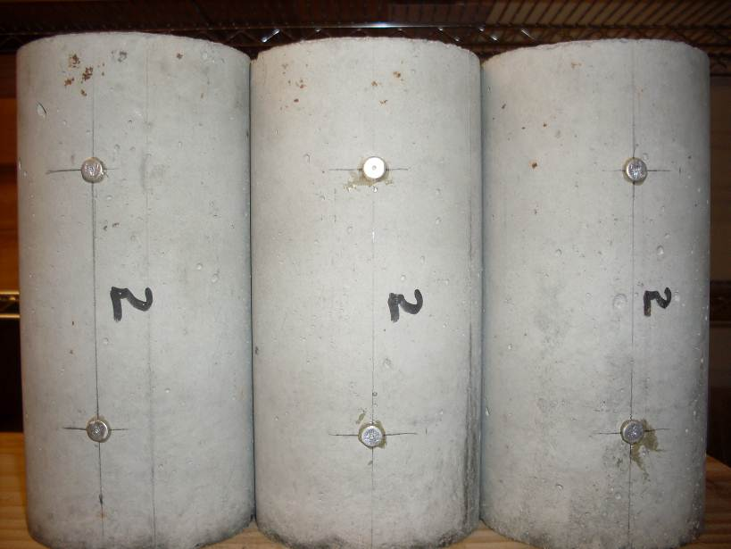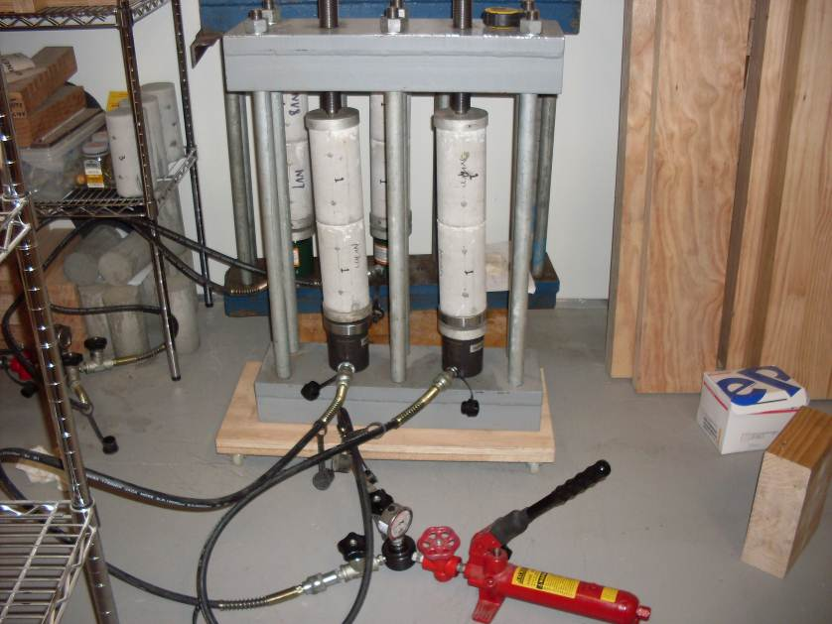
Figure 5 Creep and shrinkage test: a) shrinkage cylinders with gauge point, and b) creep tests
Figure 6 show the plots of shrinkage strains with time for the concrete with moist curing times of 7 and 28 days, and Figure 7 show the plots of creep coefficient versus loading time for concrete with moist curing times of 7 and 28 days. From these plots, we can see the creep and shrinkage both increase significantly for the first 2 months and then stabilize, but longer moist curing period reduce the shrinkage and increases the creep.
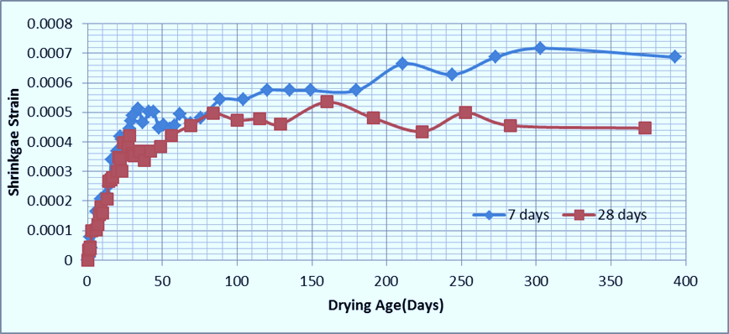
Figure 6 Development of shrinkage of concretes (7-day and 28 day moist curing)
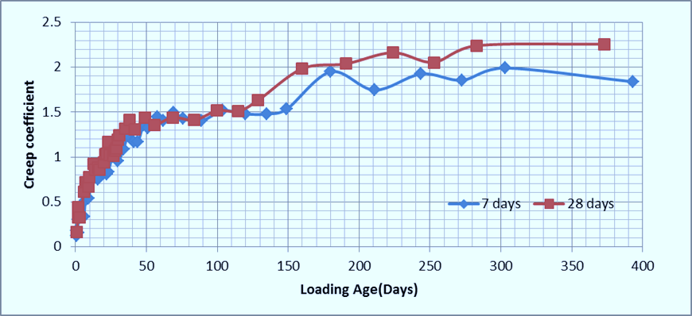=
Figure 7 Creep coefficient of concrete (7-day and 28 day moist curing)
Dynamic testing of NV
One-off dynamic testing is an important part of the proposed framework. A comprehensive ambient vibration testing program has been planned in several phases, the first of which was carried out in November 2011. The testing, conducted just before casting the in-situ concrete ‘stitch’ between two bridges, only included testing of the Southbound Bridge. For full details of the testing including test locations please refer to [26]. Future phases including detailed testing of the two bridges are in advanced preparation.
The data processing and modal parameter identification were carried out using an in-house system identification toolbox written in MATLAB [27]. Two output only system identification techniques were used, namely, Stochastic Subspace Identification (SSI) and Peak Picking (PP). Several vertical and transverse vibration modes were identified in the frequency range 0-10Hz (Table 1). Vibration mode shapes of the bridge deck have been extracted using SSI. Figure 8 shows some identified vertical and transverse mode shapes. The FE model results were compared with those obtained from experimental measurements and showed very good correlation. Updating of the FE model will soon be undertaken to produce an even better tool for RA.

Table 1 Results of modal parameter identification in South Bridge of NV

Mode number and type | Frequency by SSI, ${\text{f}}_{\text{SSI}}$  (Hz) | Frequency by FEM, ${\text{f}}_{\text{FEM}}$  (Hz) | Frequency error,  $$\frac{\left|{\text{f}}_{\text{FEM}}\text{ – }{\text{f}}_{\text{SSI}}\right|}{{\text{f}}_{\text{FEM}}}×100\%$$ | Modal Assurance Criterion (MAC)  (%)
1st transverse bending | 2.13 | 2.11 | 0.8 | 89
1st vertical bending | 2.14 | 2.15 | 0.4 | 96
2nd vertical bending | 2.58 | 2.64 | 2.2 | 89
2nd transverse bending | 2.85 | 2.67 | 6.4 | 86
3rd vertical bending | 2.90 | 2.89 | 0.4 | 94
4th vertical bending | 3.15 | 3.16 | 0.2 | 94
3rd transverse bending | 3.49 | 3.32 | 5.1 | 84
5th vertical bending | 3.46 | 3.42 | 1.7 | 89
6th vertical bending | 3.80 | 3.88 | 2.0 | 88
4th transverse bending | 4.06 | 3.96 | 2.5 | 87
7th vertical bending | 4.22 | 4.26 | 0.8 | 90
8th vertical bending | 6.86 | 6.69 | 2.5 | 86
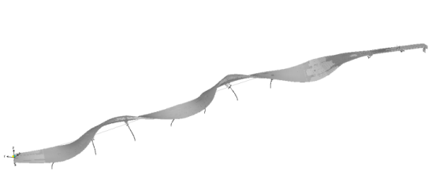
Mode Shape 1 SSI Mode Shape 1 FEM
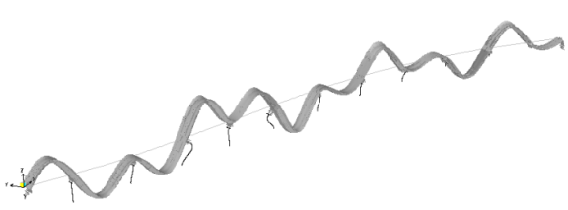
Mode Shape 6 SSI Mode Shape 6 FEM
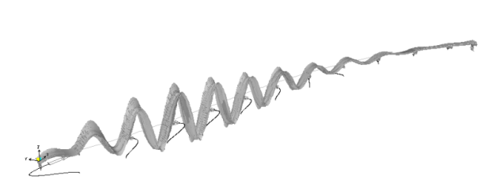
Mode Shape 12 SSI Mode Shape 12 FEM
Figure 8 Comparison of experimental and calculated mode shapes
Reliability assessment based on monitoring data
In order to conduct RA of components or the entire bridge, the key task is to formulate probabilistic models for load effects and structural resistance. In essence, the main motivation for devising ways to incorporate SHM data into a RA framework is to refine estimations of such quantities as the load effect and structural resistance parameters. In this framework, we will assume that stochastic uncertainties exist in the resistance, load and structural models and will use results of SHM to provide a more realistic reliability assessment.
FE model
For a given bridge structure, to perform its advanced RA, an FE model, constructed according to the engineering drawings, is required. Considering the uncertainty of structural parameters, connections and boundary conditions, these need to be assumed as random variables in the FE model. The initial FE model of NV assumed material properties specified in design and their prior probabilistic distributions from literature. The model not only accounts for structural geometry and stiffness (Young’s moduli of materials), but also for creep and shrinkage in concrete, relaxation in steel, and thermal expansion of materials. Available data from laboratory tests will then be used in a Bayesian updating process to produce posterior probability distribution of concrete Young’s modulus and creep and shrinkage coefficients. Furthermore, in a considerably more challenging process modal parameters (natural frequencies and mode shapes) from accelerations, time histories of strains and deflections due to creep and shrinkage, and strains and deflections due to temperature changes, all collected by the SHM system, will be used to calibrate, or update, the FE model of the structure. Novel approaches to updating using soft-computing methods [28] will be tried for the first time for an updating problem of this size. There is also considerable novelty in using several types of data for updating, not only modal parameters, as has, to the best of our knowledge, always been the case in the existing literature.
The updated FE model will be used for the following purposes:
- To calculate the load effects. As the number and locations of sensors are limited, RA for those segments without sensors can only be achieved with the help of an updated FE model. More details on this point are given later.
- To update the resistance parameters using also SHM data. This will be achieved by incorporating creep and shrinkage models and their effects on, e.g. posttensioning force losses.
- To perform RA. The proposed framework takes advantage of the calibrated FE model to assess reliability with higher accuracy.
Structural resistance model
Structural resistance can typically be expressed as a function of material strength and cross-sectional geometry, with strength showing considerable variability. Considering that resistance is time-variant due to such effects as creep and shrinkage, an analysis will be conducted by combining laboratory tests and FE model updating. To integrate SHM and laboratory data into structural resistance probability models the following steps will be performed:
- Initially, material strength properties specified in design and their prior probabilistic distributions from literature will be used.
- Available data from laboratory tests will then be used in a Bayesian updating process to produce posterior probability distributions of concrete and steel strength.
- Since the bridge is a post-tensioned structure, creep and shrinkage or concrete and relaxation in tendons are critical for predicting structural resistance. Accounting for their effects will be achieved with the help of a finite element model calibrated as explained before.
Load effect model
The load effect is the structural response to various types of loads, dead and live. Since the quantity and locations of sensors in any SHM exercise are limited, two methods will be used to formulate the load effects model. On the one hand, for certain structural components with sensors installed load effect models can be statistically achieved using the measured strain data, which includes the following main steps:
- Calculating stress time histories from extracted strain data.
- Preparing histograms of peak stresses.
- Estimating the probability density functions (PDFs) for peak stresses.
On the other hand, for components without sensors, SHM accelerations will be used together with the calibrated structural model in an inverse problem to identify the probabilistic model for the actual vehicular loads acting on the structure. Then the response of such components can be also computed using FE model. Furthermore, temperatures measured in numerous points on the structures will be used to formulate a stochastic model for the temperature field in the bridge taking into account temporal and spatial correlations.
Bayesian updating
In the proposed framework, both the structural resistance and the structural response are updated using SHM and laboratory test data. Updating is a mathematical estimation problem. Accordingly, mathematical estimation comprises the formulation of a probabilistic model of the data, i.e. its PDF [29]. The Bayesian estimation approach treats the parameters of the PDF as random variables, and makes it possible to use prior and posterior knowledge, providing a systematic methodology for integrating SHM into RA [14].
In the Bayesian approach, before updating the parameters θ are described by the so-called prior PDF, f'(θ), which describes the knowledge that is intended for combining with the SHM data. After the new information is obtained from SHM, Bayesian updating will modify prior knowledge of monitored physical quantities by considering such new information. The form of the posterior distribution for $θ$, denoted by $f^{''}\left(θ\right)$, can be calculated as follows:
$$f^{''}\left(θ\right)=\frac{P\left(ε | θ\right)∙f^{'}\left(θ\right)}{\int_{-∞}^{∞}{P\left(ε | θ\right)∙}f^{'}\left(θ\right)∙dθ} (6)$$where $P\left(ε | θ\right)$ is the conditional probability of observing the experimental outcome $ε$ assuming that the value of the parameter is $θ$.
Summary and conclusions
In this paper, an approach for integrating various types of SHM data, including dynamic test data, long term monitoring data and laboratory test data, in a RA framework for an in-service bridge is proposed. In the framework, advanced modeling tools and techniques are used for the reliability computations, and it is assumed that stochastic uncertainties exist in the resistance, load, structural model and monitoring data. The long term monitoring data, field testing and laboratory data will be used to provide a more realistic RA. As both structural resistance and structural response will be quantified by combining prior knowledge and information obtained from SHM using Bayesian updating concepts, the failure probability estimates for the bridge will also be updated. Data from the SHM system installed on NV, a newly constructed, 12-span, post-tensioned box girder bridge erected by the balanced cantilever method in Auckland, New Zealand, are also introduced in this paper and will be used to test the proposed framework. The framework presented in this paper is believed to be a practical tool for establishing rational, continuous and accurate decision support system for managing such bridge structures.
Acknowledgements
The authors would like to acknowledge the support and assistance from the NGA Newmarket and New Zealand Transport Agency for providing the opportunity to conduct research on NV.
Reference
[1] Shepherd, R., & Frost, J. D. Failures in civil engineering: Structural, foundation, and geo-environmental case studies, 1995. ASCE, New York, USA.
[2] Wang, C. H., Chen, W. Z., & Chen, A. R. Damage safety assessment and maintenance management strategy of bridges. Journal of Traffic and Transportation Engineering, 2002, 2, 21–28.
[3] Ratay, R.T. Structural condition assessment – An introduction. In Proc. 17th Analysis and Computation Specialty Conference. 2006. St. Louis, Missouri, United States. 1-2.
[4] Imai, K., & Frangopol, D. M. Reliability-based assessment of suspension bridges: Application to the Innoshima Bridge. Journal of Bridge Engineering, 2001, 6(6), 398-411.
[5] Catbas, F. N., Susoy, M., & Frangopol, D. M. Structural health monitoring and reliability estimation: Long span truss bridge application with environmental monitoring data. Engineering Structures, 2008. 30(9), 2347-2359.
[6] Phares, B. M., Rolander, D. D., Graybeal, B. A., & Washer, G. A. Reliability of visual bridge inspection. Public Roads, 2001, 64(5), 22-29.
[7] Aktan, A. E., Catbas, F. N., Grimmelsman, K., Pervizpour, M., Curtis, J., Shen, K., Qin, X., & Cinar, O. A. Health monitoring for effective management of infrastructure. In Proc. 1st European Workshop on Structural Health Monitoring. 2002. Paris, France. 1245-1253.
[8] Ko, J. M., & Ni, Y. Q. Technology development in structural health monitoring of large scale bridges. Engineering Structures, 2005, 27, 1715-1725.
[9] Peil, U. Assessment of bridges via monitoring. Structure and Infrastructure Engineering, 2005, 1(2), 101-117.
[10] Frangopol, D. M., Strauss, A., & Kim, S. Bridge reliability assessment based on monitoring. Journal of Bridge Engineering, 2008, 13(3), 258-270.
[11] Liu, M., Frangopol, D. M., & Kim, S. Bridge safety evaluation based on monitored live load effects. Journal of Bridge Engineering, 2009, 14(4), 257-269.
[12] Li, H., Li, S., Ou, J., & Li, H. Reliability assessment of cable-stayed bridges based on structural health monitoring techniques. Structure and Infrastructure Engineering, 2010, 8(9), 1-17.
[13] Xia, H. W., Ni, Y. Q., Wong, K. Y., & Ko, J. M. Reliability-based condition assessment of in-service bridges using mixture distribution models. Computers and Structures, 2012, 106-170, 204-213.
[14] Okasha, N. M., & Frangopol, D. M. Integration of structural health monitoring in a system performance based life-cycle bridge management framework. Structure and Infrastructure Engineering, 2012, 8(11), 999-1016.
[15] Ang, A. H., & Tang, W. H. Probability concepts in engineering planning and design: Decision, risk and reliability, 1984. Wiley, New York, USA.
[16] Gong, J. X., & Zhao, G. F. A general approach for computing structural reliability index. Chinese Journal of Computational Mechanics, 2003, 20(1), 12-18.
[17] Frangopol, D. M., Strauss, A. & Kim, S. Bridge reliability assessment based on monitoring. Journal of Bridge Engineering, 2008. 13(3), 258-270.
[18] Frangopol, D. M. Bridge safety and reliability, 1999. ASCE, New York, USA.
[19] Bucher, C. G., & Bourgund, U. A fast and efficient response surface approach for reliability analysis. Structural Safety, 1990, 7(1), 57-66.
[20] Melchers, R.E. Structural reliability analysis and prediction, 1999. Wiley, New York, USA.
[21] Guo, T., Sause, R., Frangopol, D. M., & Li, A. Time-dependent reliability of PSC box-girder bridge considering creep, shrinkage, and corrosion. Journal of Bridge Engineering, 2011, 16(1), 29-43.
[22] Auckland Motorways. Newmarket Viaduct replacement. http://www.aucklandmotorways. co.nz/ southern/newmarketviaduct.php, accessed 30/08/2012.
[23] Omenzetter, P., & Ibrahim, N. Evaluation of creep and shrinkage in a prestressed bridge using data from laboratory experiments and in-situ monitoring. In Proc. 21st Australasian Conference on the Mechanics of Structures and Materials. 2010. Melbourne, Australia. 185-190.
[24] Stanton, J. F., Eberhard, M. O., & Barr, P. J. A weighted-stretched-wire system for monitoring deflections. Engineering Structures, 2003, 25, 347-357.
[25] ASTM International. Annual Book of ASMT Standards. Section 4: Construction 2008. ASTM International, West Conshohocken, USA.
[26] Chen, X., Omenzetter, P. & Beskhyroun, S. Ambient vibration tests and analysis of a multiple-span elevated bridge. In Proc. 22nd Australasian Conference on the Mechanics of Structures and Materials. 2012. Sydney, Australia. (in press).
[27] Beskhyroun, S. Graphical interface toolbox for modal analysis. In Proc. 9th Pacific Conference on Earthquake Engineering. 2011. Auckland, New Zealand. 1-8.
[28] Shabbir, F. & Omenzetter, P. Model updating of a full-scale bridge structure using particle swarm optimization. In Proc. 22nd Australasian Conference on the Mechanics of Structures and Materials. 2012. Sydney, Australia. (in press).
[29] Kay, S. M. Fundamentals of statistical signal processing, 1993. Prentice Hall, Upper Saddle River, USA.

