A paddle-wheel motif versus an extended network: two crystalline forms of
2,4-bis(phenylamino)nitrobenzene

M. John Plater* and William T. A. Harrison, Department of Chemistry, University of Aberdeen, Meston Walk, Aberdeen, AB24 3UE, e-mail: m.j.plater@abdn.ac.uk

Table of Contents
M. John Plater and William T. A. Harrison

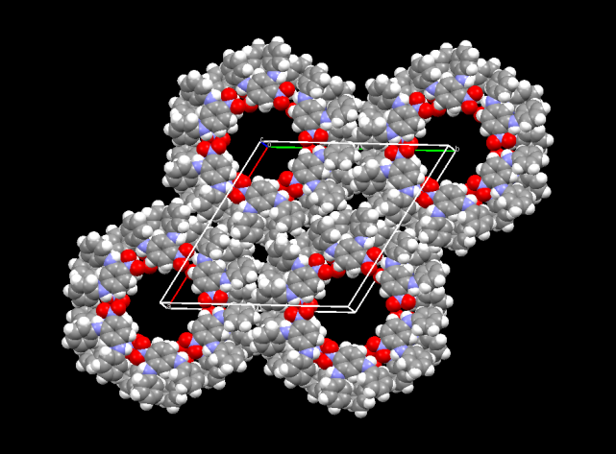
Hydrogen-bonded networks formed from a series of 2,4-bis(alkyl and aryl-amino) substituted nitrobenzenes are reported.

Abstract
2,4-Difluoronitrobenzene is reacted with either one or two amines selected from aniline, ammonia, butylamine and benzylamine. All products are characterised spectroscopically and by single-crystal structure determinations. When formed as minor component alongside 4-dimethylamino-2-(phenylamino)nitrobenzene, 2,4-bis(phenylamino)nitrobenzene crystallises as a hydrogen-bonded hexamer (paddle-wheel) motif encompassing one-dimensional channels, but as a dense framework when pure. 2,4-Bis(butylamino)nitrobenzene crystallises with the same hexamer motif but with offset sheets.

Key words: paddle-wheel, hexamer motif, channel, hydrogen bond.

Introduction
Clathrate-forming compounds such as cyclodextrins can crystallise with guests such as methyl orange, ferrocene and sodium 12-crown-4 to give a channel type arrangement of guests in the lattice.^{1–4} These materials are of interest in separation science. For example, urea can be used to separate n-alkanes from kerosene.⁵⁻⁷ Cyclic peptides can arrange into nanotubes, observed with electron microscopy, by hydrogen-bond directed self-assembly and serve as micropores in membranes.^{8–9} These examples illustrate the vital role that crystal packing forces and molecular structure play in the design of novel solids that may have uses and functional applications. In this paper we report our serendipitous discovery of a new class of compounds, which may either crystallise as hydrogen-bonded cyclic motifs or as dense, infinite networks.

Discussion
Our ongoing programme on the synthesis of mauveine derivatives¹⁰⁻¹⁴ required some specialised aromatic building blocks, which we attempted to prepare by reacting 2,4-difluoronitrobenzene 1, with aniline (Scheme 1). The nitro group activates both fluorine substituents to nucleophilic displacement. The first fluorine atom reacts easily to give 4-fluoro-2-(phenylamino)nitrobenzene 2, in good yield.

Scheme 1: The reactions of 2,4-difluoronitrobenzene 1 with aniline in ethanol or DMF or neat to form compounds 2, 3 and 4 respectively.

Spectroscopic characterisation of product 2 did not confirm whether an ortho or para isomer had formed, but an X-ray crystal structure showed that the product is the ortho isomer 2 (Figure 1). Even if 1 is heated with an excess of aniline in ethanol, the second fluorine atom in the para position is very slow to substitute. The reaction of compound 1 with aniline in refluxing dimethyl formamide (DMF) was attempted, as it is a higher boiling solvent, but this time 4-dimethylamino-2-(phenylamino)nitrobenzene 3 was formed in low yield, as confirmed by the X-ray single crystal structure (Figure 1). The dimethylamine is probably liberated from DMF by a transamidation^{15–18} reaction with aniline because the thermal decomposition of DMF, liberating dimethylamine and CO, is too slow.¹⁹ Also, compound 2 did not give compound 3 when refluxed in DMF for 8 h. We conclude that initially, the aniline reacts at the ortho position, followed by the reaction of dimethylamine at the less reactive para position.

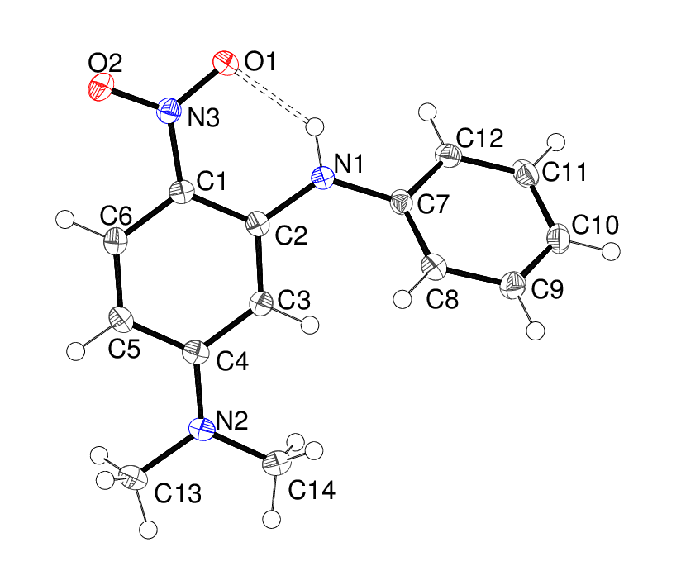
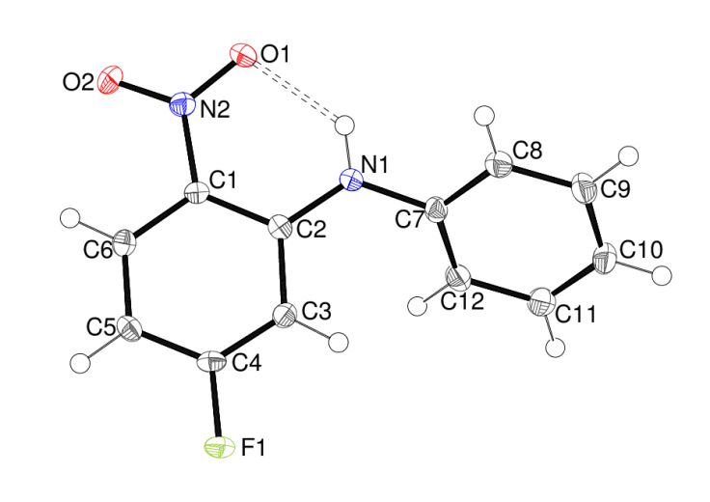

Figure 1: The molecular structures of 2 (left) and 3 (right) showing 50% displacement ellipsoids, with the intramolecular N–HO hydrogen bond indicated by a double-dashed line. The dihedral angle between the aromatic rings is 49.28 (4)° in 2 and 44.85 (4)° in 3.

Finally, compound 1 was refluxed in pure aniline for 24 h or longer, which gave a low yield of the di-substituted product 4. The remainder of the material was the mono(phenylamino) substituted product 2, which was discarded. The spectroscopic data for 4 are as expected apart from one NH signal, which is absent for this derivative. Since compounds 2 and 3 show just one NH signal beyond 9 ppm, it must be the NH signal for the para amino group that is missing. Presumably the fast inter-conversion of two conformational isomers broadens this NH signal. Interestingly two possible conformational isomers are seen by comparing the crystal structures of 4a and 4b. Two completely different crystal structures were obtained for 2,4-bis(phenylamino)nitrobenzene 4 (Figure 2). The first structure 4a, which probably incorporates solvent molecules, was an impurity crystal (a yellow needle) in a batch of compound 3, which formed as orange plates. Compound 3 appeared to be pure as characterised by NMR spectroscopy, so the amount of 4a must be very small and there was not enough to carry out elemental analysis. A second, identical X-ray data set was collected for compound 4a, when it crystallised as a minor side product with compound 5, described later.
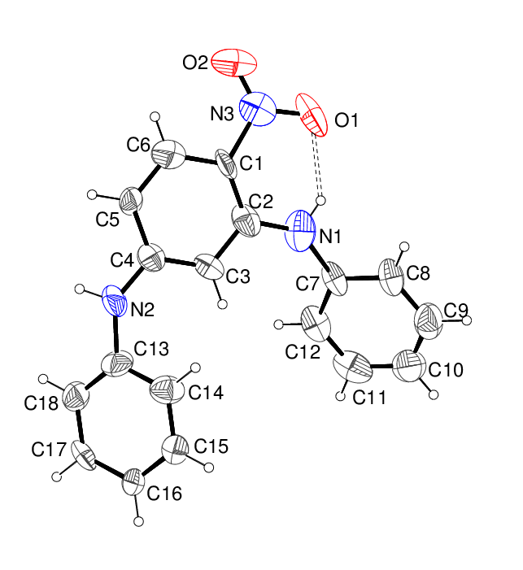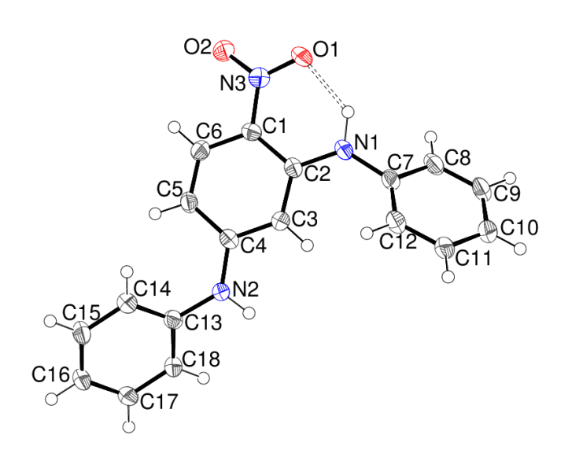
Figure 2: The molecular structures of 4a (left) and 4b (right) showing 25% and 50% displacement ellipsoids, respectively, with hydrogen bonds indicated by double-dashed lines. The dihedral angles between the central ring and the ortho- and para- bonded rings are 41.7 (5) and 41.1 (5)°, respectively in 4a and 42.83 (8) and 41.43 (10)°, respectively, in 4b. These values are very similar, but the overall molecular conformations are quite different, as indicated by the C3–C4–N2–C13 torsion angles of 6 (2) and 174.3 (3)° for 4a and 4b, respectively and the H2–N2–C4–C5 torsion angles of 5 and 162° for 4a and 4b, respectively.
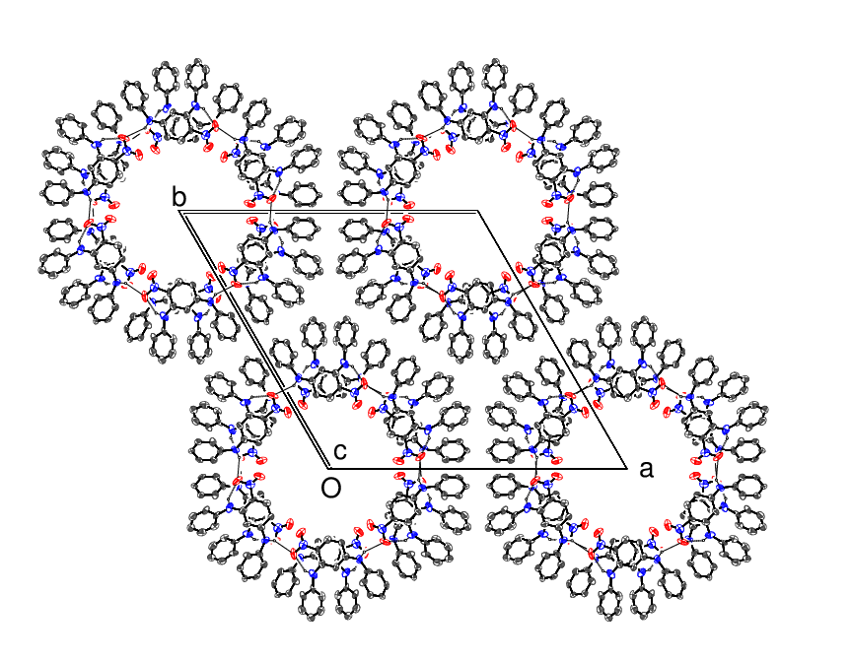
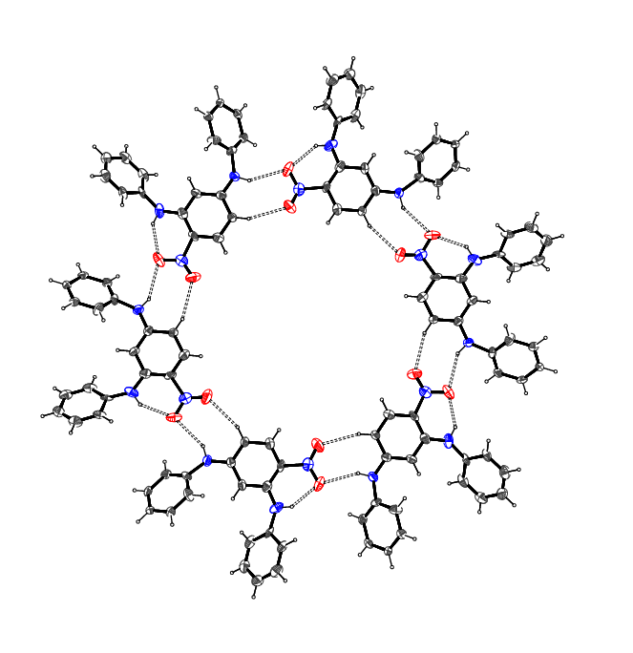
Figure 3: A hexameric hydrogen-bonded ring with graph-set motif R₆⁶(48) for the N–HO hydrogen bonds in the crystal of 4a (left) and the unit-cell packing in 4a viewed down [001] (right), showing the formation of one-dimensional channels. A PLATON²⁰ analysis of the structure indicated the volume of free space to be 753 Å³ per unit cell (14.4% of the cell volume).

In the crystal of the first phase 4a, mp 146–147 °C, the molecules of 4 are linked by side-by-side N–HO and C–HO hydrogen bonds to generate a cyclic hexamer motif; these units stack on top of each other to form large [001] channels (Figure 3) of approximate diameter 10.5 Å, assuming a Van der Waals’ radius of 1.4 Å for an O atom. The channels are presumably filled with disordered solvent molecules, although these could not be discerned in the present experiment. The second phase 4b was obtained from the crystallisation of compound 4 in a pure state, prepared by refluxing compound 1 in neat aniline, as described above, to yield fawn crystals (mp 169–170 °C), which is notably higher than that of 4a. The crystal of 4b is dense (i.e. there is no solvent space or identifiable pores or channels) and the molecules are linked by N–HO hydrogen bonds to form infinite [010] chains. The open-framework compound 4a could not be obtained by crystallising a pure sample of compound 4, but only when compound 4 was formed as an impurity in samples 3 and 5.

The crystallisation of the paddle-wheel motif is not straightforward and appears to depend upon the environment, although it can be reproduced. Open-framework structures usually only form in purely organic materials when clathrates occur. Owing to the difficulty of preparing compound 4, and also structure 4a, by this route, we prepared further derivatives 5–8 and determined their crystal structures in search of other possible paddle-wheel motifs.

The syntheses are all similar. After the reaction of 2,4-difluoronitrobenzene 1, with aniline, a preliminary purification was performed by removing the ethanol solvent, but the intermediate compound 2 was not isolated and purified (Scheme 2). This explains why small traces of some 2,4-bis(phenylamino)nitrobenzene 4 were sometimes found in the products. For example, when compound 5 was crystallised from ether/light petrol ether 40–60, it gave orange blocks of 4-amino-2-(phenylamino)nitrobenzene 5 along with a small quantity of yellow needles of 2,4-bis(phenylamino)nitrobenzene 4a. This time the yellow needles were easy to see as an impurity in the material. The crystal structure derived from one of them was the same hexamer motif 4a or channel framework as described above. However, the hydrogen-bonding arrangements in compounds 5 and 6 (Figures 4 and 5) lead to extended dense networks and not to an open framework with channels.

Scheme 2 Reaction of 2,4-difluoronitrobenzene 1 with aniline followed by NH₄OH, BuNH₂ and BnNH₂ to prepare compounds 5, 6 and 7 respectively.

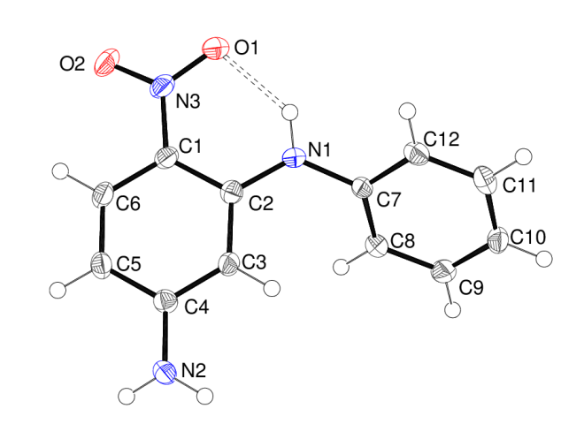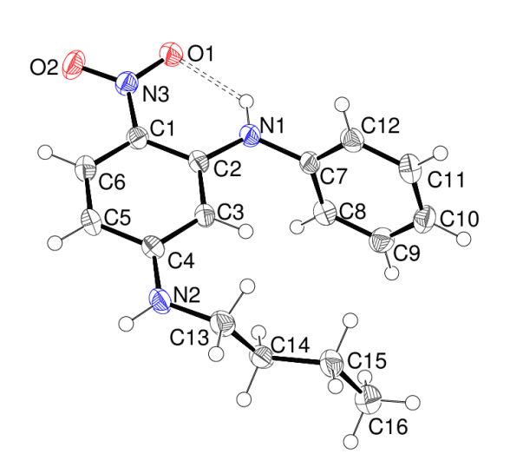
Figure 4: The molecular structures of the C1-containing molecule in 5 (left) and the C1-containing molecule in 6 (right) showing 50% displacement ellipsoids, with hydrogen bonds indicated by double-dashed lines. Compound 5 contains three molecules in the asymmetric unit, with dihedral angles between the aromatic rings of 49.17 (5), 67.37 (4) and 45.95 (5)°. Compound 6 contains four molecules in the asymmetric unit, with dihedral angles between the aromatic rings of 79.82 (6), 73.85 (7), 79.14 (5) and 64.40 (6)°.

Through persisting at the bench, we also prepared 2,4-bis(butylamino)nitrobenzene 8, by reacting an excess of BuNH₂ with 2,4-difluoronitrobenzene 1 (Scheme 3). This was a very clean reaction in a yield of 84%. Luckily, the sought after cyclic hexamer motif with identical side-by-side N–HO and C–HO hydrogen bonds was observed in the crystal structure of this compound (Figure 6). However, the rhombohedral crystal symmetry in 8, rather than the hexagonal symmetry in 4a, dictates that the hexamers are laterally displaced between layers and no channels are apparent. Three butyl groups block each channel. Nevertheless this structure demonstrates that the hexameric cyclic motif is not just restricted to 2,4-bis(phenylamino)nitrobenzene 4a. An attempt to form clathrates of compound 8 from ether/light petroleum ether with biphenyl, 4,4-dipyridyl, azobenzene, 1,6-bis(4-pyridyl)hexane and a number of other flexible dipyridyls available to us, was unsuccessful. In each case the crystals harvested were those of starting material 8, as shown by the determination of their unit cells.

Scheme 3 Reaction of 2,4-difluoronitrobenzene 1 with BuNH₂
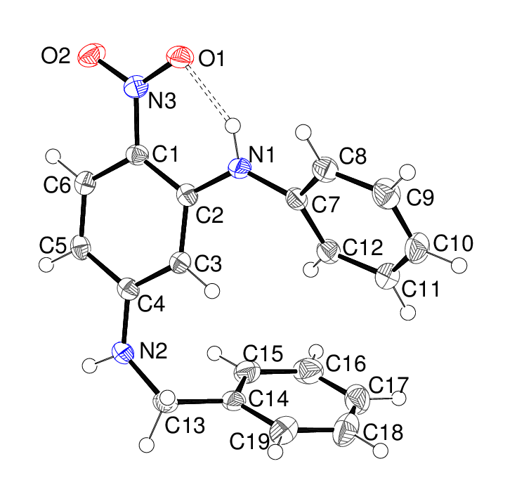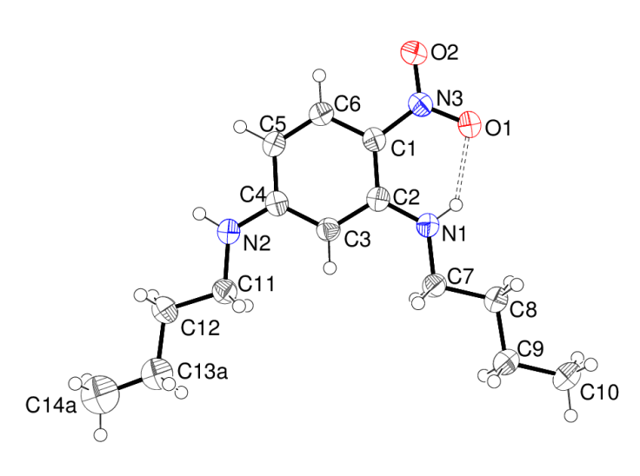

Figure 5: The molecular structures of 7 (left) and 8 (right) showing 50% displacement ellipsoids, with hydrogen bonds indicated by double-dashed lines. The C11-butyl chain in 8 is disordered over two orientations in a 0.549 (12):0.451 (12) ratio. The dihedral angles between the central and C7- and C14-rings in 7 are 37.98 (6) and 76.12 (4)° respectively.
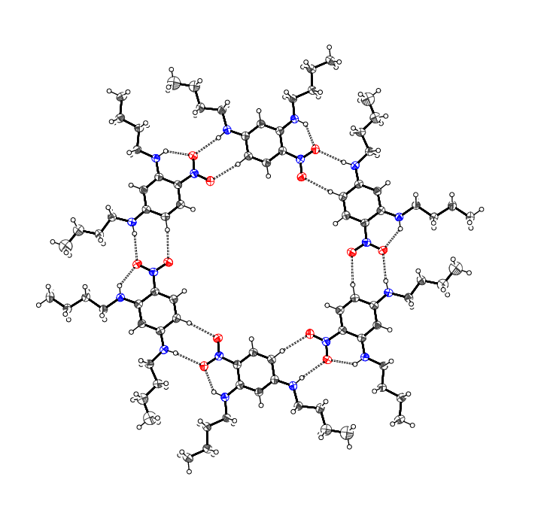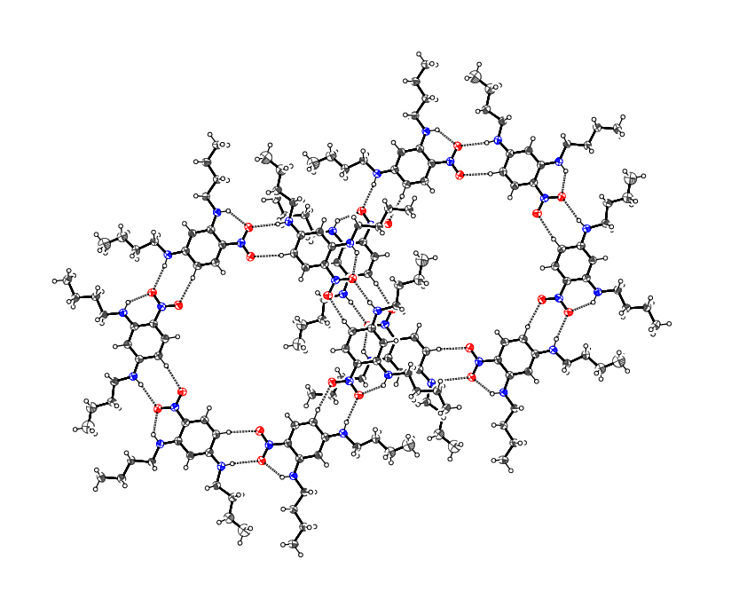
Figure 6: A hexameric hydrogen-bonded ring with graph-set motif R₆⁶(48) for the N–HO hydrogen bonds in the crystal of 8 (left) and a pair of staggered hexamers viewed down [001] (right), showing how the protruding butyl groups lead to the formation of a network without channels. It is interesting however, that PLATON indicates that there is still some 439 Å³ of solvent-accessible space per unit cell (6.1% of the cell volume).

Experimental
General: IR spectra were recorded on an ATI Mattson FTIR spectrometer using KBr discs. UV spectra were recorded using a Perkin-Elmer Lambda 25 UV-VIS spectrometer with CH₂Cl₂ as the solvent. ¹H and ¹³C NMR spectra were recorded at 400 MHz and 100.5 MHz, respectively, using a Varian 400 spectrometer. Chemical shifts, δ are given in ppm relative to the residual solvent and coupling constants, J are given in Hz. Low resolution and high resolution mass spectra were obtained at the University of Wales, Swansea using electron impact ionisation and chemical ionisation. Melting points were determined on a Kofler hot-stage microscope.

Crystal growth
For all samples, the starting material was dissolved in ether (10–50 ml) and diluted with light petroleum ether 40–60 (10–50 ml), and left to slowly evaporate at room temperature.

Crystallography
General: the intensity data for 2–8 (except 4a) were collected on a Rigaku Mercury CCD diffractometer (Mo Kα radiation, λ = 0.71073 Å, T = 100 K); those for 4a were collected at beam-line I19 at the Diamond Synchrotron Source (λ = 0.68890 Å, T = 298 K). The structures were solved by direct methods with SHELXS-97²¹ and the structural models completed and refined against |F|² with SHELXL-97.²¹ The N-bound H atoms were located in difference maps and either refined freely or as riding atoms in their as-found relative positions. The C-bound H atoms were placed in idealised locations and refined as riding atoms. The constraint U_{iso}(H) = 1.2U_{eq}(carrier) or 1.5U_{eq}(methyl C) was applied in all cases.
The diffracting power, even for data collected on a synchrotron, was extremely poor for 4a, although the structure was clearly discernible. The benzene rings were modelled as rigid hexagons with a side-length of 1.39 Å and similarity restraints on U_{ij} values were applied. The geometry of the nitro group was maintained with a planarity restraint. Difference Fourier maps in the region of the [001] channels were essentially featureless and could not be interpreted as disordered solvent molecules: the contribution to the scattering was removed with the SQUEEZE routine in PLATON [20].

2 C₁₂H₉FN₂O₂, M_{r} = 232.21, orange rod, 0.42 × 0.05 × 0.04 mm, orthorhombic, space group Pbca (No. 61), Z = 8, a = 12.6596 (9), b = 7.9294 (5), c = 20.8034 (14) Å, V = 2088.3 (2) Å³ at 100 K. Number of measured and unique reflections = 13570 and 2398, respectively (–16 ≤ h ≤ 16, –10 ≤ k ≤ 10, –26 ≤ l ≤ 26; 2θ_{max} = 52.0°; R_{int} = 0.048). Final R(F) = 0.036, wR(F²) = 0.093 for 157 parameters and 1879 reflections with I > 2σ(I) (corresponding R-values based on all 2398 reflections = 0.049 and 0.100, respectively), CCDC reference number 1026369.

3 C₁₄H₁₅N₃O₂, M_{r} = 257.29, orange plate, 0.23 × 0.11 × 0.02 mm, monoclinic, space group P2₁/c (No. 14), Z = 4, a = 11.6236 (8), b = 6.6269 (5), c = 17.1321 (11) Å, β = 107.1480 (14)°, V = 1260.99 (15) Å³ at 100 K. Number of measured and unique reflections = 13572 and 2893, respectively (–14 ≤ h ≤ 15, –8 ≤ k ≤ 8, –22 ≤ l ≤ 22; 2θ_{max} = 55.0°; R_{int} = 0.041). Final R(F) = 0.041, wR(F²) = 0.121 for 177 parameters and 2400 reflections with I > 2σ(I) (corresponding R-values based on all 2893 reflections = 0.048 and 0.127, respectively), CCDC reference number 1026370.

4a C₁₈H₁₅N₃O₂, M_{r} = 305.33, yellow needle, 0.08 × 0.01 × 0.01 mm, hexagonal, space group P6cc (No. 184), Z = 12, a = 28.807 (16), c = 7.300 (4) Å, V = 5246 (5) Å³ at 298 K. Number of measured and unique reflections = 20009 and 994, respectively (–28 ≤ h ≤ 27, –27 ≤ k ≤ 28, –7 ≤ l ≤ 6; 2θ_{max} = 40.0°; R_{int} = 0.075). Final R(F) = 0.189, wR(F²) = 0.494 for 169 parameters and 984 reflections with I > 2σ(I) (corresponding R-values based on all 994 reflections = 0.190 and 0.496, respectively), CCDC reference number 1026371. The unidentified solvent is not included in the calculations of M_{r}, etc.

4b C₁₈H₁₅N₃O₂, M_{r} = 305.33, yellow lath, 0.22 × 0.05 × 0.01 mm, monoclinic, space group P2₁/c (No. 14), Z = 4, a = 13.347 (6), b = 15.571 (7), c = 7.222 (4) Å, β = 104.416 (9)°, V = 1453.7 (12) Å³ at 100 K. Number of measured and unique reflections = 15902 and 2579, respectively (–15 ≤ h ≤ 15, –18 ≤ k ≤ 18, –8 ≤ l ≤ 8; 2θ_{max} = 50.2°; R_{int} = 0.148). Final R(F) = 0.049, wR(F²) = 0.102 for 214 parameters and 1447 reflections with I > 2σ(I) (corresponding R-values based on all 2579 reflections = 0.107 and 0.123, respectively), CCDC reference number 1026372.

5 C₁₂H₁₁N₃O₂, M_{r} = 229.24, red block, 0.50 × 0.45 × 0.19 mm, monoclinic, space group P2₁/c (No. 14), Z = 12, a = 13.5737 (10), b = 15.6234 (11), c = 16.7015 (11) Å, β = 113.4950 (16)°, V = 3248.2 (4) Å³ at 100 K. Number of measured and unique reflections = 21009 and 7408, respectively (–17 ≤ h ≤ 17, –20 ≤ k ≤ 20, –21 ≤ l ≤ 18; 2θ_{max} = 55.0°; R_{int} = 0.037). Final R(F) = 0.038, wR(F²) = 0.088 for 488 parameters and 5278 reflections with I > 2σ(I) (corresponding R-values based on all 7408 reflections = 0.063 and 0.095, respectively), CCDC reference number 1026373.

6 C₁₆H₁₉N₃O₂, M_{r} = 285.34, yellow block, 0.20 × 0.18 × 0.04 mm, triclinic, space group $P\overline{1}$ (No. 2), Z = 8, a = 10.9686 (8), b = 13.6711 (10), c = 19.8392 (14) Å, α = 85.091 (4), β = 84.013 (4), γ = 85.625 (4)°, V = 2941.0 (4) Å³ at 100 K. Number of measured and unique reflections = 34235 and 10626, respectively (–13 ≤ h ≤ 12, –16 ≤ k ≤ 16, –23 ≤ l ≤ 23; 2θ_{max} = 50.5°; R_{int} = 0.047). Final R(F) = 0.056, wR(F²) = 0.143 for 746 parameters and 8423 reflections with I > 2σ(I) (corresponding R-values based on all 10626 reflections = 0.070 and 0.152, respectively), CCDC reference number 1026374.

7 C₁₉H₁₇N₃O₂, M_{r} = 319.36, orange block, 0.59 × 0.17 × 0.10 mm, monoclinic, space group P2₁/c (No. 14), Z = 4, a = 7.5803 (5), b = 30.566 (2), c = 6.8976 (5) Å, β = 93.528 (3)°, V = 1595.14 (19) Å³ at 100 K. Number of measured and unique reflections = 10712 and 3632, respectively (–9 ≤ h ≤ 9, –39 ≤ k ≤ 39, –8 ≤ l ≤ 8; 2θ_{max} = 55.0°; R_{int} = 0.044). Final R(F) = 0.043, wR(F²) = 0.088 for 223 parameters and 2610 reflections with I > 2σ(I) (corresponding R-values based on all 3632 reflections = 0.070 and 0.095, respectively), CCDC reference number 1026375.

8 C₁₄H₂₃N₃O₂, M_{r} = 265.35, yellow block, 0.11 × 0.10 × 0.04 mm, trigonal, space group $R\overline{3}$ (No. 148), Z = 18, a = 28.3820 (19), c = 10.3665 (7) Å, V = 7231.8 (8) Å³ at 100 K. Number of measured and unique reflections = 29374 and 3679, respectively (–36 ≤ h ≤ 36, –33 ≤ k ≤ 36, –18 ≤ l ≤ 18; 2θ_{max} = 55.0°; R_{int} = 0.067). Final R(F) = 0.077, wR(F²) = 0.235 for 180 parameters and 3098 reflections with I > 2σ(I) (corresponding R-values based on all 3679 reflections = 0.087 and 0.247, respectively), CCDC reference number 1026376.

4-Fluoro-2-(phenylamino)nitrobenzene 2: 2,4-Difluoronitrobenzene (500 mg, 3.10 mmol) in EtOH (5 ml) and aniline (585 mg, 6.20 mmol) were heated in a Teflon-lined Parr bomb at 150 °C for 8 h. After cooling, crystals were present in the bomb. The ethanol was removed by pipette and the material was air dried. The product was purified by chromatography on silica gel. Elution with ether:light petrol 40-60 (25:75) gave the title compound (611 mg, 85 %) m.p. 93–94 °C (from ether/light petroleum ether 40-60). λ_{max} (EtOH)/nm 405 (log ε 3.68) and 260 (3.95); ν_{max} (KBr disc) 3325w, 1622m, 1579m, 1494m, 1414w, 1341w, 1323w, 1203s, 1076s, 993m, 852s, 811s, 748s, 733vs, 683s, 615s; δ_{H}(400 MHz; CDCl₃) 6.34 (1H, t, J = 6.4 and 5.6), 6.68 (1H, d, J = 7.6), 7.15-7.18 (3H, m), 7.33 (2H, t, J = 4.8 and 4.8), 8.12 (1H, t, J = 5.0 and 4.0) and 9.52 (1H, s); δ_{C}(100.1 MHz; CDCl₃) 101.2, 101.4, 105.8, 105.9, 124.8, 126.4, 129.7, 129.8, 129.9, 137.9, 145.5, 145.6, 166.3 and 168.0; m/z (orbitrap ASAP) 233.0716 (M⁺ + H, 100%) C₁₂H₁₀FN₂O₂ requires 233.0721.

4-Dimethylamino-2-(phenylamino)nitrobenzene 3: 2,4-Difluoronitrobenzene (5.00 g, 0.0314 mol) and aniline (11.7 g, 0.126 moles) were refluxed in DMF (50 ml) for 8 h. After cooling, the mixture was diluted with aqueous HCl (2 M) and extracted with DCM (50 ml). The organic layer was separated, dried over MgSO₄, filtered and concentrated in vacuo. Part of the product was purified by chromatography on silica gel. Elution with ether:light petrol 40-60 (25:75) gave the title compound (350 mg, 4 %) as a yellow solid, m.p. 138–139 °C (from ether/light petroleum ether 40-60). λ_{max} (EtOH)/nm 414 (log ε 4.24) and 276 (4.17); ν_{max}(KBr disc) 3275w, 1617m, 1562m, 1532m, 1486s, 1267s, 1179s, 1153s, 908m, 810m, 764s, 742s, 605s, 572s, 500s and 548m; δ_{H}(400 MHz; CDCl₃) 2.90 (6H, s), 6.15-6.19 (2H, m), 7.19 (1H, t, J = 8.0 and 7.8), 7.30 (2H, d, J = 8.0), 7.39 (2H, t, J = 6.8 and 6.8), 8.10 (1H, d, J = 9.6) and 9.92 (1H, s) ; δ_{C}(100.1 MHz; CDCl₃) 40.1, 93.2, 104.4, 124.3, 125.2, 128.9, 129.6, 139.2, 145.4 and 155.0 (one peak is missing), m/z (orbitrap ASAP) 258.1237 (M⁺ + H, 100%) C₁₄H₁₆N₃O₂ requires 258.1237. When crystals were being selected for X-ray data collection, the title compound (as orange plates) and a trace amount of 2,4-bis(phenylamino)nitrobenzene, 4a, (as yellow needles) were apparent.

2,4-bis(Phenylamino)nitrobenzene 4: 2,4-Difluoronitrobenzene (1.0 g, 6.29 mmol) in aniline (20 ml) was refluxed for 24 h. After cooling, ether (100 ml) was added and the mixture was extracted with aqueous HCl (20 ml cHCl:40 ml H₂O) to remove excess aniline. The ether layer was dried over MgSO₄ and concentrated in vacuo. The product was purified by chromatography on silica gel. Ether:light petrol 40-60 (25:75) eluted the main yellow band contaminated with a red band. The product mixture was concentrated in vacuo to a dark solid and extracted with ether (30 ml ×3), concentrated in vacuo, then extracted with petrol 40-60 (30 ml ×3) and concentrated in vacuo to give the title compound (80 mg, 4% ) as a yellow solid, mp 169–170 °C (from ether/light petroleum ether 40-60). Only a small amount of the product was purified. λ_{max} (EtOH)/nm 410 (log ε 3.97) and 265 (3.77); ν_{max} (KBr disc) 3315w, 3046w, 1621w, 1585s, 1574s, 1537s, 1495s, 1470s, 1408w, 1303w, 1282s, 1205s, 1151s, 816w, 750s, 686s, 583s and 501s; δ_{H}(400 MHz; CDCl₃) 6.26 (1H, d, J = 6.0), 6.49 (1H, d, J = 1.2), 7.01-7.04 (3H, m), 7.11 (1H, t, J = 8.4 and 8.0), 7.18-7.19 (2H, m), 7.22 (2H, t, J = 5.0 and 5.2), 7.30 (2H, t, J = 6.0 and 5.2), 8.05 (1H, d, J = 8.0) and 9.77 (1H, s); δ_{C}(100.1 MHz; CDCl₃) 96.6, 106.6, 121.8, 124.4, 124.6, 125.5, 129.3, 129.5, 129.5, 138.7, 139.3, 145.7 and 150.8; (one peak is missing) m/z (orbitrap ASAP) 306.1236 (M⁺ + H, 100%) C₁₈H₁₆N₃O₂ requires 306.1237.

4-Amino-2-(phenylamino)nitrobenzene 5: 2,4-Difluoronitrobenzene (0.500 g, 3.14 mmol) and aniline (585 mg, 6.2 mmol) in EtOH (8 ml) were heated in a Parr digestion bomb at 150 ºC for 8 h. After cooling, the ethanol was removed by pipette then EtOH (4 ml) and cNH₃/H₂O (4 ml) was added. After sealing, the mixture was heated at 150 ºC for 15 h. On cooling the mixture was mixed with DCM (50 ml) and extracted with H₂O (50 ml), then dried over MgSO₄, concentrated in vacuo and purified by chromatography on silica gel. Elution with ether:light petrol 40-60 (25:75) gave the title compound (325 mg, 45%) as orange blocks, m.p. 123–124 °C (from ether/light petroleum ether 40-60). λ_{max} (EtOH)/nm 398 (log ε 4.05) and 277 (3.85); ν_{max} (KBr disc) 3467w, 3433w, 3381w, 3346w, 3231w, 1612s, 1589s, 1561s, 1492vs, 1415s, 1273s, 1255s, 1214s, 1164s, 801s, 751vs, 690vs and 562s; δ_{H}(400 MHz; CDCl₃) 3.90-4.45 (2H, s), 6.04 (1H, dd, J = 9.6 and 2.4 ), 6.19 (1H, d, J = 2.4), 7.21 (1H, t, J = 7.4 and 7.6), 7.25 (2H, d, J = 5.6), 7.39 (2H, t, J = 7.8 and 7.2), 8.05 (1H, d, J = 9.2) and 9.83 (1H, s); δ_{C}(100.1 MHz; CDCl₃) 95.8, 106.8, 125.0, 125.3, 125.7, 129.5, 129.6, 138.7, 146.1 and 153.7; m/z (orbitrap ASAP) 230.0920 (M⁺ + H, 100%) C₁₂H₁₂N₃O₂ requires 230.0924. Fine yellow needles (5 mg) of compound 4a were characterised by an X-ray single crystal structure determination, and had an identical unit cell to the material found as an impurity in compound 3.

4-Butylamino-2-(phenylamino)nitrobenzene 6: 2,4-Difluoronitrobenzene (0.5 g, 3.14 mmol) and aniline (585 mg, 6.2 mmol) in EtOH (8 ml) were heated in a Parr digestion bomb at 150 ºC for 8 h. After cooling, the EtOH was removed by pipette then EtOH (4 ml) was added and an excess of butylamine (1.0 ml). After sealing, the mixture was heated at 150 ºC for 15 h. On cooling the mixture was mixed with DCM (50 ml) and extracted with H₂O (50 ml), then dried over MgSO₄, concentrated in vacuo and purified by chromatography on silica gel. Elution with ether:light petrol 40-60 (25:75) gave the title compound (590 mg, 66%) as a yellow solid, mp 75–76 °C (from ether/light petroleum ether 40-60). λ_{max} (EtOH)/nm 409 (log ε 4.42) and 276 (4.18); ν_{max} (KBr disc) 3419w, 3329w, 1626m, 1613m, 1558m, 1411m, 1352m, 1262s, 1164s, 1105s, 962s, 804s, 756s, 548vs and 527vs; δ_{H}(400 MHz; CDCl₃) 0.90 (3H, t, J = 7.2), 1.34 (2H, s, J = 7.2), 1.55 (2H, p, J = 7.6), 3.04 (2H, t, J = 6.8), 6.03 (1H, d, J = 10.0), 6.12 (1H, s), 7.20 (1H, t, J = 6.4 and 6.8), 7.27 (2H, t, J = 6.8 and 6.0), 7.40 (2H, t, J = 6.8 and 6.4), 8.05 (1H, d, J = 9.6) and 9.97 (1H, s); δ_{C}(100.1 MHz; CDCl₃) 13.7, 20.1, 31.0, 43.0, 92.8, 106.1, 124.7, 125.4, 129.2, 129.6, 138.9, 146.2 and 154.1 (one peak is missing); m/z (orbitrap ASAP) 286.1552 (M⁺ + H, 100%) C₁₆H₂₀N₃O₂ requires 286.1550.

4-Benzylamino-2-(phenylamino)nitrobenzene 7: 2,4-Difluoronitrobenzene (0.5 g, 3.14 mmol) and aniline (585 mg, 6.2 mmol) in EtOH (8 ml) were heated in a Parr digestion bomb at 150 ºC for 8 h. After cooling, the EtOH was removed by pipette then EtOH (4 ml) and benzylamine (672 mg, 6.28 mmol) were added. After sealing, the mixture was heated at 150 ºC for 15 h. On cooling the mixture was mixed with DCM (50 ml) and extracted with H₂O (50 ml), then dried over MgSO₄, concentrated in vacuo and purified by chromatography on silica gel. Elution with ether:light petrol 40-60 (25:75) gave the title compound (621 mg, 62%), as golden plates, m.p. 168–169 ºC (from ether/light petroleum ether 40-60). λ_{max} (CH₂Cl₂)/nm 384 (log ε 4.08) and 281 (3.97); ν_{max} (KBr disc) 3316s, 1618s, 1592s, 1577s, 1504s, 1493s, 1408w, 1323s, 1271s, 1215s, 1139vs, 816s, 746s, 695s, 687s, 639m, 613m, 587s, 566s, 545s, 501s and 452s; δ_{H}(400 MHz; CDCl₃) 4.27 (2H, s), 4.8-5.1 (1H, s, br), 6.09 (1H, s), 7.10 (2H, d, J = 7.6), 7.17 (1H, t, J = 7.4), 7.22 (2H, d, J = 7.2), 7.27-7.34 (6H, m), 8.06 (1H, d, J = 8.4) and 9.97 (1H, s); δ_{C}(100.1 MHz; CDCl₃) 47.3, 93.3, 106.1, 124.4, 125.2, 127.2, 127.7, 128.9, 129.1, 129.5, 137.4, 138.8, 145.9 and 153.7 (one peak is missing); m/z (orbitrap ASAP) 320.1391 (M⁺ + H, 100%) C₁₉H₁₈N₃O₂ requires 320.1394.

2,4-Bis(butylamino)nitrobenzene 8: 2,4-Difluoronitrobenzene (0.5 g, 3.14 mmol) and butylamine (1.0 ml) in EtOH (8 ml) were sealed in a Parr bomb and heated at 150 ⁰C for 15 h.
On cooling the mixture was mixed with DCM (50 ml) and extracted with H₂O (50 ml), then dried over MgSO₄, concentrated in vacuo and purified by chromatography on silica gel. Elution with ether:light petrol 40-60 (25:75) gave the title compound (757 mg, 84%) as a yellow solid, mp 58–59 °C (from ether/light petroleum ether 40-60). λ_{max} (EtOH)/nm 409 (log ε 4.19) and 268 (3.33); ν_{max} (KBr disc) 3316w, 2860w, 2956w, 2929w, 1616vs, 1579s, 1543s, 1460m, 1399m, 1252vs, 1165vs, 1129vs, 819vs, 786m, 750s, 669m, 651m, 589s and 561s; δ_{H}(400 MHz; CDCl₃) 0.66-0.71 (6H, m), 1.12-1.21 (4H, m), 1.31-1.45 (4H, m), 2.89 (2H, t, J = 7.2 and 7.2), 2.94 (2H, t, J = 7.2 and 7.2), 4.30-4.70 (1H, s, br), 5.35 (1H, d, J = 2.0), 5.64 (1H, dd, J = 9.2 and 2.4), 7.70 (1H, d, J = 9.6) and 8.25 (1H, s, br); δ_{C}(100.1 MHz; CDCl₃) 13.8, 20.2, 20.3, 30.8, 31.0, 42.6, 43.0, 89.9, 105.1, 123.4, 129.1, 148.7 and 154.5 (one methyl group is missing); m/z (orbitrap ASAP) 266.1863 (M⁺ + H, 100%) C₁₄H₂₄N₃O₂ requires 266.1863.

References
1. J. Szejtli, Chem. Rev., 1998, 98, 1743.
2. J. L. Atwood, J. E. D. Davies, D. D. MacNicol and F. Vogtle, Comprehensive Supramolecular Chemistry, Pergamon: Oxford, 1996, 3, 287.
3. K. A. Connors, Chem. Rev., 1997, 97, 1325.
4. J. W. Steel and J. L. Atwood, Supramolecular Chemistry, John Wiley & Sons Ltd, 2000,
272.
5. M. Obali, Commun. Fac. Sci. Univ. Ank Series B, 1988, 35, 41.
6. H. J. Hepp, US3247177, 1966.
7. N. M. Hassan, R. S. Al-Ameeri and F. Oweysi, Sep. Sci. and Tech., 1994, 29, 401.
8. D. T. Bong, T. D. Clark, J. R. Granja and M. R. Ghadiri, Angew. Chem. Int. Ed., 2001, 40, 988.
9. K. D. M. Harris, J. Solid State Chem., 1993, 106, 83.
10. M. J. Plater, J. Chem. Res., 2014, 38, 163.
11. M. J. Plater and W. T. A. Harrison, J. Chem. Res., 2014, 38, 651.
12. M. J. Plater, J. Chem. Res., 2011, 35, 304.
13. M.J. Plater and W. T. A. Harrison, J. Chem. Res., 2013, 37, 427.
14. M. J. Plater and T. Jackson, J. Chem. Res., 2014, 38, 437.
15. J. March, Advanced Organic Chemistry, 4th ed., J. Wiley & Sons, 1992, pp 424.
16. R. M. Lanigan, P. Starkov and T. D. Sheppard, J. Org. Chem., 2013, 78, 4512.
17. M. Suchy, A. A. H. Elmehriki and R. H. E. Hudson, Org. Lett., 2011, 13, 3952.
18. K. Takahashi, M. Shibagaki and H. Matsushita, Agric. Biol. Chem., 1988, 52, 854.
19. J. Juillard, Pure Appl. Chem., 1977, 49, 885.
20. A. L. Spek, J. Appl. Cryst. 2003, 36, 7.
21. G.M. Sheldrick, Acta Crystallogr., Sect. A: Fund. Cryst., 2008, A64, 112.

Acknowledgements
We thank the EPSRC National Mass Spectrometry Service Centre (University of Swansea) for the high-resolution mass spectra and the EPSRC National Crystallography Service (University of Southampton) for the X-ray data collections.

