Supplementary Material

(1) Appendix of selected crystalline organic minerals

See the text for references.

Entry | Organic Geochemical Name | Organic Structure | Picture
1 | Abelsonite  (Utah) | 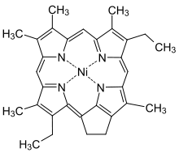 | 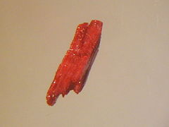
2 | Carpathite  (New Idria District, California) |  | 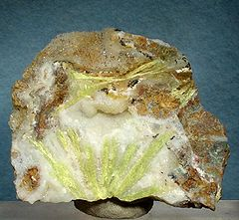
3 | Fichtelite  (Bavaria, Germany) |  | 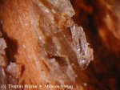
4 | Hoelite  (Freital, Germany) |  | 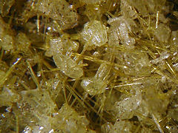
5 | Kladnoite  (Klado, Czech Republic) |  | 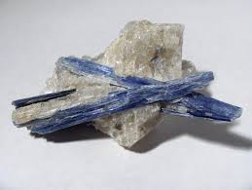
6 | Kratochvilite  (Zastavka, Czech Republic) |  | 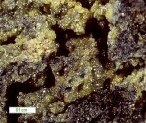
7 | Mellite or Honeystone  (Csordakuti Mine, Hungary) |  | - 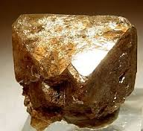
8 | Simonellite  (Tuscany, Italy) |  | 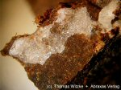

(2) IR spectra of mineral mellite (1) and synthetic mellite (2)

