Finite element model calibration of an instrumented RC building based on seismic excitation including non-structural components and soil-structure-interaction
F. Butt & P. Omenzetter
Department of Civil & Environmental Engineering, The University of Auckland, Auckland, New Zealand

ABSTRACT: This paper presents system identification, finite element model (FEM) development and model updating based on recorded seismic responses for a reinforced concrete building. The modal dynamic properties of the building were identified using state-of-the-art N4SID system identification technique. To ascertain the effect and contribution of structural and non-structural components (NSCs) and soil-structure-interaction, a three dimensional FEM of the building was developed in stages. To further improve the correlation of the developed FEM and the measured responses, a sensitivity-based model updating technique was employed taking into account concrete stiffness, soil flexibility and cladding as updating parameters. It was concluded from the investigation that the participation of soil and NSCs is significant towards the seismic response of the building and these should be considered in models to simulate the real behavior.

InTroduction
The characterization and prediction of the response of civil structures under extreme loading events such as earthquakes is a challenging problem that has gained increasing attention in recent years. The challenges associated with the civil structures such as buildings, bridges and dams include modeling their complicated interaction with the surrounding ground, varying environmental and loading conditions, and complex material and structural behavior which preclude the study of a complete system in a laboratory setting. An approach to tackle these issues is to use the recorded responses from instrumented structures and extract the dynamic characteristics such as natural frequencies, damping ratios and mode shapes using a process known as system identification (Hart and Yao 1976, Saito and Yokota 1996). The in-situ measured responses include all the real physical properties of the structure and can be useful for structural health monitoring and model updating studies (Brownjohn & Xia 2000; Farrar et al. 2000). The core of such studies is to develop a mathematical model which can replicate the true characteristics of the full-scale structures. This representative mathematical model is developed by an iterative process, called model updating, which involves systematic comparison of the in-situ measured values with the dynamic properties obtained via finite element model (FEM), and then improvement of the FEM based on the measured values. The errors in FEM arise due to the assumptions made in modeling elements, material and geometrical properties and boundary conditions.
An important aspect in modeling civil engineering structures is soil-structure-interaction (SSI). SSI involves transfer of vibratory energy from the ground to the structure and back. Mathematically it affects the solution of the governing equations of motion (Trifunac & Todorovska 1999). Due to the flexibility of soil, the natural period can be longer than the period of the fixed base building. Therefore, to represent the true in-situ conditions, SSI should be included in FEMs. Another important factor of structural modeling is the consideration of non-structural components (NSCs) such as cladding and partition walls. It is common practice to ignore NSCs in design but it has been revealed that their effect towards dynamic response can be significant (Su et al. 2005). The adequate representation of NSCs is therefore necessary to understand their contribution towards the dynamic response.
This study comprises three parts. In the first part the frequencies, damping ratios and mode shapes of an instrumented RC building are extracted using state-of-the-art N4SID system identification technique based on a recorded seismic event. For natural input modal analysis, this technique is considered to be one of the most powerful classes of the known system identification techniques in the time domain (Van Overschee & De Moor 1994). The second part consists of developing FEMs of the building in stages to highlight the importance and contribution of different structural and non-structural components on the dynamic behavior of the building. Moreover, the effect of modeling soil flexibility is also investigated. Finally, in the third part the developed FEM is compared and calibrated to the measured responses to replicate the true behavior of the building in the considered seismic event. Sensitivity-based model updating technique is used for the calibration of the FEM; cladding and soil are also included in the updating. This study highlights the importance of modeling the soil and NSCs in FEM to simulate the real behavior of structures and is expected to further the understanding of dynamic behavior of buildings during earthquakes.

description of the building and instrumentation
The building under study is situated at Lower Hutt, approximately 20km North-East of Wellington, New Zealand. It is a three storey reinforced concrete (RC) structure with a basement, 44m long, 12.19m wide and 13.4m high (measured from the base level). The structural system consists of 12 beam-column frames and a 2.54×1.95m RC shear core with the wall thickness of 229mm, which houses an elevator. The plan of the building is rectangular but additional beams along the longitudinal direction inside the perimeter beams and the shear core make it unsymmetrical in terms of stiffness distribution (Figure 1). The exterior beams are 762×356mm except at the roof level where these are 1067×356mm. All the interior beams and all the columns are 610×610mm. Floors are 127mm thick reinforced concrete slabs except a small portion of the ground floor near the stairs where it is 203mm thick. The roof comprises corrugated steel sheets over timber planks supported by steel trusses. The columns are supported on pad type footings of base dimensions 2.29×2.29m at the perimeter and 2.74×2.74m inside the perimeter and 610×356mm tie beams are provided to join all the footings together.
The building is instrumented with five tri-axial accelerometer sensors. Two accelerometers are fixed at the base level, one underneath the first floor slab, and two at the roof level as shown in Figure 2. There is also a free field tri-axial accelerometer mounted at the ground surface and located 39.4m from the south end of the building. All the data is stored to a central recording unit and is available online (www.geonet.org.nz). Figures 1 and 2 also show the common global axes x and y used for identifying directions in the subsequent discussions.

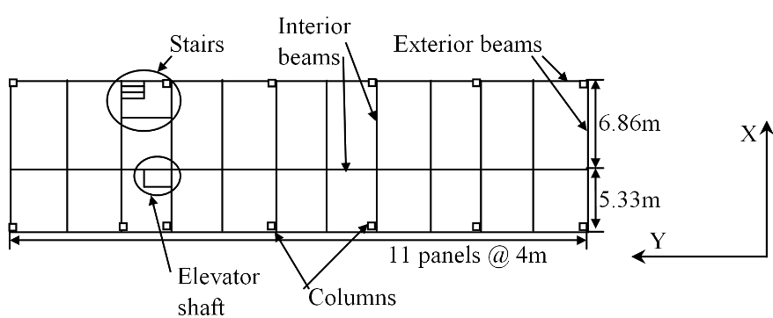
11 panels @ 4m

Figure 1. A typical floor plan of the building.

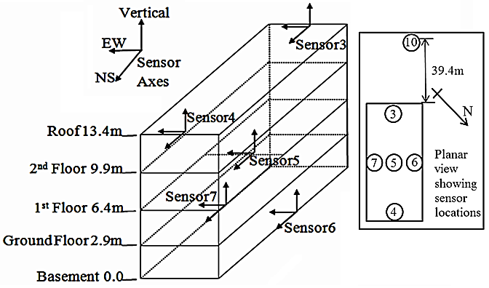

Figure 2. Three dimensional sketch of the building showing sensor array and sensor axes.

system identification under seismic excitation
In this section, the methodology of the N4SID system identification technique, the evaluation of SSI effects using this technique and extraction of frequencies, corresponding damping ratios and mode shapes will be discussed.

N4SID system identification technique
This section provides a brief explanation of the N4SID system identification technique. Full details of the technique can be found in Van Overschee & De Moor (1996). After sampling of a continuous time state space model, the discrete time state space model can be written as:
$$x_{k+1}=Ax_{k}+Bu_{k}+w_{k} (1)$$
$$y_{k}=Cx_{k}+Du_{k}+v_{k} (2)$$
where A, B, C and D are the discrete time state, input, output and control matrices, respectively, whereas x_{k} and y_{k} are the state and output vectors respectively and u_{k} is the excitation vector. Vectors w_{k} and v_{k} are the process and measurement noise, respectively, that are always present in real-life applications. The N4SID technique derives state-space models for linear systems by applying the well-conditioned operations, like SVD, to the block Hankel data matrices. The analyst, however, has to determine a proper system order. The approach based on observing trends of the estimated modal parameters in the co-called stabilization charts is often used: a range of system orders is tried and modal parameters which repeat themselves across that range are accepted as correct results. Stability tolerances are chosen based on the relative change in the modal properties, i.e. modal frequencies, damping ratios and mode shapes, of a given mode as the system order increases.

Evaluation of SSI effects
For evaluation of SSI effects using system identification procedures, Stewart & Fenves (1998) proposed the following approach. Consider structure shown in Figure 3. The height h is the vertical distance from the base to the roof (or another measurement point located on the building). The symbols denoting translational displacements are as follows: u_{g} is the free field translational displacement, u_{f} the foundation translational displacement with respect to the free field, and u the roof translational displacement with respect to the foundation. Foundation rocking angle is denoted by θ, and its contribution to the roof translational displacement is hθ. The Laplace domain counterparts of these quantities will be denoted as û_{g}, û_{f}, û and $\hat{θ}$ , respectively.
Stewart & Fenves (1998) considered three different models and associated transfer functions (H₁, H₂ and H₃) as follows:
• Flexible base model
$$H_{1}=\frac{{\hat{u}}_{g}+{\hat{u}}_{f}+\hat{u}+h\hat{θ}}{{\hat{u}}_{g}} (4)$$
where input is the free field displacement u_{g} and output is the total roof displacement u_{g}+u_{f}+u+hθ.
• Pseudo flexible base model
$$H_{2}=\frac{{\hat{u}}_{g}+{\hat{u}}_{f}+\hat{u}+h\hat{θ}}{{\hat{u}}_{g}+{\hat{u}}_{f}} (5)$$
where input is the total foundation translational displacement u_{g}+u_{f} and output is the total roof displacement u_{g}+u_{f}+u+hθ.
• Fixed base model
$$H_{3}=\frac{{\hat{u}}_{g}+{\hat{u}}_{f}+\hat{u}+h\hat{θ}}{{\hat{u}}_{g}+{\hat{u}}_{f}+h\hat{θ}} (6)$$
where input is the total foundation displacement including rocking u_{g}+u_{f}+hθ and output is the total roof displacement u_{g}+u_{f}+u+hθ.
In this study, we have considered only the flexible base model to ascertain the dynamic behavior (frequencies, damping ratios and mode shapes) of the building including SSI. Stewart & Fenves (1998) demonstrated that the poles of the flexible base transfer function H₁ give natural frequencies and damping ratios of the entire dynamical system comprising the structure, foundation and soil. For the building under study, sensor 10 (the free field sensor) was considered as the input and sensors 3, 4, 5, 6 and 7 as the outputs for the flexible base case.
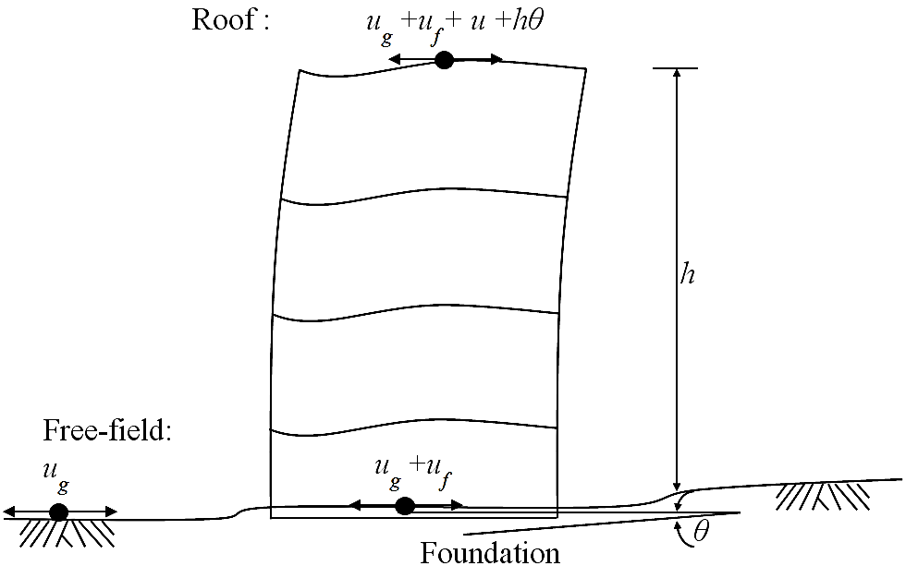
Figure 3. Inputs and outputs for evaluating SSI effects in system identification of buildings (Stewart & Fenves 1998).

Identification of modal dynamic properties
The above methodology is applied to a recorded seismic event in order to extract frequencies, damping ratios and mode shapes of the instrumented building. The earthquake was recorded on October 10th, 2009 and had epicenter 20km North-West of Wellington, Richter magnitude of 4.8, peak ground acceleration at the free-field and building base of 0.014g and 0.009g, respectively, and peak response acceleration at the roof of 0.0412g. The identified first three frequencies are 3.04Hz, 3.21Hz and 3.48Hz, whereas the corresponding damping ratios are 4.7%, 4.6% and 3.6% respectively.
The first three mode shapes of the building are shown in Figure 4 in planar view. (Note that because of a limited number of measurement points these graphs assume the floors were rigid diaphragms – a suitable assumption for RC floors.) The shape of the first mode shows it to be a translational mode along X-direction with some torsion. The second mode is translational dominant along Y-direction coupled with torsion, and the third one is nearly purely torsional. Structural irregularities, such as those due to the internal longitudinal beams being not in the middle and the shear core present near the North end of the building, create unsymmetrical distribution of stiffness which has caused the modes to be coupled translational-torsional. Another plausible
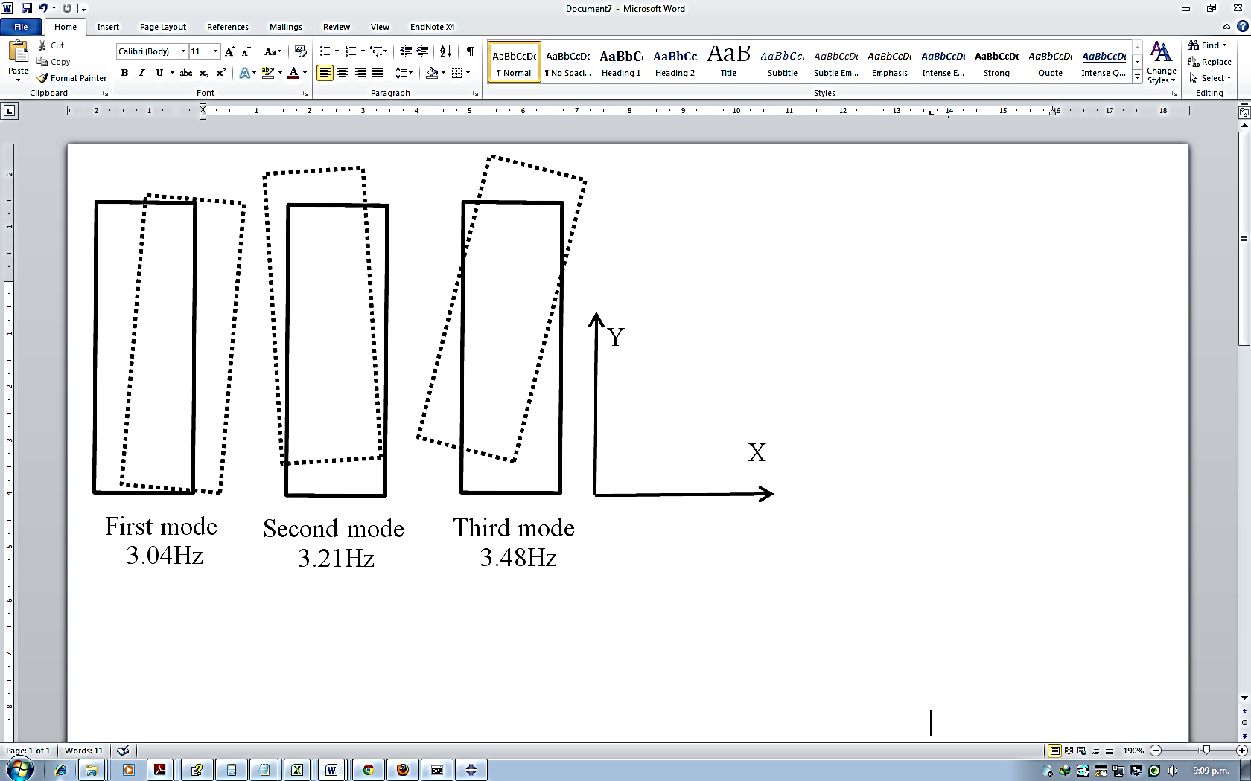
Figure 4. Planar views of the first three mode shapes.
source of mode shape coupling can be varying soil stiffness under different foundations and around different parts of the building.

development of finite element model
To evaluate the effect and contribution of structural, non-structural components and SSI, a three dimensional FEM was developed in stages using available structural drawings and additional at-site measurements. ABAQUS (ABAQUS 2011) software was used for modeling. The beams and columns were modeled as two node beam B31 elements, and slabs, stairs and shear core as four node shell S4 elements. Linear elastic material properties were considered for the analysis. Initially the base was assumed as fixed and beam to column connections were also assumed as fixed (moment resisting frame assumption). The density and modulus of elasticity of reinforced concrete for all the elements was taken as 2400 kg/m³ and 30 GPa respectively. The steel density and modulus of elasticity for roof elements were taken as 7800 kg/m³ and 200 GPa, respectively. The steel trusses present at the roof level were modeled as equivalent steel beams using beam B31 elements. The masses of the timber purlins, planks and corrugated steel roofing were calculated and lumped at the equivalent steel beams. All the dead and superimposed loads were applied as area loads or line loads at their respective positions. Figure 5 shows the three dimensional FEM having structural elements and NSCs (cladding, partition walls) and soil flexibility modeled in it as will be explained shortly.
The following stages of FEM development to ascertain the influence of different structural elements, NSCs and SSI were considered:
(a) bare fixed base frame with masses of slabs, dead and live loads lumped at nodes;
(b) fixed base frame with slabs and stairs modeled and dead and live loads applied;
(c) as in stage (b) with shear core (lift shaft) added;
(d) as in stage (c) with NSCs (partition walls and cladding) modeled;
(e) as in stage (d) with soil underneath foundation modeled; and
(f) as in stage (e) with soil around the building modeled.
SSI at the base is idealized as six DOFs springs modeling three translations and three rotations. The soil surrounding the building is modeled as springs at mid height of the basement columns. For the column springs along the longitudinal and lateral directions one translation DOF only i.e. stiffness and damping coefficients along X and Y direction, respectively, were taken into account, while for the corner column springs both X and Y translation stiffness and damping coefficients were considered. Base and column springs are modeled as SPRING1 elements. The values of spring stiffness and damping coefficients were calculated using the procedure explained in Gazetas (1991). Soil present at the site is classified according to the New Zealand Standard 1170 (Standards New Zealand 2004) as class D (deep or soft soil). The shear wave velocity was taken as 160m/s based on the investigation for the site subsoil classification (Boon et al. 2011) and correspondingly dynamic shear modulus as 47GPa considering the typical values of soil class D.
Since the structure under study is an office building, there are a large number of partition walls present. The stiffness values of gypsum wall partitions were taken from Kanvinde & Deierlein (2006) as 2800kN/m. The partitions were modeled as two nodes SPRING2 elements which are diagonal elements in the FEM. The mass due to partition walls, false ceilings, attachments, furniture and live loads were collectively applied at the floor slabs as area mass of 450kg/m². External cladding in the building is made up of fiberglass panels with insulating material on the inner side. The density and modulus of elasticity values of fiberglass were taken as 1750kg/m³ and 10GPa, respectively, from Gaylord (1974) and their mass was calculated manually (100kg/m) and applied at the perimeter beams.
The results of FEM modal analysis at different stages (a)-(f) are presented in Table 1 and compared to experimental results. An important observation from the analysis is that the values of frequencies of the bare frame, stage (a), are significantly lower compared to the experimental and also lower compared to the subsequent stage models. Stage (b) adds slabs to the bare frame increasing the stiffness and improving slightly the differences compared to the measured values. Stage (c) includes shear core which increased the first, second and third frequencies by 7%, 23% and 17% respectively from the previous stage. By modeling NSCs in stage (d), a considerable increase can be observed in the frequencies from the previous stage (c). In stage (e), the fixed base was replaced by soil springs which caused a considerable decrease, 13%, 26% and 13% for the first, second and third modal frequencies, respectively, from the previous stage (d). The final

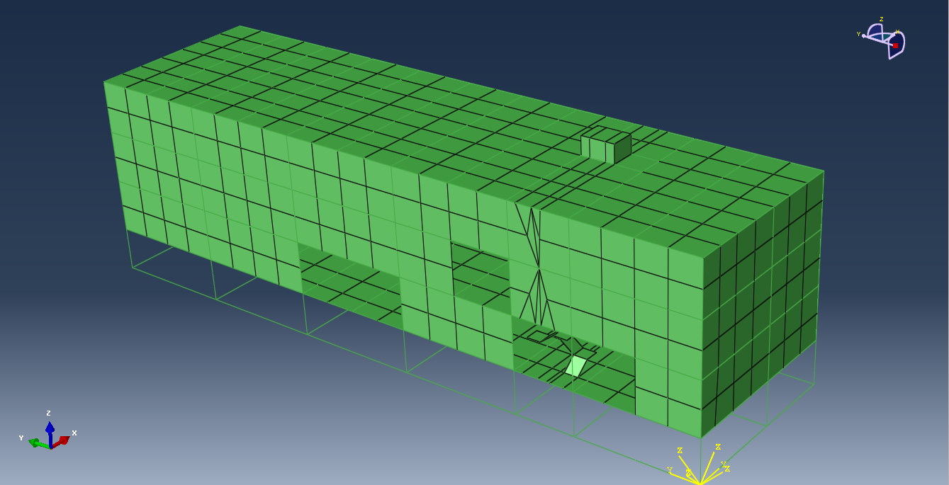

Figure 5. Three dimensional FEM of the building.

stage (f) includes modeling of the soil surrounding the building in which case all the frequencies again increased. At this final stage, all the differences compared to the measured values are under 7%. These differences will be further reduced by tuning the final stage FEM using sensitivity-based model updating technique and this is explained in the next section.

fem calibration using sensitivity-based model updating
Model updating is concerned with calibration of an FEM of a structure such that it can better predict the measured responses of that structure. The sensitivity-based model updating procedure generally comprises of three aspects: (i) selection of responses as reference data, (ii) selection of parameters to update, and (iii) an iterative model tuning. In sensitivity-based updating, corrections/modifications are applied to the local physical parameters (geometric, material and boundary and connectivity conditions) of the FEM to modify it with respect to the reference (experimental) data such as modal frequencies and mode shapes. For parameter modification in FEM, the experimental responses are expressed as functions of analytical responses (from FEM), structural parameters and a sensitivity matrix. Using the first order Taylor series this can be expressed as (Friswell & Mottershead 1996):
$$R_{e}=R_{a}+S\left(P_{u}-P_{o}\right) (7)$$
where R_{e} and R_{a} are the vectors of experimental and analytical response values, respectively, whereas P_{u} and P_{o} are vectors of updated and current parameters, respectively, and S is the sensitivity matrix.
For performing model updating to the instrumented building, the ABAQUS FEM developed in the previous section was exported to FEMtools (2008) software. Note there are slight, less than 1.7%, differences in the frequencies between FEMtools and ABAQUS models as can be seen in Tables 1 and 2. Table 2 shows that the difference between the initial FEM in FEMtools and measured frequencies are under 7% for all three modes. The correlation of mode shapes expressed by modal assurance criterion (MAC) values (Friswell & Mottershead 1996) is very good for the second mode, while for the first and third modes MAC values are satisfactory. Two types of errors, namely mean absolute relative frequency error, e_{f} , and mean MAC error, e_{MAC} , are considered for model updating and are given by:
$$e_{f}=\frac{1}{n}\sum_{i=1}^{n}{C_{r_{i}}}\frac{\left|∆f_{i}\right|}{f_{i}} ×100 \% (8)$$
$$e_{MAC}=100\%-\frac{1}{n}\sum_{i=1}^{n}{C_{r_{i}}}{MAC}_{i} (9)$$
Here n is the total number of response frequencies or mode shapes considered, C_{ri} is the relative weighting on the response, f_{i} and ∆f_{i} is the frequency and frequency error, respectively.
The response/target parameters include the three measured frequencies and MAC values. Sensitivity analysis was performed to ascertain the most suitable parameters for updating the FEM, also keeping in mind the uncertainty of the selected parameter values. This is also required to produce a genuine improvement in the FEM. Three parameters, namely (i) stiffness of soil springs for columns, perimeter and inner foundations, (ii) modulus of elasticity of all concrete members, and (iii) modulus of elasticity of cladding were selected.
Table 2 shows the frequency and MAC errors before and after updating. All the FEM frequencies are in good agreement with the measured values with the largest error not exceeding 0.8%. The MAC values have also improved slightly for the first and second modes and are equal to or above 80% , while for the third mode shape it has improved considerably but is still below 80%. The frequency error, e_{f}, has improved from 5.9% to 0.53%, while the MAC error, e_{MAC}, has improved from 22.3% to 15.3%. The maximum change in the selected updating parameter was for the cladding stiffness which decreased by 28% from the initially assumed value. This illustrates that cladding stiffness was overestimated in the initial model. For the modulus of elasticity of reinforced concrete the increase is by 20%. The values for the modulus of elasticity for reinforced concrete members and cladding were taken from literature and might not represent the actual values. Also, those material parameters are known to exhibit large variability, therefore large changes can be expected. However, the change in the soil springs stiffness after updating is only 4% which is not significant. The changes in the updating parameters represented the global changes of stiffness leading to the global changes of dynamic properties of the structure.

conclusions
This study comprises system identification of an instrumented RC building, FEM development for ascertaining the significance and contribution of structural and non-structural components and SSI towards dynamic response of the building, and finally calibration of the FEM to a recorded seismic response. It was concluded that NSCs and SSI should be included in FEMs to represent true in- situ conditions. To further improve the correlation of the
Table 1. Comparison of results of different stages of FEM modal analysis with measured values.

 | Frequencies (Hz)
Mode | Stage (a) | Stage (b) | Stage (c) | Stage (d) | Stage (e) | Stage (f) | Measured value
1 | 2.12  (-30.3%) | 2.20  (-27.6%) | 2.43  (-20.1%) | 2.98  (-2%) | 2.58  (-15.1%) | 2.90  (-4.6%) | 3.04
2 | 2.45  (-23.7%) | 2.50  (-22.1%) | 3.24  (1%) | 3.96  (23.4%) | 3.11  (-3.1%) | 3.43  (6.9%) | 3.21
3 | 2.30  (-34%) | 2.41  (-30.8%) | 3.00  (-13.8%) | 3.67  (5.5%) | 3.19  (-8.3%) | 3.65  (4.9%) | 3.48
Note: The values in parenthesis show the percentage difference between the particular FEM stage and measured values.

Table 2. Natural frequencies and MACs of initial and updated FEM and their measured values.

FEM |  |  | Measured values | Diff. b/w initial FEM and measured freq. (%) | Diff. b/w updated FEM and measured freq. (%) | Initial MAC  (%) | Updated MAC  (%)
Mode | Initial freq. (Hz) | Updated freq. (Hz) | Freq. (Hz)
1 | 2.91 | 3.02 | 3.04 | -4.34 | -0.56 | 78 | 80
2 | 3.43 | 3.20 | 3.21 | 6.71 | -0.29 | 92 | 96
3 | 3.71 | 3.51 | 3.48 | 6.65 | 0.73 | 63 | 78
Initial e_{f}=5.9%; Updated e_{f} =0.5%; Initial e_{MAC}=22.3%; Updated e_{MAC} =15.3%

developed FEM and the measured response, sensitivity-based model updating technique was applied. After updating, the frequency match was found to be very good, and mode shape correlation was good for the first and second modes, whereas for the third mode it was reasonable.

acknowledgements
The authors would like to acknowledge GeoNet staff for facilitating this research. Particular thanks go to Dr Jim Cousins, Dr S.R. Uma and Dr Ken Gledhill. The first author would also like to thank Higher Education Commission (HEC) Pakistan for funding his PhD study.

References
ABAQUS 2011. ABAQUS Theory manual and user’s manual. Providence, RI, USA: Dassault Systemes Simulia Corp.
Boon, D., Perrin, N.D., Dellow, G.D., Van Dissen, R. & Lukovic, B. 2011. NZS1170.5:2004 Site subsoil classification of Lower Hutt. Proceedings of the Ninth Pacific Conference on Earthquake Engineering, Auckland, New Zealand,14-16 April 2011:1-8.
Brownjohn, J. M. W. & Xia, P. Q. 2000. Dynamic assessment of curved cable-stayed bridge by model updating. Journal of Structural Engineering, ASCE 126(2): 252-260.
Farrar, C. R., Sohn, H. & Doebling, S. W. 2000. Structural health monitoring at Los Alamos National Laboratory. US-Korea Conference on Science and Technology, Entrepreneurship and Leadership, Chicago, 2-5 September 2000:1-11.
FEMtools 2008. FEMtools model updating theoretical manual and user’s manual. Leuven, Belgium: Dynamic Design Solutions

Friswell, M. I. & Mottershead, J. E. 1996. Finite element model updating in structural dynamics, Dordrecht, The Netherlands: Kluwer Academic Publishers.
Gaylord, M. W. 1974. Reinforced plastics: Theory and practice, 2nd ed., New York, USA: Cahners Publishing Co.
Gazetas, G. 1991. Formulas and charts for impedances of surface and embedded foundations. Journal of Geotechnical Engineering, ASCE 117(9): 1363-1381.
Hart, G. C. & Yao, J. T. P. 1976. System identification in structural dynamics. Journal of Engineering Mechanics 103: 1089–1104.
Kanvinde, A. M. & Deierlein, G. G. 2006. Analytical models for the seismic performance of gypsum drywall partitions. Earthquake Spectra 22(2): 391-411.
Saito, T. & Yokota, H. 1996. Evaluation of dynamic characteristics of high-rise buildings using system identification techniques. Journal of Wind Engineering and Industrial Aerodynamics 59(2-3): 299-307.
Standards New Zealand 2004. Structural design actions. Part 5: Earthquake actions – New Zealand. Wellington, New Zealand: Standards New Zealand.
Stewart, J. P. & Fenves, G. L. 1998. System identification for evaluating soil-structure interaction effects in buildings from strong motion recordings. Earthquake Engineering and Structural Dynamics 27(8): 869-885.
Su, R. K. L., Chandler, A. M., Sheikh, M. N. & Lam, N. T. K. 2005. Influence of non-structural components on lateral stiffness of tall buildings. Structural Design of Tall and Special Buildings 14(2): 143-164.
Trifunac, M. D. & Todorovska, M. I. 1999. Recording and interpreting earthquake response of full-scale structures. Proc. NATO Advanced Research Workshop on Strong-Motion Instrumentation for Civil Engineering Structures, Istanbul, Turkey, 2-5 June, 1999: 131-155.
Van Overschee, P. & De Moor, B. 1994. N4SID: Subspace algorithm for the identification of combined deterministic-stochastic systems. Automatica 30(1): 75-93.
Van Overschee, P. & De Moor, B. 1996. Subspace identification for linear systems. Dordrecht, the Netherlands: Kluwer Academic Publishers.

