Educational Action Research
Vol.20, No. 1, March 2012, 23-40.

Seeking researcher identity through the co-construction and representation of young people’s narratives of identity

Sarah Kearns

School of Education, University of Aberdeen, Aberdeen, UK
Email: s.l.kearns@abdn.ac.uk

Abstract

This paper tells the story of how a model of action research was used to examine my own development and emerging identity as a researcher through the Master of Research (MRes) programme at my employing university in Scotland. It is located within a context of increasing expectations on academics within vocational training departments of UK universities to give priority to research activity. My story aims to engage with how the challenges in developing 'self-as-researcher' were interwoven with my learning through undertaking a narrative inquiry project with 'More Choices, More Chances' young people (Scottish Government, 2006), as part of the MRes. The key stages of the research process, notably the search for authentic ways of gathering and representing the stories of the young people around the key themes of identity and inclusion, evoked the resonance of these themes with my own narrative of shifting and overlapping identities. In setting this paper within the context of current international literature I aim to add to current interest in reflexivity in research through illuminating the connections between the action research and narrative inquiry processes. Values around empowerment and social justice, illustrated in the paper through reflecting on the researcher/participant relationship, are interwoven in both. The visual research methods used in the narrative inquiry project are examined in terms of their contribution to an empowering ‘space’ for storytelling, and to my representation of these stories in trustworthy ways.

‘Clearly the self is actively narrated, dynamically accomplished as narrative practice provides the ever-developing stories that constitute our selves’ (Holstein and Gubrium, 2000: 124)

Keywords: action research; narrative inquiry; reflexivity; narrating the ‘self’; values; visual image.

Introduction

This paper aims to tell the story of my own development and emerging identity as a ‘beginner researcher’, framed through action research as the overarching model of inquiry. The story draws on and interweaves my experience of undertaking a narrative inquiry project as part of the Master of Research (MRes) programme within my employing university. This project engaged with the stories of young people, all aged 16 to 18, designated within the policy context in Scotland as in need of ‘More Choices, More Chances’ (Scottish Government 2006); at the time of the research they had all experienced significant areas of disadvantage in their lives, including family breakdown, state care, disrupted education, homelessness. Individual interviews were conducted with three young people within a voluntary agency offering specialised support, along with three focus groups drawn from a range of mainstream settings. The research question explored the relevance of the notion of ‘critical moments’ within their narratives of transition, and how these key turning points integrated a complex interface of intra-, interpersonal and structural factors (Henderson et al. 2007). Identity and inclusion emerged as overarching themes within the narratives. This paper sets out to connect these themes with my own story of ‘self-as- researcher’, highlighting my own ‘critical moments’ of transition. As Butler (2005) suggests, the process of self-knowing is always contextualised within relationships with others. The experience of researching with the young people has felt at times like sharing a story of vulnerability around ‘being and becoming, belonging and longing to belong’ (Yuval Davis, 2006: 201), perceiving these processes as similarly evolving, challenging and contextualised, and holding the potential for coherence, transformation and growth.

Narrating the Self

It is of course not unusual to look for coherence within a personal and professional story, to seek to transform the apparently ‘chaotic jumble’ of experiences (Heikkinen et al. 2007, 6) into a meaningful if still ‘messy’ shape (Etherington 2004). What may be less usual is the timing of my search for coherence at the final stage of my professional social work and academic career. I now find myself within the research-intensive environment of a university following the merger with an independent teacher education college, in which social work qualifying programmes, to which I contributed as lecturer, were also based. A new role emerged for me within the university as lecturer in child protection and inter-professional practice within the school of education.

The process of ‘rationalisation’ of teacher education colleges has been widespread across the UK and has been seen to challenge long-established practitioner-educator identities (Brown 2007; Houston 2010). I have been intrigued, and at times challenged, by the term ‘beginner researcher’ often applied to those newly undertaking research within the university, regardless of age and experience. My earlier projects and publications/reports undertaken with the aim of improving practice are often not defined as research in this context. It is interesting that these challenges have served to create a measure of shared experience for all, from whatever professional background. The MRes programme has offered a shared opportunity to value the identity of ‘beginner researcher’, to integrate and transform existing claims to identity rather than as a ‘crisis of confidence’, to create a sense of humility rather than humiliation.

‘What kinds of research should I do in this context, with whom and how?’ – key questions which have shaped discussions with my colleagues in reappraising how we understand ourselves within the new institution, in which large-scale quantitative projects appear to predominate. Although fully appreciating the latter approach to inquiry as vital for some major areas of social science/educational research, I found it difficult to reconcile quantitative approaches with my interest in inquiry as a search for the unique meanings people attribute to their lives. I rather wished to explore my interest in the potential of research to examine the complexity of human experience, to co-construct ‘multiple realities’ rather than a fixed ‘truth’. Reflexivity has been the key to my positioning in this regard – understanding reflexivity as ‘ a dynamic process of interaction within and between our selves and our participants’ (Etherington 2004). I was concerned also to seek ways of researching which do not deny what MacClure (1993, 287) terms the ‘inescapably moral’ dimension of previous self-justification, the core beliefs embedded in image of ‘self’. Ethical dimensions of research activity have therefore been central to constructing morally justifiable connections with my past experiences. Deeply held personal and professional values around empowerment and social justice appeared to offer the unifying thread of the narrative of ‘self’ (Etherington 2004; Griffiths, in Noffke and Somekh 2009), in engaging with issues of power within the research relationship. In this regard the choice of both action research and narrative research methodologies as founded on understanding inquiry as ‘inherently value-laden activity’ (Reason and Bradbury 2006, xxv) will be highlighted in this paper as shaping and justifying my identity as a researcher. The visual methods used to access and represent the young people’s narratives will be presented as a key evocative dimension of the reflexive process around the positioning of the researcher and the researched (van Manen 1997; Nicol 2008).

Before moving to an account of the narrative inquiry process with the young people I would wish to add another layer to the ‘story of reflexivity’ by looking back at what has brought me to this point, and what I may therefore bring to my identity as a researcher. In terms of the personal, the story has its seeds in my search through adolescence and early adulthood for a sense of coherent identity and self-efficacy within the context of family disruption. Later, my role as an adoptive mother resonated with this in bringing an intense experience of vulnerability and ‘newness’ of identity, and in bringing equally intense experiences through the process of supporting my children with complex issues of identity. Within the professional domain, looking back on my initial experiences as a social worker within children’s services, I now hear my ‘voice’ from that time as one expressing unquestioning confidence in my ability to ‘make a difference’ through giving of myself to those in need, vulnerable or marginalised. At the same time, I can see from this vantage point how more complex and fluid meanings developed around power relations, through working with imbalance of power in my everyday relationships with service users and colleagues, and through understanding how this process was inevitably contextualised within institutional and societal systems. Shifting to the role of family therapist served to intensify this internal frame of reference, strengthening my commitment to ‘partnership’, in seeking to acknowledge and address imbalance of power within therapist/client relationships. Partnership, in the context of the deeply rooted values within social work and counselling domains, engages with notions of empowerment and anti-oppressive practice (Thompson 2008). The willingness to let go of the ‘expert’ position is central to this - to be curious about the unique capacities and knowledge brought by each client to the working relationship.

So how could I integrate these ‘stories’ with the ‘new’ story I was embarking on? I was attracted to action research as holding the potential, within a broad ‘family’ of approaches (Reason and Bradbury 2006), to enhance self-knowing through a complex process of seeking ‘space between academia and practice’ (ibid: xxv). The development of my own narrative of learning through the various stages of the narrative inquiry project appeared to ‘fit’ the ‘cyclical’ approach to action research through self-observation, reflection and action (Somekh 2006). In similar ways each narrative inquiry ‘has its own rhythms and sequences, and each narrative researcher needs to work them out for her or his own inquiry’ (Clandinin and Connelly 2000, 97). Despite the often personal nature of my experience of this inquiry I hope that opening up this multilayered narrative to the critical view of readers, a process that could be described as ‘speaking partially naked’ (Clandinin and Connelly, in Denzin and Lincoln 1994, 423), may offer insights to readers on the significance of reflexivity within the research process and add to the growing body of international literature on the connections between action research and narrative.

The narrative inquiry – the beginnings

I was committed to building my narrative research project from immediate practice experience, engaging actively within my own environment (Bridges 2003) and working with teaching and research as interwoven activities. At the same time as starting the MRes I was involved in designing and delivering a series of workshops for young people designated as in need of ‘More Choices, More Chances’ (Scottish Government, 2006). During these workshops the young people were encouraged to tell stories around their experiences of ‘growing up’, and the choices and chances they wished for and valued. On the basis of these stories several workshops were facilitated with relevant professionals to respond to the young people’s stories and to draw out shared understandings of effective practice.

My research question (see introduction) emerged from reflecting, alongside university colleagues, on the process and outcomes of these workshops. I was reassured that building on the key theme of ‘what helps and when?’ directly from the young people’s ‘voice’ had the potential to be both valid and interesting to pursue in the research domain. I was able to see how storytelling could be used as a similarly empowering and anti-oppressive method within research as in practice activities. The notion of social justice could remain ‘at the heart’ in seeking the ‘voice’ of marginalised young people within research as in practice contexts (Griffiths, in Noffke and Somekh 2009).

Considering methodology

The next step therefore was to apply these reflections to the process of framing the project within a research methodology, which would enable me to achieve the continuity of my story with those of the young participants of my research (Heikkinen 2007). My colleagues, acting as ‘critical friends’, (McNiff and Whitehead 2009) helped me to rein in my enthusiasm for the ‘action’ in order to think through which methodologies might ‘fit’. As previously noted, I was attracted to action research as integrating past and present stories within current experience (Brown and Jones 2001), and as acknowledging the significance of a reflexive approach -‘inward and outward, backward and forward’ (Clandinin and Connelly 2000, 50).

At the same time I needed to reflect on what I saw as the ‘narrative within a narrative’ i.e. what frame would fit the specific research project with the young people and also be consistent with my core beliefs. Intense discussions with one key ‘critical friend’, a close colleague of a similar age and professional background, took us on an exploration of the international literature of narrative inquiry. We found many connections with our positioning on ethical practice and social justice. Furthermore, we discovered key ideas around the interrelationship between action research and narrative inquiry (Pushor and Clandinin, in Noffke and Somekh, 2009). Significant links emerged between the storytelling approaches we had both used effectively for many years within the teaching context and the narrative characteristics within action research (Heikkinen et al. 2007; Caine 2010). Most significant for me was the resonance with my understanding, through counselling practice, of ‘storied lives’ as a way of connecting with the heart of human experience through the universal human activity of storytelling (Riessman 1993). I came to see the connections to the research domain through the potential for stories to ‘provide a means by which those truths, which cannot otherwise be told, are uncovered’ (Clough 2002, 8). Equally my commitment to a self-reflexive approach within counselling practice - ‘We need to know the inner story that we tell ourselves as we listen to our clients’ stories’ (Etherington 2004, 29) - was positively recognised within narrative research.

In considering the specific implications of narrative inquiry in terms of this project with vulnerable young people I was reminded of the significance of the positioning of human stories within social, political and institutional worlds (Davies and Harre 1991) and of the impact of powerful discourses within society on narratives of disadvantage and social exclusion (White and Epston 1990; Payne 2006). I therefore considered how the positions of researcher and research participant within wider society would necessarily be mirrored within my research project. Understanding power relations as a core belief within narrative inquiry (Daya and Lau 2007) necessarily engaged me with the nature of the ‘shared space’ inhabited by both narrator and researcher (Cross 2009, 101) I needed to reflect on the areas of personal and professional interest which might connect me with the young participants in the research. Even more significant differences such as age, class and education were likely to impact on the research relationship. In this context I considered the ‘dance of forms of power’ (Nunkoosing 2005, 699) - the constant dynamic likely to flow from our different stances to the knowledge sought and offered. I considered that the broader context of young people’s current narratives of transition, characterised by negative discourse, deep ambiguities and contested meanings (Thomson et al. 2004) would necessarily emerge within the research ‘space’. Notions of dependence and independence, protection and participation, competence and vulnerability, are interwoven in deeply ambivalent ways in their experiences within social, political and institutional contexts, notably the ‘ruling regimes’ (Smith 1990, 3) of schools and social welfare departments.

I was therefore attracted to the notion of narrative as a co-construction within the relationship between researcher and research participant, through which their unique values and subjectivities interact in complex ways (Riessman 2008). In this context each interview is seen as a unique encounter (Nunkoosing 2005), from which knowledge emerges as ‘tentative, variable and blurred’ (Pinnegar and Daynes, in Clandinin 2007, 25). It is suggested that the best possible route to this knowledge is developed through a genuine search for the ‘voice’ of the research participants as expressed within the unique time and place and relational context of the encounter (Guba and Lincoln, in Denzin and Lincoln 2005). Rather than seeking in this process the ‘truths’ of the young people’s lives, my interest lay in the subjective meanings - ‘glittering fragments’ of reality (Daya and Lau 2007, 2).

Considering methods

This search for ‘voice’ triggered key questions about which methods might resonate with these conceptualisations of relationship. Stanczak (2007, 1) notes: ‘Images convey’. I had long used images in various ways within teaching contexts, almost taking for granted their power to empower and to facilitate discussion, and was intrigued to explore how these might be used in similarly empowering ways within the new domain of research. I encountered robust challenge from peers in exploring these connections, particularly with regard to questions of ethics and validity. This challenge took me on a search within the research literature.

I hoped that using images could be similarly viewed in research terms through the lens of empowerment, as enabling the young people’s narratives, representing their ‘voice’ and contributing to a ‘mandate for social action’ (Guba and Lincoln, in Denzin and Lincoln 2005, 201). The ethos of participation appeared particularly significant in the literature (Heath et al. 2009; Henderson et al. 2007). Visual methods have been increasingly perceived as redressing the balance of power within research with marginalised groups through their potential to stimulate a greater degree of choice and control (Newbury and Hoskins 2010). Their potential to empower disadvantaged young people through tapping into their visual literacy also struck me as significant. ‘Visual methods have a particular potential to give young people more control over the process of data generation, and to express themselves in a medium with which many appear to be particularly comfortable’ (Heath et al. 2009, 116).

I also considered key debates about the nature of ‘truth’ in this regard. Should images be valued for their power to stimulate interpretations and reflect ‘deeply personal, emotional intimacies’ rather than ‘empirically objective representations’? (Stanczak 2007, 12). The power of accessing data through symbolic and metaphorical approaches was legitimised through my search (Valentine 2004), confirming my belief that we can explore ‘one domain of experience in terms of the conceptual structure of another domain’ (Lakoff and Johnson 1987, 73).

In terms of the complex area of data collection methods, a new area of learning for me, I discovered that youth researchers have generally focused on generating visual material as the outcome of their research, through involving young people in activities such as photography, mapping, creating video diaries (Bagnoli 2004), and they have only more rarely sought data through triggering the responses of young people to researcher generated visual material (Heath et al. 2009; Sparrman 2006). This confirmed my interest in this approach. In selecting specific visual tools, I was encouraged by my positive experiences of using a set of 75 commercially produced photographs (‘Picture This’ - Innovative Resources, Melbourne). These had proved particularly fruitful in counselling and teaching contexts in tapping into deeply held, intuitive meanings and beliefs around emotive issues such as child welfare and mental health. My experience was that the same photograph often evoked different symbolic meanings from different individuals.

However I was aware that no researcher can ever enter fully into the world of another (Holloway and Wheeler 2010), and the original primary experience may lie in the realm of the ‘unsayable’ (Rogers, in Clandinin 2007). I aimed through the use of image to reach out to the intuitive and affective dimensions of the young people’s experiences, thereby attending to the ‘layer’ of sensation for both narrator and researcher, the sensory knowing (Ackerman 1994). In this regard I needed to remain fully aware of the potential sensitivities of the young people’s stories, reflecting that giving them free choice of images may offer an ‘externalising’ strategy (White and Epston 1990). I had experienced in counselling practice that offering this approach often allowed the safer exploration of sensitive issues through creating a measure of ‘distance’ and ‘control’.

The Research Stage

I invite the reader to follow me now into the heart of my narrative, through which I attempted to embed the insights gained from all these previous reflections. The reflexive diary in which these were recorded enabled me to return to previous observations and thoughts within the immediate experience of the research. In this way reflexivity was embedded within the action research process, through understanding reflexivity as the search for learning through accessing previous thoughts and experiences, and thereby assessing choices and actions for their value in the future (Payne 2002). These thoughts, experiences, choices and actions must be contextualised in terms not just of the personal, but also of social, cultural and institutional domains (Etherington 2004). The diary form provided an evocative framework for organizing and representing my reflections (van Manen 1997).

Preparation

As previously noted, the research process had to be rooted for me in the same code of ethics which has framed all my previous experiences. I therefore needed to place ethical research design and application at the heart of this study with young people, if I was to avoid reinforcing the vulnerability and disadvantage experienced in other areas of their lives (Heath et al. 2009). In working with young people within practice contexts I had frequently encountered dilemmas around seeking an appropriate balance between empowerment and protection. A strong ‘ethic of care’ (Miller and Bell 2002) was clearly required but it could not be assumed that distress would necessarily be consequent on the process of narrative inquiry, and also to assume that young people have less competence to understand the nature of the risks they run would, I reflected, mirror the stereotypical view of young people as lacking full social agency. To achieve the necessary balance in this process, I considered how I could offer as free a choice as possible to participate, through an open letter of invitation to all young people within the support agency, highlighting the goals of the research in clear language, while also offering the opportunity, through preliminary meetings with volunteers in their own setting, to highlight the inherent unpredictability of the research conversation, but to also stress their choice to share only what they wished. Within this ethical practice framework I also wished to understand more fully the specific context of the young people, seeking to further a process of ‘immersion’ (Delamont and Atkinson 1995). Informed consent was acknowledged as an ‘ongoing process’ (Holloway and Wheeler 2010, 59) in which their right to withdraw at any stage of the research process was absolute.

In summary, therefore, I became committed to a ‘situated’ rather than a ‘rules-based’ approach to ethical practice (Heath et al. 2009, 22), which would allow for sensitivity to each unique encounter, minimise the risk of emotional harm, but respect the competence and autonomy of each individual young person. I aimed to create a protective yet empowering ‘space’ for the research dialogues in order to seek authenticity of voice, and to work through an empathic relationship without crossing the boundaries into a therapeutic one (Watson 2009). Visual images as method were perceived as central to this ethical framework. All these dimensions of the ethical framework were developed through discussions with my supervisor and approved by the research committee of the university.

I will present in the next section excerpts from two of the individual research interviews, aiming to highlight through ‘thick description’ (Ponterotto 2006) key ‘critical moments’ in my learning and in constructing researcher identity. I include the associated images chosen by the young people to represent their stories. I have named the two young people concerned Anne and Brian for the purposes of anonymity and confidentiality.

The Interviews

In considering where to hold the interviews I reflected on the power of the visual in ‘narrative space’, notably in how spatiality may be used to best advantage (Heath et al. 2009).The relationship between ‘internal’ space inhabited by stories and ‘external’ space appeared crucial (Cross 2009). ‘Space’ can also be seen as significant within the ‘construction and reproduction of social identities’ (Heath et al. 2009, 116) within the research relationship. Offering the young people the opportunity to choose familiar territory for the interviews seemed to me more likely to promote an enabling and comfortable experience than if we had met on my territory at the university, which may have suggested a more formal and structured approach, prioritising my agenda rather than theirs. Within my ‘ethic of care’ it was also important that trusted adults should be available after the interviews to offer support if required. Both Anne and Brian chose to meet me in their usual group meeting room within the support agency.

This setting for our interviews was full of significance both for the young people as ‘insiders’ and for me as the ‘outsider’. Given my familiarity with working in community settings, I was surprised at how vulnerable I felt in my new role as a researcher, removed from my territory. However I was reassured that meeting with the young people within a setting familiar to them was effective, perceiving that this changed the balance of power between us to some degree. Anne appeared keen to introduce me to her world through referring to the photos on the walls of herself and her peers engaging with group activities, thus reinforcing for me the significance of the research ‘space’. With Brian too, I observed how his eyes were drawn instinctively to the photos of himself alongside familiar people. As part of our introductory conversation I commented on this and he confirmed my impressions.

B. ‘That’s when we did the white water rafting – I can’t believe I did that’

Prior to the interviews I had laid out the full set of ‘Picture This’ photos on a large table, encouraging Anne and Brian to choose as many as they wished which reminded them of their ‘growing up’ stories. In describing this process at a subsequent seminar with colleagues I was challenged to think through whether I may have prescribed the outcomes in some way through placing the photos according to my own agenda, whether consciously or sub-consciously. Although surprised at the time by this question (and perhaps defensive at the suggestion of manipulation that it implied), I have since acknowledged this challenge as a valid one given that I accept these visual images may hold powerful symbolic meanings for me as a researcher (in the present as well as from my past experience of them). However, in revisiting my reflexive diary, I was reassured that I had thought about how I would introduce the photos as openly as possible as ‘a way of reminding you about your stories of ‘growing up’ and ‘just pick any that tell you something about important times and how you saw yourself in the story’. I noted that I was seeking to dispel any suggestion of prescribed or preferred choices, to reject the ‘expert position’ and adopt a stance of curiosity and ‘not knowing’. Through the images I hoped Anne and Brian would be enabled to choose positions in the research process rather than to adopt those imposed by ‘self-defined experts’ (Riessman 2008; Daya and Lau 2007).

I therefore reflected on the importance of emphasising the choice of images as a personal activity which did not involve right or wrong answers. Through previous personal and professional experiences of the power of educational institutions in constructing and challenging identity I was aware that any suggestion of my own agenda may remind them of negative experiences in which they felt they had not ‘performed’ according to adult requirements. It was particularly pleasing therefore that Anne seemed to engage so spontaneously and intuitively with the images, confidently selecting four within a short period of time. From this point on, these images seemed to become the primary focus for her stories and to offer a ‘comfortable handle’ for both of us in co-constructing the narrative through dialogue. She often checked out my views on the photos, perhaps evaluating my position in terms of knowledge of her world e.g. Do you know X who I think of when I look at this? Have you ever been to a place like this?’

Brian initially sought reassurance about what might be the ‘right’ photo to choose. I reflected that the difference in age and gender between us may be significant here - that he may associate me with a teacher/authority figure. The particular vulnerability of young men in this regard seemed relevant here (Quinn et al. 2010) and I was aware of feeling more protective of him – and of the potential for blurring the boundaries of the researcher position. However, accessing his experiences through the medium of the visual image enabled me to identify areas of discomfort and address them without crossing into a therapeutic (or motherly!) role. Instead of asking questions or using direct eye contact I sought to encourage him through frequent ‘discourse markers’ (Norrick 2008), such as - ‘yes, that photo’s really interesting’. This approach seemed to give him permission to make his own selections.

The Narratives

Anne’s narrative

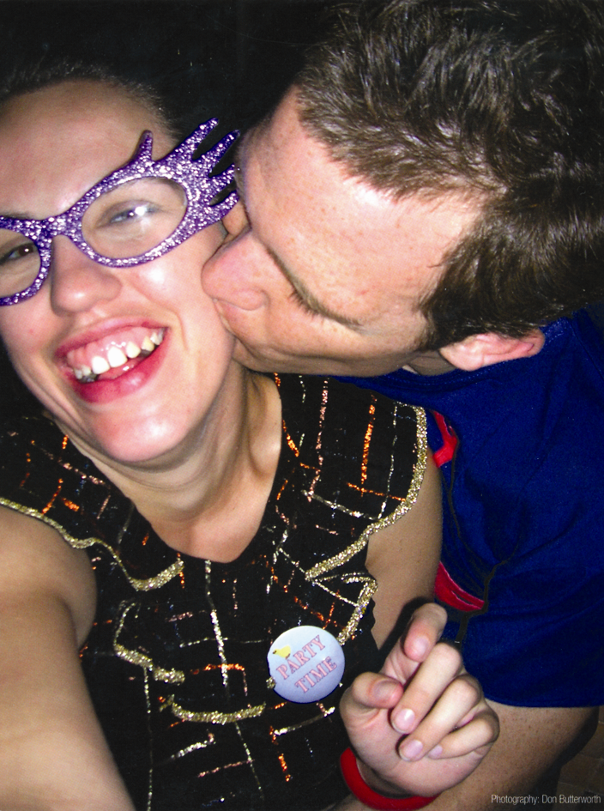

The Party Girl (fig.1)

For Anne the ‘partying’ narrative appeared to construct her ‘entrance’ (Jefferson, 1979, cited in Riessman 1993, 58) to all subsequent narratives; despite the traumatic nature of the experiences of family breakdown linked with this image it appeared to create a coherent starting point in constructing her narrative of transition. It appeared significant to me in my concern with identity themes that she appeared to make sense of this through a process of identity construction, linking ‘self’ within family, community and school contexts.

A. ‘When I was 10 my mum and dad split up…I wanted to go with my dad but I couldn’t so I argued with my mum a lot…so I wanted out of the house and the friends I was with did all that partying…drinking…I started smoking hash when I was 12…I was the life and soul of the party’.
A. ‘At school I was like ‘stupid’ and felt bad about it…the teachers didn’t know or care about my mum and dad…the bullies always picked on me….when it came to 2nd year I started hanging around with…you might call them ‘Neds’’.

In terms of the emerging relationship between us I reflected that through this choice of image and narrative content she also may have wanted to test our relative positions – what would be my response? Would I demonstrate a typical ‘adult’ response? Shock? Disapproval? I was aware I could easily make a ‘false move’ and that I must respond in an open and uncritical way. ‘That sounds like a really important time in your story of growing up’.



The Shadow in Dark Places (fig.2)

The second image (fig.2) selected by Anne involved her in revisiting an intensely traumatic experience of homelessness, the ‘darkness’ of the image associated with ‘dark’ discourse - being ‘unseen’, powerless, alienated.

A. ‘Mum said she would chuck me out on my 16th birthday…that photo is all the dark places when I was really scared and I didn’t know how I was going to handle it on my own’.

I sensed that she was anxious in recalling such traumatic experiences, which in turn caused me some anxiety, sadness, and indeed anger, on her behalf, and that in conveying empathy verbally as well as non-verbally as I did -‘that sounds like such a scary story’ - there was a danger of crossing into a therapeutic role. This may have led to me taking more control and seeking more detail of her experience. In the role of researcher I was aware of the implications of interrupting her flow of narrative, and therefore held to respect for her autonomy in telling her own story without interruption, and in managing the strong emotions it evoked. I recorded later in my diary that the distancing medium of the image appeared to help her to do this: ‘I can see the shadow that was me, but it’s not dark like that now’.
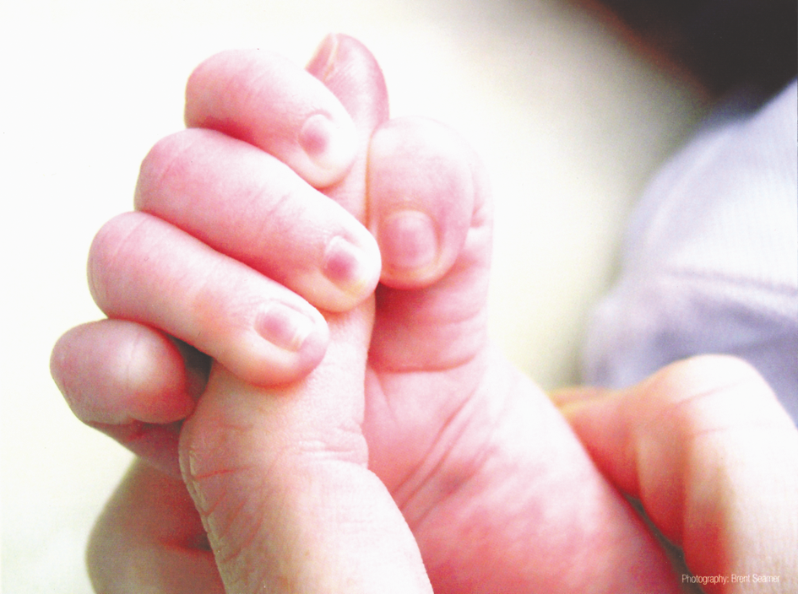

Trust (fig.3)

This image (fig.3) appeared to be chosen by Anne to construct her ‘exit’ narrative (Norrick 2008), an expression of making sense of the past and hope for the future - a symbol of ‘survival’ and ‘transformation’ - perhaps reinforcing to me the ‘grown up’, resilient and autonomous identity she now wished to present.

- ‘It’s about trust. A child’s hand’.

She made links with past experiences through the image. ‘I can also let myself be a ‘family’ person again now I’ve got my dad again…I didn’t dare see him for a while in case he pushed me away, I can trust people more’.

I was aware, however, that my own investment in a ‘happy ending’ may have influenced Anne’s choice and interpretation of the image? ‘Hope and belief in change are so much part of my personal and professional story – am I influencing hers?’ (Excerpt from reflexive journal). Was I taking too simplistic a view and yielding to the seductive impulse to ‘smooth’ the data - the ‘Hollywood effect’? (Connelly and Clandinin 1990) I needed to be aware too of the context of the research interview - that Anne may have felt some implicit pressure to tell a positive story of her current experience within the agency setting. However, the emotional content of her narrative of ‘trust’ did appear spontaneous. I was able to draw on skills from my social work/counselling experiences in checking out my assumptions by reflecting back through the medium of the image. ‘It sounds as if you feel you’ve got the support to let go a bit now’

- ‘I can look back and look forward. One thing I’ve learnt is that I can always come back here and they’ll help me…that helps me to think about the future’.

Brian’s Narrative

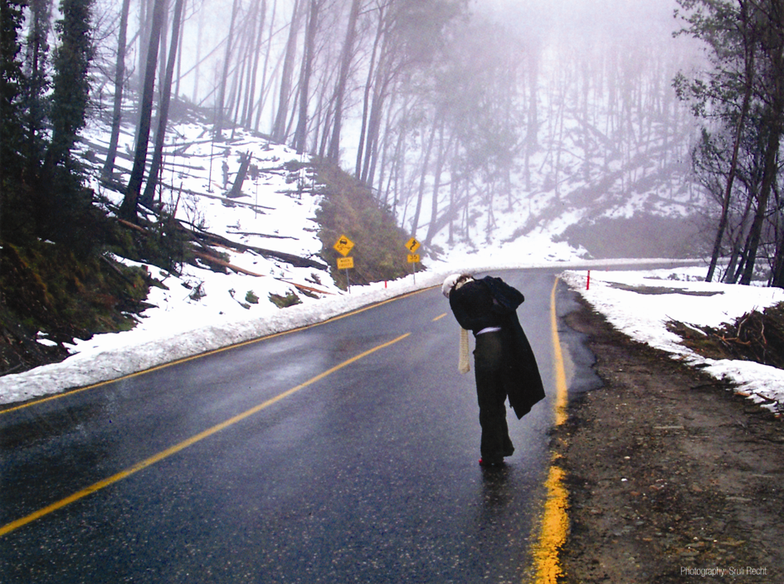

The Clown (fig.4)

Similarly Brian’s ‘entrance’ narrative involved a traumatic family event, in his case when he left the family home aged 12, with his mother and younger sister, to live in a women’s refuge. The narrative emerging from this image reflected significant disruption to his life through an abrupt change of school and community over which he had little control, thus highlighting my understanding from other contexts of the crucial interface between the personal, systemic, and institutional dimensions of young people’s experience.

B. ‘My mum couldn’t understand why I wouldn’t go to school…the times I went I just didn’t fit in…I felt a freak…in the end they took my name off the list’.

I was aware yet again at this point of how important it might prove to respond to the emotional rather than the factual content of this story - ‘he does look so alone in the picture’ – showing empathy rather than slipping into ‘adult’ mode by inquiring into the ‘truth’ of his account, thereby perhaps reinforcing the issues around loss of control embedded in the story. I sensed that referring to the visual image rather than making eye contact in exploring the emotional content offered a useful measure of ‘distance’. Looking back it may also have offered me some distance in managing my emotional response to his story.

The image he entitled ‘The Clown’ (fig.4) seemed to symbolise his school experience at that time in powerful ways. The sense of marginalisation he conveyed reminded me of working with other young people whose behaviour in school was often interpreted on a superficial level as deliberately challenging. I appreciated particularly that he was able and willing to access these insights in the research context, in which our relationship was so short-lived, and he had little knowledge beyond my word of what use I would make of them. This really brought home to me, as in other roles I have occupied, that the researcher role relies on how the researcher conveys a sense of trustworthiness and integrity, particularly in working with those whose world has been unpredictable and consistent.

B. ‘I felt alone and fogged up like that…nobody really saw me or how I felt….I can see now I became the class clown - it’s easier looking back, isn’t it? I could choose to be a real pain in the neck to the teacher - at least everyone noticed me then. I still felt sort of alone - it was my way of saying ‘You can put me down but I’m still here’ but of course I got into trouble …got excluded and that didn’t feel like me’.



Thrown in the Deep End (fig.5)

Brian used this image (fig.5) to reflect on his current experience within the personal development group run by the support agency, highlighting the effective balance between challenge, protection and support from the staff and his peer group in enabling him to take part in group activities and construct a more confident self image.

B. ‘I had never had the confidence before but once I came here it felt different. I could see everyone else was nervous and scared like me but we got so much encouragement, nobody put me down….the things I got to do were amazing - even abseiling though I hate heights. We were ‘thrown in the deep end’ but we could choose what we wanted to do first and join up with someone else who was scared. It felt like being human again – didn’t need to show off and be cool’.

I was struck by the fact that, similarly to Anne, he was able to construct a coherent narrative for the present from past experiences of exclusion, and to highlight the new choices opening up within it. I was also aware of some curiosity in seeing this image used in this positive way, which I had come to associate negatively with professionals’ metaphors for ‘drowning’ in relation to overload and stressful experiences. It was useful for me to consciously challenge previous assumptions drawn from other practice contexts.

Analysis/Representation

Following the interviews, I reflected on the contested notion of ‘validity’, the ‘fertile obsession’ (Lather 1993, 673). I wrestled particularly with how to represent authentically the ‘voice’ of the young people, without compromising my own ‘voice’ in seeking to fulfil the aims of the research. ‘How is it possible to fully credit and respect the voices of participants in research while at the same time exerting interpretive authority over those voices?’ (Rogers, in Clandinin 2007, 101). Tensions with normative understandings of ‘interpretive authority’ within the university emerged from discussion with colleagues. However, while not accepting the assumption that ‘experts know best’, I also reflected on the dilemma that the anxiety triggered by the analysis stage within small-scale qualitative projects can result in ‘the tendency to privilege the voice of the participant and silence the analytic voice of the researcher’ (Hoskins and Stoltz 2005, 97). It was crucial to remind myself of the need to also respect my own ‘analytic voice’ in drawing out themes which may ‘make a difference’ in line with the goals of the study.

In exploring these tensions further through the literature I was reassured that both action research and narrative inquiry can be seen to move beyond the ‘normative framings of validity in the human sciences’ (ibid, 674), concerned with notions of objectivity, reliability, generalisability. I took on board however that narrative analysis can be considered superficial where participants’ stories are accepted and represented uncritically as data (Atkinson 1997). I was also wary that I might fall into the trap of celebrating uncritically the ‘success’ of my narrative as researcher, the ‘Hollywood effect’ (Connelly and Clandinin 1990). In seeking resolution of what Denzin and Lincoln term the ‘crisis of representation’ (2005) I was attracted by the five principles for validation of action research as narrative (Heikkinen et al 2007), in offering a unifying approach to evaluation of my work, i.e. historical continuity, reflexivity, dialectics, workability, evocativeness.

During the interviews I was aware that I was already engaging with the process of analysis. The priority was therefore to allow full space for and stay consciously with the ‘live’ narratives in order to minimise the risk of steering them towards the narrative themes I already saw emerging. I was aware also of the risk of ‘smoothing’ them into overly coherent conclusions (Connelly and Clandinin 1990). I therefore approached the next stage of interpretation and representation of the data with some discomfort. Within the ethical framework of the research I had the responsibility to represent the young people’s continuing stake in how their deeply personal stories, valid in their holistic form, were to be shaped for a wider audience; this was all the more crucial because they were unlikely to access or challenge my representations. For this reason I met with each of them to check the transcripts alongside the images they had selected, explaining once again what would happen next, and the impact I hoped my research might have, particularly on professional readers. It was crucial to reinforce the young people’s continuing right to withdraw any material. I had previously thought about how I would show my appreciation of their contribution and decided to give all participants their selected images and titles in poster form to remind them of their stories.

Concluding Reflections

‘As I reach the point of ‘ending’ this project I realise I’m struggling with the notion of any kind of ending’ (excerpt from reflexive diary).

This concluding discussion aims to share with readers some of the mixed feelings involved at the end of this narrative of identity – this ambivalence reflects not only the sense of achievement but also the sense of uncertainty inherent in ‘unfinished business’. In one sense the confirmation of my identity as ‘researcher’ within the institutional context and from peers is clear i.e. a successful outcome to the MRes programme, and recognition of the work through several conference presentations. However this is not the end of the ‘story’ - the powerful (almost youthful!) experience through this project has motivated me to view the learning involved as a building block towards future possibilities. The immersion, even temporarily, in how the world is currently experienced by disadvantaged young people, and the sense of relationship and connection with their inner lives, offered trustingly despite their vulnerability within the world of adults, will stay with me and will be embedded in any new research project I may undertake. In this way a reflexive approach to research has illuminated what Etherington (2004, 258) describes as ‘a continuous loop that feeds back on itself’.

Similarly I hope to maintain the ‘story’ of collaboration with colleagues who are also engaged with ‘being and becoming, belonging and longing to belong’ (Yuval Davis 2006, 201), and without whom this project would not have been completed. The sense of shared identity will also scaffold my confidence in moving from ‘beginning’ researcher to a less vulnerable ‘self-as-researcher’ as yet difficult to name. However tentative and fragile my identity as a researcher may be, the confidence to take the risk with creative methodologies will be there, as long as I can be assured that my intrusion into the lives of my participants is justified in terms of ‘workability’ (Heinekken 2007) i.e. through aiming to address social justice for individuals, and perhaps even for the groups to which they belong. I cannot be sure of course that the young participants of this research gained significantly from the experience, but I hope it may have served to reinforce in some way their sense of self-efficacy and create some measure of coherence within their own life stories. I also hope that this narrative, although essentially an account of a very personal ‘journey’, may add substantially to strong current interest across international literature in reflexive approaches to research, through illuminating the ways the researcher’s own life experiences and emotional responses may impact on the research process and relationships.

Enough of words. It seems appropriate to end this paper with an image I have often used within practice contexts to symbolise the significance of ‘secure base’, in other words the strong foundations of personal and professional values, and of shared experience with colleagues, which serve to build and sustain openness within research to valuing possibilities for further continuity, creativity, transformation and growth.

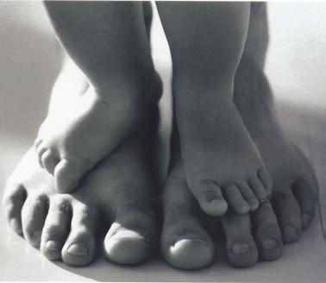

Acknowledgements

This research project and the narrative which has emerged from it has grown out of many years of direct working with children, young people and their families, as well as with practitioners from many professions and disciplines in the human services. I would like to acknowledge particularly what I have learned and gained from the young participants of this research. They have continued to reinforce my hope and belief in the possibility of change.

I am grateful for the opportunity to continue my academic and professional development within the Master of Research programme, reflecting my belief in lifelong learning. In keeping me ‘afloat’ in hitherto uncharted waters, the support of my colleagues undertaking the programme alongside me, as well as the guidance of supervisors, has been invaluable.

References

Ackerman, D. 1994. A natural history of love. New York: Random House.
Atkinson, P. 1997. ‘Narrative Turn or Blind Alley?’ Qualitative Health Research 7:325-344.
Bagnoli, A. 2004. Researching identities with multi-method autobiographies. Sociological Research Online 9, no.2.
Bridges, D. 2003. A philosopher in the classroom. Educational Action Research 11, no.2:181-196.
Brown, T., and L. Jones. 2001. Action research and postmodernism:congruence and critique. Buckingham: Open University Press.
Butler, J. 2005. Giving an account of oneself. New York: Fordham University Press.
Caine, V. 2010. Visualizing community: understanding narrative inquiry as action research. Educational Action Research 18, no.4: 481-496.
Clandinin, D.J. 2007. Handbook of narrative inquiry. London: Sage.
Clandinin, D.J., and F.M.Connelly. 2000. Narrative inquiry. Experience and story in qualitative research. San Francisco, CA: Jossey-Bass.
Clough, P. 2002. Narratives and fictions in educational research. Buckingham: Open University Press.
Connelly, F.M., and D.J. Clandinin. 1990. Stories of experience and narrative inquiry. Educational Researcher 19, no.5: 2-14.
Cross, B. 2009. Feeling my way into story space. Emotion, Space and Society 2, no.2: 98-103.
Davies, B., and R. Harre. 1991. Positioning: the discoursive production of selves.
Journal for the Theory of Social Behaviour 20, no.1: 43-63.
Daya, S., and L. Lau. 2007. Power and narrative. Narrative Inquiry 17, no.1: 1-11.
Delamont, S., and P. Atkinson. 1995. Fighting familiarity: essays on education and ethnography. Cresskill, NJ: Hampton Press.
Denzin, N.K., and Y.S. Lincoln. 1994. Handbook of Qualitative Research. London: Sage.
Denzin, N.K., and Y.S. Lincoln. 2005. Handbook of Qualitative Research. London: Sage.
Etherington, K. 2004. Becoming a reflexive researcher. London: Jessica Kingsley.
Heath, S., R. Brooks, E. Cleaver, and E. Ireland. 2009. Researching young people’s lives. London: Sage.
Heikinnen, H.L.T., R. Huttunen, and L. Syrjala. 2007. Action research as narrative: five principles for validation. Educational Action Research 15, no.1: 5-19.
Henderson, S., J. Holland, S. McGrellis, S. Sharpe, and R. Thomson. 2007. Inventing adulthoods: a biographical approach to youth transitions. London: Sage.
Holloway, I., and S. Wheeler. 2010. Qualitative research in nursing and healthcare. Chichester: Wiley-Blackwell.
Holstein, J.A., and J.F. Gubrium. 2000. The self we live by. Oxford: Oxford University Press.
Hoskins, M., and J. Stoltz. 2005. Fear of offending: disclosing researcher discomfort when engaging in analysis. Qualitative Research 5: 95-111.
Houston, N., H. Ross, J. Robinson, and H. Malcolm. 2010. Inside research, inside ourselves: teacher educators take stock of their research practice. Educational Action Research 18, no.4: 555-569.
Innovative Resources, St. Luke’s Hospital. Melbourne. Permission granted for use in this research.
Lakoff, G., and M. Johnson. 1987. The metaphorical logic of rape. Metaphor and Symbolic Activity 2, no.1: 73-79.
Lather, P. 1993. Fertile obsession: validity after poststructuralism. The Sociological Quarterly 34: 673-693.
MacClure, M. 2003. Discourse in educational and social research. Buckingham: Open University Press.
McNiff, J., and J. Whitehead, J. 2009. You and your action research project. London: Routledge.
Miller, T., and L. Bell. 2002. Consenting to what? Issues of access, gate-keeping and informed consent. In Ethics in Qualitative Research, eds. M.Mauthner, M.Birch, J.Jessop, and T.Miller, 53-69. London: Sage.
Newbury, J., and M. Hoskins. 2010. Relational inquiry: generating new knowledge with adolescent girls who use crystal meth. Qualitative Inquiry 16, no.8: 642-650.
Nicol, J.J. 2008. Creating vocative texts. The Qualitative Report 13, no.3: 316-333.
Noffke, S.E., and B. Somekh. 2009. Handbook of educational action research. London: Sage.
Norrick, N.R. 2008. Negotiating the reception of stories in conversation: teller strategies for modulating response. Narrative Inquiry 18, no.1: 131-151.
Nunkoosing, K. 2005. The problems with interviews. Qualitative Health Research 15, no.5: 698-706.
Payne, M. 2002. Social work theories and reflective practice. London: Palgrave
Payne, M. 2006. Narrative therapy. London: Sage.
Ponterotto, J.G. 2006. Brief note on the origins, evolution and meaning of the qualitative research concept ‘thick description’. The Qualitative Report 11, no. 3: 538-549.
Quinn, J., L. Thomas, K. Slack, L. Casey, W. Thexton, and J. Noble. 2006. Lifting the hood: lifelong learning and young, white, provincial working-class masculinities. British Educational Research Journal 32, no. 5: 735-750.
Reason, P., and Bradbury, H. 2006. Handbook of action research. London: Sage.
Riessman, C.K. 1993. Narrative analysis. Newbury Park, CA: Sage.
Riessman, C.K. 2008. Narrative methods for the human sciences. London: Sage.
Scottish Government.2006. More choices, more chances. Stationery Office, Edinburgh.
Smith, D.E. 1990. Texts, facts and femininity: exploring the relations of ruling. London: Routledge.
Somekh, B. 2006. Action research: A methodology for change and development. Maidenhead: Open University Press.
Sparrman, A. 2006. Film as a political and educational device: talk about men, male sexuality and gender among Swedish youth. Visual Studies 21, no.2: 167-182.
Stanczak, G.C. 2007. Visual research methods – image, society and representation. London: Sage.
Thompson, N. 2008. Practising social work. Hampshire: Palgrave MacMillan.
Thomson, R., J. Holland, S. McGrellis, R. Bell, S. Henderson, and S. Sharpe . 2004. Inventing adulthoods: a biographical approach to understanding youth citizenship. The Sociological Review 52, no. 2: 218-239.
Valentine , G. 2004. Public Space and the Culture of Childhood. Aldershot: Aldgate.
van Manen, M. 1997. From meaning to method. Qualitative Health Research 7, no.3:
345-369.
Watson, C. 2009. Picturing validity – autoethnography and the representation of self. Qualitative Inquiry 15, no.3: 526-544.
White, M., and D. Epston. 1990. Narrative means to therapeutic ends. NY: Norton.
Yuval Davis, N. 2006. Belonging and the politics of belonging. Patterns of Prejudice 40, no.3: 197-294.

