Evaluation of variation in dynamic response of two instrumented buildings under seismic excitations
F. Butt & P. Omenzetter
Department of Civil & Environmental Engineering, The University of Auckland, Auckland, New Zealand.
ABSTRACT: Natural frequencies and damping ratios are very important parameters characterizing the dynamic response of buildings. These dynamic characteristics of building structures are observed to vary during different earthquake excitations. To evaluate this variation, two instrumented buildings were studied. One of the buildings is a three storey reinforced concrete (RC) frame building with a shear core, while the other is a three storey RC frame building without shear core. Both the buildings are part of the same large complex but are seismically separated. One of them is instrumented with five and the other with four tri-axial accelerometers. The dynamic properties of the buildings were ascertained using a time domain state-space subspace system identification technique considering 50 recorded earthquake responses. Relationships between identified natural frequencies and damping ratios, and the peak ground acceleration (PGA) at the base level and peak response acceleration (PRA) at the roof level were developed. It was found that response of the buildings strongly depended on the excitation level of the earthquakes. A general trend of decreasing fundamental frequencies and increasing damping ratios was observed with increased level of shaking and response. It is concluded from the investigation that knowledge of variation of dynamic characteristics of buildings is necessary to better understand their response during earthquakes.

INTRODUCTION
The characterization and prediction of the response of civil structures under extreme loading events such as earthquakes is a challenging problem and has gained increasing attention in recent years. The challenges associated with the civil structures such as buildings, bridges and dams include modelling their complicated interaction with the surrounding ground, varying environmental and loading conditions, and complex material and structural behaviour which preclude the study of a complete system in a laboratory setting. An approach to tackle these issues is to use the recorded responses from instrumented structures and extract the dynamic characteristics using a process known as system identification (Hart & Yao 1976; Saito & Yokota 1996). The in-situ measured responses include all the real physical properties of the structure and can be useful for structural health monitoring and model updating studies (Brownjohn & Xia 2000; Farrar et al. 2000).
In characterizing the dynamic response of buildings, natural frequencies and damping ratios are very important parameters. Permanent instrumentation of buildings makes possible the studying of these parameters under different earthquakes excitation. Studies have shown that the dynamic characteristics tend to vary with vibration amplitude (Celebi 2006; Satake & Yokota 1996; Trifunac et al. 2001). It is, therefore, important to see the behaviour of buildings under different excitation scenarios. The trends of variation of dynamic characteristics like modal frequencies and damping ratios thus developed will provide quantitative data for the variations in the behaviour of buildings. Moreover, such studies will provide invaluable information for the development and calibration of realistic models for the prediction of seismic response of structures in model updating and structural health monitoring studies.
New Zealand is situated in a region where earthquakes are a common occurrence. Past earthquakes in the region have caused major losses (Comerio et al. 2010; Dowrick 1994; Dowrick 1998). The seismic response of structures therefore, is a major concern to the society. For measurement and understanding of the dynamic behaviour of structures during earthquakes, several structures across New Zealand are instrumented under the banner of the GeoNet project (Deam and Cousins 2002; www.geonet.org.nz). The buildings studied in this paper were instrumented as part of the GeoNet project. Many structures have already been instrumented in the Wellington and Canterbury regions and for more structures across New Zealand the process is in progress (Uma et al. 2011).
The main objective of this paper is to evaluate the variation in dynamic response using 50 recorded earthquakes on two instrumented buildings. State-space subspace system identification technique will be used to estimate the frequencies and damping ratios of both buildings. For natural input modal analysis, this technique is considered to be the most powerful class of the known system identification techniques in the time domain (Van Overschee & De Moor 1994). Relations between peak ground acceleration (PGA) at the base level of the buildings and peak response acceleration (PRA) at the roof level are developed with the estimated frequencies and damping ratios. The variation in frequencies and damping ratios in each mode is evaluated. The outcome of this study is expected to further the understanding of dynamic behaviour of buildings during earthquakes and provide new quantitative data for structural health monitoring and model updating studies.

description of the buildings, instrumentation and strong motion data
The buildings under study are two blocks of the GNS Science building complex at Avalon (Lower Hutt) situated approximately 20km north-east of Wellington. The building complex comprises five major blocks (Fig. 1) which are structurally separated by expansion joints. Buildings A and B are instrumented with nine tri-axial accelerometers. There is a free-field tri-axial accelerometer as well mounted at the ground surface and located at 3.94m from the south end of building A as shown in Fig. 1. All the data is stored to a central recording unit and is available online (www.geonet.org.nz). The detail of the structural systems and sensor arrays of the buildings are discussed in the following sections.

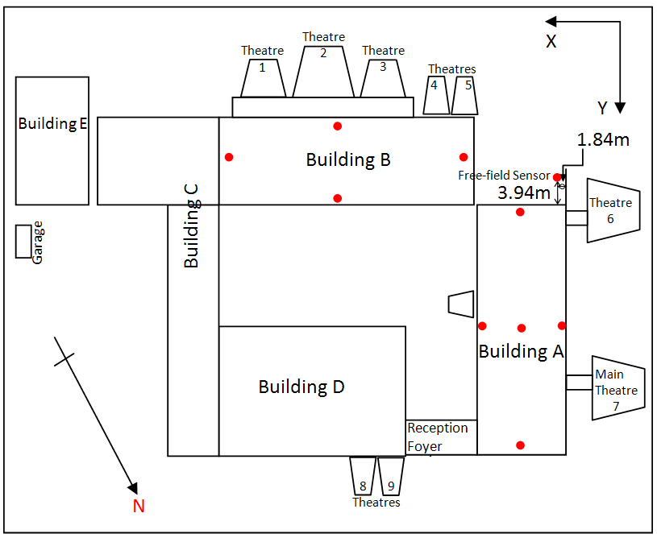
Figure 1. Layout of GNS Science building complex at Avalon. Red dots show the approximate locations of sensors. Sensors in buildings show the location as seen in plan view irrespective of the floor level.

Building A
Building A is a three storey reinforced concrete (RC) structure with a basement. The structural system consists of beam-column frames and a 229mm thick reinforced concrete shear core, which houses an elevator. The plan of the building is rectangular but the beams along the longitudinal direction inside the perimeter beams and shear core make it unsymmetrical in terms of stiffness distribution (Fig. 2(a)). All the beams and columns are of rectangular cross-section. The exterior beams are 762×356mm except at roof level where these are 1067×356mm. All the interior beams and columns are 610×610mm. Floors are 127mm thick reinforced concrete slabs except a small portion of ground floor near the stairs where it is 203mm thick. The roof comprises corrugated steel sheets over timber planks supported by steel trusses. The building is resting on separate pad type footings of base dimensions 2.29×2.29m at the perimeter and 2.74×2.74m inside the perimeter and 610×356mm tie beams are provided to join all the footings together. This building is instrumented with five tri-axial accelerometers. Two accelerometers are fixed at the base level, two at the roof level and one underneath the first floor slab as shown in Fig. 2(b).
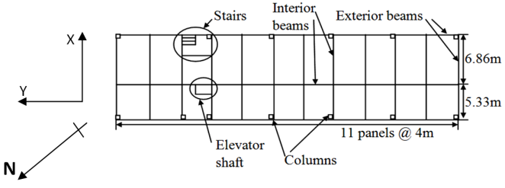  (a) | 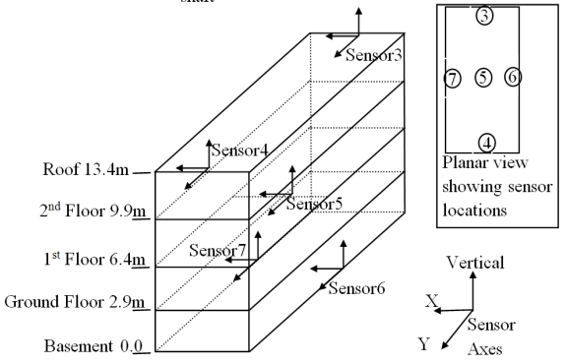  (b)
Figure 2. Building A: (a) Typical floor plan showing location of stairs and elevator shaft, and (b) Sensor array

Building B
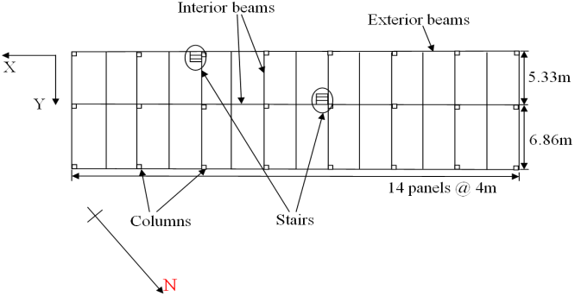  (a) | 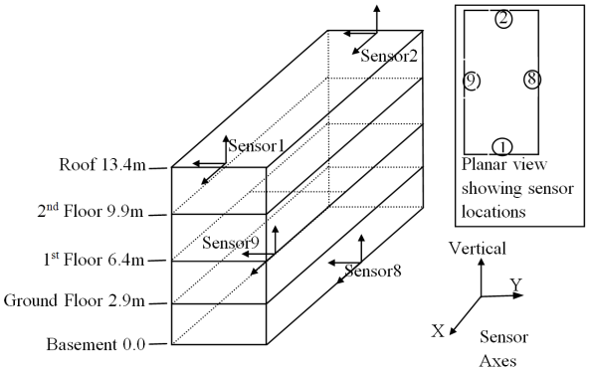  (b)
Figure 3. Building B: (a) Typical floor plan showing location of stairs, and (b) Sensor array
Building B is a three storey RC building with a basement. The floor plan is rectangular and structural system consists of beam-column frames. Floor heights, frame pattern, the sizes of beams, columns, slabs, tie beams, roof and foundations are the same as that of building A but there are more frames in longitudinal direction (Fig. 3(a)). The longitudinal direction is 56m in comparison to 44m of building A. Contrary to building A, there is no shear core present in this building. It is instrumented with four tri-axial accelerometers. Two of which are fixed at the roof level and two at the base level. Figure 3(b) shows the sensor locations and their sensitive axes directions.

Earthquake selection criteria
For this study, 50 earthquakes recorded on the buildings and which had epicentres within 200km from the buildings were selected. The reason for adopting this was to select earthquakes of such an intensity which can be recorded on the sensors and can shake the modes of interest quite well. The area surrounding the buildings had not been hit by any strong earthquake since their instrumentation. Almost all of the 50 recorded earthquakes have Richter magnitude ranging from 3 to 5 except a very few that have more than 5, with 5.2 being the maximum recorded. This means that nearly all of the earthquakes fall into the category of low intensity except a very few that can be treated as moderate events.

Methodology

State-space subspace system identification technique
In the time domain modal analysis, state-space subspace identification is considered to be the most powerful identification technique (Van Overschee & De Moor 1994). After sampling of a continuous time state space model, the discrete time state space model can be written as:
$x_{k+1}=Ax_{k}+Bu_{k} (1)$
$y_{k}=Cx_{k}+Du_{k} (2)$
where A, B, C and D are the discrete state, input, output and control matrices respectively, whereas u_{k} is the excitation vector and x_{k}, ,y_{k} are the discrete time state and output vectors, respectively. In reality, there are always process and measurement noises present so adding these to the above equations result in:
$x_{k+1}=Ax_{k}+Bu_{k}+w_{k} (3)$
$y_{k}=Cx_{k}+Du_{k}+v_{k} (4)$
Here w_{k} and v_{k} are the process and measurement noise, respectively. The data from output y_{k} and/or input x_{k} is assembled in a block Hankel matrix, which is defined as a gathering of a family of matrices that are created by shifting the data matrices in time. After this, the identification involves two steps. The first step takes projections of certain subspaces calculated from input and output observations (in block Hankel matrix) to estimate the state sequence of the system. This is usually achieved using singular value decomposition (SVD) and QR decomposition. In the second step, a least square problem is solved to estimate the system matrices A, B, C and D. Then the modal parameters, i.e. frequencies, damping ratios and mode shapes, are found by eigenvalue decomposition of the system matrix A. Further details of the identification process can be found elsewhere (Van Overschee & De Moor 1996).

Application of state-space subspace system identification technique to the instrumented buildings
The state-space subspace identification technique derives state-space models for linear systems by applying the well-conditioned operations, like SVD, to the block Hankel data matrices. In order to determine the proper system order, the trend of the estimated modal parameters in a stabilization chart is observed. Stability tolerances are chosen based on the relative change in the modal properties of a given mode as the system order increases. In this research, an identified frequency was considered to be stable if the absolute deviation between the frequency identified at the present and previous order was less than or equal to 0.01Hz. A stable damping ratio was defined by a deviation less than 5%. For mode shapes stability, model assurance criterion (MAC) between the mode shapes of the present and previous orders was to be at least 95% or greater. MAC is an index that determines the similarity between two mode shapes. For modes φ_{i} and φ_{j} the MAC is defined as (Ewins 2000):
$$MAC=\frac{{\left(ϕ_{i}^{T}ϕ_{j}\right)}^{2}}{\left(ϕ_{i}^{T}ϕ_{i}\right)\left(ϕ_{j}^{T}ϕ_{j}\right)} (5)$$
In equation (5), superscript T denotes matrix transpose.
Sampling rate of the digitized signals was 200 Hz and for establishing the stabilization diagrams system orders from 60 to 160 were evaluated. For building A, sensors 6 and 7 were taken as the inputs (excitations) while sensors 3, 4 and 5 as the outputs (responses), whereas for building B sensors 8 and 9 were taken as excitations while sensors 1 and 2 as responses.

Results
The objective of the research is to study the relationship between PGA, PRA and identified first three modal frequencies and corresponding damping ratios. Based on these relations, the variation in identified parameters is observed and conclusions are drawn in section 5.
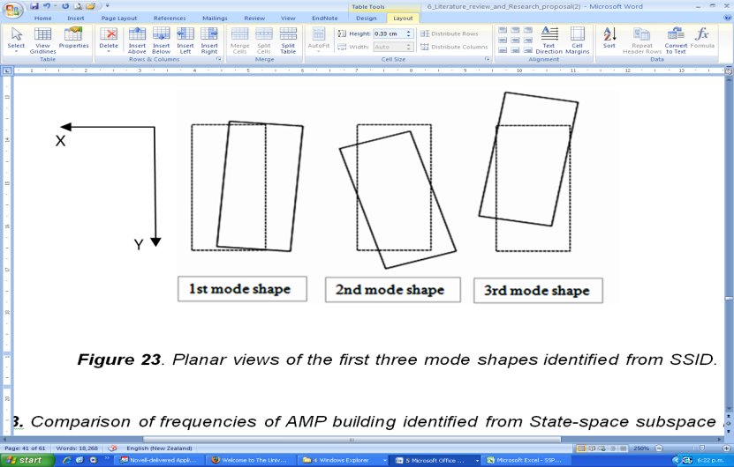  (a) |   (b)
Figure 4. Planar views of the first three mode shapes: (a) Building A, and (b) Building B
The typical first three mode shapes of building A are shown in Figure 4(a) in planar view. The shape of the first mode shows it to be a translational mode along X-direction with a little rotation. The second mode is nearly purely torsional and the third one is a dominant translational mode along Y-direction coupled with torsion. Building B has the same shapes for the first three modes (Fig. 4(b)), with the first mode being the dominant translational along Y-direction with a little rotation and the third mode being translation dominant along X-direction coupled with torsion, while the second mode is the torsional mode. Structural irregularity, due to the internal longitudinal beams being not in the middle of the transverse direction for both buildings and shear core present near the North end of building A, creates unsymmetrical distribution particularly of stiffness which has caused the modes to be coupled translational-torsional.
In this study, for building A PRA of sensor 4 (at the roof) and PGA of sensor 6 (at the base), whereas for building B PRA of sensor 1 (at the roof) and PGA of sensor 8 (at the base) were considered. The recorded maximum PRA of building A is 0.041g in the Y-direction which is double of that in the X-direction (0.021g) (Figs 5a, b). For building B, the maximum recorded PRA is also in the Y-direction (0.025g), which is a little higher than that in the X-direction (0.023g) (Figs 6a, b). However, there is only one point in that maximum range for both the buildings and all the other points are below0.015g and 0.01g (Figs 5a, b and 6a, b) for buildings A and B, respectively. It can be seen that PGA and PRA have good correlations along both X- and Y-directions. Therefore, frequencies and damping ratios relations are plotted with one of them only, i.e. PRA. The R² coefficient shown in the plots is used to calculate the fit of a regression line. The closer this value is to 1.0, the better the fit.

Frequency variation
Table 1 shows the minimum, maximum, average and percentage change (= (maximum-minimum)/average × 100) values of the identified frequencies and damping ratios for the selected 50 earthquakes. The percent change for the selected 50 events for building A in the first, second and third modal frequencies is 13%, 14% and 10%, respectively, whereas for building B it is 19%, 21% and 29%, respectively.
Frequencies are decreasing as the vibration amplitude is increasing and this is observed for both buildings in all three modes along both X- and Y-directions (Figs 7a, b and 8a, b). The first modal frequency of building A has good correlation (R²= 0.80) with PRA along X-direction as compared to other two frequencies but the correlations with PRA of the three modal frequencies in the Y-direction are not as good as those in X-direction. Building B, on the other hand, has got almost the same level of correlations based on R² values with PRA for both X- and Y-directions. There are only two and one points, respectively, in X- and Y-directions plots of building A beyond 0.015g up to 0.042g, whereas for the case of building B there is only one point available beyond 0.01g up to 0.025g. The correlations could be improved if there were more points in this range. Since most of the earthquakes are of low intensity, the region from 0 to 0.01g is densely populated but beyond that there are very few points.
During some events, the first, second or third mode or any two of them were missing in the system identification results, which shows that during those particular events these modes did not vibrate strongly enough. It reflects the fact that response of the building is sensitive to the frequency content of the earthquake also. In some events, the second and third modal frequencies tended to be very close and the minimum difference between these two was found to be 0.03 Hz. This shows the capability of state-space subspace identification technique to identify very closely spaced modes.

Damping ratio variation
The average values of damping ratio for the selected 50 events for the first, second and third modes are 2.7%, 4.7% and 2.8%, respectively, for building A, and 2.9%, 4.4% and 5.7%, respectively, for building B (Table 1). The identified damping ratios show considerable scatter for both buildings. Along X- and Y-directions, for both buildings, the first mode damping ratio shows increasing trends with the increased level of shaking and their R² values reflect a better correlation than for the second and third mode damping ratios (Figs 9a-f and10a-f). However, the second mode damping ratios, which correspond to a nearly purely torsional mode, do not show any clear trend for both the buildings, with R² values less than 0.1 for all four cases (Figs 9b, e and 10b, e). The third mode is also showing signs of increasing damping with increased level of shaking with the exception of a few outliers (Figs 9c, f and 10c, f).
Table 1. Summary of identified frequencies and damping ratios for buildings A and B.
 | Mode | Frequency (Hz) |  |  |  |  |  |  |  |  | Damping ratios (%)
 | Mode | Min. | Max. |  | Avg. |  |  | %change |  |  | Min. |  | Max. | Avg. | %change
Building A | 1st (X-translation) | 3.07 | 3.51 |  | 3.37 |  |  | 13% |  |  | 0.4 |  | 4.5 | 2.7 | 150%
Building A | 2nd (torsion) | 3.33 | 3.85 |  | 3.67 |  |  | 14% |  |  | 1.4 |  | 7.0 | 4.7 | 119%
Building A | 3rd (Y-translation) | 3.55 | 3.92 |  | 3.80 |  |  | 10% |  |  | 1.2 |  | 7.9 | 2.8 | 235%
Building B | 1st (Y-translation) | 2.91 | 3.54 |  | 3.32 |  |  | 19% |  |  | 0.1 |  | 5.4 | 2.9 | 184%
Building B | 2nd (torsion) | 3.28 | 4.06 |  | 3.80 |  |  | 21% |  |  | 0.6 |  | 7.9 | 4.4 | 164%
Building B | 3rd (X-translation) | 3.42 | 4.63 |  | 4.13 |  |  | 29% |  |  | 1.6 |  | 10.0 | 5.7 | 148%
Figure 5. PRA vs. PGA of building A for 50 earthquake records: (a) X-direction components, and (b) Y-direction components.
Figure 6. PRA vs. PGA of building B for 50 earthquake records: (a) X-direction components, and (b) Y-direction components
Figure 7. Identified first, second and third modal frequencies of building A for 50 earthquakes vs. PRA: (a) X-direction components, and (b) Y-direction components
Figure 8. Identified first, second and third modal frequencies of building B for 50 earthquakes vs. PRA: (a) X-direction components, and (b) Y-direction components
Figure 9. Identified damping ratios for building A for 50 earthquakes: (a) first mode, (b) second mode, (c) third mode vs. X-direction PRA, (d) first mode, (e) second mode, and (f) third mode vs. Y-direction PRA
Figure 10. Identified damping ratios for building B for 50 earthquakes: (a) first mode, (b) second mode, (c) third mode vs. X-direction PRA, (d) first mode, (e) second mode, and (f) third mode vs. Y-direction PRA

Conclusions
In this study, system identification using a state-space subspace system identification technique was used to identify natural frequencies and damping ratios of two three storey RC concrete frame buildings; one of them with a shear core and the other without a shear core. This technique is considered as the most powerful technique for the natural input in the time domain. To evaluate the variation in the dynamic response, the relationships between the first three natural frequencies and corresponding damping ratios with PRA were developed for 50 recorded earthquakes. The main findings of this research are as follows:
- Due to unsymmetrical distribution of stiffness, all modes are coupled translational-torsional.
- PGA and PRA have very good correlation along both X- and Y- directions.
- Modal frequencies are decreasing and damping ratios are increasing with the increase in the level of excitation except the case of nearly purely torsional mode where damping ratio shows no clear trend. The natural frequencies show a much clearer trend while damping ratios have more scattered values.
- State-space subspace system identification technique has the ability to identify very closely spaced modes.
- Since most of the earthquakes recorded so far are of low to medium intensity, it would be interesting to study the response of the buildings during stronger events.
- In some events, it is observed that the first, second, third or any two of the modes are missing in the identification results. This finding shows that dynamic response of the building is sensitive to the frequency content of the earthquakes.
Acknowledgement
The authors would like to acknowledge GeoNet staff for facilitating this research. Particular thanks go to Dr Jim Cousins, Dr S.R. Uma and Dr. Ken Gledhill.
References:
Brownjohn, J.M.W. & Xia, P.Q. 2000. Dynamic assessment of curved cable-stayed bridge by model updating, Journal of Structural Engineering, ASCE, Vol 126(2): 252-260.
Celebi, M. 2006. Recorded earthquake responses from the integrated seismic monitoring network of the Atwood Building, Anchorage, Alaska, Earthquake Spectra, Vol 22(4): 847-864.
Comerio, M., Arendt, L., Bay, G., Bruneau, M., Dusicka, P., Gavin, H., Roeder, C., Turner, F., Lai, T., Williams, R., Boyd, O., Anagnostopoulou, M., Holmes, W. & O’Rourke, T. 2010. Learning from Earthquakes: The Mw 7.1 Darfield (Canterbury), New Zealand Earthquake of September 4, 2010, Report, Earthquake Engineering Research Institute (EERI), http://www.eeri.org/site/images/eeri_newsletter/2010_pdf/EERI_NewZealand_EQRpt-web.pdf
Deam, B.L. & Cousins, W.J. 2002. Strong-motion instrumentation of buildings in New Zealand, New Zealand Society for Earthquake Engineering Conference; Proc. Intern. Conf., Napier, 15-17 March 2002.
Dowrick, D.J. 1994. Damage and intensities in the magnitude 7.8 1929 Muchison, New Zealand earthquake, Bulletin of the New Zealand National Society for Earthquake Engineering, Vol 27(3):190-204.
Dowrick, D.J. 1998. Damage and intensities in the magnitude 7.8 1931 Hawke's Bay, New Zealand, earthquake, Bulletin of the New Zealand National Society for Earthquake Engineering, Vol 31(3 ):139-162.
Ewins, D.J. 2000. Modal Testing: Theory, Practice and Application. Baldock, Hertfordshire, UK: Research Studies Press Ltd.,
Farrar, C.R., Sohn, H. & Doebling, S.W. 2000. Structural health monitoring at Los Alamos National Laboratory, US-Korea Conference on Science and Technology, Entrepreneurship, and Leadership; Proc. Intern. Conf., Chicago, 2-5 September 2000.
Hart, G.C. & Yao, J.T.P. 1976. System identification in structural dynamics, Journal of Engineering Mechanics, ASCE Vol 103: 1089-1104.
Saito, T. & Yokota, H. 1996. Evaluation of dynamic characteristics of high-rise buildings using system identification techniques, Journal of Wind Engineering and Industrial Aerodynamics, Vol 59(2-3): 299-307.
Satake, N. & Yokota, H. 1996. Evaluation of vibration properties of high-rise steel buildings using data of vibration tests and earthquake observations, Journal of Wind Engineering and Industrial Aerodynamics, Vol 59(2-3): 265-282.
Trifunac, M.D., Ivanovic, S.S. & Todorovska, M.I. 2001. Apparent periods of a building I: Fourier analysis, Journal of Structural Engineering, ASCE, Vol 127(5): 517-526.
Uma, S., King, A., Cousins, J. & Gledhill, K. 2011 in press. The GeoNet building instrumentation programme, Bulletin of the New Zealand Society for Earthquake Engineering
Van Overschee, P. & De Moor, B. 1994. N4SID: Subspace algorithm for the identification of combined deterministic-stochastic systems, Automatica, Vol 30(1): 75-93.
Van Overschee, P. & De Moor, B. 1996. Subspace identification for linear systems, Dordrecht, the Netherlands: Kluwer Academic Publishers.

