Supplementary Materials 1

The Go/No-Go test, requested every hour as part of the ecological momentary assessment protocol, was presented via the wrist-bound electronic device (PRO-Diary; see Figure S1.1). Once prompted, participants were presented with a series of 50 randomly ordered trials for 500 ms each, 40 of which were ‘Go’ trials (represented by the letter M, and requiring a rapid button-press response) and 10 of which were ‘No-Go’ trials (represented by the letter W and requiring no response). Inter-trial intervals varied randomly between 1300 ms, 1500 ms, 1700 ms, 1900 ms, and 2100 ms.


Figure S1.1. Representation of the PRO-Diary watch-faces for ‘Go’ trials (A) and ‘No-Go’ trials (B). Participants were asked to respond as quickly as possible to ‘Go’ trials using the response button on the right.

The outcome (reaction time to correct responses) was computed as the mean reaction time across the constituent ‘Go’ trials, independent of how many button-presses were made during the test. Usually, attending to and completing a Go/No-Go test can be readily assumed, as they are usually conducted as a one-off test in the lab with a supervising researcher present. However, in daily life, participants are in the middle of their usual routines, and a cut-off was needed to screen out instances where Go/No-Go tests were (i) initiated but not completed; or (ii) initiated and completed, but using rapid and arbitrary responses. These cut-offs were determined by visual inspection of response characteristic data for each test, as detailed below.

(i) Incomplete Go/No-Go tests
In a 100% accurate test, a response would be provided to each of the 40 ‘Go’ trials, and no response for every ‘No-Go’ trial. It was expected that participants would occasionally fail to respond to some ‘Go’ trials within a test, but that there would be a frequency of non-response indicating there was insufficient attendance to the test for it to be valid and reliable. A count variable was computed that indicated the number of constituent ‘Go’ trials within a test with a corresponding button-press response, and examined frequencies on a histogram for visual inspection (Figure S1.2). The data indicated that, while the vast majority of Go/No-Go tests were completed, a significant (and non-ignorable) number of tests has been initiated but not completed.

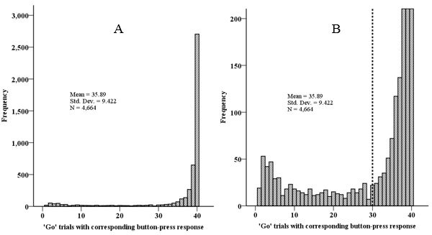
Figure S1.2. Frequency of tests by the number of constituent ‘Go’ trials with a button-press response (A) and focussing on the lower frequencies of the same histogram (B). The cut-off decision is denoted by the dashed line.

The histogram (without the dashed line) was presented to our extended research group to seek a consensus on where the cut-off should be for indicating an incomplete test rather than poor performance. The cut-off was set at < 30 (75% of ‘Go’ trials). Outcomes on those tests not achieving 30 responses (n = 557; 11.94%) were replaced by a missing value.

(ii) Initiated and completed Go/No-Go tests, but evidence of arbitrary responding
Providing responses to ≥ 30 ‘Go’ trials did not necessarily indicate a properly completed test. It was also possible that test ‘completion’ could be achieved, whilst still not attending to the stimuli, by rapidly and/or arbitrarily pressing the response button. The Go/No-Go test data recorded every button-press, whether it was the first response to a trial or not (note, outcomes were always computed on the first response only). It was therefore possible to detect when multiple responses were made to a single trial, which may be indicative of (i) accidental multiple responding; or (ii) deliberate rapid and arbitrary responding. The former is likely to be intermittent, whereas the latter is more likely to be systematic throughout the constituent trials.
To distinguish between these two possibilities among the completed tests, we computed a count of the number of constituent trials (‘Go’ or ‘No-Go’) for each test where > 1 button-press response was made. We then examined frequencies on a histogram (Figure S1.3) to visually determine where a reasonable cut-off would be.
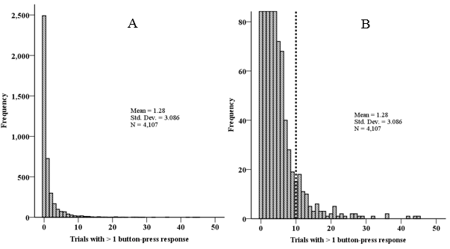
Figure S1.3. Frequency of tests by the number of constituent ‘Go’ trials with a button-press response (A) and focussing on the lower frequencies of the same histogram (B). The cut-off decision is denoted by the dashed line.

It was clear that the vast majority of tests did not show signs of arbitrary responding, but it was also clear that there were several tests with deliberate arbitrary responding. By consensus, we agreed on ≥ 10 trials with more than 1 response as a reasonable cut-off. Outcomes for those tests containing ≥ 10 trials with multiple responses (n = 113; 2.75%) were replaced by a missing value.

