Running Head: Self and Visual Awareness

Self-Relevance Prioritizes Access to Visual Awareness

C. Neil Macrae,¹ Aleksandar Visokomogilski,¹ Marius Golubickis,¹

William A. Cunningham,² Arash Sahraie¹

¹School of Psychology, University of Aberdeen, Aberdeen, Scotland

²Department of Psychology, University of Toronto, Toronto, Canada

Main Text = 2438 words

Address Correspondence To:

Neil Macrae

School of Psychology

University of Aberdeen
King’s College
Aberdeen AB24 3FX
Scotland, UK

Email: c.n.macrae@abdn.ac.uk
Abstract
As we are cognizant of only a fraction of the available visual inputs at any given time, how is information selected for access to consciousness? In particular, does the personal significance of stimuli influence perceptual selection? Given that self-relevant information is prioritized during various stages of processing, here we hypothesized that self-association may privilege access to awareness under continuous flash suppression (CFS). The results supported this prediction. Compared with geometric shapes referenced to either a friend or stranger, those previously associated with self were prioritized in visual awareness. To establish the basis of this effect, the processes underlying task performance were investigated using a hierarchical drift diffusion model approach. These analyses showed that self-prioritization mapped onto both the decisional (i.e., starting value, z) and non-decisional (i.e., t₀) parameters of the diffusion model. The implications of these findings are considered.

Keywords: self-relevance, self-prioritization, visual awareness, decision-making, diffusion modeling

Public Significance
As a core psychological construct, the self influences how people make sense of the world around them. Extending research of this kind, here we explored the possibility that the self also impacts visual processing — specifically, the ease with which information gains access to consciousness. Our results supported a linkage between the self and visual awareness. Compared with objects (i.e., geometric shapes) coupled with either a friend or stranger, those associated with self gained prioritized access to consciousness (i.e., people could report the identity of self-relevant objects faster than objects associated with other individuals). In other words, self-relevance enhanced visual awareness. This result further underscores how a sense of self helps us to navigate the intricacies of everyday life.
Extending an extensive literature documenting how self-relevance impacts judgment (Mezulis, Abramson, Hyde, & Hankin, 2004), attention (Shapiro, Caldwell, & Sorensen, 1997) and memory (Conway, 2005; Heatherton, Macrae, & Kelley, 2004; Symons & Johnson, 1997), recent research has highlighted the beneficial effects of self-referential processing on perceptual matching (Sui & Humphreys, 2015; Humphreys & Sui, 2015; Sui, He, & Humphreys, 2012). Specifically, after coupling arbitrary geometric shapes with person-related labels (e.g., circle = you, triangle = friend, square = stranger), perceptual-matching judgments are fastest and most accurate for shape-label pairs associated with self (vs. friend or stranger) — the so-called self-prioritization effect (Sui et al., 2012; Sui, Liu, Mevorach, & Humphreys, 2013). As powerful cues for attention, self-relevant stimuli are believed to influence perception in an obligatory manner that mimics the effects of physical saliency (Sui & Humphreys, 2015).
Whilst the self-prioritization effect supports a range of important outcomes (e.g., perceptual binding, memory integration, see Humphreys & Sui, 2015), perhaps its most significant contribution may reside in the influence it exerts during perceptual selection. As we are cognizant of only a fraction of the available visual inputs at any given time, a fundamental question focuses on how stimuli are selected for access to visual awareness. Although prior research is suggestive that self-relevance may facilitate this process (Sui et al., 2012, 2013), a recent study does not support this hypothesis. Using a breaking continuous flash suppression (b-CFS) paradigm to investigate stimulus prioritization (Ocampo & Kahan, 2016), Stein, Siebold, and van Zoest (2016) observed no effect of self-association on the time taken for stimuli (i.e., Gabors) to overcome interocular suppression. Interestingly, however, they did report a self-prioritization effect in a prior perceptual-matching task using the same stimuli.
The experiment reported here — conducted simultaneously with, but without knowledge of, Stein et al. (2016) — also explored the effects of self-relevance on b-CFS. It did so, however, in a complementary way, using previously established stimulus materials and a different measure of visual awareness. In exploring the effects of self-relevance on b-CFS, Stein et al. (2016) deviated from the standard self-referencing methodology in which participants associate labels with geometric shapes (Sui et al., 2012), requiring them instead to pair referents (i.e., you, stranger) with Gabor patches at different orientations. As they conceded when discussing their findings however, this reduction is stimulus complexity may have undermined the emergence of a self-prioritization effect in visual awareness. Fortuitously, here we adopted Sui et al.’s (2012) shape-label, associative-learning procedure after which b-CFS was used to investigate the potency of the stimuli to gain access to awareness (Gayet, Van der Stigchel, & Paffen, 2014; Jiang, Costello, & He, 2006; Yang, Brascamp, Kang, & Blake, 2014). Specifically, while each shape was presented to one eye, high contrast dynamic patterns were presented to the other eye, resulting in initial suppression of the shape from consciousness.
Contrasting Stein et al’s (2016) Gabor detection task (i.e. participants reported the detection of Gabors at one of 4 possible locations), participants in the current investigation were required to identify (i.e., classify) geometric shapes (i.e., shapes pertaining to self or friend or stranger) under CFS (Kang, Blake, & Woodman, 2011), thereby enabling their responses to be modeled to identify the processes underlying decision-making. This distinction between stimulus detection and identification (i.e., where vs. what) may be important as, at least to date, self-prioritization effects have only been reported in tasks in which participants respond to the meaning of the stimuli (Humphreys & Sui, 2015; Sui & Humphreys, 2015). Indeed, Stein et al. (2016) demonstrated just such an effect with Gabor-label associations in a perceptual-matching task. It is possible therefore that self-prioritization effects in visual awareness may be restricted to tasks in which stimulus identification is required (Yang & Blake, 2012), thereby mirroring the emergence of this effect in the literature on perceptual matching (Stein et al., 2016; Sui et al., 2012). We explored this possibility in the current experiment.
Although argued to be a perceptual phenomenon (Sui & Humphreys, 2015), other processes may trigger self-prioritization. For example, just as self-relevance may bias perceptual operations (e.g., information uptake), so too it may influence decisional processes (e.g., response bias) when information is encountered in ambiguous settings (Ditto & Lopez, 1992). Of theoretical importance, therefore, is the ability to decompose task performance and isolate the processes that underlie self-prioritization effects. In the context of binary decision tasks, diffusion models afford just such an opportunity (Ratcliff, 1978; Voss & Voss, 2007).
A variant of continuous sampling approaches, diffusion models parse behavioral data (i.e., accuracy and response times) into a set of latent parameters (perceptual and decisional) that underlie the decision process as it unfolds over time. Whereas the drift rate (v) estimates the rate of information acquisition (i.e., larger drift rate = faster information uptake), thus is interpreted as a measure of perceptual processing during decision-making; the distance between response thresholds (a) represents the deployment of different decisional strategies (i.e., conservative vs. liberal) and the starting point of the information accumulation process (z) reflects an a priori decisional bias for one response over another. Finally, the duration of all non-decisional processes (e.g., stimulus encoding, response execution) is given by the parameter t₀. These parameters are useful in the current context as they separate perceptual (v) and decisional (z/a) influences on task performance (Voss, Rothermund, & Brandtstädter, 2008), thereby potentially elucidating the basis of the self-prioritization effect. As such, the current data were submitted to a hierarchical drift diffusion model (HDDM) analysis (Wiecki, Sofer, & Frank, 2013).
Method
Participants and Design
Forty-five adults (30 females, mean age = 27.33, SD = 6.53) took part in the study, for which they received £5 (~ $7.50). Recruitment was via an advert on the University of Aberdeen virtual notice board. All participants had normal or corrected-to-normal visual acuity. Informed consent was obtained from participants prior to the commencement of the experiment and the protocol was reviewed and approved by the Ethics Committee at the School of Psychology, University of Aberdeen. The experiment had a 3 (Shape Association: self or friend or stranger) X 2 (Trial Type: target or non-target) repeated-measures design.

Materials and Procedure
Participants were greeted by a male experimenter and told they would be performing a perception task. The experiment had two phases. Following Sui et al. (2012), the first phase comprised a learning task in which participants were required to associate specific geometric shapes (i.e., circle, triangle, square) with 3 targets: self, a named best friend, and an unfamiliar stranger (see Sui et al., 2012). The shapes were not presented at this stage. The learning phase lasted for approximately 60 seconds and shape-target associations were counterbalanced across the sample.
Next, participants performed a detection task in which the previously learned shapes were rendered invisible using CFS. Prior to the task, sighting eye dominance was determined using the Miles test (Miles, 1930). On the basis of this test, 12 participants were identified to be left-eye dominant and 33 right-eye dominant. The target stimuli (geometric shapes) and Mondrian patterns were displayed on two 19˝ Dell monitors (1440 x 900 pixels, 60 Hz refresh rate), presented using E-prime (Psychological Software Tools, Pittsburgh, PA). Dichoptic rivalry was achieved via two mirrors angled at 45° between two computer monitors and a stationary chin- and forehead-rest at a viewing distance of 40 cm. The stimuli were presented on a 16.2° x 16.2° gray background (50 cd/m⁻²) on each screen. Both areas were surrounded by a 0.8° noise border which was identical in each eye to aid stable convergence. A fixation cross was presented in the center of each screen between trials. Target shapes (i.e., circle, square, triangle) subtended 3.25° x 3.25°, with a 0.12° grey border and a uniform inner area. The Mondrian patterns consisted of randomly generated colored squares between 0.1° and 0.8° in size presented in each participant’s dominant eye (see Figure 1). Trial order was randomized for each participant. After the start of each trial, there was a random delay of 1000 to 2000 ms between the mask and target stimulus onset. The target shape started at 0% contrast and increased in 1.2% Michelson contrast increments, every 200 ms, up to a maximum of 30% contrast (25 equal steps), after which the contrast remained unchanged until a further 5 seconds had elapsed (or a response had been made). Therefore, the maximum duration for a response in each trial was 10 seconds. Trials with an incorrect or missing response were discarded (i.e., 2.4% of the data).
Participants performed a practice session comprising 6 trials, followed by the 3 main experimental blocks (60 trials per block). In each block, participants were required to report, by means of a key press, the presence (or absence) of a specified shape as soon as a stimulus became visible (i.e., the target shape was present on 1/3 of the trials). Thus, the working memory load in each block was a single item. Block order and stimulus-response key mappings were counterbalanced across participants.

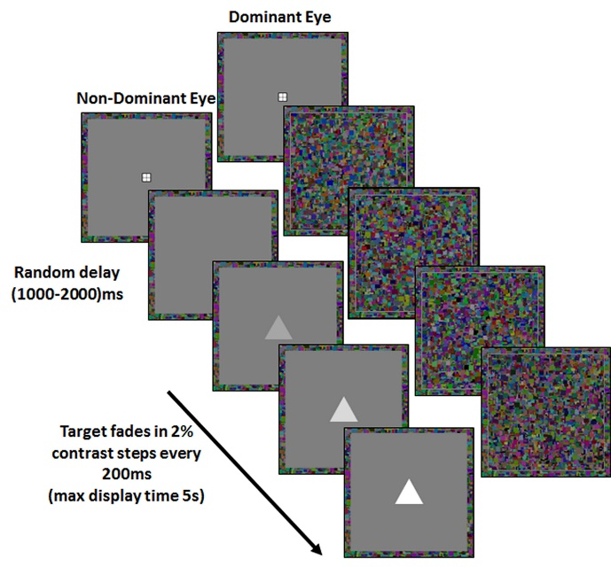

Figure 1. A schematic representation of an experimental trial. Depicted is an example of a single trial for a right-eye dominant participant. On each trial, a shape was gradually introduced to the participant’s non-dominant eye, while Mondrian patterns were presented to the dominant eye using CFS.

Results
b-CFS
One participant (female) failed to follow the instructions during CFS, thus was excluded from the analysis. Table 1 shows the accuracy and response time data. Participants’ mean suppression times were submitted to a 3 (Shape Association: self or friend or stranger) x 2 (Trial Type: target or non-target) repeated measures analysis of variance (ANOVA). As predicted, the results revealed an effect of Shape Association on the time taken to overcome interocular suppression, F(2,86) = 3.98, p = .022, η_{p}² = .08 (see Figure. 2). In particular, whereas suppression durations were shorter for shapes associated with self compared to both friend (t(43) = 1.74, p = .04, Cohen’s d = .26) and stranger (t(43) = 2.63, p = .006, Cohen’s d = .40), breakthrough times for stimuli associated with friend and stranger did not differ significantly, t(43) = 1.16, ns. Neither the main effect of Trial Type [F(1,43) < 1, ns] nor the Shape Association x Trial Type interaction [F(2,86) < 1, ns] were significant. Thus, for otherwise meaningless geometric shapes, self-relevance facilitated access to visual awareness.

Table 1. Mean reaction times (RTs) and accuracy as a function of Trial Type and Shape Association.

Trial Type Shape Association Mean RT (ms) Accuracy
Target Self 1983 (792) .98 (.14)
Friend 2170 (837) .94 (.24)
Stranger 2408 (1180) .96 (.18)
Non-Target Self 2005 (644) .95 (.22)
Friend 2297 (912) .98 (.12)
Stranger 2325 (923) .95 (.21)
Note. Standard deviations appear in parentheses.

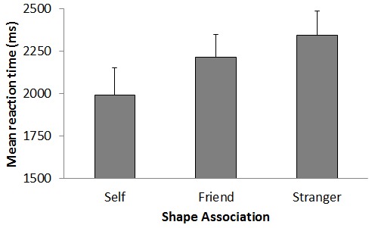
Figure 2. Mean b-CFS times as a function of shape association. Error bars represent the upper 95% confidence intervals.

Diffusion Modeling
To explore the constituent processes that contribute to the emergence of the self-prioritization effect, data were submitted to a HDDM analysis (Wiecki et al., 2013). Parameter estimation is hierarchical because both participant- and group-level parameters are estimated simultaneously in a single model, such that group-level parameters form the prior distributions from which individual participant estimates are sampled. Separate drift rates (v), starting values (z) and non-decisional processes (t₀) were estimated for each shape association and trial type. Bias (z) was modeled as a function of goal state (i.e., looking for self, friend, or stranger); non-decision time (t₀) as a function of shape association (i.e., self, friend, or stranger); and drift rate (v) as a function of the combination of goal state and shape association. Bayesian posterior distributions were modeled using a Markov Chain Monte Carlo (MCMC) with 10,000 bootstraps (following 1,000 burn in samples). Prior to analysis, trials with latencies faster than 200 ms were removed, and the HDDM software removed the 5% of trials with the longest response latencies (Radcliff & Tuerlinckx, 2002).

Table 2. Deviance Information Criterion (DIC) Values for Each Model.

Model Parameterization DIC
v 16998
v, z 16916
v, t₀ 16782
v, z, t₀ 16780
Note. v = drift rate, z = starting point, t₀ = non-decision processes. A DIC difference of 2 is positive evidence for a model, greater than 10 is strong evidence for a model (Kass & Raftery, 1995).

To determine the adequacy of this model, three additional models were tested for comparison. For the first model, only the drift parameter (v) was estimated. For the second and third models, the bias (z) and non-decision (t₀) parameters were also estimated. As can be seen in Table 2, the model that included all three parameters yielded the best fit (i.e., smallest DIC value). Interrogation of the posterior distributions revealed evidence of a decisional bias (z), such that the starting point of evidence accumulation was higher prior to responding to shapes associated with self than either friend (p_{Bayes}(self > friend) = .994) or stranger (p_{Bayes}(self > stranger) = .959; respective Ms: .531 vs. .508 vs. .488; Figure 3 panel A). In addition, a comparison of the non-decision times (t₀) across shape associations indicated faster responses for self than both friend (p_{Bayes}(self > friend) = .972) and stranger(p_{Bayes} (self > stranger = .942; respective Ms (seconds): .379 vs. .485 vs. .467, Figure 3 panel B). Conceptually, this may be linked to enhanced encoding and response execution for self-relevant stimuli. Finally, inspection of the drift parameter (v) indicated that the rate of information uptake was sensitive only to whether the target shape was present or absent (see Figure 3 panel C).
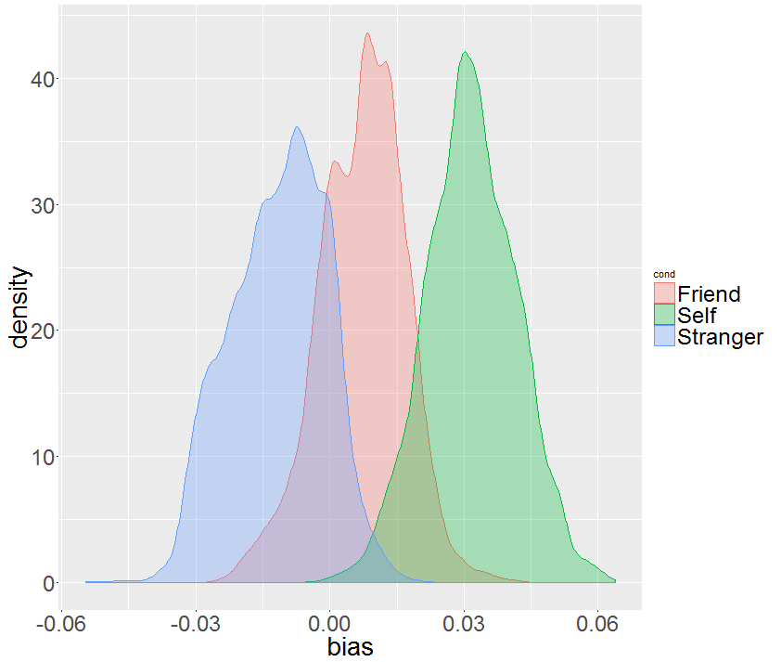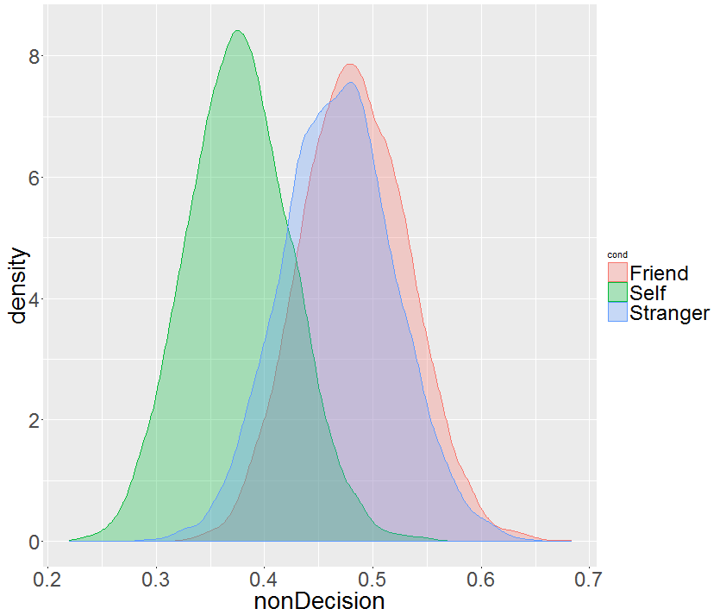
A
B
Starting point (z)
Non-decision processes (t₀)

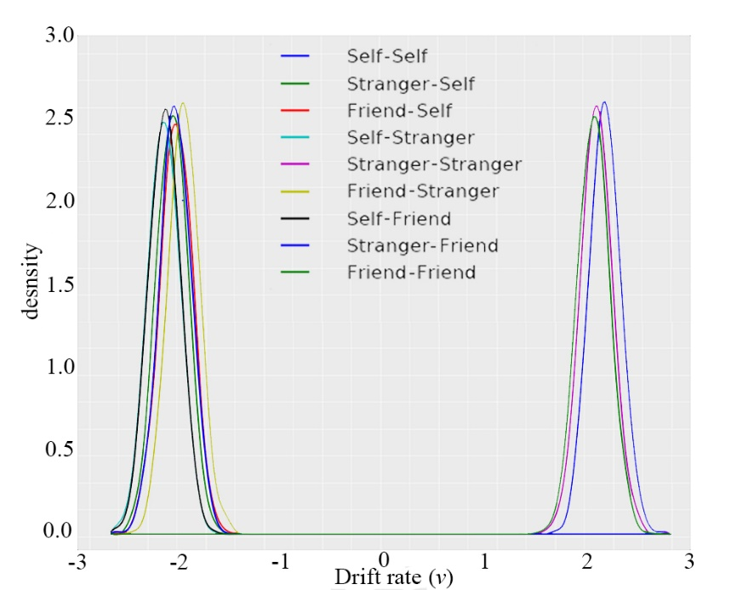
C

Figure 3. Mean posterior distributions across shape-label associations. Distributions show the posterior probability of: (A) mean starting point (z) as a function of goal state (z was re-centered by subtracting 0.5, such that 0 represents no bias); (B) non-decision processes (t₀) as a function of shape association; and (C) drift (v) as a function of goal state and shape association.
General Discussion
An emerging literature has revealed pervasive self-related biases in perceptual matching (Sui et al., 2012, 2013; Sui, Sun, Peng, & Humphreys, 2014). Developing this line of inquiry, here we demonstrated the effects of self-relevance on an earlier stage of processing — perceptual selection. Compared with items referenced to either a friend or stranger, those previously associated with self remained suppressed for shorter periods of time. As such, at least in the context of complex geometric shapes (vs. Gabors) and a target identification (vs. detection) task (cf. Stein et al., 2016), self-tagging enabled people to imbue otherwise neutral stimuli with personal significance, an operation that facilitated access to awareness.
But how exactly does self-relevance prioritize access to visual awareness? In research to date, self-prioritization is considered to be a perceptual phenomenon. Noting how early stages of perception can seemingly be penetrated by cognitive factors — including desires, beliefs, and values (Clark, 2013; Collins & Olson, 2014; Dunning & Balcetis, 2013; Lupyan, 2015) — self-relevance is believed to exert a comparable influence on stimulus processing (Sui & Humphreys, 2015). Not everyone would agree, however. Indeed, a competing viewpoint suggests that self-relevance likely influences decisional processes, notably the adoption of different response criteria when judging self-relevant (vs. non-relevant) information (Firestone & Scholl, in press). In an attempt to evaluate these competing hypotheses, the current data were submitted to a diffusion model analysis. The results revealed that self-prioritization in visual awareness mapped onto the decisional (i.e., starting value, z) parameter of the diffusion model, thereby demonstrating that participants had a prepotent bias to self-related stimuli. Critically, self-relevance did not modulate the rate of information uptake (v) during the decision-making process. What these preliminary findings suggest is that, at least in the current task context, the prioritization of self-relevant information in visual awareness reflects the operation of a decisional bias (Firestone & Scholl, in press; Pylyshyn, 1999).
Complementing existing research (Stein et al., 2016; Sui et al., 2012), here we demonstrated that self-relevance facilitates access to visual awareness for arbitrary geometric shapes under CFS. In addition, rather than modulating the rate of information uptake during decision-making (Humphreys & Sui, 2015; Sui & Humphreys, 2015), self-prioritization influenced the decisional processes that underlie response generation. Whether, of course, this is the case for other classes of stimuli and measures of visual awareness remains to be seen.

References
Almeida, J., Mahon, B.Z., & Caramazza, A. (2010). The role of the dorsal visual processing stream
in tool identification. Psychological Science, 21, 772-778.
Clark, A. (2013) Whatever next? Predictive brains, situated agents, and the future of cognitive
science. Behavioral and Brain Sciences, 36, 181-253.
Collins, J.A., & Olson, I.R. (2014). Knowledge is power: How conceptual knowledge transforms
visual cognition. Psychonomic Bulletin and Review, 21, 843-860.
Conway, M.A. (2005). Memory and the self. Journal of Memory and Language, 53, 594-628.
Ditto, P.H., & Lopez, D.F. (1992). Motivated skepticism: Use of differential decision criteria for preferred and nonpreferred conclusions. Journal of Personality and Social Psychology, 63, 568-584.
Dunning, D., & Balcetis, E. (2013). Wishful seeing: How preferences shape visual perception.
Current Directions in Psychological Science, 22, 33-37.
Firestone, C., & Scholl, B.J. (in press). Cognition does not affect perception: Evaluating the
evidence for “top-down” effects. Behavioral and Brain Sciences.
Gayet, S., Van der Stigchel, S., & Paffen, C.L. (2014). Breaking continuous flash suppression.
Competing for consciousness on the pre-semantic battlefield. Frontiers in Psychology, 5, 460.
Heatherton, T.F., Macrae, C.N., & Kelley, W.M. (2004). A social brain sciences approach to
studying the self. Current Directions in Psychological Science, 13, 190-193.
Humphreys, G.W., & Sui, J. (2015). Attentional control and the self: The self-attention network
(SAN). Cognitive Neuroscience, 7, 5-17.
Jiang, Y., Costello, P., Fang, F., Huang, M., & He, S. (2006). A gender- and sexual orientation-
dependent spatial attention effect of invisible images. Proceeding of the National Academy of Sciences of the United States of America, 103, 17048-17052.
Kang, M.S., Blake, R., & Woodman, G.F. (2011). Semantic analysis does not occur in the absence
of awareness induced by interocular suppression. Journal of Neuroscience, 31, 13535-13545.
Kass, R.E., & Raftery, A.E. (1955). Bayes Factors. Journal of the American Statistical Association, 90, 773-795.
Lupyan, G. (2015). Cognitive penetrability of perception in the age of prediction: Predictive
systems are penetrable systems. Review of Philosophy and Psychology, 6, 547-569.
Mezulis, A.H., Abramson, L.Y., Hyde, J.S., & Hankin, B.L. (2004). Is there a universal positivity
bias in attributions? A meta-analytic review of individual, developmental, and cultural differences in the self-serving attributional bias. Psychological Bulletin, 130, 711-747.
Miles, W.R. (1930). Ocular dominance in human adults. Journal of General Psychology, 3, 412-
430.
Ocampo, B., & Kahan, T.A. (2016). Evaluating automatic attentional capture by self-relevant
information. Cognitive Neuroscience, 7, 22-23.
Pylyshyn, Z. (1999). Is vision continuous with cognition? The case for cognitive impenetrability of
visual perception. Behavioral and Brain Sciences, 22, 341-365.
Ratcliff, R. (1978). A theory of memory retrieval. Psychological Review, 85, 59-108.
Radcliff, R., & Tuerlinckx, F. (2002). Estimating parameters of the diffusion model: Approaches to
Dealing with contaminant reaction times and parameter variability. Psychonomic Bulletin and Review, 9, 438-481.
Shapiro, K.L., Caldwell, J., & Sorensen, R.E. (1997). Personal names and the attentional blink: A
visual “cocktail party” effect. Journal of Experimental Psychology: Human Perception and Performance, 23, 504-514.
Stein, T., Siebold, A., & van Zoest, W. (2016). Testing the idea of privileged awareness of self-
relevant information. Journal of Experimental Psychology: Human Perception and Performance, 42, 303-307.
Sui, J., He, X., & Humphreys, G.W. (2012). Perceptual effects of social salience: Evidence from
self-prioritization effects on perceptual matching. Journal of Experimental Psychology: Human Perception and Performance, 38, 1105-1117.
Sui, J., & Humphreys, G.W. (2015). The integrative self: How self-reference integrates perception
and memory. Trends in Cognitive Sciences, 19, 719-728.
Sui, J., Liu, M., & Mevorach, C., & Humphreys, G.W. (2013). The salient self: The left intra-
parietal sulcus responds to social as well as perceptual salience after self-association. Cerebral Cortex, 4, 1060-1068.
Sui, J., Sun, Y., Peng, K., & Humphreys, G.W. (2014). The automatic and the expected self:
Separating self- and familiarity biases effects by manipulating stimulus probability. Attention, Perception, & Psychophysics, 76, 1176-1184.
Symons, C.S., & Johnson, B.T. (1997). The self-reference effect in memory: A meta-analysis.
Psychological Bulletin, 121, 371-394.
Voss, A., Rothermund, K., & Brandtstädter, J. (2008). Interpreting ambiguous stimuli: Separating perceptual and judgmental biases. Journal of Experimental Social Psychology, 44, 1048-1056.
Voss, A., & Voss, J. (2007). Fast-dm: A free program for efficient diffusion model analysis. Behavior Research Methods, 39, 767-775.
Wieki, T.V., Sofer, I., & Frank, M.J. (2013). HDDM: Hierarchical Bayesian estimation of the drift-
diffusion model in python. Frontiers in Neuroinformatics, 7:14. doi: 10.3389/fninf.2013.00014.
Yang, E., & Blake, R. (2012). Deconstructing continuous flash suppression. Journal of Vision, 12, 8.
Yang, E., Brascamp, J., Kang, M.S., & Blake, R. (2014). On the use of continuous flash
suppression for the study of visual processing outside of awareness. Frontiers in Psychology, 5:724. doi: 10.3389/fpsyg.2014.000724.

Based on a small-to-medium effect size (Almeida, Mahon, & Caramazza, 2010), G*Power 3 (f = .17, α = .05, power = 0.8) revealed a requirement of 39 participants (an additional 10% were recruited to allow for drop out).
When screened in this way, analysis of the b-CFS reaction times yielded effects identical to those reported previously. A main effect of Shape Association was observed (F(2,86) = 14.81, p < .001, η_{p}² = .257), such that suppression durations were shorter for shapes associated with self compared to both friend (t(43) = -19.93, p < .001, Cohen’s d = 3.00) and stranger (t(43) = -4.56, p < .001, Cohen’s d = .69), breakthrough times for stimuli associated with friend and stranger did not differ significantly, t(43) = -1.06, p = .293, Cohen’s d = 0.16.
Self-relevance did, however, influence non-decisional processes (t₀) that include stimulus encoding. Thus, while it is possible that self-relevance impacted perceptual operations, this effect did not occur during the critical evidence-gathering (v) phase of the decision-making process. Indeed, it is just as likely that self-relevance influenced t₀ by facilitating response execution.

