Suppement 4 – Bland Altman plots according to sex

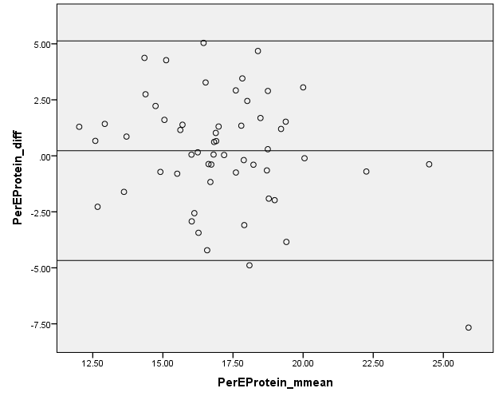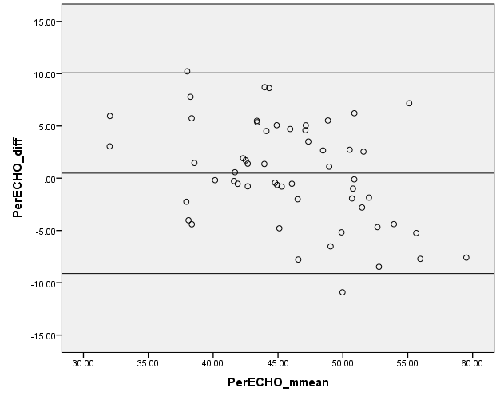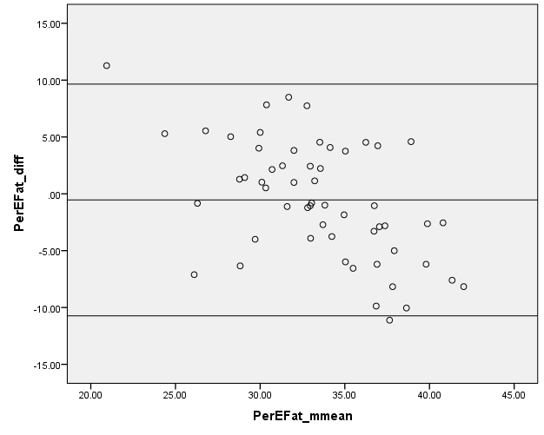
Figure A. Bland Altman plots to assess relative agreement for percentage energy from protein, carbohydrates and fat between the SCG FFQ and food diary for women (n=56).

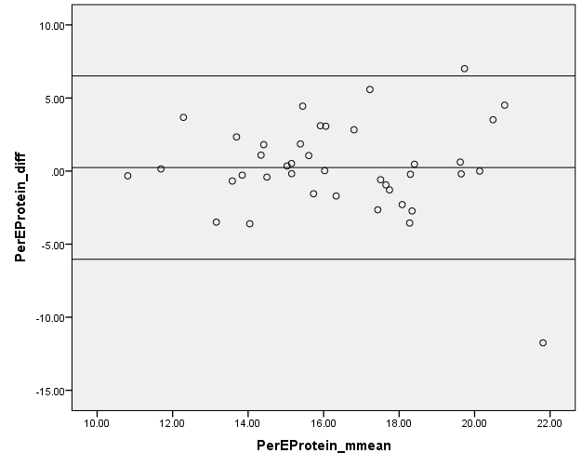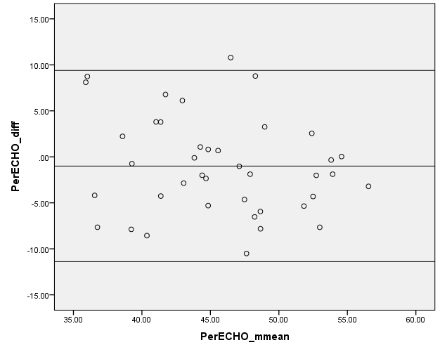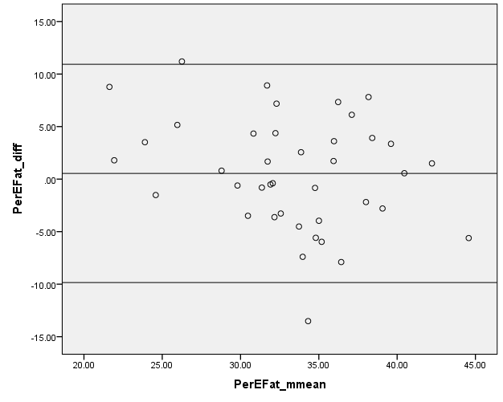
Figure B. Bland Altman plots to assess relative agreement for percentage energy from protein, carbohydrates and fat between the SCG FFQ and food diary for men (n=40).

