Supplementary box 1: The mini-mental Parkinson
Orientation  Time: Day, date, month, year, time to nearest hour  Place: Room/ department, building, town, region, country | (5)  (5)
Attention and mental control  Serial sevens | (5)
Visual registration  Name all six objects (supplementary figure 1)  All correct on first attempt: 3 points, second attempt: 2 points, third attempt: 1 point. | (3)
Set shifting  Identify the way in which each picture differs from the others (supplementary figure 2) | (4)
Visual recall  Name the objects missing from the second set of cards (supplementary figure 3)  And the order in which they were first shown  Two set fluency  Name three animals starting with “C”  Concept processing  Which of these things differs from the other two:  Train, bag, boat  Hat, glove, rake  Orange, carrot, grapes | (3)  (1)  (3)  (3)

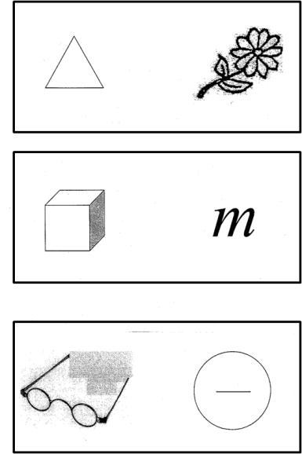
Supplementary figure 1: Mini mental Parkinson visual registration cards
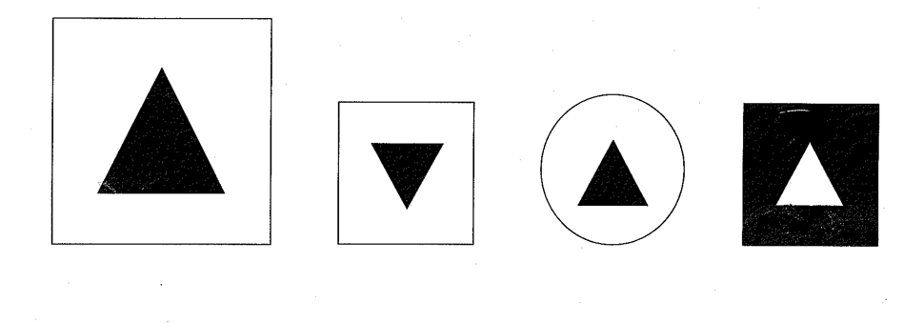
Supplementary figure 2: Mini mental Parkinson set shifting cards
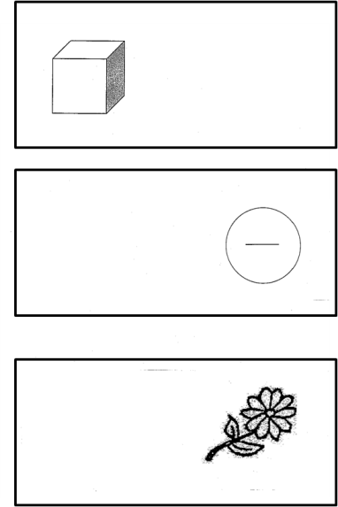
Supplementary figure 3: Mini mental Parkinson visual recall cards

