In the eye of the illusion: variation in perceptual phenomena within an inverted percept

Jan B. Deręgowski and Benjamin W. Tatler
School of Psychology, University of Aberdeen, Aberdeen AB24 3FX

Abstract

Monocular depth cues can lead not only to illusory depth in two-dimensional patterns, but also to perspective reversals in three-dimensional objects. When a viewer perceptually inverts (reverses) a three-dimensional object, stimuli on the inner surfaces of that object also invert.
However, the perceptual fate of anything occurring within the space that is enclosed by the walls of a perceptually reversible object is unknown. In the present study, perceptions of the relative vertical heights of stimuli within a truncated pyramidal chute were compared for stimuli placed laterally, on the inner surface of the chute, or centrally, suspended within the volume enclosed by the chute. The typical inversion was obtained for lateral stimuli, but central stimuli did not invert. While central stimuli maintained their veridical vertical order, participants experienced a considerable compression of perceptual depth. These results imply a dilution of the illusion within the centre of the volume of space that it encloses.

INTRODUCTION

Monocular perspective cues not only support our veridical perceptions of space, but can also give rise to perceptual distortions of depth, which in turn dominate our perceptions of space and objects within that space (Gregory, 2009). The Ponzo illusion provides an elegant example of this: two converging lines on a flat fronto-parallel plane are interpreted as receding depth from the viewer, and the apparent size of objects within the converging lines depends upon their placement in the pattern. An object placed toward the convergent end of the pattern is appears larger than the same object placed toward the divergent end of the pattern. In this way the retinal projection of the object between the lines is overshadowed in our perception by the depth cues provided by the converging lines.

The Ponzo illusion is not confined to the two-dimensional fronto-parallel plane, but can be found in real three-dimensional depth, using planks of wood placed on the ground, with the same observed effect of line convergence on the apparent size of an object (Brislin & Keating, 1976).

The inner wall of a pyramidal chute provides similar converging lines as the two-dimensional Ponzo illusion. However, when viewed monocularly from above, the chute can be perceived either veridically, as a hollow concave chute narrowing in width as its depth from the observer increases, or inverted (that is reversed in depth) as a solid convex pyramidal form rising toward the observer (Deręgowski, 2014). When the viewer’s percept is of the veridical chute, the typical Ponzo illusion is observed for objects placed on the inner wall of the chute, with an object positioned closer to the floor of the chute appearing larger than when it is placed nearer to the opening of the chute. Thus the retinal projection of the objects - which would be smaller when placed toward the narrow end because it is further from the participant in true depth - is overshadowed by the illusion, with the object that projects a smaller retinal image being perceived as larger.

However, when the viewer’s percept is of the inverted form of the pyramid, the normal association between converging lines and perceived recession in depth is broken. In the inverted percept, the width of each face of the pyramid broadens with recession in perceived depth. Furthermore, the Ponzo illusion is also disrupted with an object no longer appearing larger when positioned toward the narrow end of the converging edges of the wall (Deręgowski, 2015). On the contrary, an object positioned toward the broader end of the wall of the chute appears larger than one positioned toward the narrower end, and this presumably reflects a greater influence of the size of the retinal projection for the object (or perhaps a combination of retinal size and perceived depth) in the viewer’s perception of size.

Not only does the perceptual inversion of the chute abolish the Ponzo illusion on its inner surfaces, but it also results in a compression of the perceived height of the object, with the inverted form appearing considerably shorter than the normal form (Deręgowski, 2014).

While the perceptual consequences of depth inversion upon perceptions of objects on the surface of a three-dimensional object and upon the perceived height of the object have been characterised, it is unclear whether the entire volume of a three-dimensional shape is affected in the same way. Thus, for our pyramidal chute is in unclear whether the space which the walls enclose is inverted in the same way during depth reversal of the three-dimensional form. If it is, then stimuli placed within the volume of the pyramidal chute, but without any contact with its walls should be inverted in the same way as those positioned upon the inner surfaces of the chute. If this were so, then the Ponzo illusion would have to be thought of as a “planar” phenomenon, just as the Oppel-Kundt illusion was thought to be by Vurpillot (1963), a contention questioned subsequently by Deręgowski & McGeorge (2006). The depth compression that accompanies the perceptual inversion of a pyramidal chute (Deręgowski, 2014) provides us with a means to consider not only whether the space within the chute is inverted but also whether the extent of the inversion is the same for this inner space than it is for the surfaces of the chute.

Figure 1 illustrates the situation when two stimuli are placed at two different depths within a pyramidal chute, with a vertical separation of d. These two shapes can either be positioned on the surface of the inner wall of the chute, with L1 above L2, or suspended in the centre of the chute, without making contact with the walls, with C1 above C2.

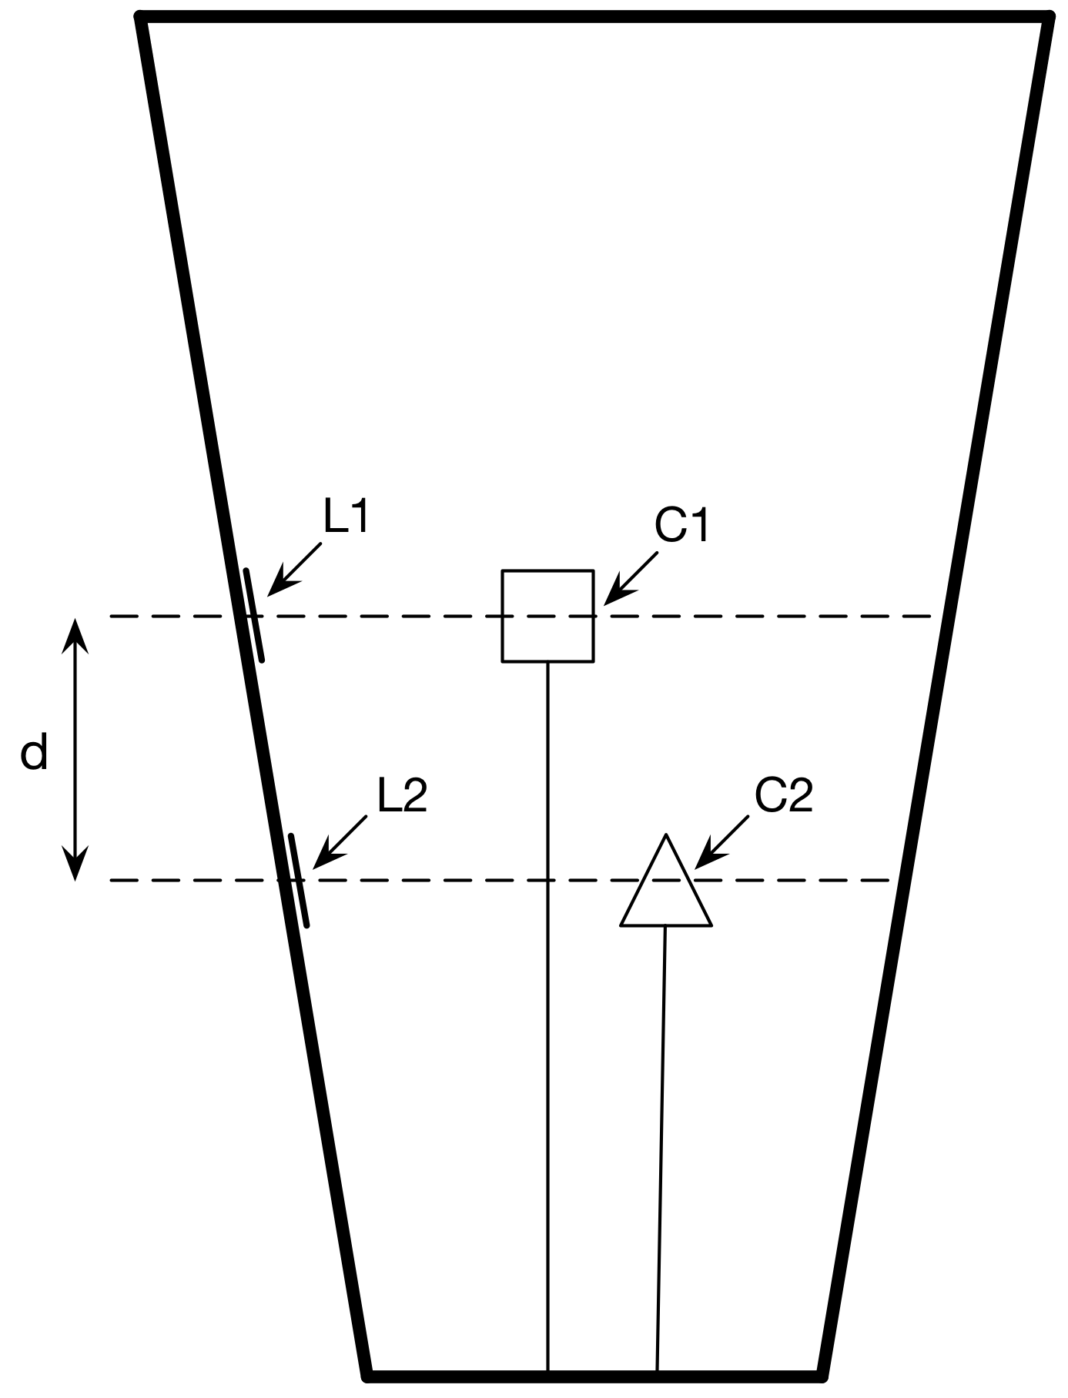
Figure 1. Schematic of possible arrangement of lateral (L1 and L2) and central (C1 and C2) stimuli with a vertical separation of d, within a truncated pyramidal chute that can be used to consider illusory effects within the volume of space enclosed by the walls of the pyramidal chute.

Upon inversion the perceptual judgements of the relative heights of L1 and L2 and the distance between them can be expected from previous work (Deręgowski, 2014, 2015): L2 will now appear to be above L1 and the distance between L2 and L1 will appear to be less than the normal (uninverted) percept (see Figure 2, upper row). The effects of perceptually inverting the chute on perceptual judgments of the relative heights and distance between C1 and C2 are unknown, and are the topic of this paper.

There are four possible percepts for the relationships between the stimuli positioned centrally within the chute (Figure 2, lower row). If the space within the chute inverts C2 will now appear closer to the observer than C1, as depicted in possible percepts I and II in Figure 2. If the space within the chute is perceptually compressed, as is the case for the surfaces of the chute upon inversion, then the perceived distance between C1 and C2 should also be compressed (possible percept I). The extent to which inverted space within the chute is compressed can be used to discern whether the illusion is consistent throughout the volume enclosed by the walls of the shape or not. That is, the degree of compression for laterally placed and centrally placed shapes may be the same (a and b in Figure 2 might be equal); the depth compression illusion may be present but lessened within the volume (b < a); or there may be no compression of depth in the space enclosed by the chute (percept II in Figure 2). In contrast it may be that there is no perceptual inversion of the space within the chute, and that the viewer continues to see C1 as closer than C2 (percepts III and IV in Figure 2). In the case that there is no inversion for the centrally placed shapes, it seems likely that space would similarly not be compressed (percept III in Figure 2). However, it is possible that the uninverted space is never-the-less compressed (percept IV in Figure 2).

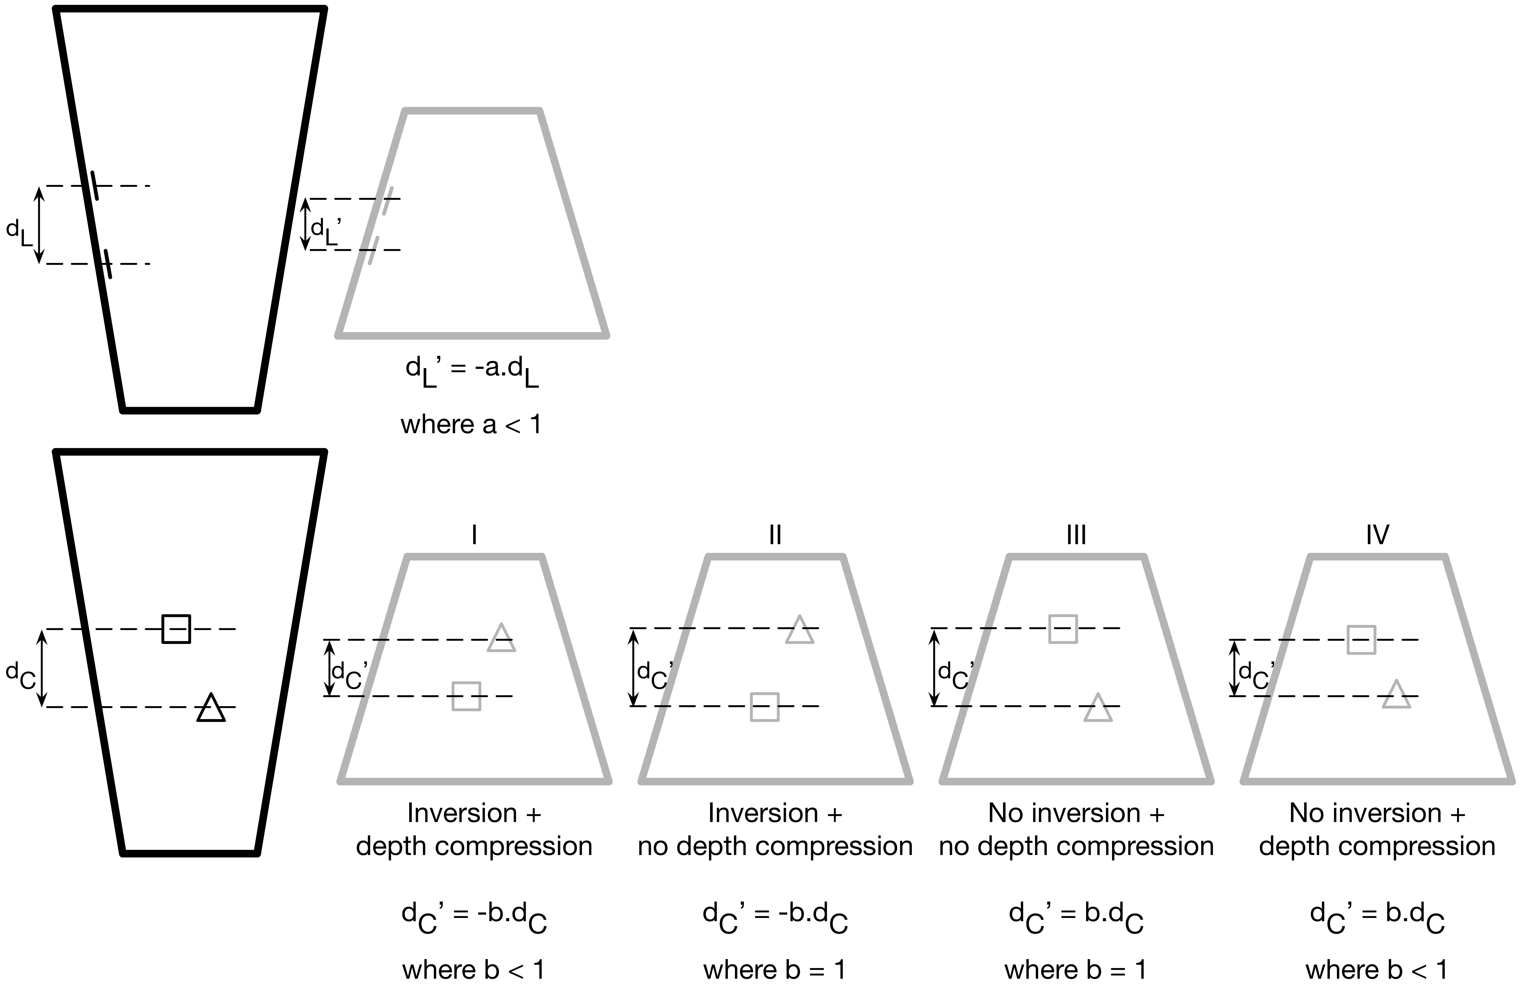

Figure 2. Possible percepts for lateral stimuli (upper row) and central stimuli (lower row) when the pyramidal chute (configuration shown in solid black at left end of each row) is perceived in inverted form (depicted by the grey truncated pyramids). Prior studies (Deręgowski, 2014, 2015) suggest only one likely percept for lateral stimuli when inverted. Four possible percepts for central stimuli can be proposed.

METHOD

Participants. Fourteen participants took part in the experiment reported here (a further four participants failed the initial screening described below and were excluded from subsequent testing). All participants were University students and had normal or corrected-to-normal vision.

Apparatus. A truncated pyramidal chute with a square base was used as the perspectively reversible object. Each of the four sides of the pyramidal chute was made of stout cardboard and measured 10 cm across the narrow end and 20 cm across the wide end. The height of the pyramidal chute was 30 cm. Shapes for perceptual judgments were located either on the inner surface of one of the four walls (lateral targets) or suspended within the centre of the internal volume of the chute (central targets). Figure 3A shows the arrangements of central and lateral targets used in the present study (and explained in detail below). The chute was placed on the surface of a desk.

Lateral targets were a black square and a black triangle each measuring 3 cm from top to bottom and cut from a thin piece of card. The targets were glued to a piece of card that was cut to fit precisely onto the inner surface of one of the walls of the chute. Four arrangements of lateral targets were used, in order to present two different vertical spacings between the two targets, each shown once with the square above the triangle and once with the triangle above the square (Figure 3A, upper row).

Central targets were supported by stiff wire that was fixed to a 10 cm-square piece of cardboard that fitted precisely on top of the base of the pyramidal chute. As for lateral targets, the two shapes were a black square and a black triangle, measuring 3 cm from top to bottom, cut from thin card and mounted on the supporting wire so that they were horizontal with respect to the fronto-parallel plane when viewed from above. In order to ensure that both targets were visible from above and did not overlap with each other a horizontal separation of 5 cm between the two wire mountings was used. As for lateral targets, four arrangements were used: two vertical spacings, each once with the square higher than the triangle and once with the triangle higher than the square (Figure 3A, lower row).

A vertical scale (with numbers hidden from the participant) was used for participants to indicate their judgments about the heights of the stimuli within the pyramidal chute (see procedure below). The scale in cm was visible to the experimenter and was used to calculate the perceived distance between the two stimuli. These distances in cm were later normalized to the veridical distance between the two stimuli such that a value of 1 indicated an estimate that matched the true distance. The vertical scale was placed close to the pyramidal chute, on the surface of the same desk. In this way the response scale did not occlude the view of the chute, nor did the chute occlude the view of the scale. Subjects were free to position the scale wherever they wanted at the start of the experiment so that they could comfortably provide the required estimates while viewing the chute from above.

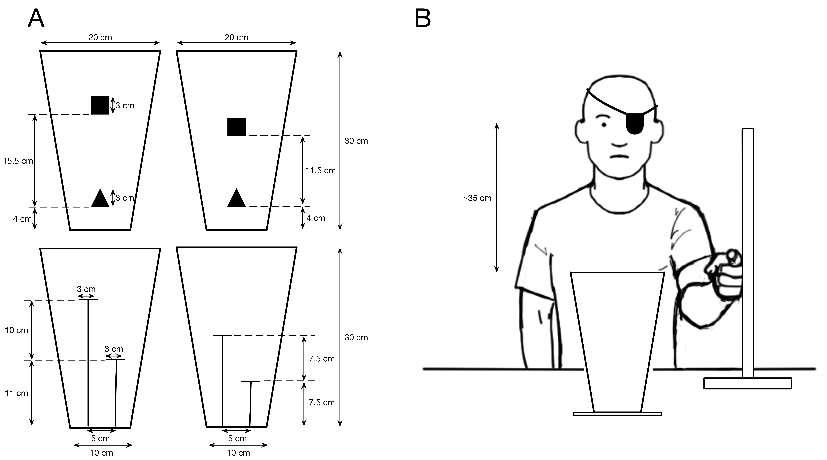
Figure 3. A) The spatial arrangement of stimuli within the pyramidal chute. The chute 10 cm across its base, 20 cm across its opening and stood 30 cm in height. The upper row shows the two spacings used for the lateral stimuli, affixed to the inner surface of one wall of the chute. The lower row shows the two spacings used for the centrally placed stimuli (supported by stiff wire attached to the base of the chute). Note that these four configurations, in which the square was physically above the triangle, were repeated with the triangle above the square. B) Diagram illustrating the setup for this experiment. The chute and scale were placed on a desk. Participants stood so that they viewed the chute from directly above it and so their eyes were around 35 cm (depending on the subject’s height and posture) from the top of the chute. Participants provided height estimates by pointing to the vertical scale (with numbers hidden from the participant’s view). The drawing in panel B was kindly created for us by Dr. Clare Kirtley.

Procedure. Participants were first screened to see whether they were able to invert monocularly. For this, the participant was shown in turn a truncated conical chute, a truncated 4-sided pyramidal chute and a truncated 3-sided pyramidal chute. Any participant that was unable to invert these three objects when viewed monocularly was excluded from subsequent testing.

For the main experiment, participants were asked to stand in a position that allowed them to view the pyramidal chute from directly above. They were free to stand wherever they felt comfortable in order to allow this. Participants were also free to move during the experiment if they wished to. They were also asked to position the vertical scale on which they made their responses such that it was in a position whether they felt comfortable providing responses while viewing the chute from above. In this way viewing distances varied between participants, depending mainly on their height and posture, but was around 35 cm from the top of the chute (Figure 3B). Participants were then presented with eight stimulus configurations (the four arrangements depicted in Figure 4, and the same four arrangements with the target shapes switched so that the triangle was the upper shape) in random order. For each stimulus configuration the participant was asked to provide three height estimates: (1) the height of the base of the pyramid, which acted as a reference point for interpreting (2) the height of the square and (3) the height of the triangle. The participant was asked to provide these estimates first when viewing the normal monocular percept of the chute and then during perspective reversal, when viewing the perceptually inverted form. Four replications of each of these measures were collected over the course of each testing sessions.

Analysis. The question under test was whether stimuli placed centrally in a pyramidal chute undergo perceptual inversion and same degree of depth compression as stimuli placed on the inner walls of the chute when the viewer perceptually inverts the chute. Therefore, the raw estimates of height were not of interest but rather the percepts of the relative vertical distances between the stimuli when paced centrally or laterally. The estimates provided by each participant for the eight stimulus configurations for both normal and inverted percepts were used to compute a perceived distance between the two stimuli shown in each configuration, with positive values indicating a perception that the physically higher object was higher and negative values indicating the contrary. The perceived distance between stimuli was then normalised by the true distance. The results were explored with t-tests where appropriate.

RESULTS

The perceptual distances between the stimuli were calculated by asking participants to indicate the perceived heights of the base of the chute and each of two stimuli positioned within the chute. These two stimuli were positioned either laterally, affixed to the inner surface of one of the walls of the chute, or centrally, suspended within the centre of the space enclosed by the chute (see Method and Figure 3 for the spatial arrangement of stimuli within the pyramidal chute). The perceived distances were normalised by the true distance between the stimuli, such that a value of 1 indicates that the estimate matched the true difference in height between the two stimuli; conversely a value of -1 indicates a complete inversion of the perceived heights of the stimuli, with the subject indicating the correct difference in height but in the opposite direction. Figure 4 shows the perceived distance between the stimuli when placed laterally or centrally and when viewed under normal and inverted perceptions of the pyramidal chute.

Figure 4. Perceptual distance between the two stimuli (square and triangle) when placed laterally (on the inner surface of the chute) or centrally (within the volume of the chute) when viewed the chute was perceived normally or perceptually inverted. Estimates are normalized by the true vertical distance between the two stimuli. Positive perceptual distances reflect estimates where the observer indicated that the physically higher stimulus was the perceptually higher of the two. Negative values indicate instances where the physically higher stimulus was perceived as lower than the other stimulus. Error bars show one standard error around the mean.

For targets placed laterally, on the inner surface of the chute, the typical inversion effect was observed, with participants experiencing a reversal in their perception of which of the two stimuli was closer when the chute was perceived as inverted. For the normal percept, participants judgments of the vertical distance between the two stimuli when placed laterally was not different from the true vertical distance between the stimuli, t (13) = .906, p = .381. When inverted, there was some indication of a compression in depth (with estimates decreasing from an average of 107% of the true distance to 85% of the true difference), and indeed by taking the negative of the estimates for depth during inversion and comparing these to estimates made for normal perception, a significant compression of perceptual depth was observed t (13) = 1.93, p = .038 (1-tailed).

For stimuli placed centrally, no inversion of the stimuli was observed when participants viewed them under conditions of perceptual inversion of the pyramidal chute. When the chute was perceptually inverted, the physically higher stimulus was still judged to be higher than the other stimulus, t (13) = 1.82, p = .046 (1-tailed). While no inversion of the perceived arrangement of central stimuli occurred the perceived vertical distance between the stimuli was far less when the chute was perceived as inverted than when it was perceived normally, t (13) = 3.81, p = .002. As was found for lateral targets, when viewed normally, the judgments that participants made of the vertical distance between targets were reasonably accurate, and did not differ significantly from the true distance, t (13) = 1.61, p = .132.

DISCUSSION

When a pyramidal chute undergoes perspective reversal and is perceived in inverted form, two stimuli positioned on the inner walls of the chute undergo the same perceptual reversal, with the physically closer stimulus now appearing further from the participant than the physically more distant stimulus.

The same was not found for stimuli positioned within the centre of the volume of space enclosed by the walls of the chute. Even when the pyramidal chute was viewed as inverted by the participant, the physical arrangement in depth of the central stimuli prevailed: the physically higher stimulus still appeared to be above the physically lower of the two stimuli. To our knowledge this is the first report that the volume of space contained within a depth illusion is not itself subject to the depth illusion.

While the central stimuli did not invert with the rest of the pyramid, there was a measurable compression of perceived depth, with participants judging the two stimuli as being much closer to each other in depth when the pyramidal chute was viewed in it inverted form than when viewed normally. Thus, the space within the illusion is not immune to the illusion that surrounds it, but is subject to the depth compression typically observed during depth reversal (Deręgowski, 2014, 2015). The extent to which depth was compressed during perceptual inversion of the chute was not the same for lateral and central stimuli. For lateral targets, while the percept was inverted, the compression in depth was only around 22%. For central targets, the percept remained uninverted but the difference in perceived depth was large, reducing by 81% of the true vertical separation between the targets. From the four possible percepts of central targets during inversion of the object that they are placed within that were illustrated in Figure 2, the results of this study are consistent with option IV.

If depth compression and inversion are considered as separable perceptual phenomena then the results could be interpreted as suggesting that depth compression is greater within the centre of the illusion that it is at the surfaces of the inverted object. Thus, the illusory compression in depth increases with distance into the inverted form, but in the absence of inversion. An alternative and more likely suggestion however is that depth compression and perceptual inversion cannot be separated and thus the results arise from a weakening of the effect in the centre of the illusion. Thus, for stimuli positioned centrally, the illusion is enough to shift the relative perceptual positions of the two stimuli in the direction of reversal but not strong enough to result in a perceptual reversal. The centrally-diluted illusion described here is somewhat reminiscent of the reduction in effect of the Ebbinghaus illusion, wherein the strength of the effect is reduced as the spacing between the central circle and the surrounding circle increases (Roberts, Harris and Yates, 2005).

One aspect of our findings that we did not consider was the relationship between the perception of the central objects and the percept of the (inverted) chute itself. In all of the diagrams that we present we have drawn the central shapes as occurring within the perceptual space enclosed by inverted percept of the chute. However, since we only measured the relative distance between the two objects, we cannot tell whether this was indeed the case. Indeed, if the objects were perceived as occurring within the volume of the illusion, this presents a somewhat challenging perception of the form. An inverted pyramidal chute is typically perceived as a convex solid, with the base of the chute forming the upper surface of the perceived solid. Perception of the centrally suspended objects within this volume presents something of an impossible percept. Plausible perceptual interpretations would have to be either of a translucent pyramid enclosing the central objects or of an open-topped pyramid with objects within it. It may, however, be that the objects are not perceived within the volume of the pyramid at all but shifted to outside (e.g., above) the space occupied by the perception of the pyramid. We cannot distinguish these possible percepts of the central objects with respect to the inverted percept of the chute from the present results.

Our phenomenal report offers a first insight into the perceptual effects that are present within 3-dimensional depth illusions, and suggests that the volume of space contained within a depth illusion is not all affected by the illusion in the same manner. In the eye of the illusion, the illusion is calmed.

Acknowledgments: We thank Dr. Clare Kirtley for kindly drawing the experimental setup for us in Figure 3B. We are grateful to Nicholas Wade and an anonymous reviewer for their helpful comments.

Word count: 3,340

References

Brislin, R.W., & Keating, C.F. (1976). Cultural differences in the perception of a three-dimensional Ponzo illusion. Journal of Cross-cultural Psychology, 7, 397-412.

Deręgowski, J. B. (2014). Perspectival reversals of a solid: A phenomenal description. Perception, 43, 1261–1263.

Deręgowski, J. B. (2015). Illusions within an Illusion. Perception, 44, 1416–1421

Deręgowski, J. B., & McGeorge, P. (2006). Oppel–Kundt illusion in three-dimensional space. Perception, 35(10), 1307-1314.

Gregory, R.L. (2009). Seeing through illusions. Oxford: Oxford University Press.

Roberts, B., Harris, M. G., & Yates, T. A. (2005). The roles of inducer size and distance in the Ebbinghaus illusion (Titchener circles). Perception, 34(7), 847-856.

Vurpillot, E. (1963). L'organisation perceptive: son rôle dans l'évolution des illusions optico-géométriques (Paris: Vrin)

Here we use the term “inversion” to refer to the change in depth of the percept from veridical (receding in depth) to illusory (approaching in depth). We might equally refer to this as a “reversal” in depth, but in line with previous studies of this class of illusion we use the term “inversion” throughout this report.

