PAPER: Reaching the Hard to Reach? The ‘Rural Public Access WiFi Service’ Delivery Model – Role, Potential and Pitfalls

Hassan Hamdoun, Fiona Williams, Althaff Mohideen, Lorna Philip, Gorry Fairhurst and John Farrington
dot.rural Digital Economy hub, University of Aberdeen
Aberdeen, UK
{hassan.hamdoun, fiona.williams, althaff.mohideen, l.philip, g.fairhurst, j.farrington}@abdn.ac.uk

ABSTRACT
The Digital Economy (DE) has opened up new opportunities for societal wellbeing across many domains of life. Businesses and government in the UK and elsewhere are seeking to capitalise upon these opportunities in terms of reduced operational costs and improved services. However, a sizeable minority of the UK population lack access to basic DE enabled services and therefore do not yet participate in this Digital Economy. There is a growing social and economic gap between those who are connected and those who are not, the ‘digitally excluded’. This paper outlines the Rural Public Access WiFi Service (PAWS) delivery model that is designed to promote connectivity amongst ‘hard to reach’ households in a remote rural area. It describes the deployment methods and technology enablers surrounding a pilot using satellite broadband connectivity for a case study in remote and rural south Shropshire on the English/Welsh border. This includes analysis of social and technological data to give insights into the reasons behind rural digital exclusion and the online behaviour and experiences of households now receiving Internet access via the PAWS technology. The paper concludes with some reflections on the potential and the pitfalls of the model adopted in PAWS to provide connectivity to a ‘hard to reach’ population.

Keywords
Digital exclusion; Digital by Default; Rural Broadband; Infrastructure barriers; Technology innovation; IT as a utility

INTRODUCTION
The proliferation of the Internet and widespread adoption of mobile and handheld devices (8 billion world-wide by 2017) has created new web-centred applications, services and economic and political models [1]. The Internet is contributing to change across many societal domains including, for example, the economy [2], employment, business operations and wider private sector activities [3], the flow of information and e-commerce [4], healthcare [5] and education [6]. Access to a reliable, high speed Internet service is now accepted as being essential to support economic growth and innovation [7], yet a sizable minority of the UK’s population (and the population of other Western societies) have never used the Internet (7.1 million adults in the UK) [8] and many lack access to basic Internet services. For some, inadequate infrastructure has left their communities off the digital map. In the UK, this is most notable in remote and rural areas, where one-fifth of rural premises may, in connectivity terms, be classified as ‘not served’ or ‘under-served’ [9].
Digital inclusion is increasingly important as public, private and third sector services move to online delivery rather than offline provision models. With the UK government pursuing a ‘Digital by Default’ strategy whereby the platform for delivering public services will move to online provision, the digitisation of transactional services e.g. in health information and advice and welfare payment applications [10] will only increase. Efficiency savings have been highlighted as a key benefit of this move [11].
Concurrently, the UK government’s £530 million Broadband UK (BDUK) programme is supporting industry-led deployment of both ‘superfast’ and ‘standard’ broadband across the UK [12]. However, the provision of universal broadband access to achieve digital inclusion for the ‘final few’ has proved to be a challenge not only because of the socio-economic barriers associated with non-use of the Internet, but also from a technology perspective, because of the difficulties in providing traditional (copper or fibre) digital infrastructure to many of the unconnected or under-served premises.
The Rural Public Access WiFi Service (PAWS) project seeks to address the challenge of digital inclusion in ‘hard to reach’, remote, rural communities. An inter-disciplinary perspective, drawing upon expertise in Internet engineering and rural social science, allows social, technological and economic barriers associated with digital exclusion to be explored in an integrated manner.

THE RURAL PAWS CASE STUDY

A community in south Shropshire has been the focus of Rural PAWS activities - a study area characterised as one where a sizeable number of properties were ‘digitally excluded’ due to infrastructure limitations. Other barriers to digital inclusion in the area included lack of interest and/or computer literacy.
Four households, containing ten individuals, agreed to participate and remain in the Rural PAWS project for a period of 12 months during which they would have free access to a satellite broadband service (installed at no cost). The connectivity available throughout the 12 month period would be rate-limited for normal use, but with full broadband access for government and other ‘white-listed’ web sites. This limitation on the broadband offered was purposive in order to explore the minimum level of service required to allow users to meet ‘Digital by Default’ expectations.

A SATELLITE BROADBAND SERVICE
In the current working Rural PAWS architecture (Fig. 1), satellite connectivity at the case study households uses an Avanti Hylas satellite operating in the Ka frequency band and a Hughes HN9200 Indoor Unit (IDU) that passes user data to/from a specially configured PAWS router with custom software. The router is a Netgear WNDR3800 (with WiFi support), used as an open Linux platform with Cerowrt and the kernel version 3.10.28.
WiFi Protected Access (WPA) provides user authentication. At the University of Aberdeen, the PAWS Management Server (PMS) provides network monitoring and traffic analysis. This enables update, management and monitoring of the deployed Rural PAWS routers. Fig. 2 shows the PAWS network architecture.
3.1 Access Technology
Satellite broadband infrastructure can be economically attractive when rapid deployment is required or there is a larger than normal distance to the point of service provision. Where the cost of deployment can be justified, recent advances in satellite technology (Ka-Band spectrum and high-efficiency radio techniques) have allowed satellite broadband to emerge as a successful access technology for reaching remote areas with higher scalability for one-to-one applications – compared to copper (DSL) lines and fixed wireless broadband technologies.
3.2 Traffic Management
While commercial satellite broadband can offer high speed access, this is not the primary goal of Rural PAWS. The aim is not to displace satellite ISPs from the market, but instead to offer a minimal service – sufficient for occasional use, and to enable stimulation of the market as well as to bring communities on-line and allow them to enter a digital society.
PAWS therefore employs Internet traffic management tools for both outgoing and incoming traffic to realise a service with three traffic classes: essential network services (Assured Forwarding (AF42)), Best Effort (BE) for prioritised traffic (white-listed government services) and Less than Best Effort (LBE) for all other “free” traffic. Traffic arriving at a PAWS router is first classified using a multi-field classifier into one of the three classes. It is then buffered and, scheduled for transmission. Traffic shaping seeks to provide the best service for each traffic class, with each class assigned a capacity limit. Classes may be tuned, similar to the way ISPs configure commercial services, by selecting the rate limit for a class as a trade off against the cost associated with delivery.
3.4 Monitoring Online Usage
Rural PAWS utilises a combination of technical and social science data collection techniques to study online behaviour, and inform the choice of parameters and measure the acceptability of PAWS. These include and allow traffic analysis for each traffic class. This analysis is complemented by social science data collected from participant diaries and interviews ‘in-situ’ Pre-deployment interviews focused on existing practice, experiences and personal views of participants in respect of the Internet. Mid-way through the 12 month PAWS experiment participants were re-interviewed.

PAWS POTENTIAL AND PITFALLS
Early analysis of combined PAWS data has provided an understanding of what users are doing online, information that will be used to inform the development of the next phases of the study. Three households have indicated that they will remain connected, they are ‘getting by’ with the PAWS service for now and will consider value articulated in terms of relevance and acceptability of potential cost-models for ‘an Internet service’ at a later stage in the study. One household (older generation couple) are yet to be convinced of the benefits of being online and may not retain an Internet connection when the PAWS project ends and they are required to start paying for an Internet connection.

5.1 Behavioural Perspectives
If our study households are illustrative of the population at large, we find that connecting non-Internet users is likely to lead to many hard to reach households appreciating the utility of being online and that may encourage them to explore the options of signing up to a paid Internet service. Others, despite using the Internet, may remain unconvinced as to the utility of being online, may accept the need to use the Internet only for very specific functions, or may choose not to use the Internet at all. This is the most difficult sector of the population to engage in digital society and they remain a problem to those pursuing a public service Digital by Default provision model.
Thus PAWS becomes a potential platform for ISP providers to access the ‘hard to reach’ market with a pilot service leading to commercial service uptake. In another role, PAWS can become the provider of last resort (a ‘safety net’) that ensures access to public services online to all but, to minimise costs, does not allow access to other, non-public benefit Internet activities. Whichever way PAWS is viewed a fundamental challenge is ensuring that all actors involved interpret the service offered by PAWS in the same way and that stakeholders in the agreement can specify the benefits, responsibilities and accountabilities in the delivery of the PAWS model.
5.2 Technological Considerations
The PAWS model presents a series of challenges, not least those of funding the capital outlay - provision of satellite equipment, installation costs and running costs of the service. PAWS user categories might suggest that there are potential government savings that could justify government investment in such a service or PAWS might act as a conduit to recruit users to a paid higher grade broadband satellite service and as such might be worthy of ISP attention. Either way, this raises questions in terms of packaging the Rural PAWS service and simultaneously the technical specification of such a service. It may be attractive to consider a hybrid, which could share the costs.
Technical and commercial challenges in preparing for future PAWS deployment include choice of an acceptable rate limit (peak speed) for each traffic class. The business model of many ISPs also impose a downlink usage (volume) limit for the offered service to the subscriber, a deployed service will therefore determine need appropriate volume limits for each traffic class. Last, but not least, ensuring the offered service level is understood by the users, allowing them to decide whether they need to migrate to a paid service as their usage/requirement increases.

CONCLUSIONS
The most pressing issues appear to be how to engage with the most hard to reach non-Internet users, and how to ensure that they can access online public services when they have no interest or ability to be digitally connected in their own home. One way of addressing these challenges is through public provision of basic online connectivity that is open to all at no cost to the user. This raises interesting questions in the domains of public policy and use of public funds, and their relation to service providers’ financial and technical models of provision. These will be the topics of study in the on-going work of the PAWS project.

ACKNOWLEDGEMENTS
The research described here is supported by the award made by the RCUK Digital Economy programme to the dot.rural Digital Economy Hub at University of Aberdeen; award reference: EP/G066051/1.

REFERENCES
[1] ICT Fact and Figures, 2014, International Telecommunication Union, http://www.itu.int/en/ITU-D/Statistics/Documents/facts/ICTFactsFigures2014-e.pdf
[2] Digital Britain Final Report, June 2009, BIS department,
http://webarchive.nationalarchives.gov.uk/+/http:/www.culture.gov.uk/images/publications/digitalbritain-finalreport-jun09.pdf
[3] Capitalizing on connectivity: Realizing the benefits of broadband for UK small and Medium Sized Enterprises. Broadband stakeholder group report, http://www.broadbanduk.org/2014/03/06/capitalising-on-connectivity/
[4] Information Economy Strategy, HM UK Government, June 2013, https://www.gov.uk/government/uploads/system/uploads/attachment_data/file/206944/13-901-information-economy-strategy.pdf
[5] Increasing research and innovation in health and social care policy, Policy paper, March 2013, Department of Health, https://www.gov.uk/government/policies/increasing-research-and-innovation-in-health-and-social-care
[6] International education strategy: global growth and prosperity,
Policy paper, July 2013, Department for Business, Innovation and Skills and Department for Education,
https://www.gov.uk/government/uploads/system/uploads/attachment_data/file/225562/international-education-industrial-strategy-
infographics.pdf

[7] ICT for the UK’s future report, October 2009, Royal Academy of Engineering, http://www.raeng.org.uk/publications/reports/ict-for-the uksfuture
[8] Internet Access - Households and Individuals, 2013, UK Office of National Statistics, http://www.ons.gov.uk/ons/publications/re-reference-tables.html?edition=tcm%3A77-316654
[9] The availability of communications services in the UK, 16th May 2013, Ofcom, http://stakeholders.ofcom.org.uk/binaries/research/markets-infrastructure/economic-geography.pdf,
[10] Policy paper: UK Government Digital Strategy, December 2013, https://www.gov.uk/government/publications/government-digital-strategy/government-digital-strategy
[11] Research and analysis, Digital Efficiency Report, 2012 Cabinet Office, UK Government, https://www.gov.uk/government/publications/digital-efficiency-report/digital-efficiency-report#annex-1-list-of-case-studies
[12] Guidance, Broadband Delivery UK, updated September 2013, Department for Culture, Media and Sport
https://www.gov.uk/broadband-delivery-uk

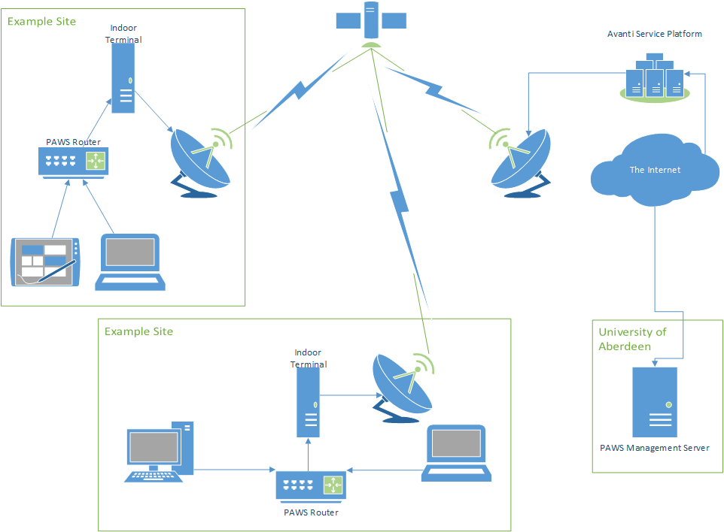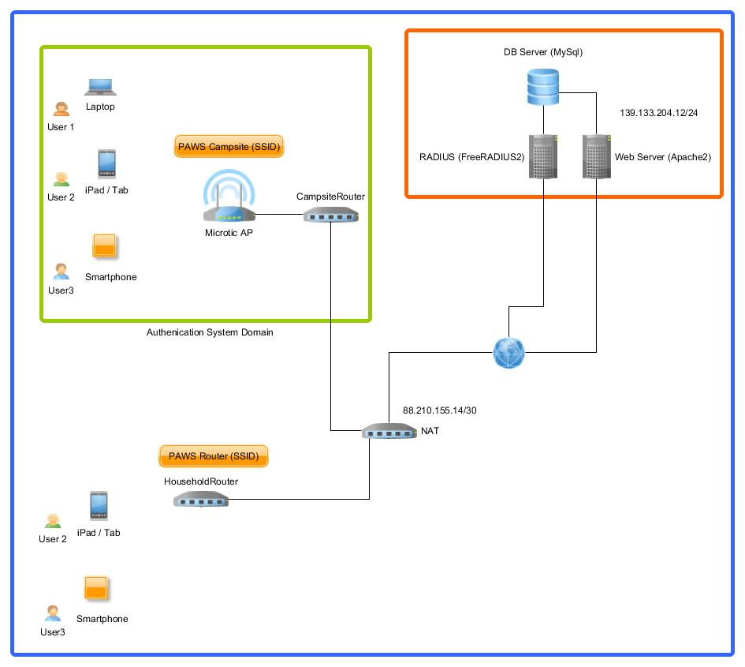
Figure 1: PAWS Platform
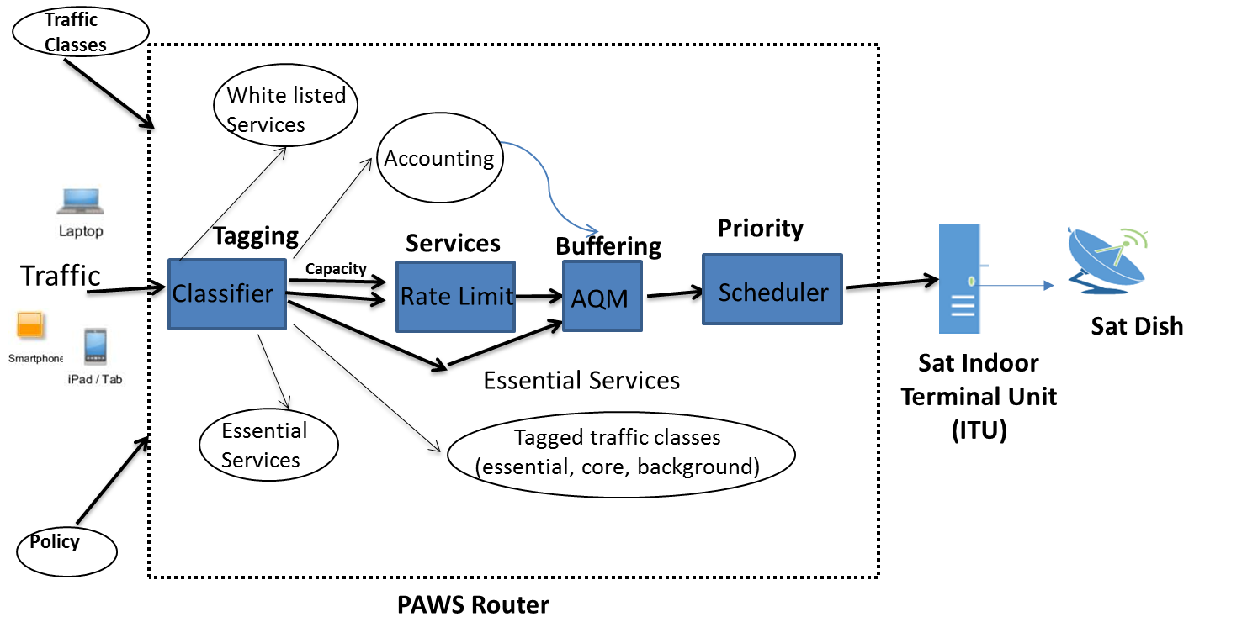

Figure 2: PAWS Technology Architecture

