The consistent hexameric paddle-wheel crystallisation motif of a family of 2,4-bis(alkylamino)nitrobenzenes: alkyl = pentyl, hexyl, heptyl, octyl

M. John Plater*, William T. A. Harrison, Laura M. Machado de los Toyos and Lewis Hendry

Department of Chemistry, University of Aberdeen, Meston Walk, Aberdeen AB24 3UE, UK

Abstract
Three examples of 2,4-bis(alkylamino)nitrobenzenes have been crystallised (alkyl = pentyl, hexyl, heptyl) and the single crystal structures were determined. The three structures are similar and adopt a cyclic hydrogen bonded hexameric motif. The octyl alkyl chains prevented a crystal structure determination owing to disorder.

Key words: hexameric, hydrogen bond, supramolecular, crystallisation, porous

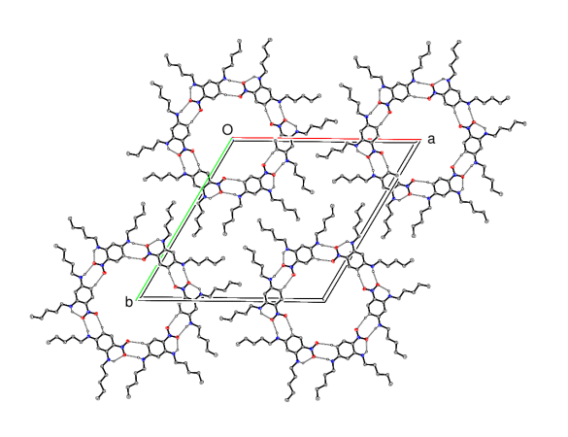
Table of Contents
The crystallisation of nestled hydrogen
bonded hexameric motifs from
2,4-bis(alkylamino)nitrobenzenes

Introduction

DNA is known for its ability to store and transfer genetic information.¹ However, the discovery of the guanine–quadruplex structure has highlighted a new function for DNA in biology.² Guanine-quadruplexes are four-stranded nucleic acid secondary structures formed by DNA molecules (Figure 1). The planar, stacked, guanine-quadruplexes are formed by Hoogsteen hydrogen bonding of guanine bases rather than by Watson–Crick base pairing.³ They can form readily in solution under physiological conditions. Their stabilisation is dependent on the presence of the monovalent cations sodium and potassium.⁴ Potassium ions are more physiologically relevant than sodium ions owing to their high intracellular concentration. The stabilisation of the quadruplex is due to the coordination of the cations by the guanine oxygen atoms in the channel formed by the stacked guanine-tetrads.⁵

Figure 1 A guanine-quadruplex formed from Hoogsteen hydrogen bonds and a templating monovalent cation.

Recently we reported the crystal structures of non-biological cyclic hexameric motifs formed from six 2,4-bis(butylamino)nitrobenzene molecules or six 2,4-bis(phenylamino)nitrobenzene molecules in which adjacent molecules are linked by N–HO hydrogen bonds (Figure 2).⁶ The hexamers formed from 2,4-bis(butylamino)nitrobenzene have a staggered stacking arrangement so that channels do not occur in the crystal but the hexamers formed from 2,4-bis(phenylamino)nitrobenzene are stacked on top of each other so that large channels arise. This work might be related to solution studies by Whitesides and Reinhoudt on melamine–cyanuric/barbituric acid hexamers, although the building blocks here are different and there are fewer hydrogen bonds to support the self assembly of the hexamer.^{7–10} Derivatives of melamine and dibutylbarbituric acid can aggregate into different motifs, but the use of a more crowded melamine derivative favours the formation of single hexamers known as rosettes.^{11–13} In the light of these interesting studies we sought further examples to explore the structural requirements of the building block 1 that lead it to crystallise in the hexamer motif. However, it should be noted that not all derivatives crystallise as hexamers.⁶

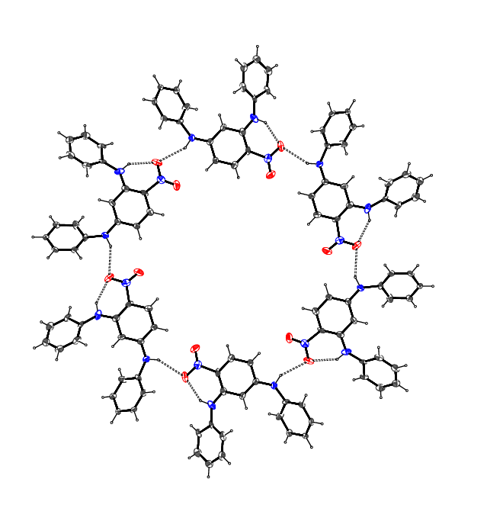
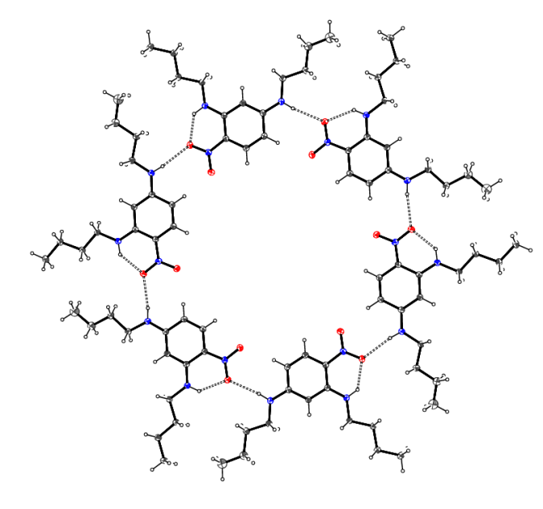

Figure 2 Hexameric hydrogen-bonded motifs: 2,4-bis(butylamino)nitrobenzene 1 and 2,4-bis(phenylamino)nitrobenzene 2.

Discussion
Compounds 4-7 were prepared in yields ranging from 44–70% by reacting 2,4-difluoronitrobenzene 3 with the appropriate long-chain amine (Scheme 1). Both of the fluorine atoms in 3 are activated by the nitro group and can be displaced by nucleophilic substitution (S_{N}Ar). Our previous studies showed that the fluorine atoms can be distinguished with good selectivity, and that the ortho fluorine atom is completely displaced first.⁶ The para fluorine atom is slower to displace but this does occur with an excess of amine present.

Scheme 1 Synthesis of the alkyl-substituted building units.

Crystal structures

Compound 4 is essentially isostructural with the same space group and packing⁶ as compound 1 (compare to Figure 2 above), with one molecule in the asymmetric unit in the trigonal space group $R\overline{3}$. The pentyl chains adopt extended conformations, with the terminal methyl group of the para-chain statistically disordered over two adjacent sites, and an intramolecular N–HO hydrogen bond from the ortho-NH group to one of the nitro group oxygen atoms which closes an S(6) ring (Figure 3). The nitro group is almost coplanar with its attached ring [dihedral angle = 2.34 (2)°]. In the crystal, the molecules are linked by N–HO [HO = 1.96 (2) Å; N–HO = 132 (2)°] hydrogen bonds (from the para-NH group) to generate hexamers (Figure 4), which have $\overline{3}$ point symmetry about their centroids. Each intermolecular N–HO [HO = 2.23 (3) Å; N–HO = 165 (2)°] hydrogen bond is reinforced by an adjacent short C–HO [HO = 2.35 Å; C–HO = 168 °] interaction from the 5-position of the benzene ring, as seen previously.⁶ No other short directional intermolecular interactions could be identified. The rhombohedral crystal symmetry for 4 means that the stacking pattern for the hexamers in the c direction is staggered and therefore no channels are apparent as they are in compound 2.⁶ However, a PLATON¹⁴ analysis indicated a significant void, of volume ∼240 Å³, centred at the origin, the centroid of the hexamer, and symmetry equivalent locations, presumably corresponding to regions of highly disordered solvent molecules.
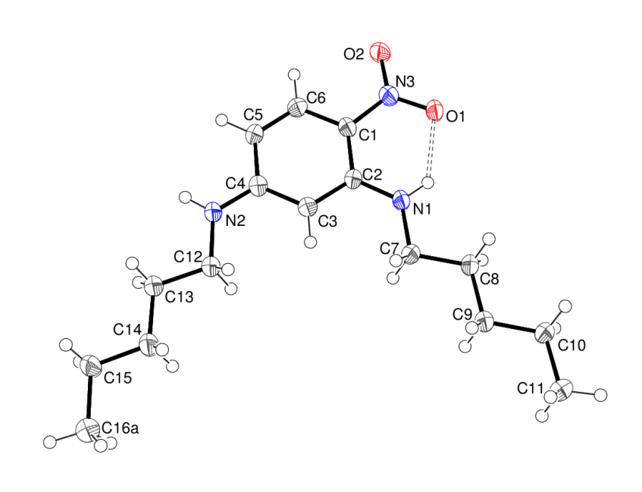

Figure 3 The molecular structure of compound 4, showing 50% displacement ellipsoids. The intramolecular N–HO hydrogen bond is indicated by a double-dashed line. The alkyl chain disorder is not shown.

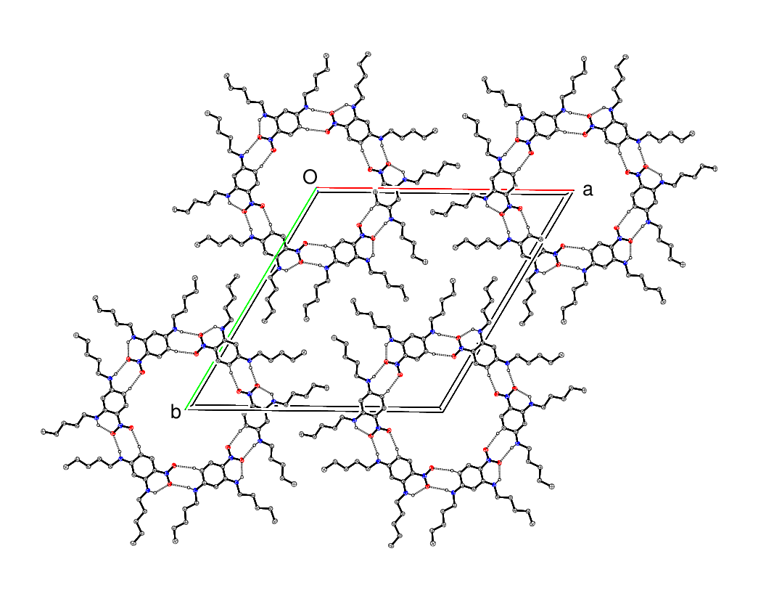

Figure 4 Partial packing diagram for compound 4 showing the N–HO plus C–HO hydrogen-bonded hexameric motifs and the ‘nestled’ alkyl chains. The C-bound H atoms not involved in hydrogen bonds are omitted for clarity. The alkyl chain disorder is not shown.

Compound 5 crystallises in the triclinic space group $P\overline{1}$ with six molecules in the asymmetric unit (Figure 5). Four of the six molecules feature disorder of the terminal atoms of the para-alkyl chains and an intramolecular N–HO hydrogen bond occurs within each molecule. Despite the lower crystal symmetry, the packing for compound 5 is essentially the same as for compound 4, and a hexamer arises, with N–HO hydrogen bonds and reinforcing C–HO links between molecules. One reason for the symmetry lowering may be that some of the para-hexyl chains adopt non-extended conformations (i.e.: gauche C–C–C–CH₃ torsion angles), with the terminal methyl groups displaced either above or below the plane of the hexamer. In terms of stacking, the hexamers are staggered and no channels are apparent in the extended structure.

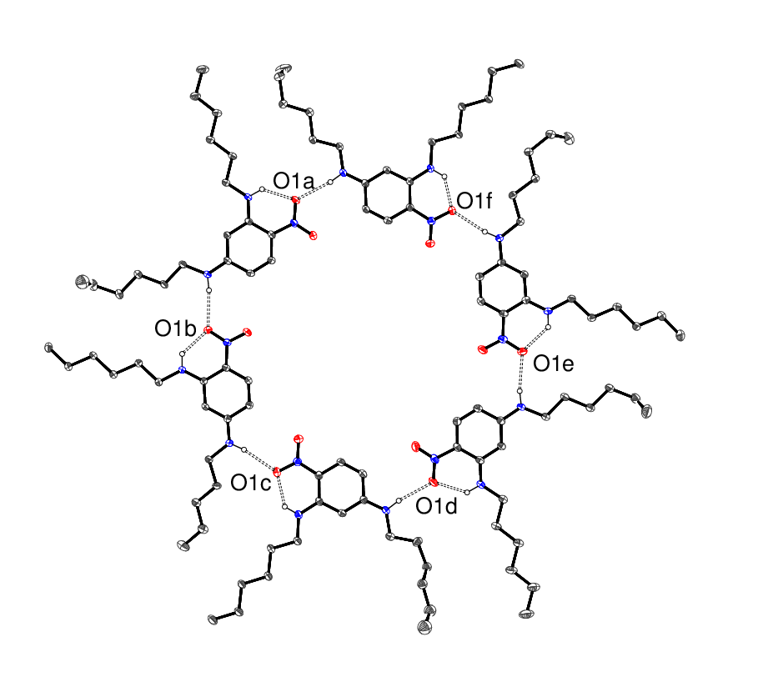

Figure 5 The molecular structure of compound 5, showing 50% displacement ellipsoids. The hydrogen bonds are indicated by double-dashed lines. Note that some of the terminal methyl groups are orientated out of the plane of the hexamer. The alkyl chain disorder is not shown.

Compound 6 crystallises in the triclinic space group $P\overline{1}$ with nine molecules in the asymmetric unit (see supplementary Figures 6 and 7), but again hexamers arise in the crystal. One of these is comprised of six independent molecules and the other is centrosymmetric (i.e.: has point symmetry $\overline{1}$ about its centroid) and comprises three unique molecules and their inversion-generated clones. In both cases, cooperative N–HO and C–HO bonds link adjacent molecules within their hexamers, as seen for compounds 4 and 5. No channels are evident in the extended structure.

In terms of compound 7, the refinement is extremely poor and the terminal portions of some of the octyl chains are badly disordered or indistinct (see supplementary Figures 8 and 9). However, it may be discerned that compound 7 (triclinic: space group $P\overline{1}$) crystallises with no fewer than 12 molecules in the asymmetric unit. Here, there are two independent hexamers, each comprised of six unique molecules, with the same complementary N–HO and C–HO links between the molecules as seen in compounds 4-6.

Conclusion

The syntheses and crystal structures of the family of 2,4-bis(alkylamino)nitrobenzenes (alkyl = nC₅–C₈) have been described. Although the crystal symmetries are different, which possibly correlates with different orientations of the terminal parts of the alkyl chains, a robust supramolecular hexameric N–HO hydrogen-bonded motif is present in each structure.

Experimental

The IR spectra were recorded on an ATI Mattson FTIR spectrometer using KBr discs. The UV spectra were recorded using a Perkin-Elmer Lambda 25 UV–Vis spectrometer with CH₂Cl₂ as the solvent. ¹H and ¹³C NMR spectra were recorded at 400 MHz and 100.5 MHz, respectively, using a Varian 400 spectrometer. Chemical shifts, δ are given in ppm and measured by comparison with the residual solvent. Coupling constants, J are given in Hz. Low resolution and high resolution mass spectra were obtained at the University of Wales, Swansea using electron impact ionisation and chemical ionisation. Melting points were determined on a Kofler hot-stage microscope.
Single crystal growth
For all samples, the starting material was dissolved in dichloromethane/light petroleum ether (40-60) and the solution was left to slowly evaporate at room temperature.
Crystallography
The intensity data for compounds 4-7 were collected on a Rigaku Mercury CCD diffractometer (Mo Kα radiation, λ = 0.71073 Å, T = 100 K). The structures of compounds 4 and 5 were routinely solved by direct methods with SHELXS-97¹⁵, but uninterpretable E-maps emerged for compounds 6 and 7 with SHELXS-97. However, the ‘dual-space’ algorithm in SHELXT¹⁶ gave recognisable structures in space group P1 for compounds 6 and 7, which were both transformed to the centrosymmetric space group $P\overline{1}$ prior to refinement. All of the structural models were completed and refined against |F|² with SHELXL-2014. Some of the terminal groups of the alkyl chains are disordered over two orientations. The N-bound H atoms were located in difference maps and refined freely for compound 4 or placed in idealised locations (N–H = 0.88 Å) for compounds 5, 6 and 7 and refined as riding atoms. The C-bound H atoms were placed in idealised locations (C–H = 0.97–0.99 Å) in all cases and refined as riding atoms. The constraint U_{iso}(H) = 1.2U_{eq}(carrier) or 1.5U_{eq}(methyl C) was applied in all cases. For compound 7, the benzene rings were modelled as rigid hexagons (C–C = 1.39 Å). For compound 4, a PLATON¹⁷ analysis indicated a significant void, of volume ∼240 Å³, centred at the origin, the centroid of the hexamer, and symmetry equivalent locations, presumably corresponding to regions of highly disordered solvent molecules. The application of PLATON/SQUEEZE¹⁷ indicated a very low electron density of about 14 e per cavity, although a small reduction in R-factors was achieved. The final R-factors for compound 6 and especially 7 are extremely high (see below), but chemically plausible structures have resulted and their gross features can at least be discerned.
4 C₁₆H₂₇N₃O₂, M_{r} = 293.40, yellow block, 0.06 × 0.05 × 0.03 mm, trigonal, space group $R\overline{3}$ (No. 148), Z = 18, a = 29.6593 (7) Å, c = 10.4920 (6) Å, V = 7993.0 (6) Å³ at 100 K. Number of measured and unique reflections = 35044 and 4071, respectively (–38 ≤ h ≤ 32, –38 ≤ k ≤ 38, –13 ≤ l ≤ 13; 2θ_{max} = 54.9°; R_{int} = 0.069). Final R(F) = 0.067, wR(F²) = 0.163 for 199 parameters and 2641 reflections with I > 2σ(I) (corresponding R-values based on all 4071 reflections = 0.108 and 0.185, respectively), CCDC reference number 1518390. The presumed disordered solvent is not included in the calculations of M_{r}, etc.
5 C₁₈H₃₁N₃O₂, M_{r} = 321.46, orange rod, 0.31 × 0.06 × 0.06 mm, triclinic, space group $P\overline{1}$(No. 2), Z = 12, a = 18.3214 (3) Å, b = 18.6127 (4) Å, c = 20.0953 (4) Å, α = 104.147 (2)°, β = 105.226 (2)°, γ = 111.987 (2)°, V = 5663.6 (2) Å³ at 100 K. Number of measured and unique reflections = 89863 and 25863, respectively (–23 ≤ h ≤ 23, –24 ≤ k ≤ 24, –26 ≤ l ≤ 26; 2θ_{max} = 55.0°; R_{int} = 0.048). Final R(F) = 0.063, wR(F²) = 0.143 for 1240 parameters and 16177 reflections with I > 2σ(I) (corresponding R-values based on all 25863 reflections = 0.111 and 0.165, respectively), CCDC reference number 1518391.
6 C₂₀H₃₅N₃O₂, M_{r} = 349.51, orange block, 0.30 × 0.10 × 0.07 mm, triclinic, space group $P\overline{1}$(No. 2), Z = 18, a = 11.2731 (3) Å, b = 30.5744 (7) Å, c = 31.0881 (8) Å, α = 62.603 (2)°, β = 85.518 (2)°, γ = 87.659 (2)°, V = 9484.0 (4) Å³ at 100 K. Number of measured and unique reflections = 109635 and 35305, respectively (–13 ≤ h ≤ 13, –37 ≤ k ≤ 37, –37 ≤ l ≤ 37; 2θ_{max} = 51.0°; R_{int} = 0.055). Final R(F) = 0.094, wR(F²) = 0.234 for 2015 parameters and 20746 reflections with I > 2σ(I) (corresponding R-values based on all 35305 reflections = 0.156 and 0.267, respectively), CCDC reference number 1518392.
7 C₂₂H₃₉N₃O₂, M_{r} = 377.56, orange rod, 0.32 × 0.09 × 0.08 mm, triclinic, space group $P\overline{1}$(No. 2), Z = 24, a = 21.8346 (12) Å, b = 24.4599 (11) Å, c = 25.5751 (12) Å, α = 97.386 (4)°, β = 92.123 (4)°, γ = 90.780 (4)°, V = 13534.0 (12) Å³ at 100 K. Number of measured and unique reflections = 112684 and 52845, respectively (–26 ≤ h ≤ 26, –30 ≤ k ≤ 29, –30 ≤ l ≤ 31; 2θ_{max} = 52.0°; R_{int} = 0.099). Final R(F) = 0.204, wR(F²) = 0.404 for 2463 parameters and 18381 reflections with I > 2σ(I) (corresponding R-values based on all 52845 reflections = 0.359 and 0.461, respectively), CCDC reference number 1518393.

Syntheses

2,4-Bis(pentylamino)nitrobenzene and general procedure

2,4-Difluoronitrobenzene (1.0 g, 6.28 mmol) and n-pentylamine (3.0 ml, 25.1 mmol) in EtOH (8 mL) were sealed in a teflon-lined Parr bomb and heated at 150 °C for 15 h. On cooling, the mixture was mixed with CH₂Cl₂ (50 mL), extracted with 60 mL of aqueous HBr (8% 60 mL), dried over MgSO₄, filtered then concentrated under reduced pressure and purified by chromatography on silica gel. Elution with ether : light petroleum ether 40–60 (25:75) gave compound 4 (0.63 g, 70%) as a yellow solid, mp 123–124 °C (from dichloromethane:light petroleum ether 40–60). λ_{max} (EtOH)/nm 415 (log ε 4.8) 405 (4.83), 402 (4.83) and 398 (4.82); ν_{max} (KBr)/cm^{–1} 3317s, 2955m, 2929m, 2857m, 1614vs, 1579vs, 1543vs, 1459m, 1400s, 1328m, 1310vs, 1260vs, 1248vs, 1189vs, 1165vs, 1131vs, 1030vs, 817vs, 793w, 767w, 751s, 734s, 671s, 652m, 605m, 591vs and 555vs; δ_{H} (400 MHz; CDCl₃) 0.91-0.96 (6H, m), 3.42-4.0 (8H, m), 3.72-3.76 (4H, m) and 3.20-3.28 (4H, m), 5.80 (1H, s), 5.91 (1H, dd, J = 9, 2) and 8.0 (1H, d, J = 9); δ_{C} (100.1 MHz; CDCl₃ 13.4, 13.4, 22.4, 22.4, 28.5, 28.5, 29.1, 29.3, 43.0, 44.0, 90.0, 105.3, 123.5, 129.1, 148.6 and 154.2; m/z (orbitrap ASAP) 294.2175 [M + H]⁺ 100% C₁₆H₂₈N₃O₂ requires 294.2176

2,4-Bis(hexylamino)nitrobenzene

Following the procedure for 4, but using n-hexylamine (3.0 mL) in place of n-pentylamine gave compound 5 (603 mg, 59%), as a yellow solid, mp 85–86 °C (from ether:light petroleum ether 40–60). λ_{max} (EtOH)/nm 403 (log ε 4.8) and 252 (log ε 4.82); ν_{max} (KBr)/cm⁻¹ 3320m, 3071w, 2929m, 2856m, 2952m, 1614vs, 1579s, 1543s, 1462m, 1401s, 1313s, 1259vs, 1191vs, 1167s, 1129s, 819vs, 752m, 593s and 564s; δ_{H} (400 MHz; CDCl₃) 0.89–0.95 (6H, m), 1.30–1.49 (12H, m), 1.65–1.79 (4H, m), 3.18-3.28 (4H, m), 5.86 (1H, s), 6.03 (1H, dd, J = 9, 2 Hz) and 8.05 (1H, d, J = 9) (2 × NH peak missing); δ_{C} (100.1 MHz; CDCl₃) 13.9, 14.1, 22.6, 26.7, 28.7, 31.5, 42.9, 44.0, 91.2, 105.1, 124.1, 129.2, 148.4, 153.5 (4 peaks are overlapping); m/z (Orbitrap ASAP) 322.2497 [M + H]⁺ 100%, C₁₈H₃₂N₃O₂ requires 322.2497

2,4-Bis(heptylamino)nitrobenzene

Using n-heptylamine (3.0 mL) in place of n-pentylamine gave compound 6 (777 mg, 70%), as a yellow solid, mp 79–80 °C (from ether:light petroleum ether 40–60). λ_{max} (EtOH)/nm 406 (log ε 4.8) and 251 (log ε 4.83); ν_{max} (KBr disc) 3319m, 2626m, 2853m, 1614vs, 1578s, 1542s, 1514m, 1466m, 1403s, 1382m, 1313s, 1258vs, 1226s, 1188vs, 1167vs, 1130s, 1087s, 819vs, 752m, 593s and 564s; δ_{H} (400 MHz; CDCl₃) 0.88-0.93 (6H, m), 1.31–1.46 (16H, m), 1.64–1.79 (4H, m), 3.18–3.27 (4H, m), 5.79 (1H, s), 6.00 (1H, dd, J = 9, 2 Hz) and 8.04 (1H, d, J = 9) (2 × NH peak missing); δ_{C} (100.1 MHz; CDCl₃) 14.0, 22.5, 26.9, 27.1, 28.8, 28.9, 28.9, 30.8, 31.7, 42.9, 43.7, 90.83, 105.0, 123.9, 129.2, 148.4, 153.8 (3 peaks are overlapping); m/z (Orbitrap ASAP) 350.2810 [M + H]⁺ 100%, C₂₀H₃₆N₃O₂ requires 350.2810.

2,4-Bis(octylamino)nitrobenzene

Using n-octylamine (3.0 mL) in place of n-pentylamine gave compound 7 (523 mg, 44%), as a yellow solid, mp 70–71 °C (from ether:light petroleum ether 40–60). λ_{max} (EtOH)/nm 404 (log ε 4.8) and 254 (log ε 4.81), ν_{max} (KBr disc) 3323m, 2926m, 2853m, 1614vs, 1577s, 1540s, 1514m, 1465m, 1401s, 1379m, 1329m, 1312s, 1259vs, 1219s, 1188vs, 1166s, 1129s, 1090s, 1055m, 820vs, 752m, 594s and 570s; δ_{H} (400 MHz; CDCl₃) 0.88–0.92 (6H, m), 1.30–1.41 (20H, m), 1.64–1.79 (4H, m), 3.18–3.30 (4H, m), 5.80 (1H, s), 6.00 (1H, dd, J = 9, 2 Hz) and 8.04 (1H, d, J = 9) (2 × NH peak missing); δ_{C} (100.1 MHz; CDCl₃) 14.0, 22.6, 27.0, 27.1, 29.2, 30.8, 31.7, 42.9, 43.8, 91.1, 105.0, 124.0, 129.18, 148.4, 153.6 (7 peaks are overlapping); m/z (Orbitrap ASAP) 378.3123 [M + H]⁺ 100%, C₂₂H₄₀N₃O₂ requires 378.3126.

References

1. Y. Chen and D. Yang, Current Pro. Nuc. Chem., 2012, 17, 1.
2. D. Yang and K. Okamoto, Fut. Med. Chem. 2010, 2, 619.
3. D. Sen and W. Gilbert, Nature, 1988, 334, 364.
4. D. Sen and W. Gilbert, Nature, 1990, 344, 410.
5. T. van Mourik and A. J. Dingley, Chemistry, 2005, 11, 6064.
6. M. J. Plater and W. T. A. Harrison, J. Chem. Res., 2015, 39, 98.
7. C. T. Seto and G. M. Whitesides, J. Am. Chem. Soc. 1993, 115, 905.
8. P. Timmerman, R. H. Vreekamp, R. Hulst, W. Verboom, D. N. Reinhoudt, K. Rissanen, K. A. Udachin and J. Ripmeester, Chem. Eur. J. 1997, 3, 1823.
9. M. Arduini, M. Crego-Calama, P. Timmermann and D. N. Reinhoudt, J. Org. Chem. 2003, 68, 1097.
10. A. G. Bielejewska, C. E. Marjo, L. J. Prins, P. Timmerman, F. de Jong and D. N. Reinhoudt, J. Am. Chem. Soc. 2001, 123, 7518.
11. J. A. Zerkowski, C. T. Seto and G. M. Whitesides, J. Am. Chem. Soc. 1992, 114, 5473.
12. J. A. Zerowski, C. T. Seto, D. A. Wierda and G. M. Whitesides, J. Am. Chem. Soc. 1990, 112, 9025.
13. M. J. Plater, J. P. Sinclair, S. Aiken, T. Gelbrich and M. B. Hursthouse, Tetrahedron, 2004, 60, 6385.
14. A. L. Spek, Acta Cryst. 2009, D65, 148.
15. G. M. Sheldrick, Acta Cryst. 2008, A64, 112.
16. G. M. Sheldrick, Acta Cryst. 2015, A71, 3.
17. A. L. Spek, Acta Cryst. 2015, C71, 9.

Electronic Supplementary Information
Compound 6 (Figures 6 and 7) and compound 7 (Figures 8 and 9).

Acknowledgements

We thank the EPSRC National Mass Spectrometry Service (University of Swansea) for the mass spectrometry data and the EPSRC National Crystallography Service (University of Southampton) for the X-ray intensity data collections.

