Floor formation processes and the interpretation of site activity areas: insights from a geo-ethnoarchaeological study of a turf house at Thverá, northeast Iceland

Karen Milek

Department of Archaeology
School of Geosciences
University of Aberdeen
St. Mary’s, Elphinstone Road
Aberdeen, AB24 3UF
United Kingdom

Telephone: +44 1224 273693
Fax: +44 1224 272331
E-mail address: k.milek@abdn.ac.uk
Abstract (50-200 words: currently 195)

The importance of identifying activity areas on archaeological sites has focussed much ethnoarchaeological and geoarchaeological research on floor formation processes, especially cultural practices and preservation conditions affecting the distributions of artefacts, organic residues, and elements in occupation deposits. In preparation for a (geo)archaeological project on the use of space in Viking Age buildings in Iceland, a geo-ethnoarchaeological study was conducted at abandoned 19th- and early 20th-century turf buildings at Thverá, northeast Iceland. Micromorphological analysis of the floor deposits in different rooms, compared to the former resident's descriptions of how space had been used and how floors had been maintained, revealed that only a small number of activities resulted in the accumulation of residues that were diagnostic of how space had been used on a daily basis. Instead, floor layers were dominated by residues associated with maintenance events, such as the intentional spreading of ash, and the relaying of fresh turf. This study highlighted the fact that floor "maintenance" and "cleanliness" are socially constructed concepts that have a dramatic impact on the composition of occupation surfaces and cannot be overlooked by archaeologists attempting to use the spatial analysis of floor composition to interpret site activity areas.

Keywords
Site formation processes; Activity areas; Ethnoarchaeology; Geoarchaeology; Iceland; Turf buildings

Highlights (save as separate file) (3-5 bullet points, max 85 characters each including spaces)

Introduction

The interpretation of site activity areas, and the differentiation between the residues of the past use of space and other processes that may have affected the composition of occupation surfaces, is a key problem faced by all archaeologists who are engaged with research on settlement sites and are interested in how households organised their daily lives and economic activities. The methodological challenge of answering these questions is significant, because in the absence of obvious features such as hearths, cooking pits, storage pits or sleeping platforms, the interpretation of activity areas is normally dependent on a clear understanding of the agents behind the observed patterns in the distributions of artefacts, microrefuse, organic residues, and/or elements that accumulated on presumed occupation surfaces (e.g. Metcalfe and Heath 1990; Middleton and Price 1996; Sampietro and Vattuone 2005; Smith et al. 2001; Sullivan and Kealhofer 2004; Vizcaíno and Cañabate 1999). However, the composition of archaeological occupation surfaces is determined by variable and complex sets of interactions between a wide range of processes (Carr, 1984; Gé et al., 1993; LaMotta and Schiffer, 1999; Wandsnider, 1996). Most floor formation processes are intentional or accidental human actions, which frequently result in the deposition or removal of particular artefacts and residues – especially larger objects, which tend to be removed, discarded, or redistributed when buildings are abandoned (Lange and Rydberg 1972; Stevenson 1982; Tomka 1993). But there is also a range of natural processes that can alter the composition of occupation deposits with the passage of time, as they become subject to the same physical, chemical, and biological processes that affect local landforms and soils (Rolfsen 1980; Schiffer 1996; Wood and Johnson 1978). It is therefore essential to develop a rigorous framework for detecting and interpreting activity areas – not merely for analysing spatial patterns in the composition of occupation deposits, but for detecting the possible palimpsest of cultural and natural floor formation processes that may also have affected this composition.

For over three decades, ethnoarchaeological, ethnohistoric and experimental studies of the formation processes affecting occupation surfaces have been making an important contribution to the development of methodologies used by archaeologists to sample, analyse, and interpret spatial data with relation to site activity areas (e.g. Bartram et al., 1991; Binford, 1978; Brochier et al., 1992; Deal, 1985; Gifford-Gonzalez et al., 1985; Hayden and Cannon, 1983; Murray, 1980; Nielsen, 1991; Simms, 1988; Shahack-Gross et al., 2004, 201??). Increasingly wary about the reliability of artefact distributions, especially artefacts over 1-2 cm in size, which are most likely to be seen and removed during cleaning events or dumped or cached during abandonment events, the trend has been to analyse the spatial distributions of the most minute residues: microrefuse (bones and artefacts under 2 mm in size), phytoliths, organic residues, elements (especially P and Ca), and stable isotopes (especially of N and C), and to use multiple overlapping datasets whenever possible (e.g. Fladmark, 1982; Metcalfe and Heath, 1990; Middleton and Price, 1996; Sanchez Vizcaíno and Cañabate, 1999; Sampietro and Vattuone, 2005; Shahack-Gross et al., 2008; Sherwood et al., 1995; Smith et al., 2001; Sullivan and Kealhofer, 2004; Terry et al., 2004; Wilson et al., 2005, 2008). Although most archaeologists are conscious of the fact that occupation deposits are commonly palimpsests, and may therefore be made up of the artefacts and residues of multiple, super-imposed events (e.g. see Ascher, 1968; Carr, 1987; Kroll and Isaac, 1984; Malinsky-Buller et al., 2011), the most common method of sampling continues to involve scooping loose bulk samples into a polythene bag, which inevitably homogenises any super-imposed events and produces time-averaged results. In comparison to the analysis of artefact distributions or bulk samples, the taking of undisturbed block samples for impregnation with resin, thin sectioning, and micromorphological analysis with petrographic microscopes remains surprisingly rare, even though the ability of soil micromorphology to distinguish minute lenses (i.e. events) and changes in the composition of occupation deposits over time has been well attested since the late 1980s (e.g. Boivin, 1999; Courtey et al., 1989; Davidson et al., 1992; Goldberg and Macphail, 2006; Macphail et al., 2004; Macphail and Crowther, 2007; Matthews, 1995; Matthews et al., 1997; Milek and French, 2007; Shahack-Gross et al., 2005).

Compared to more southern regions, particularly Latin America and the Near East, only a few geo-ethnoarchaeological studies have been conducted in the northern regions of Europe and North America (e.g. Knudson et al., 2004; Wilson et al., 2005, 2008), and these have so far focussed on the ability of multi-element analysis (ICP-AES) of soils to detect site activity areas. The lack of ethnoarchaeological research on cultural and natural floor formation processes in northern regions, particularly in buildings constructed of turf/sod, the most common building material until the mid-20th century in areas lacking good building timber, meant that there was a weak foundation for interpreting archaeological site activity areas. Therefore, in order to develop an analytical and interpretive framework for a larger (geo)archaeological project on how space in Viking Age turf buildings in the North Atlantic region were organised and used (Milek, 2006), a geo-ethnoarchaeological study was conducted on recently abandoned 19th- and early 20th-century turf buildings that had been preserved on a farm called Thverá, in northeast Iceland.

The results of this geo-ethnoarchaeological study are presented here, beginning with general observations about the site formation processes associated with turf building materials, the residues that may become integrated into floor deposits during the building and repair of turf buildings, how they decay and collapse, and how they – and the floor deposits within them – ultimately become incorporated into the archaeological record. A soil micromorphological study of the floor sediments in the main dwelling house and a sheephouse at Thverá then permits the composition of the occupation deposits to be compared to the former resident's descriptions of the original functions of the rooms and how their floors had been maintained, and allows an assessment of which the activity areas would be archaeologically visible. Finally, the floor formation processes recorded at Thverá are compared to ethnographic data from the archives of the National Museum of Iceland and to floor formation processes observed in other, world-wide, ethnoarchaeological and experimental studies. Although some floor formation processes in Icelandic turf buildings followed similar trends to those observed elsewhere, many had not previously been recorded and appear to be unique to turf building materials, and to cultural adaptations to a cool and damp environment.

The Turf Buildings at Thverá, Laxárdalur, Northeast Iceland

The farm of Thverá is located in the Laxárdalur valley in northeast Iceland (Figure 1), on the west side of the Laxá River. The farm has been by-passed by the modern road system, but in the past it was in a favourable location at the cross-roads of the main north-south route through the valley, an important ford across the Laxá river, and the upland track that skirted the mountain of Hvítafell to the west (Oleson and Kjær 1972). The nineteenth-century house that is the subject of this study is located on top of a 2 m high artificial mound (termed a 'farm mound' in the North Atlantic region), which suggests a long settlement history on the site, but the mound has never been excavated, and the precise date of its foundation is not known. A burial that was accompanied by a horse, dating to c. 900-1000 AD, was found at the southern border of the farm, and it is therefore possible that the farm has been occupied since the Settlement Period (Eldjárn and Friðriksson 2000, 204; Friðriksson 1999).

The turf house at Thverá was built in 1852 and was continuously occupied until its abandonment in 1960, when the residents of the house moved into a modern concrete building c. 70 m to the south. The turf house was then used in a limited way as a storage facility until it was taken over by the National Museum of Iceland in 1965. At that time, the parts of the house that had fallen into disrepair (e.g. the smithy) were rebuilt, and the debris that had accumulated since abandonment was cleaned out. Áskell Jónasson, the farmer who had been born in the bedroom of the turf house in 1938 and who had lived there until its abandonment, was commissioned by the National Museum to undertake the necessary upkeep of the walls and the roof, but otherwise to disturb the house as little as possible. He laid fresh turf over the earthen floors of the house in order to ‘make them nice’ for visitors, which had the effect of sealing and protecting the floors from any further disturbance. Although the house is open to the public, visitation is low because the farm is far from a major road, and visitors have probably had a negligible impact on the house and its floor deposits. The likelihood that the floor sediments were well preserved, and the availability of a reliable informant who was willing to talk about what daily life had been like inside the turf house, made the site ideal for the investigation of floor formation processes.

Methodology

The ethnoarchaeological study at Thverá was designed to document the character of the floor deposits in a turf-built house and animal buildings, and to compare the composition and structure of the floor deposits with how the spaces had been used, as explained by Áskell Jónasson, in order to determine the extent to which room functions left characteristic signatures in the floor sediments. The research was carried out over the course of three field seasons, during which time numerous interviews were conducted with Áskell, and he also answered two questionnaires that clarified issues related to the organisation and use of space inside the house, and floor maintenance and repair practices.

during which time records were made of the turf construction techniques, the physical properties of the turf as a building material, its organic content, which was determined by loss on ignition at 550ºC, and the nature of its organic matter (i.e. the importance of grass stems and leaves, roots, and amorphous, decomposed organic matter). Records were also made of turf building maintenance and repair practices, and the processes of collapse and decay that were occurring to the outbuildings in the farm’s homefield, some of which were still in use (sheephouse 1 and attached hay barn), some of which had been abandoned over the previous 50 years and were in various stages of collapse (sheephouses 2 and 3, and a storage building), and some of which had collapsed so long ago (beyond Áskell's memory) that they were low grassy mounds well on their way to becoming archaeological monuments.

In order to study in detail the effects of daily use, trampling, and maintenance practices on the floor sediments, a geoarchaeological sampling programme was conducted, which involved the excavation of narrow test trenches in the earthen floor deposits from all of the main rooms and corridors in the house and sheephouse 2 (Figure 3). After written and photographic records were made of the exposed sections through the floor deposits, undisturbed block samples for soil micromorphological analysis were taken from the floors and underlying soils using 9x6x5 cm aluminium sampling tins, following the method outlined in Courty et al. (1989). Thin sections were manufactured from the block samples at the Department of Archaeology at the University of Cambridge, UK. The samples were dried using acetone replacement of water, were then impregnated with crystic polyester resin and thin sectioned following the method described by Murphy (1986). Thin sections were first studied at a scale of 1:1, scanned using a flatbed scanner, and then analysed with petrological microscopes at magnifications ranging from x4 to x250 with plane-polarized light (PPL), cross-polarized light (XPL), and oblique-incident light (OIL).

Micromorphological analysis permits the identification of the mineral, organic, and anthropogenic components in the soils and sediments, including ash, charcoal, organic matter in various stages of decomposition, minute artefacts, and bones. In thin section it is also possible to observe the physical organisation of these components, and the microscopic structures of soils and sediments, which are affected by sedimentary processes such as mode of deposition, pedological processes such as bioturbation and leaching, and mechanical processes such as compaction by trampling and truncation episodes (Courty et al. 1989). Micromorphological descriptions followed the international, standardised descriptive terminology in Bullock et al. (1985) and Stoops (2003). In the text that follows, specialised micromorphology terms are explained briefly the first time they are mentioned,

The Lifecycles of Turf Buildings: Construction, Use, Maintenance, and Collapse

In common with other nineteenth- and early twentieth-century farm buildings in Iceland, the buildings at Thverá were constructed primarily of turf and stone and had an inner framework of wooden posts and beams that held up a timber, brushwood, and turf roof. The walls of the buildings were typical for the period: 1.5-2.0 m thick, with several lower courses of stone capped by numerous courses of turf laid grass-side down (cf. Urbanczyk 1999, 126) (Figure 2.5). At Þverá, most turf walls were constructed of long strips of turf, known in Icelandic as strengur, but the smaller, brick-like kvíahnaus was also used (cf. Ólafsson & Ágústsson 2003, 6-7) (Figure 2.6).

The turf used to construct the buildings at Thverá was harvested from a low-lying, wet area close to the river east of the house, and had an organic content of 40-60% (determined by loss on ignition) (Figure 2.9). Icelanders consider wetland turf to be the best building material because the dense root mat and the high organic content relative to mineral content give it more coherence, make it more water absorbent, and give it better insulating properties than dry turf (Gestsson 1982; Steinberg 2004). In the turf cutting area at Thverá the root mat was so dense that it was possible to cut two layers of turf: a surface grassy layer with its underlying root mat and a subsurface layer, which had a slightly less dense root mat and slightly higher mineral content. Áskell Jónasson informed me that these two types of turf had different structural qualities, which influenced their use as building materials. The tangle of the root mat just under the litter layer made the upper, grassy turf more coherent, while the subsurface turf was less ‘strong’; however, the less organic subsurface turf shrank less upon drying and was therefore better at retaining its size and shape. As a result, roofs were always constructed of the grassy, more coherent, more waterproof turf, while walls were constructed of either type. In an archaeological context, these differences could potentially be manifest in the differential organic content of turf collapse, with turf roof collapse containing higher organic content than turf wall collapse. This has in fact been noted in the field (e.g. Milek 2002).
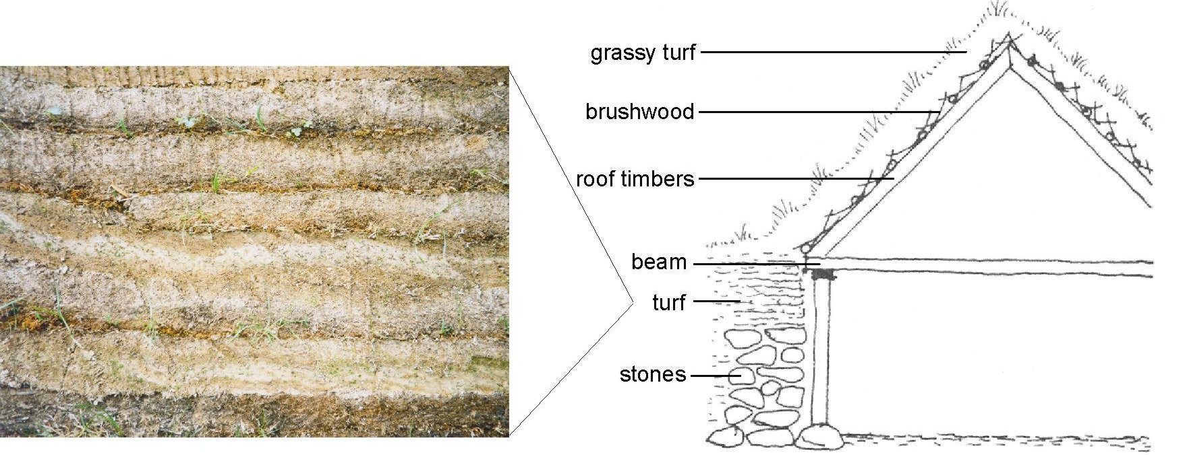

Figure 2.5 Schematic section of the kitchen at Þverá, showing the construction of the walls and roof (from Olesen & Kjær 1972, 35), and a close-up of a turf wall (left). The stripy aspect of the wall was produced by the redistribution of iron as the turf dried out.

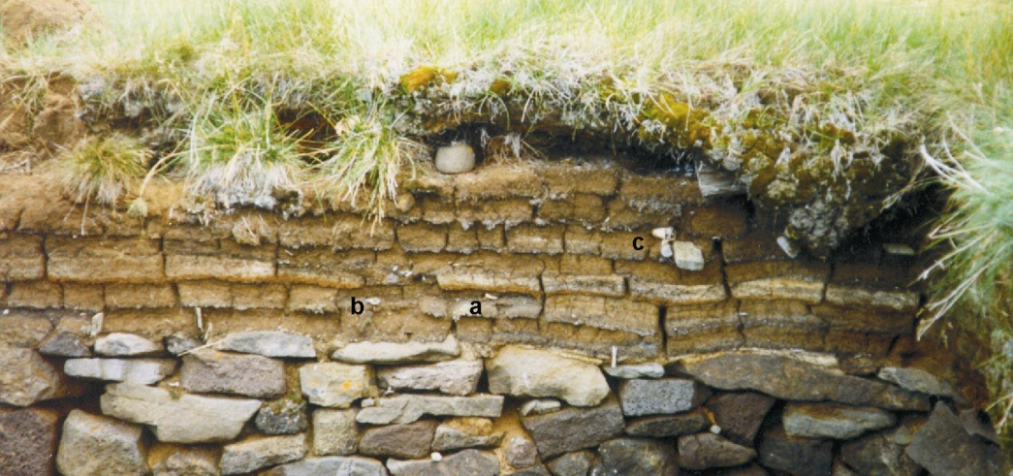 | Figure 2.10 Inner edge of a turf wall in sheephouse 3, the roof of which had collapsed. Note the ceramic fragment (a) and the bone fragments (b, c), which were embedded in the turf when it was cut.
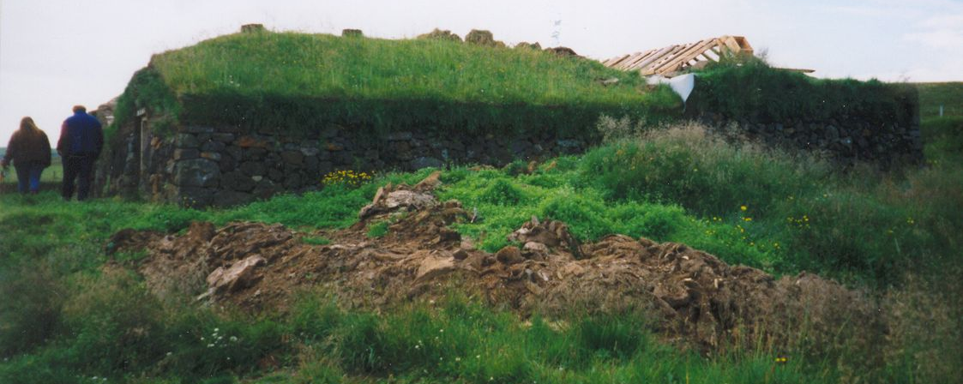 | Figure 2.11 Midden heap containing fragments of turf waste that was produced during the repair of the roof of sheephouse 1.

If the turf was cut near the vicinity of the house, as it was at Þverá, it may contain artefacts and bones that had previously been spread about as a result of waste disposal, manuring, animals, or playful children (McIntosh 1974). This process was indeed active at Thverá and was observed in the form of ceramics and bones that were found embedded in the turf wall of sheephouse 3. This building had been abandoned prior to living memory, and its roof had collapsed, leaving the turf walls standing as an empty shell. Eventually, when these walls collapse, the older, residual artefacts embedded in them will end up in a layer of wall collapse debris above the turf roof collapse and the floor – a warning to archaeologists to avoid using the artefacts found in turf collapse layers for dating purposes.

At Þverá, the main part of the house had two separate roofs, each with its own ridge line (Figure 2.6). The roofs were supported by rows of posts resting on stone post pads positioned along the inner edges of the walls (Figure 2.5). The roof timbers were covered by a mat of birch and willow brushwood, on which were laid long strips of turf (c. 40 x 150 cm) that were pegged down to prevent them from slipping (Figure 2.8). With the grass side of the turf facing upwards, the roof absorbed the rainfall and the grass remained alive and green (Figure 2.7). Gísli Gestsson (1982) noted that the pitch of the roof was normally adjusted according to the amount of rainfall received in a particular area, with a pitch of lower than 45° in drier regions and higher than 45° in rainy areas, where it was advantageous to promote runoff. Nineteenth-century ethnographic sources record that during the hay harvest the grass on the roof was mowed with a scythe (Henderson 1818), and I observed this practice myself in 1998.

As the house at Thverá proves, a well-built, well-maintained turf house could last for over 100 years (Nilsson 1943, 293). However, such longevity required regular repairs to turf walls, which eventually begin to be weathered by repeated cycles of wetting and drying, freezing and thawing, and especially to roof timbers, which succumb to rot and have to be replaced every 10-20 years. At Þverá, when repairs were made to the roof of sheephouse 1 in 1999, the old turf and brushwood that had been stripped from the roof were simply left in a heap next to the building (Figure 2.11). Such heaps of turf waste could be used as manure for the fields, burnt as fuel, used for odd fill-jobs, or left in the turf midden, where they would eventually puzzle future archaeologists. Every time roofs or walls at Thverá were repaired, turf fragments, soil, and bits of brushwood inevitably found their way onto the floors (Áskell Jónasson, pers. comm.). Even if the floors were subsequently swept, these episodes of rapid sedimentation may be detected by high resolution geoarchaeological techniques such as thin section micromorphology.

There were several turf farm buildings at Thverá that had been abandoned during the late nineteenth or early twentieth centuries, and which provided insights into how turf buildings collapse. After abandonment, the first major change to the buildings was the inward collapse of the roof, a process that was sometimes precipitated by the removal of the roof-supporting posts in order to reuse them elsewhere. If the posts were left in place, it could take up to fifty years for the roof to collapse, although this time span could be shorter if the roof timbers were already old and rotting when the building was abandoned. While the roof was still intact, it continued to protect the floor from rain and sunlight, and to prevent plant growth. The eventual collapse of the roof instantly sealed the floor and protected it from major disturbance, but from that point onwards it became subject to soil-formation processes, such as bioturbation by earthworms and plant roots. The roof sometimes collapsed straight downwards, leaving the timber, brushwood, and turf layers that were in the roof in their original stratigraphic position. However, it was more common to observe only parts of the roof collapsing inwards at any one time, leaving fragments of turf, brushwood, and timber dangling from above. If the roof collapsed a little bit at a time, pieces of wood, brushwood, and turf were likely to become inverted and mixed.

Turf walls often remained upstanding for decades after the roof had collapsed, creating a concave ruin that could act as a trap for windblown sand and silt (Figure 2.10, Figure 2.13). Following the collapse of the roof, the upper layer of turf on the walls was exposed to sunlight and rain and was therefore able to begin growing again (Figure 2.10, Figure 2.13). However, the organic matter in the underlying turves gradually decayed, causing them to shrink, and as they were further degraded by repeated cycles of wetting and drying, and freezing and thawing, the walls gradually lost coherence. Stacks of turf on either the inner or outer faces sometimes separated from the core of the wall and leaned out at a dramatic angle, eventually tumbling under the weight of gravity (e.g. the back wall of the skemma in Figure 2.13). The edges of the wall could also slump and ‘melt’ outwards, leaving only the core in situ (Figure 2.14). The degradation of their outer skin made the turf walls vulnerable to wind erosion and to abrasion by sheep, which sometimes used them as wind shelters. The erosion face pictured in Figure 2.14 still had tell-tale balls of sheep wool adhering to it.

Spatial Organisation and Floor Formation at Þverá

The house at Thverá faces east, towards the Laxá river, and its back rooms are set slightly into an east-facing slope. The original floor surfaces in the house rested partly on natural soil and partly on the older building remains and occupation debris that made up the farm mound.

The house is of the ‘passage house’ type (Icelandic gangabærinn), a form that developed in Iceland in the fourteenth century and which was named after the central passageway (göng) that gave access to the main rooms of the house (Ágústsson 1987). During the 110 years that it was in use the house underwent several alterations and additions, and as new materials became available in the twentieth century they were incorporated into the structure. The front rooms, which included a front parlour, an entrance room, a guest bedroom, and a separate smithy, were constructed later than the rest of the house, in the 1870s, and followed the late nineteenth-century fashion of having front-facing gables constructed of wooden planks (Figure 2.4). These front rooms also differed in other ways from the older part of the house: the roofs were covered with corrugated iron instead of turf, and the ‘good’ rooms (i.e. parlour and guest room) were floored with well-joined wooden floorboards. Because such structural materials are not analogous to the Viking Age archaeological record, these front rooms were excluded from the geoarchaeological study. The smithy went out of use shortly after 1940, after which it was used as a store room for agricultural implements and riding tack until the roof collapsed. In the course of my investigation I found that the smithy’s earthen floor had been truncated to a level lower than when it was in use, an event that probably occurred when it was rebuilt in c. 1980 and which eliminated the potential of this building for further archaeological study.

The geoarchaeological sampling programme involved the excavation of shallow trenches (c. 20 cm wide and 20 cm deep) in all of the main rooms and corridors of the house and sheephouse 2, in order to expose the floors in section and to facilitate the extraction of vertically oriented micromorphology samples (Table 2.1, Figure 2.15). Bulk sediment samples were also taken from each of the layers visible in section in order to ensure that sediment was available in case supplementary analyses were required. However, it was not possible to take bulk samples on a systematic grid, since I did not have permission to excavate the interior of the house in full. The micromorphology samples were processed at the McBurney Geoarchaeology Laboratory, University of Cambridge, using the methods described in Appendix 2.

Table 2.1 Micromorphology samples taken at Þverá. Samples discussed in this chapter and described in Appendix 3, Table A3.4, are highlighted in bold.
Sample | Location | Field Description of the Floor Sediments (from top to bottom)
ÞVR97-1-3 | Kitchen  Profile A-B | 7.5 YR 3/2 very dark brown humose loam (degraded turf).  5 YR 2.5/1 black organic loam and ash containing small bone fragments, charred organic material, and a few larger inclusions such as ceramic fragments.  10 YR 4/2 dark greyish brown and 7.5 YR 4/6 strong brown silt (peat ash).  10 YR 2/2 very dark brown organic loam.
ÞVR97-4 | Kitchen  Profile C-D | 7.5 YR 3/3 dark brown humose loam (degraded turf).  10 YR 4/1 dark grey ash and charcoal.
ÞVR97-5 | Byre feeding bench  Profile E-F | 10 YR 3/3 dark brown peaty turf.
ÞVR97-6 | Byre stall  (below floor boards)  Profile E-F | 10 YR 3/3 dark brown peaty turf.  10 YR 3/1 coarse sand.
ÞVR98-1-3 | Fuel storage area  Profile K-L | 10 YR 2/2 very dark brown peaty, organic loam (degraded turf) containing lenses of black organic silt loam.  10 YR 2/2-2/1 very dark brown and black organic silt loam.  7.5 YR 3/4 dark brown sandy silt loam.
ÞVR98-6-7 | Main corridor  Profile M-N | 10 YR 2/2 very dark brown, compact silt loam.  10 YR 2/2-2/1 black, compact silt loam.  7.4 YR 3/3 dark brown, compact sandy silt loam.  10 YR 2.5/1 black, compact organic loam.  7.5 YR 2.5/2-4/4 very dark brown organic loam.
ÞVR98-10-12 | Bedroom  (below floor boards)  Profile O-P | 10 YR 4/2 dark greyish brown sandy loam.  10 YR 3/4 dark yellowish brown sandy silt loam.
ÞVR98-14-18 | Byre threshold  Profile G-H | 10 YR 2/2-2/1 very compact black organic silt loam.  10 YR 2/2 very dark brown, very compact, very organic silt loam.  10 YR 2/1 black sandy silt loam with lenses of pink, grey and brown silt (possibly ash).
ÞVR98-23 | Byre floor  Profile I-J | 10 YR 2/2 very dark brown, very compact organic silt loam (turf).  10 YR 2/1 black, very compact organic clayey silt.  10 YR 2/1 mixed black, dark grey and light grey, very compact silty sand (ash).  10 YR 2/1 and 2/2 mixed black and very dark brown, very compact silt loam.
ÞVR98-26-27 | Inner pantry  Profile Q-R | 7.5 YR 3/4 dark brown, loose peaty turf.  7.5 YR 4/6 strong brown, compact sandy silt with white flecks.  7.5 YR 3/4 dark brown peaty turf.
ÞVR98-30-31 | Outer pantry  Profile S-T | 10 YR 3/1 very dark grey peaty turf.  10 YR 3/1 very dark grey sandy loam.  7.5 YR 2.5/3 very dark brown peaty turf.
ÞVR98-34 | Smithy  Profile U-V | 7.5 YR 2.5/2 very dark brown peaty turf.  7.5 YR 3/1 very dark grey sandy silt.  7.5 YR 3/4 dark brown organic silty clay.
ÞVR99-1-6 | Sheephouse interior  Profile W-X | 10 YR 2/2 very dark brown peaty.  10 YR 3/1 very dark grey peaty.  Finely laminated 10 YR 2/2 very dark brown and 7.5 YR 3/3 dark brown, very organic silt and clay.
ÞVR99-11-15 | Sheephouse  threshold  Profile Y-Z | 10 YR 3/4 dark yellowish brown, loose, peaty.  10 YR 2/2 very dark brown organic clayey silt.  Mixed 10 YR 2/2 very dark brown and 10 YR 3/1 very dark grey clayey silt.

The following sections contain a brief description of each room, its function, and the cultural practices associated with it as described by Áskell Jónasson. The floor sediments themselves are then described as they appeared in the field and in thin section, and their correspondence with the known formation processes is discussed in order to assess the degree to which the cultural practices were archaeologically visible. Only the relevant micromorphological characteristics are discussed here; more detailed descriptions of the thin sections can be found in Appendix 3, Table A3.4.

Front Rooms

As mentioned above, the front rooms were added to the house in the 1870s. The front door opens into an entrance room (bæjardyr), which gives direct access to the ‘good’ rooms of the house: a sitting room (south parlour) on the left, and guest room (north parlour) on the right. This organisation allowed a guest to be entertained and accommodated without giving them access to the simpler quarters in the main part of the house. Above both of the parlours were lofts, which were accessed by ladders from the entrance room. These were used as extra work spaces and sleeping areas. Behind these ladders were small spaces that had been used as storage areas; an outside entrance had been added to the southern storage area at a later date (Figure 2.15). Because the front parlours were floored with well-joined timber boards, they were not included in the archaeological investigation.

The floor of the entrance room was a very ‘hard-trodden earth floor’ (harðtroðið moldargólf), which had been subjected to heavy foot traffic and wear, particularly in front of the door. In front of the door it had also frequently become damp, which brought the sediment closer to its plastic limit (i.e. the point at which the water content made it mouldable) and facilitated its compaction. Áskell Jónasson informed me that if the floors in the entrance room became too wet, ash was sprinkled over them in order to absorb the water and to dry them out. If the floors became worn and uneven, the depressions were sometimes filled using a mixture of soil and ash, and it was also customary to cover the floors of the entrance room with fresh turf on a yearly basis. Sometimes the old turf was spaded out first in order to prepare the floor surface for the fresh turf.

Central Corridor

Beyond the entrance hall there is a 1 m-wide corridor (göng) that gives access to the main part of the house (Figure 2.15). The central part of this corridor is very ‘hard-trodden’ and compact, but along the walls, out of reach of foot traffic, loose sediment had accumulated (Figure 2.16). Like the entrance room, the heavy traffic in the corridor made it prone to wear. Áskell Jónasson informed me that depressions were sometimes repaired with a mixture of soil and ash and that the floors were covered with a fresh layer of turf every year.

In section, the central, trampled part of the floor was marked by a concave depression that had been filled with fine, compact layers of alternating dark brown and brown silt loam (Figure 2.17). Adjacent to the edges of the stone walls, the original ground surface was unaltered. In thin section (sample ÞVR98-6), it was possible to see that all the layers were composed of turf – that is, the A horizon of an Andosol, containing an abundance of partially decomposed plant fragments. The uppermost 2 cm, which contained the clean, fresh turf that had been laid in the corridor prior to opening the house to the public, had lost the granular or subangular blocky microstructure of natural turf and was so compacted that its microstructure had become massive (no porosity). The brown and dark brown layers of the nineteenth- and early twentieth-century floors were clearly visible in thin section; in fact, the lowermost dark brown layer resolved into two discrete layers, which were separated by another lighter brown one. The lighter brown layers consisted of ‘clean’ turf and contained only the occasional charcoal fragment. The darker brown layers, on the other hand, were heavily stained with dark brown organic pigment and contained highly fragmented charcoal (c. 10%), nodules of heat-oxidised iron (5%), and rare pieces of burnt and unburnt bone, all under 2 mm in size (Figure 2.18). The lighter and darker brown layers also had differing microstructures, with the lower parts of the ‘clean’ turf layers preserving the original subangular blocky structure of the turf and the ‘dirty’ turf layers exhibiting either a prismatic or a platy structure – a good indicator that they were compacted by trampling (Bresson & Zambaux 1990; Courty et al. 1994, 259; Davidson et al. 1992, 62; Gé et al. 1993; Rentzel & Narten 2000).

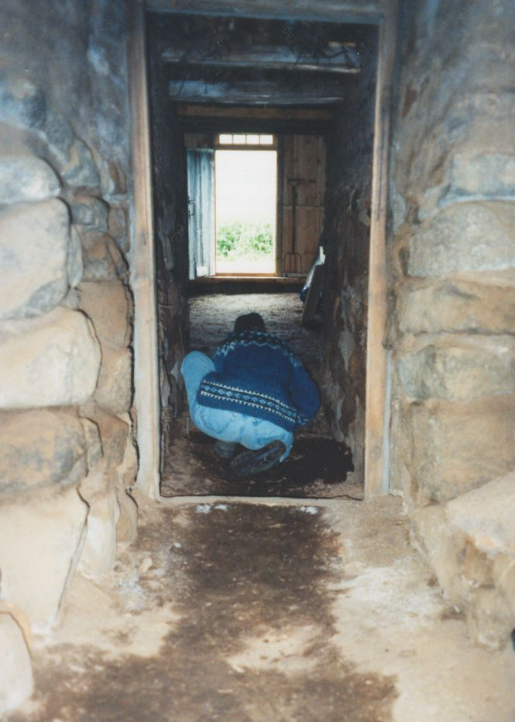 | Figure 2.16 The main corridor (göng) at Þverá, facing east towards the front entrance, being sampled for micromorphological analysis. Note that in the central part of the corridor, which receives heavy foot traffic, the floor is moist and compact, while loose, dry sediment has accumulated along the edges of the walls.
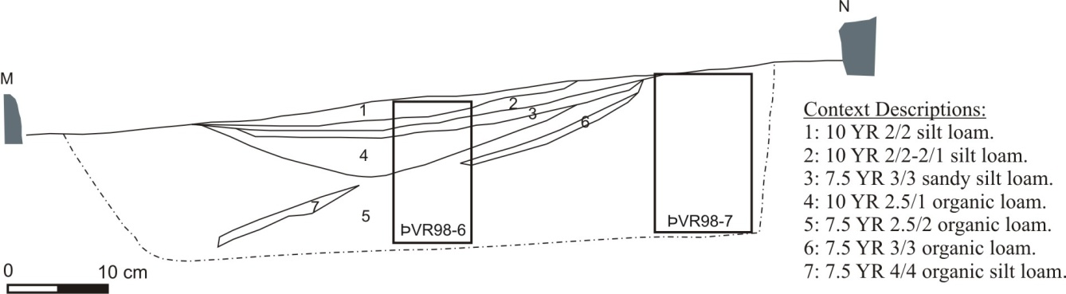
Figure 2.17 Section drawing of the floor in the main corridor of the house (Section M-N).

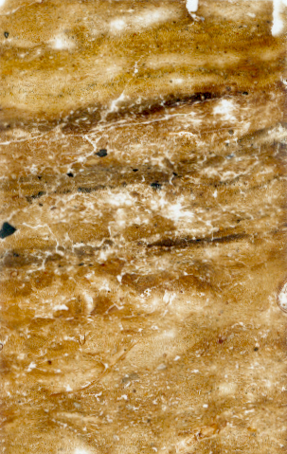  ÞVR98-6 (PPL)  1 cm  original soil  turf  turf  turf  floor surface  floor surface  200 µm  floor surface |  | 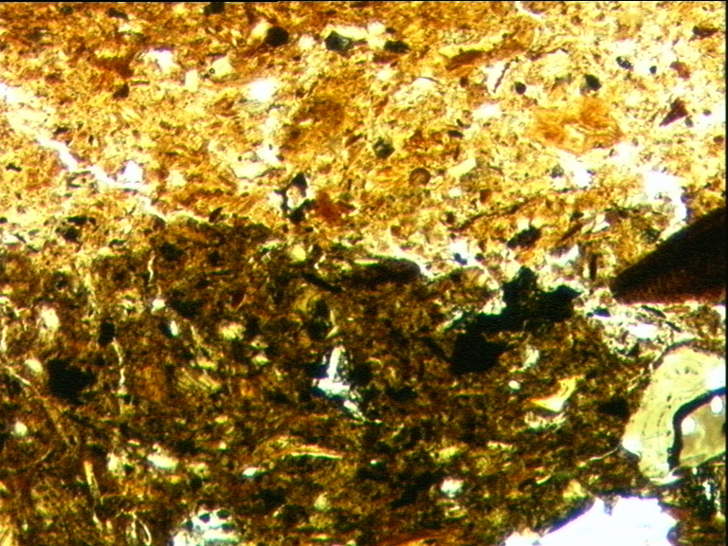
Figure 2.18 Thin section ÞVR98-6, from the centre of the corridor floor, and a close up of the boundary between a ‘dirty’, trampled floor surface and the clean turf that had been laid on top of it.
There was a very close correspondence between the characteristics of the floor sediments in the corridor and the cultural practices discussed by Áskell Jónasson. The dark brown layers were trampled surfaces, while the clean turf layers between them were created when the fresh turf was laid on the floor in order to fill the depression caused by compaction and wear. It is interesting to note that only three trampled surfaces and two fresh turf layers were preserved, which indicates that the floor has been truncated. This may have occurred through repeated wearing down by trampling or during a repair episode, when the old floor deposits were spaded out. The convex depression in the central part of the floor indicates, however, that wear by trampling probably played the most important role in the truncation of the floor deposit. In the past, heavily trampled floors are also likely to have been truncated in this way, which means that the depth of the floor sediment and the number of discrete, trampled surfaces cannot be used to estimate the rate or duration of floor formation.

Kitchen

To the right of the main corridor is the kitchen (eldhús, literally ‘fire room’). This had been dubbed the ‘old kitchen’ because in 1880 the family had created a ‘new kitchen’ by removing part of a turf wall adjacent to the pantry and installing an iron stove (Figure 2.15). While Áskell had lived in the house, the old kitchen was primarily used for food storage and preparation, and the old hearths were mainly used for doing the washing and for making special foodstuffs, such as blood pudding. Food was not consumed in the kitchen, but in the sitting/sleeping room (baðstofa), at the back of the house, as was common practice throughout Iceland and the Faeroe Islands in the nineteenth and early twentieth centuries.

The old kitchen is entered through a wooden door in a wooden partition wall that rests on a row of stones on the edge of the corridor. These stones act as a threshold, and one must step over the stones, and stoop through the door frame in order to enter the room. There is a central, open, stone hearth (hlóðir), raised by stones up above the ground, as well as a second one that was built next to it later, against the west wall (see Figure 2.19). Ash was stored in a receptacle between the hearths until it was needed to maintain the floors or to fertilise the fields. At the back of the hearth is a low stone wall that separates the fire from the fuel storage area at the far end of the room. All the furnishings that used to line the walls of the kitchen were portable and have been removed. Along the western wall there had stood two or three barrels containing foodstuffs preserved in whey, and along the eastern wall there had been a low wooden platform, on which had stood the butter churn and a washing basin, as well as a bench between two posts. From the rafters of this room meat and fish had been hung and were gradually smoked, for there was no chimney or other hole through which smoke could escape. From the middle of the western wall stretches another corridor that leads to the cattle byre and the cool milk store at the back of the house (Figure 2.15).

Since the walls were lined with furnishings, foot traffic was restricted to the centre of the room, and these floors are purported to have been swept daily. If part of the floor became worn, malodorous, or wet (e.g. due to a spill or a leak in the roof) ash was deposited on it and stamped down, and the floor was swept over. The floor thus became covered with ash deposits of uneven thickness. When this steadily accruing floor surface eventually caused the roof to become uncomfortably low, it was shovelled out, and the sediment was used to fertilise the fields.

Two sampling trenches were placed in the kitchen, one directly in front of the hearth, and one that extended from the middle of the floor to the western wall. In section, the kitchen floor was characterised by layers of pink to grey ash and black charcoal, which covered an undulating soil surface (Figure 2.21). At 30-40 cm from the western wall, the black charcoal-rich layer contained several large pieces of ceramic from a single plate (up to 5 cm in size) that had either broken in situ or had been swept there. Towards the centre of the floor the black charcoal layer was up to 5 cm thick, but it thinned out at c. 20 cm from the western wall, and the underlying soil surface took on a more greyish-brown aspect. In front of the hearth the floor sediment was rich in ash and large pieces of charcoal (up to 2 cm in size), and it capped a flagstone that must have been exposed when the hearth was first built.

In thin section the black charcoal layer in the middle of the floor was seen to consist of pure coal ash, and the pink to grey layer below it was made up of pure peat ash. Below them was a 1-cm-thick brown layer that had not been distinguished in the field: an organic silt loam, stained brown with organic pigment, containing nodules of heat-oxidised iron, burnt tephra grains, and the occasional fragment of burnt bone (<1.1 mm). This layer originally had a well-developed platy microstructure, but 75% of it had been reworked by soil fauna (Figure 2.20). In front of the hearth, the floor sediment that had accumulated over the flagstone was characterised by abundant coal ash, wood charcoal, and calcitic wood ash, as well as frequent heat-oxidised iron nodules and occasional fragments of burnt and unburnt bone. Like the other central parts of the kitchen floor, this layer has a well-developed platy structure due to being compacted by trampling.

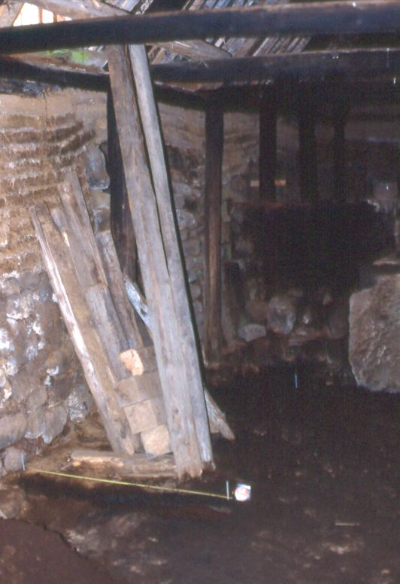 | 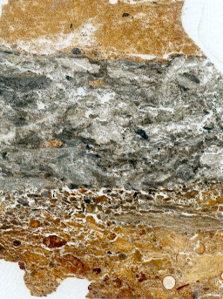  original soil  coal ash  organic silt loam  peat ash  turf  1 cm
Figure 2.19 The kitchen at Þverá, from the door, facing northwest towards the hearths. Sampling trench A-B is in the foreground. | Figure 2.20 Thin section ÞVR97-2, from the kitchen floor, showing the thick coal ash layer, and underlying trampled and bioturbated floor surface.
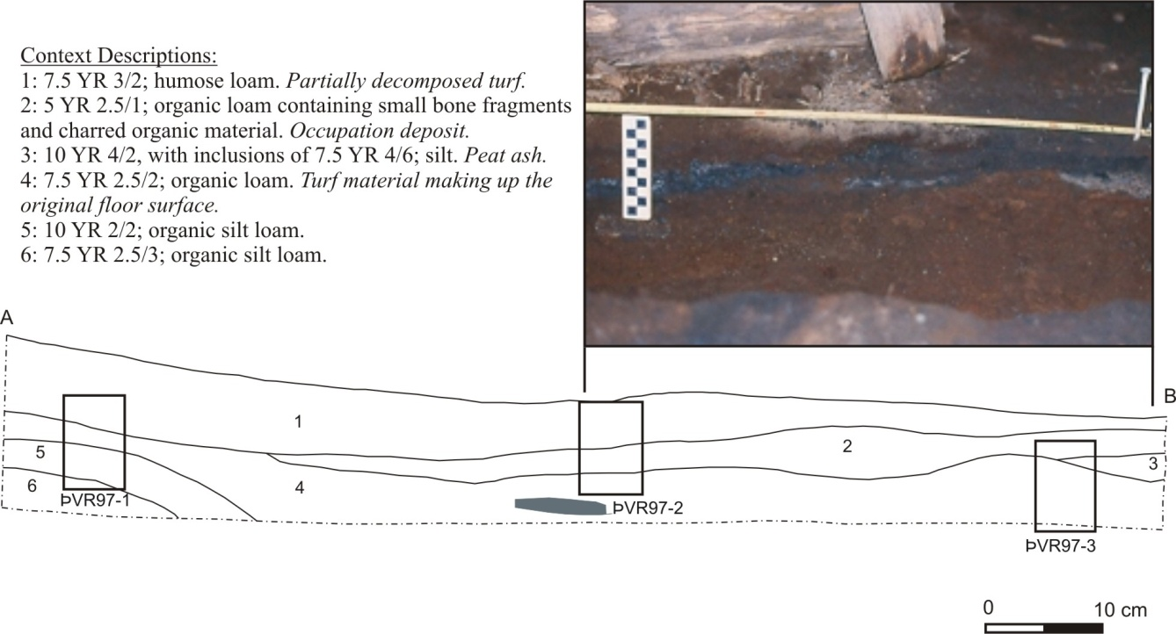
Figure 2.21 Photograph and section drawing of the ashy kitchen floor (Section A-B).

The sedimentary characteristics of the kitchen floor corresponded very closely to the formation processes described by my informant. The well-developed platy microstructures are typical of compacted and trampled surfaces (Davidson et al. 1992), and various hearth residues – including burnt bone and highly-oxidised iron nodules from peat/turf ash – have been embedded into the organic-stained, trampled surface. The layers of pure ash could only have been deposited in extremely rapid or instantaneous dumping events, of the kind described by my informant, when the floor had become wet or uneven, and was in need of repair.

Fuel Storage Area

Behind the hearths and the low stone wall, there is a space at the back of the kitchen that was used for the storage of fuel, including sheep dung, peat, brushwood, and, after 1880, coal. A small hatch had been installed in the roof in order to enable fuel to be dropped in more easily. As in other parts of the house, ash was sprinkled on the floors of this area if they became wet or worn.

The sampling trench, which stretched from the middle of the floor to the western wall, did not show any clear floor layers in the field (Figure 2.22). In thin section, however, it was possible to see that the uppermost sediment horizons in the middle of the storage area contained a moderately- to well-developed platy microstructure – good evidence of compaction by trampling. It was also possible to identify the residues of the fuels that had been stored in this area. These included a lens of fine coal fragments, fresh wood fragments, an aggregate of herbivore dung, which contained abundant faecal spherulites, and lenses of peat, which contained horizontally bedded phytoliths (see Figure 2.23). It is notable that the thin section taken adjacent to the west wall (ÞVR98-1) did not exhibit any structural indicators of trampling and also contained coal fragments up to 8 mm in size, while all the coal fragments in the sample taken from the middle of the room were below 2 mm in size. This size sorting is probably a product of the ‘edge effect’ noted by several ethnoarchaeologists, in which larger objects tend to be kicked out of areas of heavy foot traffic, and accumulate on the edges of the trampled areas (e.g. Wilk & Schiffer 1979, 533).
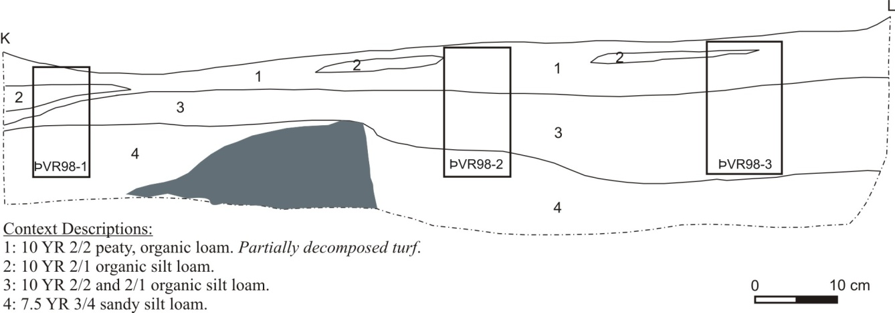

Figure 2.22 Section drawing of the floor in the fuel storage area (Section K-L).

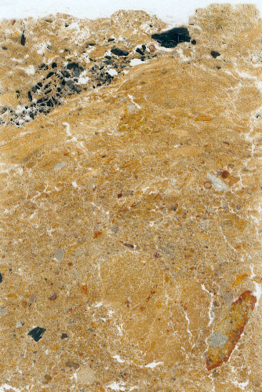  (PPL)  200 µm  a  1 cm  ÞVR98-1 | 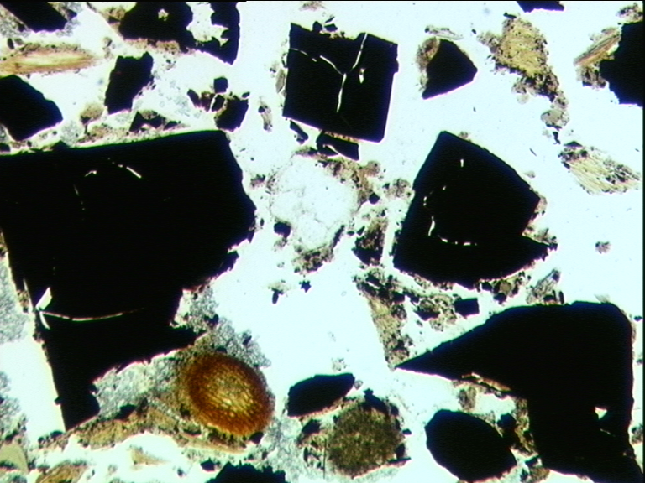
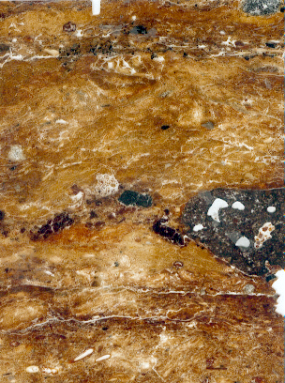  b  1 cm  ÞVR98-3 | 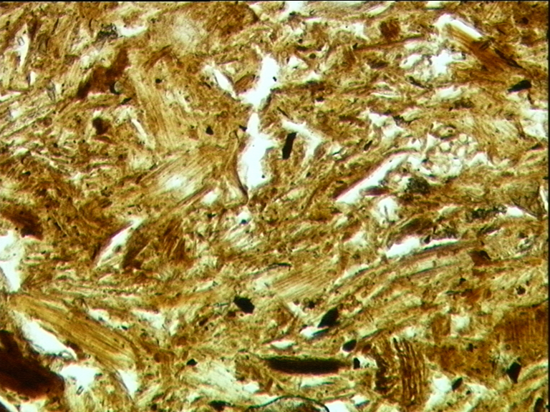  100 µm  (PPL)
Figure 2.23 Thin sections ÞVR98-1 and ÞVR98-3, from the fuel storage area, and micrographs showing some of the fuel residues: (a) coal; (b) herbivore dung, which contained chopped plant tissues and which was identical to reference samples from the cattle byre and sheephouse.
Pantry

To the left of the main corridor is the pantry (búr), which is entered through a wooden partition wall resting on a row of stones. Like the entrance to the kitchen, these stones act as a threshold, and one must step over the stones and stoop through the door frame in order to enter the room (Figure 2.24). There was once a wooden partition wall in the middle of the pantry, but only its foundation stones remain (see Figure 2.15). The inner pantry (innra búr), the room furthest from the door, was used for storing the butter churn and different foodstuffs, most of which were contained in barrels. The outer pantry (fremra búr) was used more as a work area; the milk separator was kept in this room, on a bench near the partition wall. As in other parts of the house, the floors of the pantry were treated with ashes if they became wet, malodorous, worn, or uneven, and were shovelled out onto the fields when they became too thick. In addition, the floors were sometimes covered with fresh turf, although Áskell did not remember this being done as often in the pantry as in the corridor and entrance room.

Sampling trenches were opened both to the north and to the south of the former partition wall. In section, the floors were characterised by fine brown, reddish brown, and dark brown peaty turf (organic silt loam) layers, which interdigitated with uneven and discontinuous layers of ash and charcoal (Figure 2.25). In thin section (sample ÞVR98-26), the dark brown silt loam layers of the outer pantry contained organic pigmentation, an abundance of silt-sized organic residues, highly fragmented charcoal and coal (<1.5 mm), horizontally oriented plant tissues and amorphous organic matter, occasional fragments of burnt bone (<2 mm) and heat-oxidised iron nodules, and one nut shell fragment. This layer had a very well-developed platy structure, and was undoubtedly a trampled occupation surface (Figure 2.26). At the bottom of this trampled surface there was a layer of large charcoal fragments up to 1.5 mm in size, which must have been intentionally dumped. The trampled floor layer was capped by two layers of very peaty turf, which were distinguished by a sharp boundary and an abundance of red oxidised iron in the lower turf layer. These turf layers had clearly been intentionally laid and can be associated with the practice of periodic turf deposition that was described by Áskell.

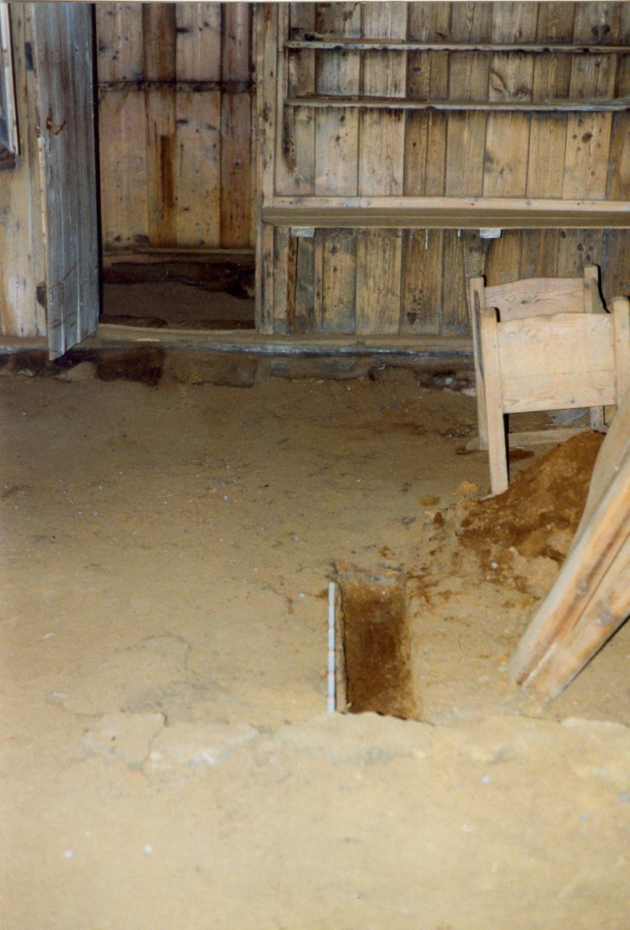 | Figure 2.24 Photograph of the outer pantry (búr), facing north, showing the door and its stone threshold. In the foreground is the line of stones that had been the foundations for a wooden partition wall.
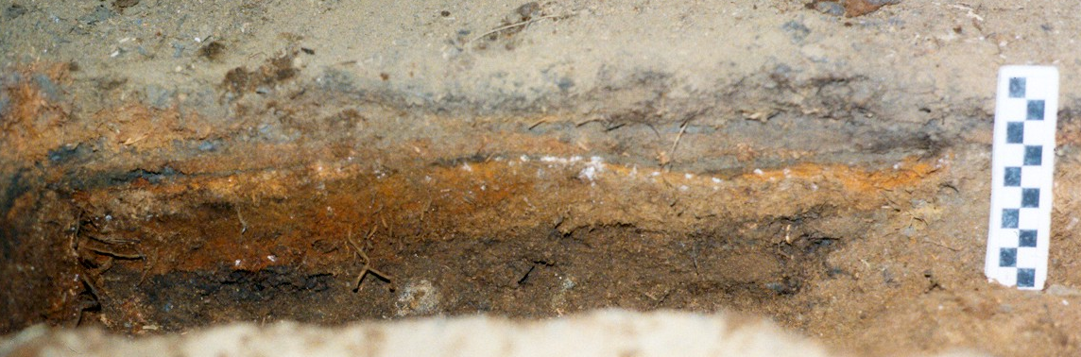
Figure 2.25 Section through the floor in the outer pantry, showing the interdigitating layers of turf and ash.
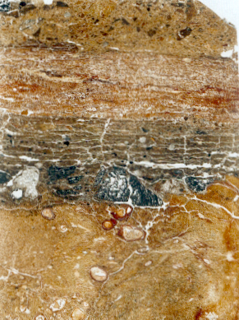  ÞVR98-26 (PPL)  1 cm  ch  pl  b  200 µm | 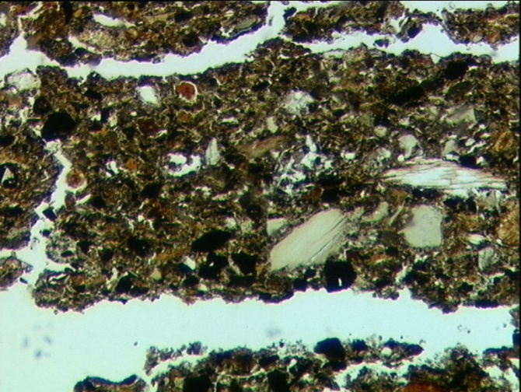
Figure 2.26 Thin section ÞVR98-26, from the outer pantry, and a micrograph of the trampled floor surface. Note the platy structure, bone fragment (b), plant tissue (pl), and charcoal fragments (ch).
In the inner pantry (sample ÞVR98-30), two floor surfaces separated by a layer of ‘clean’ turf were distinguished. These were very similar to the trampled floor surface in the outer pantry, except that the lower layer had been heavily reworked by soil fauna and its original platy structure only survived in its lowermost part. There was also a fine lens of waterlain silt and clay at the bottom of this layer, which was not observed elsewhere in the house. The floor surfaces were capped by two distinct layers of turf, which were separated by a sharp boundary. At this boundary, there was a small aggregate (5 mm) of organic silt loam identical to the floor layers, which appeared to be a sliver of a truncated floor surface (Appendix 3, Table A3.4, p. 350). There is therefore extremely good correspondence between the micromorphological characteristics of the floor sediments and the information provided by Áskell; namely, that fresh floor surfaces of clean turf were occasionally laid and that the floors were shovelled out when they became too thick.

Back Rooms for Sitting, Sleeping, and Storage

The part of the house that was used for sitting and sleeping is at the end of the main corridor, up a short flight of steps. This area has wooden floor boards as well as panelling covering the turf walls. Two wooden partition walls divide the area into three rooms: a sitting/sleeping room (baðstofa) in the centre, a bedroom on the south side, and a small storage room on the north side. The floorboards are not joined as well as those in the front parlours, and the gaps between them are up to 2 mm wide. According to Áskell, they had been cleaned by scrubbing them with sand, and when the sediment below them was examined, it was clear that the gaps between the floorboards had permitted some sand to filter through them and to accumulate below (Figure 2.27).

Cattle Byre

From the kitchen, a passageway leads to the cattle byre (fjós) and the cool milk storage area at the back of the house (Figure 2.15). The cattle byre has stalls (bás) for four cows and used to have room for a fifth, but one stall had to be removed in c. 1900 to make way for the thick turf wall that replaced the wooden partition wall between the byre and the passageway. Against the eastern wall there is a feeding trough that was built of turf and lined with wood, and in the middle of the byre there is a stone-lined channel (flór) for the collection of dung and urine. Where this ditch met the north wall of the byre a stone could be removed in order to make it easier to shovel out the dung (Figure 2.28). The floors of the stalls are currently covered with wooden floorboards, but when Áskell was a child they had been covered with flag stones at the front and turf at the back. Like the turf floor coverings in the main part of the house, the turf bedding in the cattle byre could be easily cleaned out and replaced. The floors and dung channel had been regularly sprinkled with ash in order to absorb moisture and to mask odours.

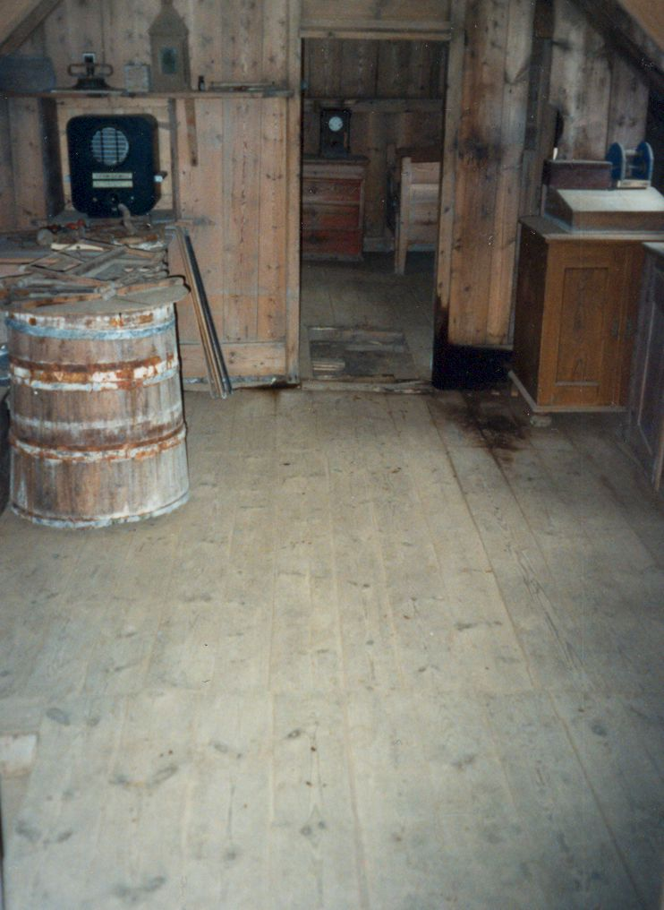 | 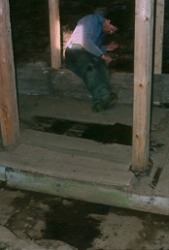
Figure 2.27 The sitting/sleeping room, facing south into the bedroom. Loose sand was found in the cavity below the floorboards. | Figure 2.28 The cattle byre, facing northeast, showing the stalls, feeding trough, and dung channel being sampled.

The sampling trench that was placed in the part of the byre not covered with floor boards (profile I-J) revealed a floor composed of highly compacted, multi-layered, silty organic sediment, which came away in hard, thin, platy aggregates during excavation. A well-developed platy microstructure and localised massive microstructure was also observed in the thin section taken from this profile, ÞVR98-23. Experiments have shown that such structures are created by heavy compaction under moist conditions (Bresson & Zambaux 1990), as may be expected in a cattle byre. The fine layers observed in thin section were composed of dung, long strands of partially decomposed plant tissue (hay), coal ash, peat ash, and very dark brown, organic silt loams composed of mixtures of the above (Figure 2.29). Rare fragments (<1%) of burnt and unburnt bone were found associated with the ash layers and the mixed, loamy layers, and had clearly entered the deposit along with the ash.

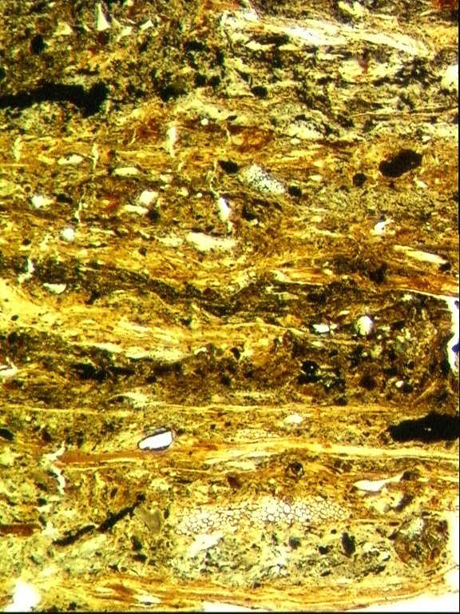  plant & coal  plant  plant  200 µm  plant & coal  dung/plant  plant & coal  plant  coal & plant  coal & plant  dung/plant  dung/plant  coal ash  coal ash  200 µm  ÞVR98-23 (PPL) | 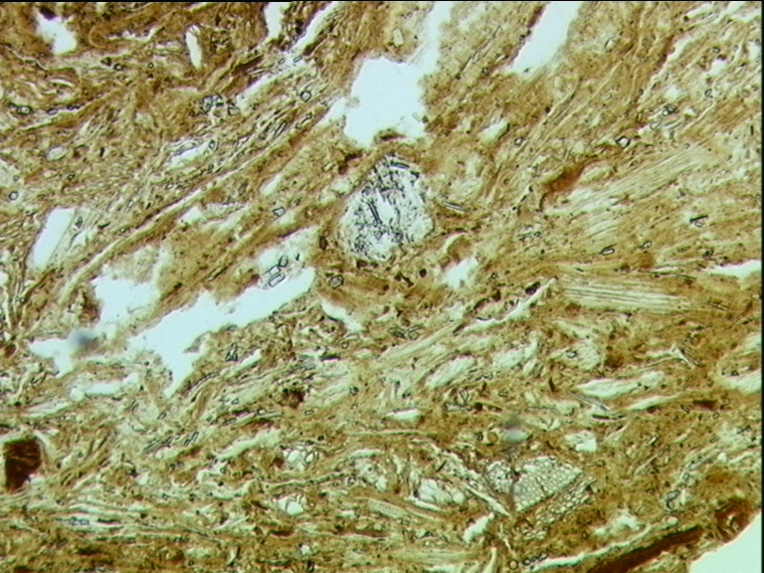  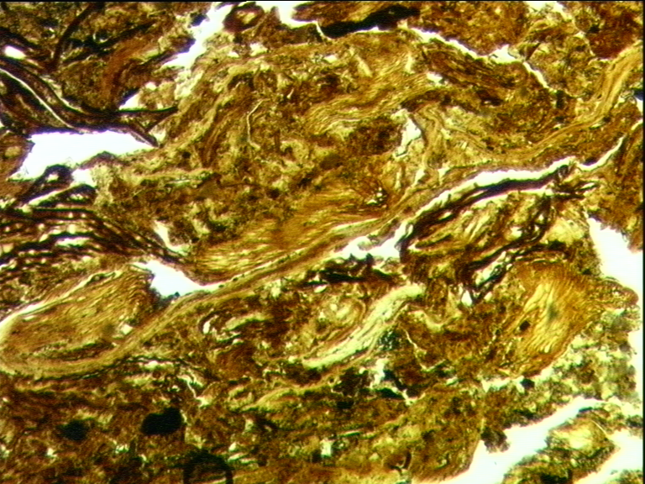  ÞVR98-23 (PPL)
Figure 2.29 Horizontal bedding of dung, herbaceous plant, and coal ash in the cattle byre. | Figure 2.30 Examples of dung lenses in the cattle byre; they consist of chopped plant tissues.
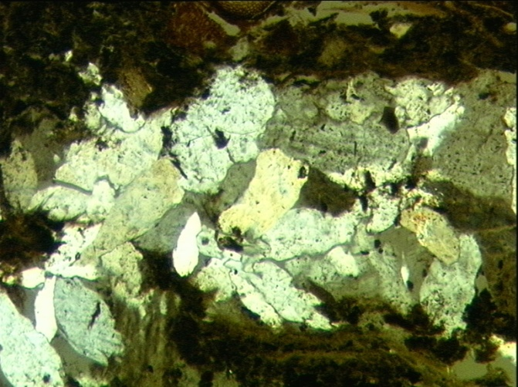  ÞVR98-23 (partial XPL)  ÞVR98-23 (partial XPL)  s  b  ca  200 µm  200 µm | 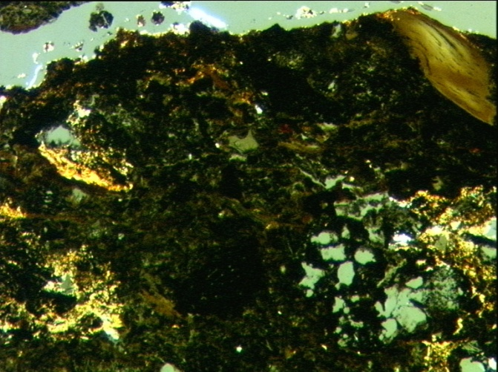
Figure 2.31 Hypidiotopic gypsum infilling of a planar void at the bottom of the byre sequence. | Figure 2.32 Micritic calcium carbonate coatings and crystal intergrowths (ca) in a lens dominated by coal ash and amorphous organic matter. Note also the bone fragment (b) and the vesicular globule of non-metallurgical slag (s).

Discrete dung lenses were readily identifiable and consisted of herbaceous plant tissues and associated phytoliths embedded in amorphous organic matter (Figure 2.30). The plant tissues varied in length, but had a distinct, ‘chopped’ appearance, often with broken, squared ends. The shorter plant tissues were randomly oriented, but longer strands were predominantly horizontally or sub-horizontally aligned, a pattern that has been observed in other modern reference samples of cattle dung (see Appendix 3, Table A3.3). Hay layers consisted of long strands of horizontally bedded plant tissues and associated phytoliths embedded in amorphous organic matter, and in certain heavily compacted layers it was difficult to tell if the horizontally bedded plant matter was derived from cattle dung, hay, or a combination of the two (a difficulty also noted by Heathcote 2004).

Minute calcareous spherulites (monohydrocalcite, CaCO3•H2O), which are often present in cattle dung (Brochier 1996; Canti 1999), were not present in the floor deposits in the cattle byre. It is possible that the cattle did not produce spherulites, but if faecal spherulites had originally been present, they appear not to have survived in the highly organic, acidic environment of the byre, where they would have been frequently doused with liquid excreta. In the middle of the floor sequence there was localised reprecipitation of silt-sized calcium carbonate in the form of coatings around platy peds and intergrowths in the groundmass (Figure 2.32). It is interesting to note that calcium carbonate mobilisation and redistribution has also been observed in modern stabling deposits in England, where faecal spherulites had been expected, but were not observed in thin section (Heathcote 2000, 2004).

At the bottom of the floor sequence in the cattle byre, the long, horizontal planar voids that separated the platy peds were infilled with gypsum (CaS04•2H2O; Figure 2.31). Such crystalline pedofeatures are normally associated with arid conditions and, to my knowledge, this is the first time that they have been observed in stabling deposits in temperate or maritime environments. Like the neo-formed calcium carbonate crystals, these gypsum infillings are likely to derive from calcium mobilised higher up the profile, which was carried downwards by a wetting front. There are abundant sources of calcium in these deposits, including plant matter, ash, and the cattle excreta, which may in fact have originally contained faecal spherulites (Canti 1999; Cook & Heizer 1965). Considering that the byre was roofed and protected from rain, the percolating liquid that caused this downward redistribution of calcium was most likely urine rather than water.
There is very close correspondence between the cultural practices described by Áskell Jónasson and the floor sediment characteristics observed in thin section. The housing and feeding of cattle in this space was evident in the highly compacted lenses of dung and herbaceous plant tissues. In addition, the practice of regularly sprinkling the byre floor with ash in order to absorb moisture and odours resulted in the dung and hay layers being interbedded with lenses of coal and peat ash.

Sheephouse

Sheephouse 2 was built in the early twentieth century, and had not been used regularly for the over-wintering of sheep since the 1950s. During its use, the dung and hay that accumulated on the floor of the sheephouse had been shovelled out and spread over the infield on an annual basis. Áskell Jónasson reported that sometimes ash had been sprinkled over the floor surface in order to make it easier to shovel up the litter that accumulated over the following year. Since its abandonment the building had seen only occasional use, mainly during the lambing season, and it had not been cleaned out.
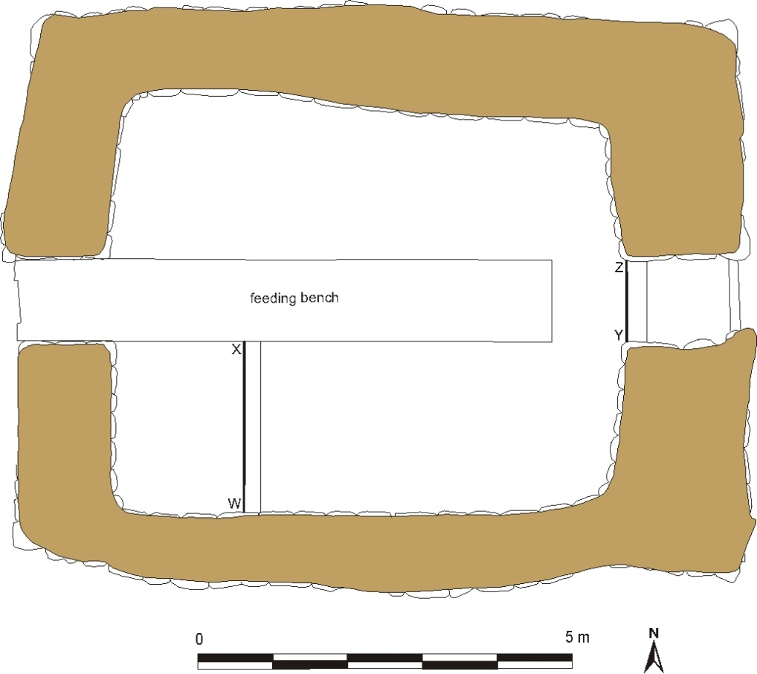

Figure 2.33 Plan of sheephouse 2 with the location of the sampling trenches indicated by the letters W-Z.

The floor of the sheephouse contained a 10-17 cm thick deposit of horizontally bedded dark brown organic matter. This material, which still included visible strands of hay, lifted off in thin plates but was not as compact as the floor layer in the cattle byre. In thin section (ÞVR99-1) this deposit was seen to consist of a sequence of layers of dung and horizontally bedded grass tissues, as well as organic silt loams made up of soil mixed with partially decomposed plant tissues (Figure 2.34). The deposit had a well-developed platy structure, which was probably a result of compaction by the trampling of animals as well as of the desiccation and shrinkage of the horizontally bedded organic matter.

The sequence contained a clear discontinuity, presumably from an episode of cleaning when the floor deposit had been truncated. This discontinuity was marked by a large horizontal planar void, below which the sediment was compacted to a depth of 1-2 mm. The organic sediment below the discontinuity had been subjected to much more reworking by soil fauna than the layers above (50-70% reworked rather than 5-10%), and the faunal channels did not cross the upper boundary of this layer. It would therefore appear to represent an older accumulation of dung and hay, dating to before 1950, when the sheephouse was still in regular use. The discontinuity probably represents the last cleaning episode in the sheephouse before it was abandoned and relegated to only occasional use.

The layers of sheep dung did not contain any faecal spherulites, but were readily identifiable on the basis of their organic composition: short segments of ‘chopped’ plant tissues and associated silica phytoliths, which were randomly oriented and embedded in amorphous organic matter (Figure 2.35). The sheep dung at Thverá therefore bore a close resemblance to other modern analogues of sheep dung observed by myself and other researchers (cf. Appendix 3, Table A3.3, p. 345). As in the cattle byre, the layers that consisted of very long, horizontally bedded plant tissues were easily identified as hay, but the plant tissues in more reworked layers could have been derived from either dung or hay.

A number of unusual crystalline pedofeatures were observed in the sheephouse sediments. A layer of organic silt loam in the middle of the sequence contained several clusters of spherulitic siderite: small crystals, 5-10 µm in diameter, of iron carbonate (FeCO3), which appeared reddish brown in PPL and yellow to orange in XPL due to their iron content, and which have a distinctive extinction cross in XPL due to their spherulitic shape (Figure 2.37). Spherulitic siderite forms in reducing conditions – it is common in bogs, for instance (Landuydt 1990) – and has been found in waterlogged occupation deposits (Gebhardt & Langohr 1996). Its presence in the sheephouse at Thverá indicates that localised reducing conditions occurred in the sealed floor layers, either because they were occasionally saturated by urine, or because bacterial decomposition of the abundant organic matter eventually used up all of the available oxygen.

One localised area in the floor sequence also contained vivianite, a compound of iron and phosphate (Fe3(PO4)2•8H2O) that forms under reducing conditions when there is an abundance of available iron and phosphorus. The vivianite crystals, which had oxidised when the samples were taken, were readily identifiable on the basis of their blue colour and pleochroism in plane-polarised light. They were present in the form of discontinuous hypocoatings around large planar voids and crystal intergrowths in the organic groundmass (Figure 2.36). Because the formation of vivianite depends on an availability of phosphorus, it is not uncommon to find it in bogs. In archaeological contexts it has been observed in waterlogged cess deposits and organic-rich occupation deposits subjected to periodic or prolonged waterlogging (Gebhardt & Langhor 1999; Landuydt 1990; Milek 1996). Its formation in the sheephouse at Thverá is a result of the abundance of phosphate-rich sheep dung and plant matter, and is further evidence that localised reducing conditions occurred in the floor deposits. Since the farm buildings at Thverá are located on a well-drained slope, these reducing conditions must have been created by the build-up of organic matter on the floor of the sheephouse and the input of urine during the winter months when the sheep were housed there.

As in the cattle byre, the flow of liquid through the floors of the sheephouse resulted in the mobilisation of calcium and the localised precipitation of calcium carbonate (CaCO3) in the form of coatings and infillings in voids. In the sheephouse, however, the crystals were not only in the form of micrite, but were sometimes larger, lathe-shaped, and oriented perpendicular to the walls of the voids (Figure 2.38; Figure 2.39). The calcium could have derived from either the plant material in the bedding (i.e. hay) or animal excreta, or both (Cook & Heizer 1965, 19).
Discontinuity  Figures 2.38-3239  Figure 2.37  Figure 2.36  Figure 2.35  100 µm  1 cm | 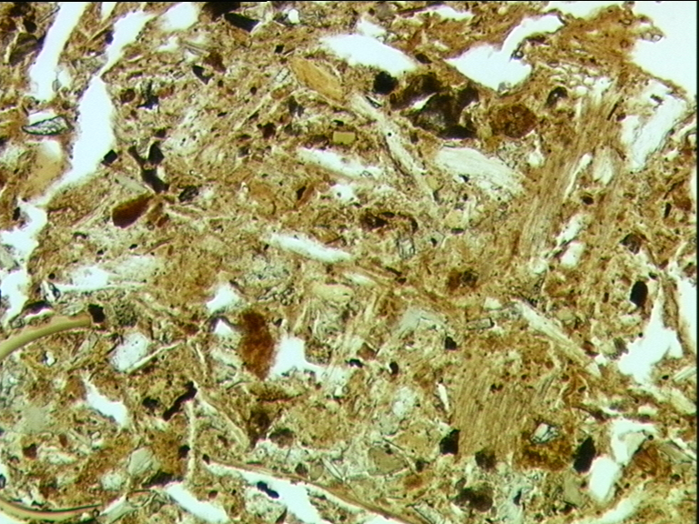  ÞVR99-1 (XPL)
Figure 2.34 Thin section ÞVR99-1, from the floor of the sheephouse. It contains a sequence of dung, hay, and soil deposits. | Figure 2.35 Sheep dung. Note the randomly oriented plant tissues, often truncated, with squared ends, and associated phytoliths.
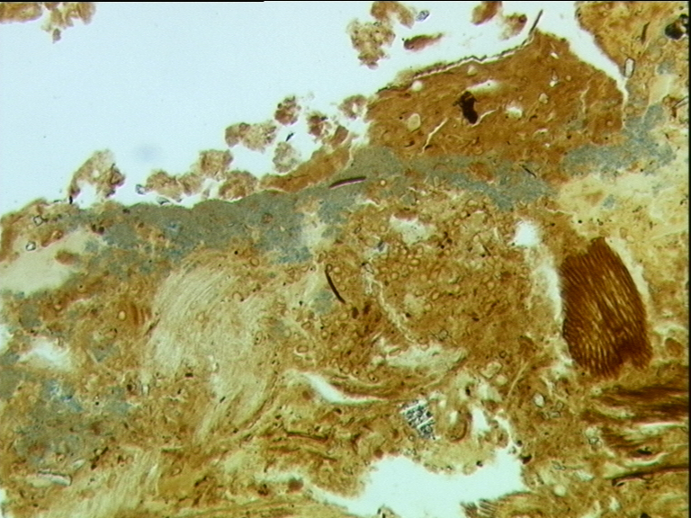  v  v  200 µm  50 µm  ÞVR99-1 (PPL) | 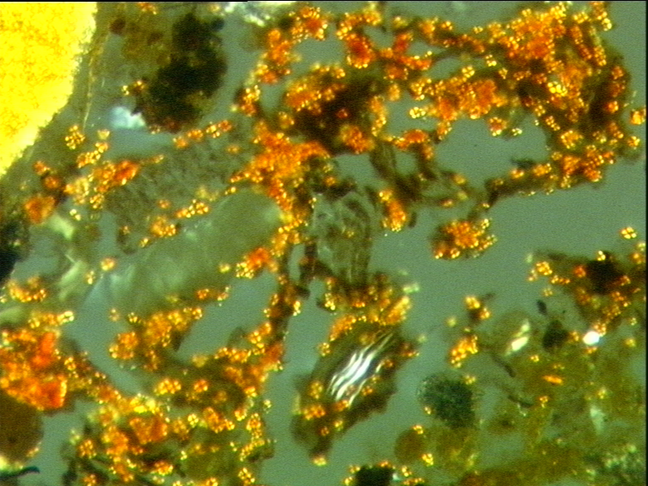  ÞVR99-1 (partial XPL)
Figure 2.36 Hypocoating and intergrowths of vivianite (small blue crystals; labelled ‘v’). | Figure 2.37 Spherulites of siderite.
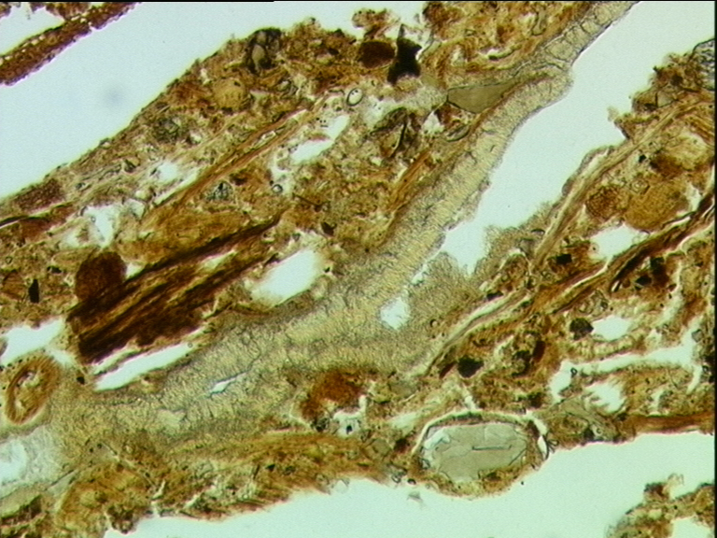  ca  ca  200 µm  200 µm  ÞVR99-1 (PPL) | 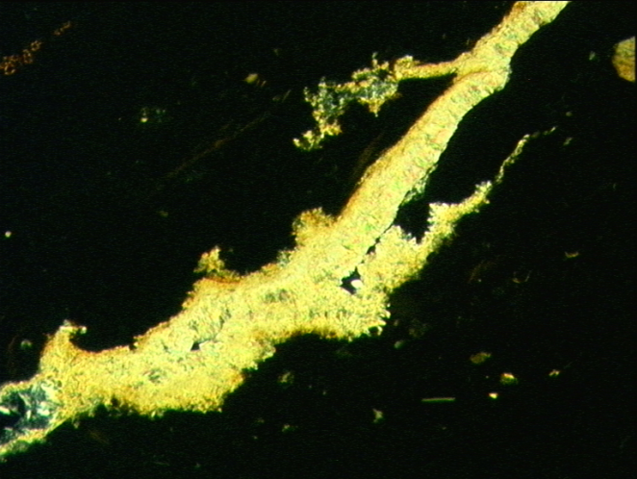  ÞVR99-1 (XPL)
Figure 2.38 Infilling of calcium carbonate. | Figure 2.39 As Figure 2.38, but in XPL.
The floor deposit in the sheephouse was readily distinguishable from the domestic floors in the house. It consisted predominantly of sheep dung and hay, and the abundance of organic matter and liquid excreta had created reducing conditions, which had not been in evidence anywhere within the domestic residence. The practice of shovelling out the floors of the sheephouse on an annual basis prior to its abandonment was also clearly observed in thin section in the form of a sharp discontinuity in the sequence. From the archaeological point of view, this practice meant that most of the material that had accumulated during the life of the sheephouse had been removed, and it would not be possible to judge the longevity of the building on the basis of the thickness of its occupation deposits. In addition, the practice of shovelling out the floors effectively removed all evidence of the ash that had sometimes been sprinkled over the floor after a cleaning episode.

It should also be noted that the organic matter that comprised the floor sediments in the sheephouse was highly palatable to soil fauna and had encouraged post-depositional bioturbation. The lower third of sample ÞVR99-1 in particular (the portion of the sequence below the discontinuity) had been heavily reworked, so that only c. 30% of the original fabric had survived (Figure 2.34). While the pockets of original fabric showed the characteristic horizontal orientation of plant tissues, the reworked groundmass consisted only of organic-rich faunal excrements, in which the original organisation of the sediment had been destroyed. It would therefore be realistic to expect organic-rich sediments in the archaeological record, especially those associated with animal stabling areas, to be reworked by soil fauna. In such cases it would be difficult to distinguish horizontal bedding in the field, and it would probably require a high resolution technique such as thin section micromorphology to identify the original organisation and composition of the sediment.

Discussion
The ethnoarchaeological study at Thverá revealed that a diverse set of activities had affected the ultimate composition and structure of the floor deposits. Table 2.2 summarises these floor formation processes, how frequently they occurred, and where. It also outlines how they were manifest in the sections observed in the field and in the thin sections.

Table 2.2 Summary of floor formation processes at Thverá and their archaeological visibility.
Practice | Frequency and location | Archaeological evidence | Micromorphological evidence
Trampling | • Heaviest: byre, byre passageway  • Very heavy: entrance room, main corridor  • Heavy: centre of kitchen, centre of pantry, sheephouse | • In paths of heavy traffic: sediment very firm and may break into flat, platy peds; concave depressions where the heaviest trampling has compressed and worn the floor; artefacts are highly fragmented  • ‘Edge effect’ against walls and other physical barriers: sediment is loose and artefacts are larger | • In paths of heavy traffic: microstructure platy, prismatic;  organic pigmentation of the groundmass; artefacts are highly fragmented (most <2 mm) and are embedded in the floor sediment  • ‘Edge effect’ against walls and other physical barriers: sediment is loose and most artefacts are >2 mm
Wetting | • Frequently: byre, byre passageway, sheephouse  • Often: entrance room, main corridor  • Periodically: throughout the house, due to roof leaks and spills | • Well-developed platy structure suggests compaction while sediment was moist  • Depletion of iron; formation of iron pedofeatures, such as nodules or pans | • Well-developed platy structure and localised massive structure  • Depletion of iron; formation of iron nodules or pans  • Depletion and redistribution of calcium carbonate; formation of calcareous pedofeatures, such as calcium carbonate and gypsum coatings, infillings, and crystal intergrowths in the groundmass  • Siderite and vivianite formation in the sheephouse suggest periodic saturation with urine
Sweeping | • Daily: throughout the house  • Periodically, as needed, following the deposition and stamping of ash | • Some size sorting, with larger objects swept away or to the side  • Loose sediment and objects accumulate on the edges of walls and furniture | • Difficult to identify  • Well-swept areas have artefacts <2 mm in size
Ash deposition | • Periodically, as needed: throughout the house and byre  • Annually: in the sheephouse after shovelling out the floors in the spring | • Layers of pure ash or charcoal, which must have been deposited in a discrete event  • Ash/charcoal present in parts of the house where ash could not have spread accidentally by sweeping or trampling (i.e. not adjacent to hearth) | • Lenses of pure ash or charcoal, which must have been deposited in a discrete event
Turf deposition | • Annually: entrance room, corridor  • Every few years: pantry | • ‘Clean’ sediment layers between trampled floor surfaces | • ‘Clean’ turf layers, which may contain evidence of original soil microstructure, between ‘dirty’, floor surfaces with compaction microstructures
Raw fuel deposition | • Frequently: fuel storage area | • Not identified | • Layers of wood tissues, peat, coal crumbs, and dung crumbs
Dung deposition by animals | • Frequently/periodically: cattle byre and sheephouse | • Layers of very dark brown, very compacted, highly organic sediment | • Layers of herbivore dung identifiable on the basis of ‘chopped’ plant tissues, phytoliths
Shovelling out | • Periodically: byre  • Annually, or as needed: kitchen, byre, and sheephouse | • Abrupt boundaries | • Knife-edge truncation boundaries  • Relict slivers of truncated floors
Turf/soil  deposition during roof/wall repair | • Every 10-20 years: throughout the house, byre, and sheephouse | • Not identified  • Potentially indistinguishable from intentionally laid turf layers | • Difficult to identify  • Potentially distinguishable as ‘clean’ layers of mixed turf, soil, and organic matter

Many floor formation processes were visible at both the macroscopic and microscopic scales, but the additional detail provided by micromorphological analysis was often essential for the correct identification of past activities. This was especially the case for the identification of periodic wetting, since this process was mainly manifest in the redistribution of iron, calcium, and phosphorous, and the formation of new crystalline or crypto-crystalline pedofeatures. Micromorphological analysis was also essential for the identification of microscopic residues that could not be identified in the field, such as dung, plant and wood tissues, and even, in some cases, ash residues. Size sorting could potentially be detected in the field, especially if microrefuse analysis was conducted on bulk samples, but it was also visible in thin section. The size sorting of the charcoal embedded in the floor sediments was one of the best indicators of whether it had been spread around accidentally by trampling (in which case they were usually under 2 mm) or whether it had been intentionally dumped (in which case they were larger). The mode of deposition could also be inferred from the sedimentary structure of the floor deposit, with micro-laminations and the horizontal orientations of inclusions suggesting a gradually accreting surface, and thicker layers with randomly oriented inclusions indicating that deposition occurred in a single dumping event. Finally, although truncation episodes could be evident in the field in the form of abrupt boundaries between layers, it was easier to verify this in thin section, where knife-edge boundaries and sometimes slivers of truncated floor deposits could be seen more clearly.

This study demonstrated that the ultimate composition and structure of the floors of turf houses were the result of a complex but detectable set of processes. Importantly, it also showed the relative impacts of floor use and floor maintenance practices, and it highlighted the fact that in some parts of the house it was the floor maintenance practices that had the greater impact. This was particularly the case in the pantry, where the floors were composed of intentionally deposited ash and turf layers but contained little evidence for food storage or the dairy processing activities that had taken place in this area. The kitchen, where the fireplace was located, did contain the thickest ash layers, as well as a broken ceramic plate, but, since ash had been deposited in several other parts of the house as well, this material cannot be used as a simple marker for cooking activities. At Þverá, it was the fuel storage area, where the floor contained raw fuel residues, and the byre and sheephouse, where the floors contained dung and hay layers, which provided uncontroversial evidence for the activities that had taken place. Areas of heavy and light foot traffic were also readily identifiable. Heavily trampled, compacted floor sediments were characterised by platy, prismatic, or massive microstructures, while untrampled areas tended to have more porous, granular microstructures. Trampling also caused size sorting of the artefacts, bones, and charcoal fragments, with heavily trampled pathways containing material under 2 mm in size, and the edges of pathways containing larger fragments. In extreme cases, such as the central part of the main corridor, the floor sediment had become so compacted that a depression was clearly visible.

Table 2.3 Impact of floor use and activity area function on the archaeological record at Þverá.
Activity Area | Quality of Evidence * | Summary of Evidence for Area Function (descending importance) | Caveats
Byre | ••• | • Horizontally bedded and compacted cattle dung and hay litter  • Microstructures related to compaction by trampling (well-developed platy; localised massive)  • Mobilisation and redistribution of calcium due to liquid excreta flow-through | • Herbivore dung was also found in the fuel storage area, though in less trampled sediment
Sheephouse | ••• | • Horizontally bedded sheep dung and hay litter  • Microstructures related to compaction by trampling (well-developed platy)  • Mobilisation and redistribution of calcium due to liquid excreta flow-through  • Presence of vivianite and siderite, attesting to abundant phosphorus and reducing conditions | • Herbivore dung was also found in the fuel storage area, though in less trampled sediment  • Deposits are very palatable to soil fauna, and reworking by soil fauna destroyed the original horizontal bedding
Fuel Storage Area | ••• | • Residues of stored fuels: herbivore dung, coal, fresh peat, and wood | • Herbivore dung was also found in the byre, though heavily compacted
Main Corridor | •• | • Concave depression formed by compaction due to heavy trampling at its centre  • Microstructures related to compaction by trampling (massive, platy, prismatic)  • Composed of multiple layers of ‘clean’ and ‘stained’ turf, which reflects the frequent need to resurface | • Microstructures related to compaction are present in the trampled areas of most rooms  • Layers of turf were also used to resurface the pantry
Kitchen | •• | • Thickest accumulation of ash and charcoal on the floor, particularly next to the hearth  • Ceramic fragments embedded in floor sediment | • Ash and mixtures of ash and soil could be deposited anywhere in the house if it became necessary to fill a depression or dry out a damp spot
Pantry | • | • Multiple layers of fresh turf, indicating periodic resurfacing to keep the floor clean  • Ash and charcoal deposited in order to keep the floor clean and dry | • Layers of turf were also used to resurface heavily trampled areas such as the corridors  • Ash could be deposited anywhere in the house in order to keep the floors dry
Sitting/Sleeping Area | • | • Accumulation of loose, uncompacted sand below raised floor boards | • Evidence for raised floor boards indicates how the room was constructed, but not necessarily its function
* Key for ranking the abundance of evidence: ••• abundant evidence; •• some evidence; • little evidence

In all of the areas studied, the effects of the floor maintenance activities described by Áskell Jónasson were clearly in evidence. This included both deposition processes, such as the laying down of fresh turf or the sprinkling of ash, and erosion processes, such as the cleaning out of floor layers, which left discontinuities (knife-edge boundaries) in floor sequences. These practices effectively eliminated the possibility that the depth of the floor sediment or the number of discrete surfaces in it could be used to infer the intensity or duration of occupation of the buildings. In addition, periodic truncation of the floors meant that it would never be possible to recover the full floor sequence.

The ethno-geoarchaeological study at Thverá proved invaluable on several fronts. It confirmed that it should be possible to detect at least some types of activity areas in Icelandic turf houses, and that the potential of detecting activity areas could be increased through the use of geoarchaeological techniques such as thin section micromorphology. It also reinforced the fact that any study of activity areas must begin with a study of floor formation processes, and it broadened my awareness of the range of possible floor formation processes that could have been taking place in Iceland in the ancient as well as in the recent past. A particularly important discovery was that floor maintenance practices such as turf deposition, ash deposition, and floor sediment removal had been such an integral part of the daily and yearly routine at Þverá. These practices had had a profound impact on the final composition and structure of the floor deposits, and, although it is not possible to draw a direct analogy between cultural practices in nineteenth-century and Viking Age Iceland, it is nevertheless beneficial to be able to draw from a broad repertoire of possible interpretations.

Floor Maintenance Practices in Turf Houses
Since floor maintenance practices had such an important impact on floor formation at Þverá, I was interested in learning whether the practices recorded there were a localised phenomenon or whether they were more widespread. This information was available from the Ethnology Department at the National Museum of Iceland, which, since the early 1960s, has been issuing questionnaires about traditional ways of life to people who used to live in turf houses. Many interesting topics are covered by these surveys, including turf construction techniques, farming and manuring practices, cooking and cleaning practices, and so on. Floor formation processes were mentioned in replies to Questionnaire 65: Cleaning and Laundry, which had been issued in March 1986. The 104 letters received in reply have been digitised and placed in a database that can be searched using key words. The results of my queries are summarised here, and a selection of quotations from the original manuscripts is provided in Table 2.4, below.

The survey compiled by the National Museum of Iceland demonstrated that all the methods used to maintain the earthen floors at Thverá had been common throughout Iceland. The most frequently cited maintenance practices were sweeping and the deposition of ash when floors became wet or uneven. Ash was also commonly mixed with refuse in byres, especially with urine, since this prevented it from flowing, made it a better fertiliser, and made it easier to work with when putting it on the fields (e.g. MS 8196, MS 7874). The ability of ash to absorb moisture is frequently cited; this quality made it useful not only within the house and the byre, but also on roads and pathways (MS 8227). Its quality as a fertiliser was also frequently highlighted (e.g. MS 8315, MS 9150).

In addition to confirming that house floors throughout Iceland were frequently maintained by depositing ash and fresh turf on them, sweeping them, and periodically shovelling them out, the archives at the National Museum of Iceland also brought to light some additional floor maintenance practices in early twentieth-century Iceland. Áskell Jónasson had described a mixture of soil and ash that was used to fill in holes in the floor (e.g. those produced by dogs). The archives revealed that some households also used sheep dung as packing material to fill holes and subsequently covered it with ash in order to mask its odour (e.g. MS 8188). In addition to ash, sand was sometimes spread on earthen floors, and stones were laid down in the heavily trampled passages, particularly if it had been raining for a long time and they were becoming muddy. Several informants mentioned the problem of dust rising off the dry floors in the houses and the desirability of making them as hard- packed as possible (e.g. MS 7844, MS 7844, MS 7870, MS 7877). Until the floors were old enough and hard enough, some households sprinkled water on them to keep the dust from rising – a practice that is still common among societies inhabiting traditional dwellings with earthen living floors (e.g. Fernández et al. 2002). The deposition of ash was also described as being useful in this regard, presumably since the lack of organic matter in it made it easy to compact. Once the floors were well hardened they could be swept, and sweeping is often described as a daily activity. The most common tools for sweeping were birds’ wings (e.g. swan), although straw brooms are also mentioned.

Table 2.4 References to cultural floor formation processes in turf houses, selected from replies to ‘Questionnaire 64: Cleaning and Laundry’, Ethnography Department, National Museum of Iceland.
Manuscript No. | References to Cultural Floor Formation Processes
Deposition of ash, turf, sand, water, and stones

7835 | ‘We used to put ash on the floors when they got wet, and after a while the floors got so thick that they had to be shovelled out.’
7844 | ‘Until the floors were hard-packed it was necessary to sprinkle some water on them to keep the dust from rising.’
7871 | ‘We sometimes spread sand on the earthen floor and then swept it.’
7874 | ‘Ash was used on turf floors, since if they had ash on them, they were less dusty.’  ‘We always used ash on the floor of cattle byres.’
7933 | ‘If the earthen floor got wet, we spread ash over the wet spot, and after a while we swept the floor.’
8065 | ‘Ash was especially used on the floor inside the main entrance since it got especially wet there.’
8077 | ‘In the entrance of grandfather’s farmhouse they put turf down.’
8188 | ‘And if the dog made holes in the floor, they put sheep dung in it, and ash over that, to keep the smell away.’
8225 | ‘Ash was used in cattle byres and also on turf floors inside houses when they got wet.  ‘Earthen floors were usually dry and hard-stamped, but when it had been raining for a long time it became necessary to lay stones down in the passages to walk on.’  ‘Also, dogs dug holes into the floor, and my mother filled up the holes with ash.’
8227 | ‘Turf floors were swept, and if they were a bit wet, dry ash was put on them before they were swept because then they became dry.’
Sweeping

7844 | ‘If the earthen floors were good and old, the surfaces were so dry and hard that it was all right to sweep them.’
7861 | ‘Earthen floors were swept.’
7870 | ‘The earthen floor was so hard it was as though it was wooden, and it was swept every day.’
7877 | ‘We had wooden floors in part of the house and earthen floors in part of the house. The earthen floor was stamped hard and kept dry so that it did not muck up the wooden floors.’
7882 | ‘The wings of birds were used to sweep the earthen floor.’
7953 | ‘Earthen floors were swept.’
8021 | ‘Floors were swept with birds’ wings.’  ‘Wooden floors were cleaned by scrubbing them with ash or sand.’
8188 | ‘We swept the earthen floors with the wing of a swan and later with a broom.’
8227 | ‘Turf floors were swept and if they were a bit wet, dry ash was put on them before they were swept because then they became dry.’
Removal of Floor

7835 | ‘We used to put ash on the floors when they got wet, and after a while the floors got so thick that they had to be shovelled out.’
7903 | ‘When the roof leaked, they shovelled away the wet earthen floor.’
8086 | ‘Earthen floors were shovelled out when they got too thick because of all the ash that was put on them.’

The ethnographic archives provide evidence that similar techniques for maintaining clean, dry, even, and comfortable floors were practised throughout Iceland. Of course, they do not tell us if every household used these techniques, or how high the standards of cleanliness were in nineteenth- and early twentieth-century Iceland in general. The questionnaires have given a voice to those families that did work to maintain their floors, not to those families that did not.

Alternative accounts of daily life in nineteenth- and early twentieth-century Iceland can be found in contemporary travel diaries. Although it has not been possible to conduct an exhaustive search of all of these texts, my research has so far failed to discover any references to floor maintenance practices. Indeed, most descriptions of turf houses in these travel diaries are extremely negative, as the following examples illustrate:

Thick turf walls, the earthen floors kept continually damp and filthy, the personal uncleanliness of the inhabitants, all unite in causing a smell insupportable to a stranger. No article of furniture seems to have been cleaned since the day it was first used; and all is in disorder…. There is no mode of ventilating any part of the house; and as twenty people sometimes eat and sleep in the same apartment, very pungent vapours are added, in no small quantity, to the plentiful effluvia proceeding from fish, bags of oil, skins, &c. (Mackenzie 1812, 113)

Sometimes the inside of the rooms are panelled with boards, but generally the walls are bare, and collect much dust, so that it is scarcely possible to keep any thing clean. It is seldom the floor is laid with boards, but consists of damp earth, which necessarily proves very unhealthy…. Foreigners always complain of the insupportable stench and filth of the Icelandic houses, and, certainly, not without reason… (Henderson 1818, 76-77)

Travel diaries were a popular genre of literature in the nineteenth century, and they were usually penned by military or naval men, or by the privileged class of Europeans who could afford to go on tour. They may therefore be expected to contain a biased perspective on living conditions and standards of cleanliness in the homes of peasant farmers. Visitors to Iceland do not appear to have observed or inquired about housekeeping activities, probably because they did not stay with any one family for more than a night or two, and/or because they were not interested in the subject. It is therefore impossible to know if their accounts were fair and if they describe conditions as they really were amongst at least a portion of the population.

It is interesting to note that early twentieth-century travel diaries from other parts of the North Atlantic region are more forthcoming about floor maintenance practices and suggest that the techniques used in Iceland were common throughout the region. In the Western Isles of Scotland, for example, travel diaries make reference to the intentional deposition of ash, calcareous sand, and dry, powdered peat on earthen floors as well as the shovelling out of floor sediments and their use as manure on the fields (Gordon 1937, 19; Kissling 1943, 86; MacKenzie 1905, 402). In the Northern Isles of Scotland, eighteenth- to early twentieth-century travellers and administrative documents also recorded the use of turf, peat, and dry soil from the uplands, and turf ash and peat ash from domestic fires as bedding in byres in order to soak up animal wastes (sources compiled and summarised by Fenton 1978, 195, 281). Layers of dung, grass, ashes, and dry soil could build up to a thickness of 1-1.5 m, at which point they were shovelled out and moved to an outdoor dung midden in order to continue the composting process, before being used to manure the fields (ibid., 281). The addition of dried peat to the repertory of good flooring materials in the Scottish Isles is interesting, for this material would have had similar properties to the wetland turf used in Iceland. It is notable that a micromorphological study of Iron Age house floors at Bostadh Beach, on the Isle of Lewis, and Cladh Hallan, on South Uist, showed that they had been constructed of well-humified peat, peaty turf, and ash (Tams 2003, 186).

The practices of surfacing floors with peaty turf or peat and of placing ash on them in order to keep them hard and dry, appear to have been peculiar to the North Atlantic region. An extensive search through the ethnographic and ethnoarchaeological literature has so far failed to identify another culture that used these materials to maintain their floors. Traditional societies frequently use earthen materials to construct and maintain smooth, hard floor surfaces, including clays, mixtures of soil and dung, and calcareous plasters, all of which create very durable surfaces on drying (e.g. Boivin 2001, 73-111; Moore 1982; Sinclair 1953, 22). Such materials are also well attested in the archaeological record (e.g. Boivin & French 1998; Courty et al. 1989, 242-243; Gé et al. 1993; Matthews 1995; Matthews et al. 1997; Matthews & Postgate 1994; Milek 1997). However, the use of peaty turf and ash in nineteenth- and twentieth-century Iceland and other parts of the North Atlantic appears to be a localised development.

In order to understand why peaty turf and ash may have been selected as flooring materials in Iceland, it is important to consider the environmental conditions in the region and the physical properties of these particular materials. Iceland’s climate is characterised as ‘cold-temperate oceanic’: temperatures in the inhabited parts of the island range from c. -2-11°C (annual mean of 4-5°C), and precipitation from 500-2300 mm per year (Þórarinsson 1987). The island is therefore cooler and wetter than most of the other regions where ethnoarchaeological research has been carried out. Icelandic soils also have very particular physical and mechanical properties resulting from the abundance of allophone, an amorphous/semi-crystalline clay that is formed from the weathering of volcanic materials (Maeda et al. 1977). Icelandic Andosols typically have very high water retention, and are capable of holding over 100% their own weight in water when their organic content is above 10% (Arnalds 2004). These soils also have very high and very close plastic and liquid limits (the water contents at which soils become mouldable and liquid, respectively) relative to soils with layered silicate clays (Arnalds et al. 1995). This means that it takes a great deal of water to make an Andosol mouldable, but then little additional water to turn it into a slippery slurry.

Considering both the climate of Iceland and the properties of its soils, it is perhaps not surprising that the materials used to maintain the floors in turf houses are characterised by their ability to absorb moisture. All dry organic matter is absorbent, but this is particularly true of peat moss (Sphagnum), a common component of peaty, wetland turf, whose leaves contain many empty cells that absorb water (Steinberg 2004). Peaty turf that was harvested from wetlands would therefore have been as ideal as a flooring material as it was as a roofing material, particularly for the parts of the house that had a tendency to become wet (e.g. the entrance or the cattle byre), or for the parts of the house that most needed to be kept dry (e.g. the pantry). Fuel ash residues of all kinds are also highly absorbent. The principal components of peat ash are silica phytoliths and diatoms, both of which absorb water and have minute ridges that can adsorb larger organic compounds. Charcoal and all other charred organic materials (e.g. charred bone, peat, seaweed) are microporous, and are therefore also capable of adsorbing liquids and organic compounds, including those that cause odours and tastes (Byrne & Marsh 1995; Cheremisinoff & Morresi 1980). The absorbent/adsorbent properties of all of these materials are so effective that they are all being marketed commercially today – peat moss to help control moisture levels in garden soils, and diatomaceous sediment and charcoal as filtering materials. The addition of these materials to floors would have kept them dry, and the ash residues in particular would have reduced any odours. The silt size and abrasive qualities of ash also make it an effective insecticide (Hakbijl 2002).

In other ethnographic studies, the routine maintenance of house floors has sometimes been associated with symbolic meanings (e.g. Boivin 2000), and it is possible that in Iceland peaty turf and ash had some symbolic properties in addition to their practical, physical ones. It should be noted, however, that Áskell Jónasson viewed floor maintenance practices as entirely practical. Repeated and varied lines of questioning failed to elucidate any symbolic meaning in or particular perceptions about the materials themselves. Ash was viewed as readily available, as an effective absorbent of moisture and odours, and as a valuable fertiliser for the fields. Likewise, there was no particular meaning or ritual involved in the practice of ash deposition – the task was not carried out at a particular time of day, and it was not the task of a particular person, but was done on an ad hoc basis.

Nevertheless, it is significant that the maintenance of floors was consciously viewed as being ‘good practice’: it was important for the preservation of salubrious, hygienic, and comfortable living conditions inside the house. In addition, this ‘good practice’ for keeping a house clean and comfortable was clearly related to the self-esteem of the householders and the maintenance of social status through hospitality. Due to its location at an important local crossroad and its status as a church farm, Thverá would have received more than the usual number of visitors. Prior to the construction of the front parlours, visitors would have been entertained in the inner part of the house, and ‘good’ domestic practices such as the maintenance of the earthen floors would have been visible for all to see.

It is impossible to know how long Icelanders have intentionally been depositing ash and turf on house floors. Several thirteenth-century Icelandic sagas mention sweeping and the use of reeds and straw as bedding material on house floors (e.g. Njal’s Saga, Chapter 136; Gisli’s Saga, Chapter 16) (Dent 2001, 28; Magnusson & Pálsson 1960, 287), and the use of straw on house floors is also mentioned in several Old Norse poems that could be earlier in date (e.g. Lokasenna, verse 46; Rígsþula, verse 27) (Larrington 1996, 46, 249). However, neither ash nor turf is mentioned as flooring material in the texts. As far as I am aware, the only reference to the spreading of ash on house floors occurs in the Saga of Harald Fairhair, in Heimskringla, which was written by Snorri Sturluson in the mid-thirteenth century. In this story, which purports to relate an event that took place in the late ninth century, ash was strewn about a hut by a sorceress in order to cover the tracks – literally and figuratively – of the men she had hidden so that they could help her murder two sorcerers (Sturluson 1992, 86). The ash had magical cleansing properties that helped to eradicate all traces of the men, even to the supernatural sensibilities of the sorcerers, who were expert trackers. Of course, this mythical story provides no information about whether or not ash had been spread on the floors of houses in the Viking Age, but it hints at the possibility that ash may once have been perceived as a powerful cleanser, or that it may have been capable of symbolic cleansing as well as of physical cleansing.

Methodologies for the Interpretation of Floor Formation Processes and Activity areas on Archaeological Sites

Many floor formation processes and floor sediment characteristics that were observed at Thverá are comparable to those recorded in ethnoarchaeological and experimental studies conducted in other parts of the world (Table 2.5). One of the most important observations made by these studies is that artefacts are only rarely found in floor sediments. With the single exception of the broken plate fragments that had been swept against the north wall of the kitchen, the materials in the floor deposits at Thverá were minute: charcoal less than 2 cm in size, bone fragments less than 2 mm in size, silt-sized ash residues, and microscopic organic residues, including the decomposed remains of plant tissues and dung. World-wide ethnoarchaeological and experimental studies reveal that such size sorting is typical of house floor assemblages, and that it has two main causes (Table 2.5) (LaMotta & Schiffer 1999). First, cleaning by hand usually results in the removal of larger objects, leaving only smaller objects embedded in floor sediments. In addition, trampling causes objects to physically abrade and fragment, while scuffing of the floor surface by feet, like sweeping, causes larger, lighter objects to get moved to one side. The floor sediments at Thverá were typical in that the parts of the house where the floors had been heavily trampled contained charcoal and bone fragments less than 2 mm in size, while objects up to 5 cm in size, such as the plate fragments, were found only on the fringes of the areas of heavy traffic, adjacent to walls or under furniture.

Archaeologists must therefore be aware that although the presence of artefacts in the floor deposit of a building may be suggestive of the activities that took place there, the distributions of larger artefacts (e.g. those over 1-2 cm in size) may be a less reliable source of information about the spatial organisation of these activity areas than that of the fine residues. For this reason, it is important to study floor deposits using several different analytical techniques, including both macroartefact distributions and microrefuse and geoarchaeological analyses capable of revealing the distributions of the finer residues (Table 2.5). In addition to providing a more accurate picture of how space had been used, the spatial distributions of different size fractions can provide valuable information about the agents and modes of transport and the potential sources of the materials (Stein & Teltser 1989). In the geoarchaeological case studies presented in this thesis, sediment samples taken on systematic grids were sieved and analysed to the 1 mm size fraction and geochemical and geomagnetic analyses were used to detect even finer mineral and organic residues that could not be observed with the naked eye. Comparing the distributions of the larger and smaller size fractions provided more reliable information about the functions of different activity areas, as well as information about floor formation processes such as cleaning and trampling (Dunnell & Stein 1989; Sherwood et al. 1995).

Table 2.5 Cultural floor formation processes and research strategies for identifying them.
Observations made in world-wide ethnographic, ethnoarchaeological, and experimental studies | Observations made at Þverá, Iceland | Research strategies
Deposition of material during occupation

Primary deposition on floor surfaces  • Items are often stored out of the way of heavy foot traffic (e.g. along the base of walls, in corners, under furniture)  • Primary refuse deposition tends to be of smaller items (<2cm)  • Types and patterns of primary refuse on floor surfaces will depend on culturally specific habits, beliefs, taboos, and perceptions of comfort, cleanliness, and purity  (Bartram et al. 1991, 103; Binford 1978, 346; Bulmer 1976, 178-179; Deal 1985, 254-258; Fladmark 1982; Gifford 1980, 98-100; Hayden & Cannon 1983; McKellar 1983, cited in Schiffer 1996, 62-63; Murray 1980; O'Connell 1987, 92-95) | • Most domestic refuse with the exception of ash was disposed of in an outdoor midden  • Raw fuel residues accumulated in fuel storage area  • Fuel ash residues accumulated in kitchen  • Dung and hay accumulated in cattle byre and sheephouse | • Microrefuse, geochemical, and micromorphological analyses used to acquire data on the minute floor components most likely in their primary context  • Comparison of microartefact and macroartefact distributions to distinguish primary refuse from secondary refuse and cached items
Secondary deposition on floor surfaces  • Types and distributions of natural materials (e.g. clay, sand, plasters, plant materials) and secondary refuse on floor surfaces will depend on culturally specific habits, beliefs, taboos, and perceptions of comfort, cleanliness, and purity  (Boivin 2001, 73-111; Moore 1982; Sinclair 1953, 22) | • Ash was frequently spread over floors throughout the house and animal stabling areas  • A mix of soil and ash and sometimes dung could be used to fill depressions in the floor  • Fresh turf was laid on floors, especially in heavy traffic areas and pantry | • Spatial distributions of burnt bone and high magnetic susceptibility used to track the movement of hearth refuse  • Micromorphological analysis to identify the composition of fine layers within the floors
Trampling (including kicking and scuffing)

Vertical displacement of objects  • Greater depth penetration of smaller artefacts, while large, blocky particles tend to rise to the surface  • Greater depth penetration on looser, more permeable floor sediments (up to 16 cm in sand)  (Bartram et al. 1991, 104; Gifford 1978, 81-83; 1980, 101-102; Gifford-Gonzalez et al. 1985, 808-810; Hayden & Cannon 1983; Hitchcock 1987, 417; Lewarch & O'Brien 1981, 308; Nielsen 1991a, 489; O'Connell et al. 1991, 67; Stockton 1973, 116; Villa & Courtin 1983, 275-277) | • Little vertical displacement observed, since floor sediments became very hard and compact | • Collected full depth of floor deposit for bulk analyses  • Subsamples taken from homogenised sediment  • Micromorphological analysis used to assess the integrity/disturbance of the floor deposits
Horizontal displacement of objects  • Greater displacement of larger and lighter artefacts  • Greater displacement on more compact floor sediments, where there is less chance of artefact burial (up to 336 cm on hard surfaces)  (Bartram et al. 1991, 104; Gifford-Gonzalez et al. 1985, 808-810; Nielsen 1991a, 491; Stockton 1973; Villa & Courtin 1983, 277; Wilk & Schiffer 1979, 533) | • Areas of heavy foot traffic (e.g. central floor areas and corridors) contain artefacts and bones <2 mm in size, while larger pieces >1 cm in size were found in the loose sediment along the edges of walls | • Microrefuse, geochemical, and micromorphological analyses used to acquire data on the minute floor components most likely in their primary context  • Comparison of micro- and macrorefuse distributions to detect horizontal displacement of larger items
Fragmentation of objects  • More breakage of larger and less robust artefacts and bones (e.g. thinner, less dense)  • More breakage on harder, more compact floor surfaces  (DeBoer & Lathrap 1979, 133; Gifford-Gonzalez et al. 1985, 813; Kirkby & Kirkby 1976, 237; Nielsen 1991a, 493; Villa & Courtin 1983, 278) | • Areas of heavy foot traffic (e.g. central floor areas, and corridors) contain artefacts and bones <2 mm in size | • Microartefact and micromorphological analysis
Cleaning (including sweeping and hand removal)

Horizontal displacement of objects  • Frequent cleaning will usually result in the complete removal of primary refuse from house floors, but hard-to-reach places can act as artefact traps (e.g. along walls, corners, under furniture)  • ‘Pick up cleaning’ results in greater displacement of larger objects  • Effects of sweeping vary depending on the type of broom and the hardness of the underlying floor, but generally it will displace lighter objects  • Greater displacement on more compact floor sediments, where there is less chance of artefact burial  • More displacement of sharp or noxious objects, objects that pose a hindrance to movement, and objects with little value or recycling potential  • More displacement where there is greater spatial constraint on living space  • More displacement where cultural ideology dictates cleanliness  • More displacement where the individual(s) responsible for cleaning have more inclination and more time to clean  (Arnold 1990; Binford & Bertram 1977, 95; Boivin 2001, 119; Cribb 1991, 128; Deal 1985, 260; DeBoer & Lathrap 1979, 128-9; Fladmark 1982; Hayden & Cannon 1983; Hitchcock 1987, 416; McKellar 1983, cited in Schiffer 1996, 62-63; Murray 1980, 497; Nielsen 1991b, cited in Sherwood 1995, 451-452; O'Connell 1987, 95; O'Connell et al. 1991, 66; Simms 1988, 204) | • Floors swept regularly  • Frequently swept, central floor areas and corridors contained few artefacts over 2 mm in size  • Large artefacts (e.g. broken ceramics) were found next to the kitchen wall, where they were buried by loose sediment  • Floor sediments were truncated/removed with a spade when they became too thick, and were used to fertilize the hay field | • Microartefact, geochemical, and micromorphological analyses used to acquire data on the minute floor components most likely in their primary context  • Comparison of microartefact and macroartefact distributions used to detect horizontal displacement of larger items  • Micromorphological analysis used to identify discontinuities (possible cleaning/truncation events) in the floor sediments
Abandonment behaviours

Change of building form and/or function  • Building may undergo structural changes or additions, with the result that the pattern of floor formation process will change  • Building may be used for storage of usable objects if residents move to a house nearby, or if they plan to return  • Building may revert to a different function (e.g. animal building, barn, workshop, dumping area), with the result that there will be a change in floor formation processes  (Deal 1985, 264-267; Joyce & Johannessen 1993, 150; Stevenson 1982, 253) | • During its life, the size of the byre was altered, and a new wall put in place that capped an earlier floor layer  • House used to store redundant objects since its abandonment (acts as the ‘attic’ for the new house) | • Careful field observations; separate recording of distinct floor layers; phasing of structural elements (e.g. post holes, hearths)  • Micromorphological analysis used to detect subtle changes in the nature and rate of floor deposition
Interruption of normal discard and cleaning practices; refuse deposition; symbolic ‘death’ assemblages  • Immediately prior to abandonment, normal discard and cleaning practices may cease, resulting in refuse accumulation on floors  • Abandoned structures may be used as refuse dumps  • Structures may be abandoned (or destroyed) with objects placed on the floor in a meaningful or symbolic way  (Hayden & Cannon 1983; LaMotta & Schiffer 1999; Stevenson 1982, 246) | • Not observed | • Micromorphological analysis used to detect changes in the nature and rate of floor deposition
Removal of usable objects and features  • Objects and features (e.g. hearths, posts) are more likely to be removed if abandonment was planned and gradual, if residents do not plan to return, if residents move to a house nearby, if objects are portable, and there is a means of transport  • The removal of certain objects and not others may be dependent on the perceived value of certain items, cultural habits, beliefs, and taboos  (Deal 1985; Gekas & Phillips 1973; Graham 1993, 37; Lange & Rydberg 1972, 430; Moore 1982, 76; cited in Schiffer 1976, 192; Simms 1988, 208; Smith 1996; Stevenson 1982, 241; Tomka 1993) | • Wooden partition wall in the pantry was removed after abandonment | • Careful separation of fine floor layers during excavation  • Location of multiple context boundaries used to detect partition walls that have been moved

While many of the cultural floor formation processes observed at Thverá were similar to those observed in other parts of the world, other processes were unique to Iceland. In particular, the deposition of turf and ash on the floors of residential and animal buildings appears to have been a localised adaptation to the climatic conditions and soils in Iceland – a practice which made use of the highly absorptive/adsorptive qualities of readily available materials, and which may also once have had more symbolic connotations. In order to be able to identify the intentional deposition of turf and ash in archaeological floor deposits, it is necessary to integrate macroscopic observations, such as how floor layers are related to features such as hearths, with higher resolution analytical methods that are capable of elucidating the mode(s) and agent(s) of deposition. As discussed above, the particle size of the materials and the degree of size sorting provide information about how material was deposited, but it is also useful to be able to observe sedimentary structures such as bedding. Both particle size analysis and micromorphological analysis can be used to determine particle size and the degree of sorting; micromorphological analysis has the additional benefit of revealing any fine sedimentary structures that are present and any differences in the composition of individual lenses (Matthews 1995; Matthews et al. 1997; Milek 1997). It is also capable of detecting abrupt discontinuities or truncations within the floor sequence that may not have been detected in the field. For this reason, micromorphological analysis is one of the most important techniques used in the geoarchaeological case studies that follow.

In addition to the varied and complex cultural floor formation processes, there is also a range of natural processes that may affect the final composition and structure of floor sediments (Table 2.6). Some of these processes can begin while the building is still in use – the scavenging of bones by dogs, for example, as well as the decomposition of organic matter by bacteria and fungi. However, the majority of these processes become active after the building has been abandoned and the roof collapses, at which point the floor sediments become susceptible to the percolation of rain water, increased biological activity, and frost penetration. Common soil formation processes such as leaching, soil fauna activity, and plant growth are active in Iceland. However, it is worth noting that the low temperatures and short summers in Iceland do create slower rates of biological turnover relative to temperate regions. Fortuitously, this means that archaeological floor deposits are usually subjected to only minor disturbances by soil fauna (see Chapters 4 and 6). Freeze-thaw processes, which are active throughout the winter months in surface soils up to about 1 m in depth, have the potential to be very destructive (Olafur Arnalds, pers. comm.) (Table 2.6). Whether freeze-thaw processes have an effect on archaeological floor sediments will depend on how deeply they were buried, whether they were wet at the time of freezing (i.e. whether their pores contained water that could swell on freezing), and the frequency with which winter temperatures in the local area fluctuate above and below freezing.

Table 2.6 Relevant natural floor formation processes and research strategies for identifying them.
Observations made in world-wide field and experimental studies | Observations made in Iceland | Research strategies
Scavenging of bones by canines

Horizontal displacement, differential attrition, and loss of bones  • Movement, attrition, and fracturing of larger bones  • Loss of smaller, less robust bones  (Banning & Köhler-Rollefson 1992, 110; Bartram et al. 1991, 103; Binford 1981, 42-81; Binford & Bertram 1977, 79; Bulmer 1976, 179; Hill 1976; Kent 1981, 368; Lyon 1970; Miller 1975, 212-213; Simms 1988, 204-5) | • Dogs are potential scavengers | • Examination of bones for signs of carnivore damage (e.g. punctures, pits, scoring, furrows)
Organic decay

Shrinkage, loss of cell structure, and disappearance of organic matter  • More rapid decay by bacteria and fungi in warm, moist (but not anoxic), more biologically active environments and in oxidising conditions  • Organic matter decomposition causes an increase in acidity due to the production of carbonic and humic acids  • Organic matter decomposition contributes to elevated levels of total organic carbon content and many other elements, including phosphorus, nitrogen, calcium, potassium, magnesium, and barium  (Carr 1982, cited in Schiffer 1996, 164; Cook & Heizer 1965; Cronyn 2001; FitzPatrick 1993; Kenward & Hall 2000) | • Most archaeological sites in Iceland are freely draining, and uncharred organic matter rarely survives in an identifiable form | • Loss on ignition used to estimate the organic matter content of sediments  • Micromorphological analysis used to identify organic staining, partially decomposed organic residues and biominerals diagnostic of particular organic remains (e.g. phytoliths)
Leaching and redistribution of sediment components

Degradation, fragmentation, and loss of calcareous materials (e.g. bones, ash)  • More leaching in more acidic, permeable soils  • More leaching with increased moisture  • More leaching of smaller, less robust materials, calcareous materials (e.g. calcined bone is more prone to dissolution than unburnt bone, which still has intact collagen fibres)  (Gifford 1981, 417; Hare 1980; Miller 1975; Noe-Nygaard 1987, 23) | • Icelandic soils are weakly to strongly acidic (wetlands with abundant Sphagnum particularly so) and provide ideal conditions for the leaching of calcareous materials | • A comparison of the spatial distributions of burnt bone, calcium, and pH values can be used to detect leaching  • Micromorphological analysis used to detect depletion pedofeatures
Redeposition of calcium, phosphorous, iron, and other elements lower in the sediment profile  • In reducing conditions, iron can reprecipitate as siderite  • In oxidising conditions (e.g. lower boundary of a wetting front) iron can precipitate as oxides or hydroxides (e.g. coatings, pans, nodules)  • Where pH>7, calcium can reprecipitate as crystals of calcium carbonate or calcium phosphate  • Where pH<5.5, phosphorus can form compounds with iron or aluminium, and in reducing conditions can form vivianite  (FitzPatrick 1993; Landuydt 1990) | • Calcareous, ferrous, and phosphatic pedofeatures of all kinds have been observed at Þverá, and in soils and archaeological sediments elsewhere in Iceland | • Micromorphological analysis used to detect textural, crystalline, and cryptocrystalline pedofeatures
Faunalturbation

Displacement of soil and objects and destruction of stratigraphic boundaries  • Burrowing mammals and invertebrates can move soil/sediment and objects to depths of several metres  • Size of objects moved depends on the size of the burrows; worms can move objects up to 2 mm in size  • Accumulation of earthworm casts on the surface can bury objects at a rate of up to 5 mm per year  • More faunalturbation in surface soils, neutral to alkaline soils, loamy soils, organically rich soils, and warmer environments (>7°C mean annual temp)  (Bourlière 1964, 72-88; Edwards & Lofty 1972, 118; Rolfsen 1980, 116-117; Stein 1983; Thorp 1949; Wood & Johnson 1978, 320-328) | • Iceland has few burrowing animals (e.g. puffins)  • Some burrowing invertebrates (e.g. worms, beetles, mites, but no ants) are present, but their activity is limited by cool temperatures and short summers  (Guðmundsson 1987) | • Observation of animal burrows in the field  • Micromorphological analysis used to detect soil fauna channels and excrement
Alteration of soil chemistry  • Earthworm casts contain higher pH, total and exchangeable Ca, exchangeable K and Mn, and available P than surrounding soils; abundant reworking by earthworms can therefore affect localised chemical signatures on a site  (Stein 1983, 281) | • Earthworm activity is limited by cool environmental conditions | • Micromorphological analysis used to detect soil fauna channels and excrement  • Systematic sampling rather than spot sampling helps to avoid the misinterpretation of very localised signatures
Floralturbation

Vertical displacement of soil and objects and destruction of stratigraphic boundaries  • Plants and trees mechanically mix soil during root growth and decay (the latter produces root casts)  • Tree fall causes inversion and mixing of horizons and any objects in them  • More floraltubation in surface soils  (Mueller & Cline 1959; Rolfsen 1980, 115; Wood & Johnson 1978, 328-333) | • There are few trees in Iceland, but shrubs and herbaceous plants do penetrate soils and archaeological sediments  • Root damage should be minimal if floors are buried by a sufficient depth of roof collapse | • Micromorphological analysis used to detect root channels
Freeze-thaw processes

Destruction of original structure by ice lensing and alternating freezing and thawing  • Ice lensing causes localised compaction, platy microstructures, and smooth-walled planar voids  • Repeated freezing and thawing causes the fine silt suspended in melting water to form cappings on the lenticular peds  (van Vliet-Lanoë 1985a; 1985b, 133-136; van Vliet-Lanoë et al. 1984) | • Freeze-thaw structures are commonly observed  • Depth of frost penetration varies; deeply buried floor sediments are unlikely to be affected, while more shallow sites will be more susceptible | • Micromorphological analysis used to identify freeze-thaw structures and micro-sorting
Vertical displacement of materials by frost heave  • More uplift of objects with greater surface area and greater effective height  • More uplift in more frost-susceptible sediments (silty) that have more available water, less of an overburden, slower freezing, and more freeze-thaw cycles  (Brink 1977; Corte 1962; Jackson & Uhlmann 1966, 454; Johnson & Hansen 1974; Johnson et al. 1977; Kaplar 1965; Lewis 1991, 91; Taber 1929, 461; Texier et al. 1998, 454; van Vliet-Lanoë 1985b, 125-128; Wood & Johnson 1978, 338-341) | • Andosols are susceptible to frost heave since they are silty, have high water retention, and are subject to repeated freeze-thaw cycles every winter  • Depth of frost penetration varies; deeply buried floor sediments are unlikely to be affected, while more shallow sites will be more susceptible | • Observation of frost-related features in the field  • Micromorphological analysis used to identify freeze-thaw structures and micro-sorting
Horizontal displacement of objects by frost creep and frost thrust  • Subsurface objects lifted by frost heave can move downslope upon thawing and settling  • Surface objects lifted by needle ice can move horizontally c. 5cm/year  • More movement in more frost-susceptible sediments (silty) that have more available water, less of an overburden, slower freezing, and more freeze-thaw cycles  (Bowers et al. 1983; Rolfsen 1980, 113; Texier et al. 1998, 455; Wood & Johnson 1978, 347-348) | • Frost creep could occur in houses built on a slope  • Floors buried by roof collapse are protected from surface processes such as frost thrust | • Observation of frost-related features in the field  • Micromorphological analysis used to identify freeze-thaw structures and micro-sorting
Fragmentation of objects by frost wedging  • Greater fragmentation of less robust, more porous artefacts and bones  • Breakage occurs in pores and along lines of structural weakness, and may often result in laminar or foliated fractures  • Greater fragmentation with more available water, more rapid freezing, and more freeze-thaw cycles  (Miller 1975, 219; Swain 1988; Taylor 2000, 21-23; van Vliet-Lanoë 1985b, 129) | • Depth of frost penetration varies; objects in deeply buried floor sediments are unlikely to be affected, while objects in shallow sites will be more susceptible | • During microrefuse analysis, foliated bone fragments should be noted as possible frost shatter and refitted whenever possible

Although many post-depositional processes can be detected by careful field observations, processes such as the redistribution of calcium, phosphorus and iron, floral- and faunalturbation, and freeze-thaw microstructures, are easiest to observe using sediment thin section micromorphology (Table 2.6) (Matthews et al. 1997). In some cases, micromorphological analysis is also capable of filtering out the effects of these post-depositional processes, thereby permitting more precise observations of the original composition and structure of floor sediments. For example, in thin section it is possible to identify areas that have been reworked by soil fauna or plant roots, and to omit those areas when describing the sediment and quantifying its components. This provides a more accurate assessment of the composition of the original floor sediments than microrefuse or geochemical analyses conducted on loose, homogenised sediment, since the latter inevitably includes any reworked, intrusive material that had infilled faunal or root channels.

Micromorphological analysis is also the most effective method of identifying organic remains that have been affected by the processes of decomposition or burning. Partially decomposed organic matter that cannot be recovered by flotation can often be identified in thin section on the basis of the remaining cell structure (Babel 1975; Goldberg et al. 1994). Even completely decomposed or combusted organic matter can sometimes be identified on the basis of the surviving silt-sized biominerals, such as phytoliths (e.g. for grasses and dung), calcium oxalate crystals (for some plants), and calcareous faecal spherulites (for dung) (Brochier 2002; Brochier et al. 1992; Canti 1999; Matthews et al. 1997). This potential of micromorphological analysis to identify the sources of decomposed organic matter is not matched by geochemical analyses, since many types of materials will result in elevated levels of the same elements. For instance, decomposed dung, decomposed plant matter, and their ashes will all contribute phosphorus, calcium, and potassium to floor sediments, and geochemical distribution plots alone cannot distinguish between these materials (see Appendix 3, Table A3.2).

Even though bulk geochemical analyses cannot provide as precise or as diagnostic information about the original composition of floor sediments, they are an essential complement to micromorphological analysis. First, the fact that bulk sediment samples can be taken on a systematic grid (e.g. 0.5 or 1.0 m2) enables them to provide complete horizontal coverage of floor surfaces, while the need to take micromorphology samples from exposed vertical sections and the cost of producing thin sections means that micromorphological analysis will always be more targeted. Complete horizontal coverage of floor surfaces is essential for the detection of activity areas that may not have been visible in the field – activity areas that may be inferred from their relative enrichment or lack of enrichment in certain elements or magnetic properties. Moreover, geochemical analyses provide essential information about the chemical preservation conditions in floor sediments and how they vary over horizontal space (Table 2.6). For example, it is not possible to use the distributions of bones, ashes, or metal artefacts to draw inferences about activity areas unless it is known that pH (which affects bone and ash preservation) and soluble salt content (which affects metal preservation) do not vary significantly across the floor surface. Likewise, since phosphorus can leach at pH 6-7 it is essential to know the horizontal distribution of pH values across a floor surface before it is possible to understand the significance of phosphorus enhancement or lack of enhancement, or any phosphatic pedofeatures observed in thin section (see Appendix 3, Table A3.1).

The ethnoarchaeological study at Thverá and the preceding overviews of floor formation processes clearly demonstrate that the most effective method of studying the organisation and use of space in Icelandic turf houses is to integrate a study of the layout of the buildings, their internal features, and their macroartefact distributions with multiple overlapping microscale datasets. Comparative microrefuse distributions, micromorphological analysis, and geochemical and magnetic analyses of microscopic residues are crucial for determining the final composition and structure of the floor sediments, for interpreting the original composition and structure of the floor sediments, and, on this basis, for interpreting the locations of activity areas. In the chapters that follow, the analyses of Viking Age building forms and internal features are followed by detailed microrefuse and geoarchaeological studies in which multiple overlapping data sets are used to improve the interpretation of floor formation processes and of the locations of activity areas. The insights into the range of possible floor formation processes that were gained during the course of the ethnoarchaeological study at Thverá formed a crucial part of my interpretive framework and will be referred to throughout this dissertation.

References

Ascher, R., 1968. Time's arrow and the archaeology of a contemporary community. In: Chang, K.C. (Ed.), Settlement and Archaeology. National Press, Palo Alto, California, pp. 43-52.

Arnalds, O. (2004) Volcanic soils of Iceland. Catena 56: 3-20.

Arnalds, O., Hallmark, C. T. & Wilding, L. P. (1995) Andisols from four different regions of Iceland. Soil Science Society of America Journal 59: 161-169.

Arnold, P. J. (1990) The organisation of refuse disposal and ceramic production within contemporary Mexican houselots. American Anthropologist 92: 915-932.

Ágústsson, H. (1987) Íslenski torfbærinn. In Jóhannsson, F. F. (ed.), Íslensk Þjóðmenning I: Uppruni og Umhverfi: 227-344. Reykjavik: Bókaútgáfan Þjóðsaga.

Babel, U. (1975) Micromorphology of soil organic matter. In Gieseking, J. E. (ed.), Soil Components Volume 1: Organic Components: 369-475. New York: Springer-Verlag.

Banning, E. B. & Köhler-Rollefson, I. (1992) Ethnographic lessons for the pastoral past: camp locations and material remains near Beidha, southern Jordan. In Bar-Yosef, O. & Khazanov, A. (eds), Pastoralism in the Levant: Achaeological Materials in Anthropological Perspective: 181-201. Madison, WI: Prehistory Press.

Bartram, L.E., Kroll, E.M., Bunn, H.T., 1991. Variability in camp structure and bone food refuse patterning at Kua San hunter-gatherer camps. In: Kroll, E. M., Price, T.D. (Eds), The Interpretation of Archaeological Spatial Patterning. Plenum Press, New York, 77-148.

Binford, L., 1978. Dimensional analysis of behavior and site structure: learning from an Eskimo hunting stand. American Antiquity 43, 330-361.

Binford, L. R. (1981) Bones: Ancient Men and Modern Myths. New York: Academic Press.

Binford, L. R. & Bertram, J. B. (1977) Bone frequencies - and attritional processes. In Binford, L. R. (ed.), For Theory Building in Archaeology: 77-153. New York: Academic Press.

Boivin, N. (2000) Life rhythms and floor sequences: excavating time in rural Rajasthan and Neolithic Çatalhöyük. World Archaeology 31: 367-388.

Boivin, N. (2001) 'Archaeological Science as Anthropology': Time, Space and Materiality in Rural India and the Ancient Past. PhD thesis: University of Cambridge.

Boivin, N. L. & French, C. A. I. (1998) New questions and answers in the micromorphology of the occupation deposits at the Souks site, Beirut. Berytus 1997-1998: 181-209.

Bourlière, F. (1964) The natural history of mammals. New York: Knopf.

Bowers, P. M., Bonnichsen, R. & Hoch, D. M. (1983) Flake dispersal experiments: noncultural transformations of the archaeological record. American Antiquity 48: 553-572.

Bresson, L. M. & Zambaux, C. (1990) Micromorphological study of compaction induced by mechanical stress for a dystrochreptic fragiudalf. In Douglas, L. A. (ed.), Soil Micromorphology: A Basic and Applied Science: 33-40. Amsterdam: Elsevier.

Brink, J. W. (1977) Frost-heaving and archaeological interpretation. Western Canadian Journal of Anthropology 7: 61-73.

Brochier, J. E. (1996) Feuilles ou fumiers? Observations sur le rôle des poussières sphérolitiques dans l'interprétation des depots archéologiques holocènes. Anthropozoologica 24: 19-30.

Brochier, J. E. (2002) Les sédiments anthropiques: méthodes d'étude et perspectives. In Miskovsky, J. C. (ed.), Géologie de la Préhistoire: Méthodes, Techniques, Applications: 453-477. Paris: Géopré Éditions.

Brochier, J. E., Villa, P., Giacomarra, M. & Tagliacozzo, A. (1992) Shepherds and sediments: geo-ethnoarchaeology of pastoral sites. Journal of Anthropological Archaeology 11: 47-102.

Bullock, P., N. Fedoroff, A. Jongerious, G. Stoops, T. Tursina & U. Babel 1985: Handbook for Thin Section Description. Wolverhampton: Waine Research Publications.

Bulmer, R. (1976) Selectivity in hunting and in disposal of animal bone by the Kalam of the New Guinea Highlands. In Sieveking, G. d. G., Longworth, I. H. & Wilon, K. F. (eds), Problems in Economic and Social Archaeology: 169-186. London: Duckworth.

Byrne, J. F. & Marsh, H. (1995) Introductory overview. In Patrick, J. W. (ed.), Porosity in Carbons: Characterization and Applications: 1-48. London: Edward Arnold.

Canti, M. G. (1999) The production and preservation of faecal spherulites: animals, environment and taphonomy. Journal of Archaeological Science 26: 251-258.

Carr, C. (1982) Handbook on Soil Resistivity Survey: Interpretation of Data from Earthen Archaeological Sites. Evanston, Illinois: Centre for American Archaeology Press.

Carr, C., 1984. The nature of organization of intrasite archaeological records and spatial analytic approaches to their investigation. Advances in Archaeological Method and Theory 7, 103-222.

Carr, C., 1987. Dissecting intrasite artefact palimpsests using Fourier methods. In: Kent, S. (Ed.), Method and Theory for Activity Area Research: An Ethnoarchaeological Approach. Columbia University Press, New York, pp. 236-291.

Cheremisinoff, P. N. & Morresi (1980) Carbon adsorption applications. In Cheremisinoff, P. N. & Ellerbusch, F. (eds), Carbon Adsorption Handbook: 2-15. Ann Arbor: A. A. Science Publishers.

Cook, S. F. & Heizer, R. F. (1965) Studies on the Chemical Analysis of Archaeological Sites. Berkeley: University of California Press.

Corte, A. E. (1962) Vertical migration of particles in front of a moving freezing plane. Journal of Geophysical Research 67: 1085-1090.

Courty, M.-A., Goldberg, P. & Macphail, R. (1989) Soils and Micromorphology in Archaeology. Cambridge: Cambridge University Press.

Courty, M.-A., Goldberg, P. & Macphail, R. (1994) Ancient people - lifestyles and cultural patterns. In Wilding, L. & Oleshko, K. (eds), Micromorphological Indicators of Anthropogenic Effects on Soils: 250-269. Acapulco: International Society of Soil Science.

Cribb, R. (1991) Nomads in Archaeology. Cambridge: Cambridge University Press.

Cronyn, J. M. (2001) The deterioration of organic materials. In Brothwell, D. R. & Pollard, A. M. (eds), Handbook of Archaeological Sciences: 627-636. Chichester: John Wiley & Sons.

Davidson, D. A., Carter, S. P. & Quine, T. A. (1992) An evaluation of micromorphology as an aid to archaeological interpretation. Geoarchaeology: An International Journal 7: 55-65.

Deal, M., 1985. Household pottery disposal in the Maya Highlands: an ethnoarchaeological interpretation. Journal of Anthropological Archaeology 4, 243-291.

DeBoer, W. R. & Lathrap, D. W. (1979) The making and breaking of Shipibo-Conibo ceramics. In Kramer, C. (ed.), Ethnoarchaeology: Implications of Ethnography for Archaeology: 103-138. New York: Columbia University Press.

Dent, J. M. (ed.) (2001) Three Icelandic Outlaw Sagas: The Saga of Gisli, the Saga of Grettir, the Saga of Hord. London: Viking Society for Northern Research.

Dunnell, R. C. & Stein, J. K. (1989) Theoretical issues in the interpretation of microartefacts. Geoarchaeology: An International Journal 4: 31-42.

Edwards, C. A. & Lofty, J. R. (1972) Biology of Earthworms. London: Chapman and Hall.

Eldjárn, K. (2000) Kuml og Haugfé úr Heiðnum sið á Íslandi. (2nd edition ed. Adolf Friðriksson) Reykjavik: Mál og Menning.

Fenton, A. (1978) The Northern Isles: Orkney and Shetland. Edinburgh: John Donald Publishers.

Fernández, F. G., Terry, R. E., Inomata, T. & Eberl, M. (2002) An ethnoarchaeological study of chemical residues in the floors and soils of Q'eqchi' Maya houses at Las Pozas, Guatemala. Geoarchaeology: An International Journal 17: 487-519.

FitzPatrick, E. A. (1993) Soil Microscopy and Micromorphology. Chichester: John Wiley & Sons.

Fladmark, K.R., 1982. Microdebitage analysis: initial considerations. Journal of Archaeological Science 9: 905-220.

Friðriksson, A. (1999) Kuml að Thverá í Laxárdal, Reykdælahreppi, Suður-Þingeyjarsýslu. Reykjavik: Þjóðminjasafn.

Friðriksson, A. (2000) Viking burial practices in Iceland. In Eldjárn, K. & Friðriksson, A. (eds), Kuml og Haugfé úr Heiðnum sið á Íslandi: 549-610. Reykjavik: Mál og Menning.

Gé, T., Courty, M.-A., Matthews, W. & Wattez, J. (1993) Sedimentary formation processes of occupation surfaces. In Goldberg, P., Nash, D. T. & Petraglia, M. D. (eds), Formation Processes in Archaeological Context: 149-163. Madison: Prehistory Press.

Gebhardt, A. & Langhor, R. (1999) Micromorphological study of construction materials and living floors in the medieval motte of Werken (West Flanders, Belgium). Geoarchaeology: An International Journal 14: 595-620.

Gebhardt, A. & Langohr, R. (1996) Archaeological study of post-occupational processes from a medieval motte in Werken (West Flanders, Belgium). In Colardelle, M. (ed.), L'Homme et la Nature au Moyen-Age, Actes du Ve Congrès International d'Archéologie Médiévale (Grenoble): 214-216. Paris: Errance.

Gekas, G. & Phillips, C. (1973) An Archaeological Study of the Variables of Moving. Arizona State Museum Library.

Gestsson, G. (1982) Brugen af sten og tørv i de islandske huse fra landnamstid til nyere tid: The use of stone and turf in the Icelandic houses within historical times. In Myhre, B., Stoklund, B. & Gjærder, P. (eds), Vestnordisk Byggeskikk Gjennom to Tusen År: 162-172. Stavanger: Arkeologisk Museum i Stavanger (Skrifter 7).

Gifford, D. P. (1978) Ethnoarchaeological observations of natural processes affecting cultural materials. In Gould, R. A. (ed.), Explorations in Ethnoarchaeology: 77-101. Albuquerque: University of New Mexico Press.

Gifford, D. P. (1980) Ethnoarchaeological contributions to the taphonomy of human sites. In Behrensmeyer, A. K. & Hill, A. P. (eds), Fossils in the Making: Vertebrate Taphonomy and Paleoecology: 93-106. Chicago: University of Chicago Press.

Gifford, D. P. (1981) Taphonomy and paleoecology: a critical review of archaeology's sister disciplines. Advances in Archaeological Method and Theory 4: 365-438.

Gifford-Gonzalez, D. P., Damrosch, D. B., Damrosch, D. R., Pryor, J., Thunen, R. L., 1985. The third dimension in site structure: an experiment in trampling and vertical dispersal. American Antiquity 50, 803-818.

Goldberg, P., Macphail, R.I., 2006. Practical and Theoretical Geoarchaeology. Blackwell, Oxford.

Goldberg, P., Lev-Yadun, S. & Bar-Yosef, O. (1994) Petrographic thin sections of archaeological sediments: a new method for paleobotanical studies. Geoarchaeology: An International Journal 9: 243-257.

Gordon, S. (1937) Afoot in Wild Places. London: Cassella.

Graham, M. (1993) Settlement organization and residential variability among the Rarámuri. In Cameron, C. M. & Tomka, S. A. (eds), Abandonment of Settlements and Regions: Ethnoarchaeological and Archaeological Approaches: 25-42. Cambridge: Cambridge University Press.

Guðmundsson, F. (1987) Animal life on land. In Nordal, J. & Kristinsson, V. (eds), Iceland: 1986: 23-25. Reykjavik: The Central Bank of Iceland.

Hakbijl, T. (2002) The traditional, historical and prehistoric use of ashes as an insecticide, with an experimental study on the insecticidal efficacy of washed ash. Environmental Archaeology 7: 13-22.

Hare, P. E. (1980) Organic geochemistry of bone and its relation to the survival of bone in the natural environment. In Behrensmeyer, A. K. & Hill, A. P. (eds), Fossils in the Making: Vertebrate Taphonomy and Paleoecology: 208-219. Chicago: University of Chicago Press.

Hayden, B., Cannon, A., 1983. Where the garbage goes: refuse disposal in the Maya Highlands. Journal of Anthropological Archaeology 2, 117-163.

Heathcote, J. (2000) Stables without spherulites. Paper presented to the Workshop of the International Working Group in Archaeological Soil Micromorphology, Sondrio, Italy, 2000.

Heathcote, J. (2004) Experimental results from stabling deposits. Paper presented to the Workshop of the International Working Group in Archaeological Soil Micromorphology, Stirling, United Kingdom, 2004.

Henderson, E. (1818) Iceland; or the Journal of a Residence in that Island During the Years 1814 and 1815. Edinburgh: Oliphant, Waugh and Innes.

Hill, A. P. (1976) On carnivore and weathering damage to bone. Current Anthropology 17: 335-336.

Hitchcock, R. K. (1987) Sedentism and site structure: organizational changes in Kalahari Basarwa residential locations. In Kent, S. (ed.), Method and Theory for Activity Area Research: 374-423. New York: Columbia University Press.

Hutson, S.R., Stanton, T.W., Magnoni, A., Terry, R., Craner, J., 2007. Beyond the buildings: formation processes of ancient Maya houselots and methods for the study of non-architectural space. Journal of Anthropological Archaeology 26, 442-473.

Jackson, K. A., Uhlmann, D.R. (1966) Particle sorting and stone migration due to frost heave. Science 152: 545-546.

Johnson, D.L., Hansen, K.L. (1974) The effects of frost-heaving on objects in soils. Plains Anthropologist 19: 81-98.

Johnson, D. L., Muhs, D. R. & Barnhardt, M. L. (1977) The effects of frost heaving on objects in soils II: laboratory experiments. Plains Anthropologist 22: 133-147.

Joyce, A. A. & Johannessen, S. (1993) Abandonment and production of archaeological variability at domestic sites. In Cameron, C. M. & Tomka, S. A. (eds), Abandonment of Settlements and Regions: Ethnoarchaeological and Archaeological Approaches: 138-153. Cambridge: Cambridge University Press.

Kaplar, C. W. (1965) Stone migration by freezing of soil. Science 149: 1520-1521.

Kent, S. (1981) The dog: an archaeologist's best friend or worst enemy - the spatial distribution of faunal remains. Journal of Field Archaeology 8: 367-372.

Kenward, H. & Hall, A. (2000) Decay of delicate organic remains in shallow urban deposits: are we at a watershed? Antiquity 74: 519-525.

Kirkby, A. & Kirkby, M. J. (1976) Geomorphic processes and the surface survey of archaeological sites in semi-arid areas. In Davidson, D. A. & Shackley, M. L. (eds), Geoarchaeology: Earth Science and the Past: 229-253. London: Duckworth.

Kissling, W. (1943) The character and purpose of the Hebridean black house. Journal of the Royal Anthropological Institute 73: 75-99.

Knudson, K.J., Frink, L., Hoffman, B.W., Price, T.D., 2004. Chemical characterization of Arctic soils: activity area analysis in contemporary Yup'ik fish camps using ICP-AES. Journal of Archaeological Science 31, 443-456.

Kroll, E.M., Isaac, G.L., 1984. Configurations of artifacts and bones at Early Pleistocene sites in East Africa. In: Hietala, H.J. (Ed.), Intrasite Spatial Analysis in Archaeology. Cambridge University Press, Cambridge, pp. 4-31.

LaMotta, V. M. & Schiffer, M. B. (1999) Formation processes of house floor assemblages. In Allison, P. M. (ed.), The Archaeology of Household Activities: 19-29. London: Routledge.

Landuydt, C.J. (1990) Micromorphology of iron minerals from bog ores of the Belgian Campine area. In Douglas, L. A. (ed.), Soil Micromorphology: A Basic and Applied Science: 289-294. Amsterdam: Elsevier.

Lange, F.W. , Rydberg, C.R. (1972) Abandonment and post-abandonment behavior at a rural Central American house-site. American Antiquity 37: 419-439.

Larrington, C. (ed.) (1996) The Poetic Edda. Oxford: Oxford University Press.

Lewarch, D. E. & O'Brien, M. J. (1981) The expanding role of surface assemblages in archaeological research. Advances in Archaeological Method and Theory 4: 297-342.

Lewis, H. A. (1991) The Influence of Soil Frost Action on Artifact Displacement in Temperate, Boreal and Arctic Regions: A Review and Experimental Study. MSc Dissertation: University of Sheffield.

Lyon, P. J. (1970) Differential bone destruction. American Antiquity 35: 213-215.

Mackenzie, G. S. (1812) Travels in the Island of Iceland in the Summer of the Year MDCCCX. (2nd edition) Edinburgh: Archibald Constable.

MacKenzie, J. B. (1905) Antiquities and old customs of St. Kilda, compiled from notes made by Rev. Neil MacKenzie, minister of St. Kilda 1829-43. Proceedings of the Society of Antiquaries of Scotland 39: 397-402.

Macphail,R., Cruise, G.M., Allen, M.J., Linderholm, J., Reynolds, P., 2004. Archaeological soil and pollen analysis of experimental floor deposits; with special reference to Butser Ancient Farm, Hampshire, UK. Journal of Archaeological Science 31, 175-191.

Macphail, R., Crowther, J., 2007. Soil micromorphology, chemistry and magnetic susceptibility studies at Huizui (Yiluo Region, Henan Province, Northern China), with special focus on a typical Yangshao floor sequence. Indo-Pacific Prehistory Association Bulletin 27, 103-113.

Maeda, T., Takenaka, H. & Warkentin, B. P. (1977) Physical properties of allophane soils. Advances in Agronomy 29: 229-264.

Magnusson, M. & Pálsson, H. (eds) (1960) Njal's Saga. London: Penguin.

Malinsky-Buller, A., Hovers, E., Marder, O., 2011. Making time: 'living floors', 'palimpsests' and site formation processes – a perspective from the open-air Lower Paleolithic site of Revadim Quarry, Israel. Journal of Anthropological Archaeology X, XX-XX.

Matthews, W. (1995) Micromorphological characterisation and interpretation of occupation deposits and microstratigraphic sequences at Abu Salabikh, Southern Iraq. In Barham, A. J. & Macphail, R. I. (eds), Archaeological Sediments and Soils: Analysis, Interpretation, and Management: 41-74. London: Institute of Archaeology.

Matthews, W., French, C. A. I., Lawrence, T., Cutler, D. F. & Jones, M. K. (1997) Microstratigraphic traces of site formation processes and human activities. World Archaeology 29: 281-308.

Matthews, W. & Postgate, J. N. (1994) The imprint of living in an early Mesopotamian city: questions and answers. In Luff, R. & Rowley-Conwy, P. (eds), Whither Environmental Archaeology?: 171-212. Oxford: Oxbow.

McIntosh, R. J. (1974) Archaeology and mud wall decay in a west African village. World Archaeology 6: 154-171.

McKellar, J. A. (1983) Correlates and the explanation of distributions. Atlatl, Occasional Papers 4: 2-5.

Metcalfe, D., Heath, K.M., 1990. Microrefuse and site structure: the hearths and floors of the Heartbreak Hotel. American Antiquity 55, 781-796.

Middleton, W.D., Price, T.D., 1996. Identification of activity areas by multi-element characterization of sediments from modern and archaeological house floors using inductively coupled plasma-atomic emission spectroscopy. Journal of Archaeological Science 23, 673-687.

Milek, K.B., French, C.A.I., 2007. Soils and sediments in the settlement and harbour at Kaupang. In: Skre, D. (Ed.), Kaupang in Skiringssal. Aarhus University Press, Aarhus, pp. 321-360.

Milek, K. (1996) The Micromorphology of Medieval Occupation Surfaces: Natural and Cultural Contributions to Site Formation at Forehill, Ely, Cambridgeshire. MPhil thesis: University of Cambridge.

Milek, K. (1997) Micromorphology and the medieval urban environment: examples from Ely and Peterborough, Cambridgeshire, England. In Boe, G. D. & Verhaeghe, V. (eds), Environment and Subsistence in Medieval Europe: Papers of the 'Medieval Europe Brugge 1997' Conference, Volume 9: 155-168. Zellik, Belgium: Institute for the Archaeological Heritage.

Milek, K. (2002) Sveigakot 2001: Area S - long house. In Vésteinsson, O. (ed.), Archaeological Investigations at Sveigakot 2001: 8-28. Reykjavik: Fornleifastofnun Íslands.

Miller, G. J. (1975) A study of cuts, grooves, and other marks on recent and fossil bone: II. Weathering cracks, fractures, splinters, and other similar natural phenomena. In Swanson, E. (ed.), Lithic Technology: Making and Using Stone Tools: 211-226. The Hague: Mouton Publishers.

Moore, H. L. (1982) The interpretation of spatial patterning in settlement residues. In Hodder, I. (ed.), Symbolic and Structural Archaeology: 74-79. Cambridge: Cambridge University Press.

Mueller, O. P. & Cline, M. G. (1959) Effects of mechanical soil barriers and soil wetness on rooting of trees and soil mixing by blow-down in Central New York. Soil Science 88: 107-111.

Murphy, C. P. 1986: Thin Section Preparation of Soils and Sediments. Berkhampstead: AB Academic Publishers.

Murray, P., 1980. Discard location: the ethnographic data. American Antiquity 45, 490-502.

Nielsen, A.E., 1991. Trampling the archaeological record: an experimental study. American Antiquity 56, 483-503.

Nielsen, A. E. (1991b) Where do microartefacts come from? Paper presented to the 56th Annual Meeting of the Society for American Archaeology, New Orleans, Louisiana, 1991b.

Nilsson, A. (1943) Den sintida bebyggelsen på Islands landsbygd. In Stenberger, M. (ed.), Forntida Gårdar i Island: 271-306. Copenhagen: Ejnar Munksgaard.

Noe-Nygaard, N. (1987) Taphonomy in archaeology, with special emphasis on man as a biasing factor. Journal of Danish Archaeology 6: 7-62.

O'Connell, J. F. (1987) Alyawara site structure and its archaeological implications. American Antiquity 52: 74-108.

O'Connell, J. F., Hawkes, K. & Jones, N. B. (1991) Distribution of refuse-producing activities at Hazda residential base camps. In Kroll, E. M. & Price, T. D. (eds), The Interpretation of Archaeological Spatial Patterning: 61-76. New York: Plenum Press.

Ólafsson, G. & Ágústsson, H. (2003) Þjóðveldisbærinn og Þróun Íslenska Torfbærins. Rekjavik: Þjóðminjasafn Íslands.

Olesen, A. H. & Kjær, O. V. (1972) Thverá: En Islandsk Tørvegård. Copenhagen: Rhodos.

Rentzel, P. & Narten, G.-B. (2000) Zur Entstehung von Gehniveaus in sandig-lehmigen Ablagerungen - Experimente und archäologische Befunde. Jahresberichte der Archäologischen Bodenforschung Basel-Stadt 1999: 107-127.

Rolfsen, P. (1980) Disturbance of archaeological layers by processes in the soil. Norwegian Archaeological Review 13: 110-118.

Sakaguchi, T., 2007. Refuse patterning and behavioural analysis in a pinniped hunting camp in the Late Jomon Period: a case study in layer V at the Hamanaka 2 site, Ruben Island, Hokkaido, Japan. Journal of Anthropological Archaeology 26, 28-46.

Sampietro, M.M., Vattuone, M.A., 2005. Reconstruction of activity areas at a Formative household in northwest Argentina. 20, 337-354.

Sanchez Vizcaíno, A., Cañabate, M., 1999. Identification of activity areas by soil phosphorus and organic matter analysis in two rooms of the Iberian sanctuary "Cerro El Pajarillo". Geoarchaeology 14, 47-62.

Schiffer, M. B. (1976) Behavioral Archaeology. New York: Academic Press.

Schiffer, M. B. (1996) Formation Processes of the Archaeological Record. Salt Lake City: University of Utah Press.

Shahack-Gross, R., Marshall, F., Ryan, K., Weiner, S., 2004. Reconstruction of spatial organization in abandoned Maasai settlements: implications for site structure in the Pastoral Neolithic in East Africa. Journal of Archaeological Science 31, 1395-1411.

Shahack-Gross, R., Albert, R.-M., Gilboa, A., Nagar-Hilman, O., Sharon, I., Weiner, S., 2005. Geoarchaeology in an urban context: the uses of space in a Phoenician monumental building at Tel Dor (Israel). Journal of Archaeological Science 32, 1417-1431.

Shahack-Gross, R., Simons, A., Ambrose, S.H., 2008. Identification of pastoral sites using stable nitrogen and carbon isotopes from bulk sediment samples: a case study in modern and archaeological pastoral settlements in Kenya. Journal of Archaeological Science 35, 983-990.

Sherwood, S. C., Simek, J. F. & Polhemus, R. R. (1995) Artifact size and spatial process: macro- and microartifacts in a Mississippian house. Geoarchaeology: An International Journal 10: 429-455.

Simms, S.R., 1988. The archaeological structure of a Bedouin camp. Journal of Archaeological Science 15, 197-211.

Sinclair, C. (1953) The Thatched Houses of the Old Highlands. Edinburgh: Oliver and Boyd.

Smith, D. (1996) Hebridean blackhouses and a speculative history of the 'culture favoured' Coleoptera of the Hebrides. In Gilbertson, D., Kent, M. & Grattan, J. (eds), The Outer Hebrides: The Last 14,000 Years: 207-216. Sheffield: Sheffield Academic Press.

Smith, H., Marshall, P., Parker Pearson, M., 2001. Reconstructing house activity areas. In: Albarella, U. (Ed.), Environmental Archaeology: Meaning and Purpose. Kluwer Academic Publishers, Dordrecht, pp. 249-270.

Stein, J. K. (1983) Earthworm activity: a source of potential disturbance of archaeological sediments. American Antiquity 48: 277-289.

Stein, J. K. & Teltser, P. A. (1989) Size distributions of artifact classes: combining macro- and micro-fractions. Geoarchaeology: An International Journal 4: 1-30.

Steinberg, J. M. (2004) Note on the organic content of turf walls in Skagafjörður, Iceland. Archaeologia Islandica 3: 61-70.

Stevenson, M. G. (1982) Toward an understanding of site abandonment behaviour: evidence from historic mining camps in the southwest Yukon. Journal of Anthropological Archaeology 1: 237-265.

Stockton, E. D. (1973) Shaw's Creek Shelter: human displacement of artefacts and its significance. Mankind 9: 112-117.

Stoops, Georges 2003: Guidelines for Analysis and Description of Soil and Regolith Thin Sections. Madison, WI: Soil Science Society of America.

Sturluson, S. (1992) Heimskringla: History of the Kings of Norway. (trans. L. M. Hollander) Austin: University of Texas Press.

Sullivan, K.A., Kealhofer, L., 2004. Identifying activity areas in archaeological soils from a colonial Virginia house lot using phytolith analysis and soil chemistry. Journal of Archaeological Science 31, 1659-1673.

Swain, H. (1988) Pottery survival in the field: some initial results of experiments in frost shattering. Scottish Archaeological Review 4: 87-89.

Taber, S. (1929) Frost heaving. Journal of Geology 37: 428-461.

Tams, A. R. (2003) Soil Micromorphology of Archaeological Deposits with Particular Reference to Floor Surfaces on Settlement Sites in the Western Isles, Scotland. PhD thesis: University of Edinburgh.

Taylor, J. (2000) Cultural depositional processes and post-depositional problems. In Francovich, R. & Patterson, H. (eds), Extracting Meaning from Ploughsoil Assemblages: 16-26. Oxford: Oxbow.

Terry, R.E., Fernández, F.G., Parnell, J.J., Inomata, T., 2004. The story in the floors: chemical signatures of ancient and modern Maya activities at Aguateca, Guatemala. Journal of Archaeological Science 31, 1237-1250.

Texier, J. P., Bertran, P., Coutard, J. P., Francou, B., Gabert, P., Guadelli, J. L., Ozouf, J. C., Plisson, H., Raynal, J. P. & Vivent, D. (1998) TRANSIT, an experimental archaeological program in periglacial environment: problem, methodology, first results. Geoarchaeology: An International Journal 13: 433-473.

Þórarinsson, S. (1987) Geology and physical geography. In Nordal, J. & Kristinsson, V. (eds), Iceland 1986: 1-9. Reykjavik: Central Bank of Iceland.

Thorp, J. (1949) Effects of certain animals that live in the soil. Science Monthly 68: 180-191.

Tomka, S. A. (1993) Site abandonment behavior among transhumant agro-pastoralists: the effects of delayed curation on assemblage composition. In Cameron, C. M. & Tomka, S. A. (eds), Abandonment of Settlements and Regions: Ethnoarchaeological and Archaeological Approaches: 11-24. Cambridge: Cambridge University Press.

Urbanczyk, P. (1999) North Atlantic turf architecture as an example of environmental adaptation. Archaeologia Polona 37: 119-133.

van-Vliet-Lanoë, B. (1985a) From frost to gelifluction: a new approach based on micromorphology and its applications to arctic environment. Inter-Nord 17: 15-20.

van-Vliet-Lanoë, B. (1985b) Frost effects in soils. In Boardman, J. (ed.), Soils and Quaternary Landscape Evolution: 117-158. Chichester: John Wiley & Sons.

van-Vliet-Lanoë, B., Coutard, J.-P. & Pissart, A. (1984) Structures caused by repeated freezing and thawing in various loamy sediments: a comparison of active, fossil and experimental data. Earth Surface Processes and Landforms 9: 553-565.

Villa, P. & Courtin, J. (1983) The interpretation of stratified sites: a view from underground. Journal of Archaeological Science 10: 267-281.

Wansnider, L., 1996. Describing and comparing archaeological spatial structures. Journal of Archaeological Method and Theory 3(4), 319-384.

Wilk, R., Schiffer, M.B. 1979. The archaeology of vacant lots in Tucson, Arizona. American Antiquity 44, 530-536.

Wilson, C.A, Davidson, D.A., Cresser, M.S., 2005. An evaluation of multielement analysis of historic soil contamination to differentiate space use and former function in and around abandoned farms. The Holocene 15, 1094-1099.

Wilson, C.A, Davidson, D.A., Cresser, M.S., 2008. Multi-element soil analysis: an assessment of its potential to aid archaeological interpretation. Journal of Archaeological Science 35, 412-424.

Wood, W. R. & Johnson, D. L. (1978) A survey of disturbance processes in archaeological site formation. Advances in Archaeological Method and Theory 1: 315-381.

Figure Captions

Figure 1. Map of Thverá, with an insert showing the location of the farm in the Laxárdalur valley, and in Iceland (adapted from Olesen & Kjær 1972, 24)

Figure 2. Turf buildings at Thverá: (a) front of the house, showing the four front rooms, each with its own wooden gable; (b) back of the house, facing east, showing the grassy turf roof with protruding light shafts; (c) south side of the house showing the separate roof ridges of the rooms, short, brick-like kvíahnaus turf blocks on the left and the longer strengur turf strips on the right; (d) roofs of sheephouse 1 (right) and attached hay barn (left) undergoing repair, with a mat of birch brushwood on top of the timber roof beams being prepared for the topmost layer of grassy turf; (e) sheephouse 2, fifty years after abandonment, with its roof on the brink of collapse and an outer skin of stones beginning to peel away; (f) storage building with a collapsed roof and degrading walls.

Figure 3. Plan of the turf house with room functions labelled and showing the locations of the sampling trenches, indicated by letters A-Q (adapted from Oleson and Kjær 1972, 25). Where floorboards were present (indicated by horizontal and vertical lines), samples were taken below the floor boards.

