M. John Plater* and Andrea Raab

Who made mauveine first: Runge, Fritsche, Beissenhirtz or Perkin?

Department of Chemistry, University of Aberdeen, Meston Walk, Aberdeen AB24 3UE,UK

Corresponding author: m.j.plater@abdn.ac.uk

Table of contents

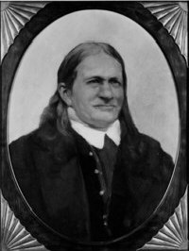
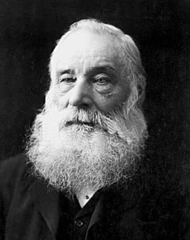
The studies of Runge in 1834 on the
oxidation of aniline with Ca(OCl)₂ are examined
in the light of a modern method of analysis using
LC-MS. It is concluded that Runge’s
experiments, performed 22 years before Perkins,
did produce mauveine but in an impure form.
The early studies on aniline oxidation prior to
Perkin’s work is reviewed.

FF Runge WH Perkin

Key words: amines, aniline, mauveine, history of science, oxidation.

Abstract
The oxidation of aniline or a mixture of aniline with o-toluidine and p-toluidine following Runge’s original method as carefully as possible, using chloride of lime [Ca(OCl)₂], produces a coloured solution from which small amounts of mauveine were purified, isolated and analysed by LC-MS. The oxidation of aniline by the method of Fritsche and Beissenhirtz, using potassium dichromate and sulfuric acid, similar to WH Perkin’s patented method, also gave small quantities of mauveine. The composition of the anilines are suggested depending upon their sources, and Kekulé’s comments on these early contributions are summarised.

KEY investigators studied the electron rich aromatic amine aniline which preceded William Henry Perkin’s (1838-1907) patented work on mauveine in 1856, age 18. Aniline was a substance which August Wilhelm von Hofmann (1818-1892) sometimes used to speak of as his ‘first love.’^{1,2} In his first published paper³ in 1843, at the age of 25, he showed that krystallin,⁴ which had been prepared by Otto Unverdorben (1806-1873) in 1826, age 20, Friedlieb Ferdinand Runge’s (1795-1867) kyanol,⁵ prepared in 1834, age 39, Carl Julius Fritsche’s (1808-1871) aniline,^{6,7,8} prepared in 1840, age 32 and Nikolay Nikolaevich Zinin’s (1812-1880) benzidam,⁹ prepared in 1842, age 30, were all the same compound for which Hofmann selected Fritsche’s name aniline. Also, in a postcript to an article,⁸ Erdmann, one of the journal editors, presented a case that aniline and crystallin, which was found by Unverdorben in 1826, are the same substance. The aniline had been prepared by different methods which is relevant here because it is likely to have affected the purity. Unverdorben thermally decomposed indigo and Fritsche decomposed indigo by distillation with alkali. These methods would probably have given pure aniline free of toluidines because Indigo is not methylated. Runge’s aniline, obtained from coal-tar, is likely to have contained toluidines since aniline synthesised from benzene contained 10% toluidines. Zinin prepared aniline by the action of hydrogen sulphide with ammonia on nitrobenzene. This aniline would have been free from toluidines because the benzene used to make nitrobenzene was prepared by the method of Eilhard Mitscherlich (1794-1863), at the age of 39, by thermally decarboxylating benzoic acid with lime.¹⁰

Aniline is electron rich and our 19th century forefathers experimented upon it with oxidants. The first was Runge in 1834 who treated aniline or kyanol with calcium hypochlorite (known then as chloride of lime, bleaching lime or chalk bleach Ca(OCl)₂) and noticed a deep blue colour. Figure 1 is a copy of an entry in Friedrich August Kekulé’s (1829-1896) Lehrbuch der Organischen Chemie, with a translation here.¹¹ Perkin examined the reaction in 1869.¹²

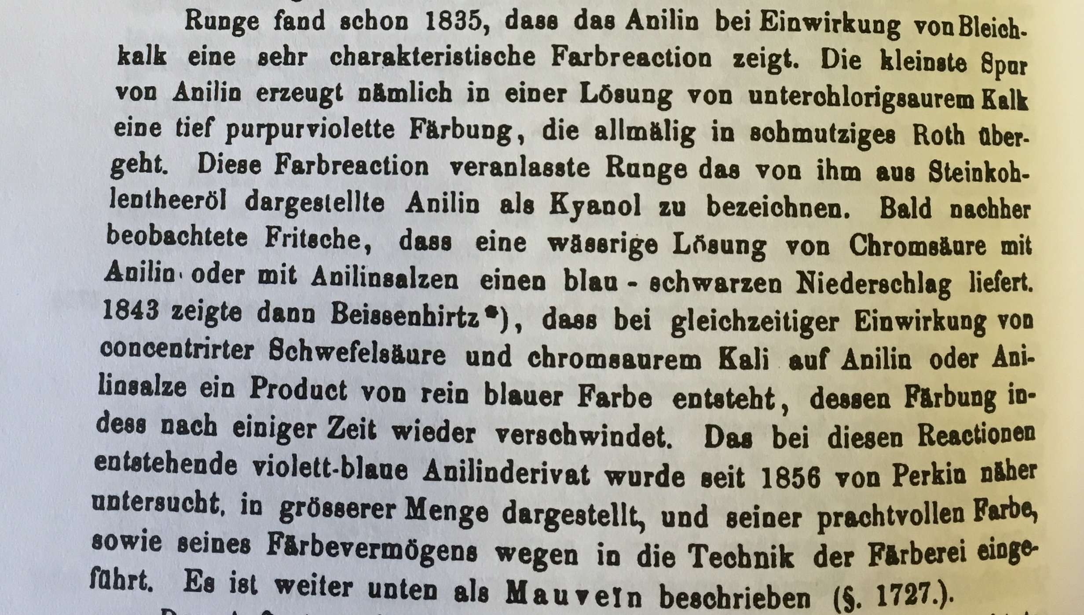

Translation

Runge found in 1835 that aniline shows a very characteristic colour reaction when mixed with bleaching lime.⁵ The smallest trace of aniline produces, when mixed with a solution of hypochloric lime, a deep purple colour, which slowly changes to a dirty red. This colour reaction was the reason that Runge named aniline produced from coal tar kyanol. Soon afterwards Fritsche observed, that a diluted solution of chromic acid mixed with aniline or aniline salts produced a blue-black precipitate. F. Beissenhirtz showed in (1853) that the reaction of concentrated sulfuric acic and potassium chromate with aniline or aniline salts results in a pure blue colour, which is unstable over time. The violet-blue aniline derivative produced during this reaction was studied in detail since 1856 by Perkin and produced in larger amounts. Due to its brilliant colour and the ability to stain cloth it was introduced into dye working. It is described later in the text as mauveine.

Figure 1 An entry in Kekulé’s Lehrbuch der Organischen Chemie, 1866, Vol. 2, page 668.¹¹ The entry of the year 1843 is a mistake and should be 1853.

Kekulé made comments regarding the work of Runge, but also on the work of Fritsche and Beissenhirtz on the oxidation of aniline. Fritsche’s work^{6,7,8}, published in 1840, treated aniline with a dilute solution of chromic acid to give a dark precipitate. The work of Beissenhirtz¹³ followed who used the same reagents that Perkin used to make mauveine (Figure 1 and 2). Some aniline or its salt was treated with a few drops of cH₂SO₄ and K₂Cr₂O₇ to give a deep blue colour.

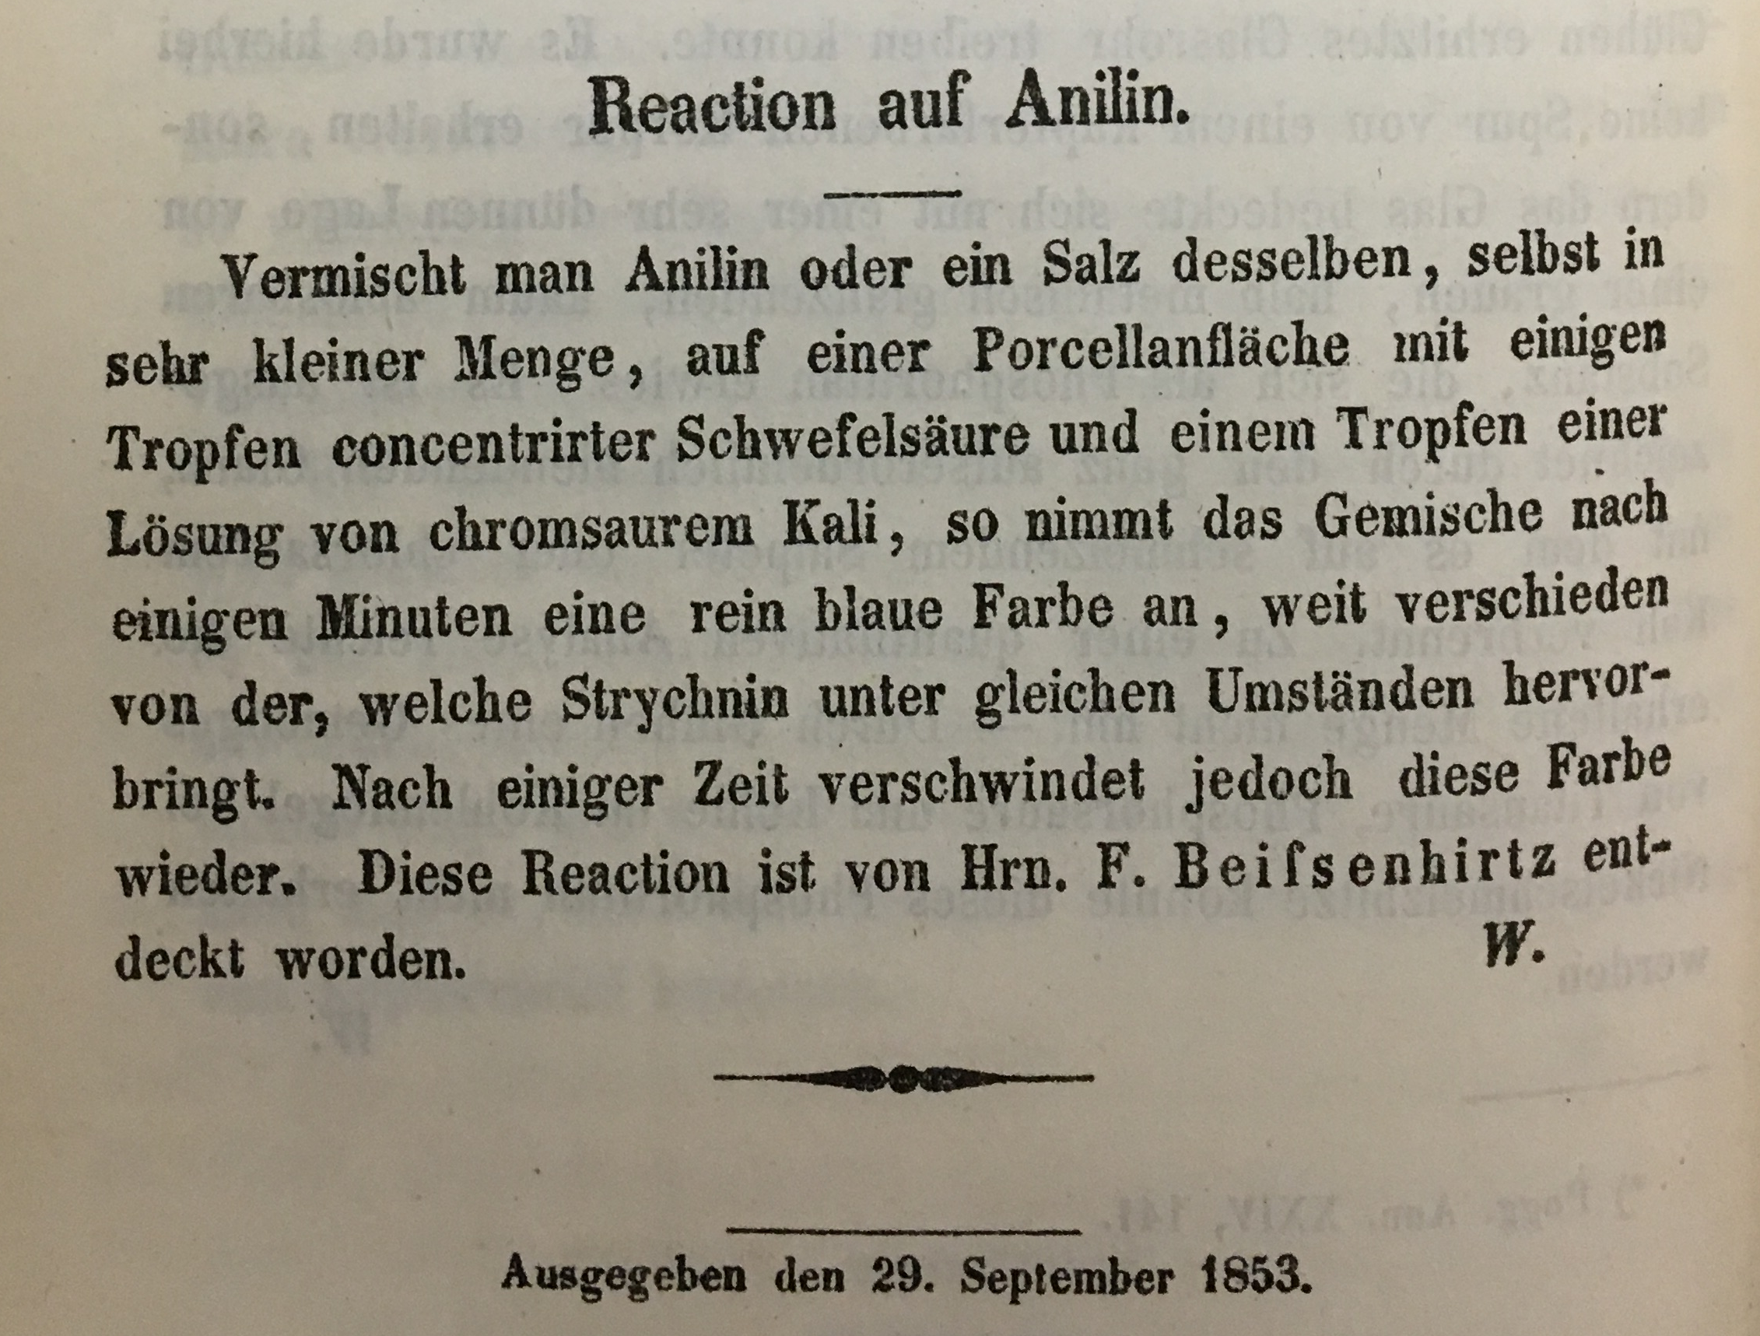

Translation

Reaction with Aniline

When you mix aniline, or a salt of this, even in low amounts, on a porcelain surface, with some drops of concentrated sulfuric acid and one drop of potassium dichromate solution then the mixture will show a clear or pure blue colour, which is very different from the colour that strychnine would produce under the same circumstances. The colour however vanishes after some time. This reaction has been discovered by F. Beissenhirtz.

Figure 2 A copy of Beissenhirtz’s paper published in 1853.¹³

Kekulé’s account stating ‘The violet-blue aniline derivative produced during this reaction was studied in detail since 1856 by Perkin; suggests that in his view Beissenhirtz made mauveine first. Kekulé describes this reaction and the product as the subject of a further study by Perkin which he patented (Figure 3).^{14,15}

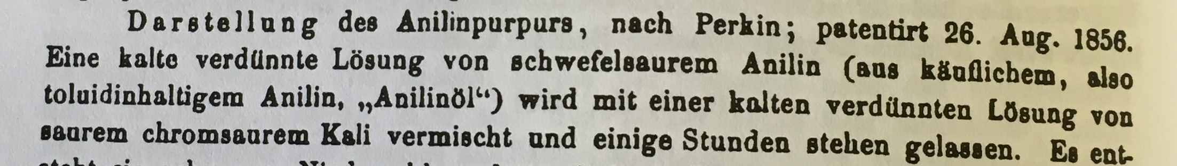

Translation

Preparation of aniline purple following Perkin patent 26 Aug. 1856. A cold diluted solution of sulfuric acid containing aniline (prepared from over the counter available toluidine containing aniline or aniline oil) is mixed with a cold diluted solution of acidic potassium chromate solution and left standing for several hours.

Figure 3 An entry in Kekulé’s Lehrbuch der Organischen Chemie, 1866, Vol. 2, page 686.¹¹

Discussion
There are three main types of mauveine: (1) Mauveine made by Perkin’s patented method which consists mainly of mauveine A, B2, B and C.¹⁶ (2) Mauveine archived in museums in London, Manchester and New York which has a different composition and mainly consists of mauveine A and B.^{16,17,18} (3) Mauveine known as Schunck’s^{18,19,20} or Caro’s mauveine²¹ which is mainly pseudo-mauveine with a small amount of mono-methylated chromophore present. These are summarised in Figure 4. Perkin worked with impure aniline which contained o-toluidine and p-toluidine so the mauveine prepared was a mixture of compounds.

Figure 4 The structures of some key mauveine chromophores and their molecular weights.

The fascinating historical work of the above investigators is rather close to the founding study of Perkin, but did they make mauveine? Their experimental work gives no evidence that either of them isolated and purified mauveine or developed the potential of this reaction to give a sought after, stable purple dye* for fashion. Nevertheless it is interesting to see if they might have generated impure solutions or precipitates containing small quantities of mauveine. A series of reactions were repeated to mimic their experimental conditions as carefully as possible. The literature is old and typically, as for Perkin’s work, experimental quantities are not given in the papers. It is more like a series of qualitative tests to make colour. We looked at using both pure and impure aniline, because Fritsche’s aniline, made from Indigo, might be pure aniline, and Runge’s aniline isolated from coal tar, might contain some toluidines. Two oxidants were examined, calcium hypochlorite and potassium dichromate. Aqueous reactions were performed at room temperature for 12 h and were worked-up, which was not done by Runge, Fritsche or Beissenhirtz, but was done by Perkin. The filtered precipitates were washed with water and extracted with methanol. Prior to LC-MS the extracts were purified by chromatography.

Figure 5 shows the LC-MS charts obtained for the oxidation of aniline or impure aniline with Ca(OCl)₂, and a chart for the oxidation of pure aniline with K₂Cr₂O₇.²⁰

(i)

(ii)

(iii)

(iv)

Figure 5 LC-MS Charts for the oxidation of (i) pure aniline with Ca(OCl)₂ (ii) a mixture of aniline, o-toluidine and p-toluidine with Ca(OCl)₂ (iii) a mixture of aniline, o-toluidine and p-toluidine hydrochloride with Ca(OCl)₂ (iv) pure aniline with K₂Cr₂O_{7.}

min | m/z 363 | m/z 377 | m/z 391 | m/z 405 | m/z 419 | m/z 433
3.2 | 91.5
4.8 |  |  |  | 1.0
5.1 |  |  |  | 1.6

(i)

min | m/z 363 | m/z 377 | m/z 391 | m/z 405 | m/z 419 | m/z 433
3.2 | 6.3
4.0 |  | 1.7 | 1.7
4.1 |  |  | 3.9
4.3 |  |  | 3.0 | 1.8
4.5 |  |  | 6.4 | 4.7
4.6 |  |  |  | 7.3 | 2.2
4.8 |  |  |  | 6.8 | 1.4
4.9 |  |  | 1.3 | 7.9 | 7.1
5.0 |  |  |  | 5.2
5.1 |  |  |  |  | 8.2
5.2 |  |  |  |  | 11.8
5.3 |  |  |  | 2.2
5.4 |  |  |  |  | 5.6

(ii)

min | m/z 363 | m/z 377 | m/z 391 | m/z 405 | m/z 419 | m/z 433
3.7 |  | 3.7
3.9 |  |  | 2.0
4.2 |  |  | 14.6
4.4 |  |  |  | 3.0
4.6 |  |  | 8.5 | 9.8
4.7 |  |  |  | 1.9
4.8 |  |  |  | 7.9
5.0 |  |  |  | 20.0 | 1.6
5.4 |  |  |  |  | 8.6
5.7 |  |  |  |  | 15.5

(iii)

min | m/z 363 | m/z 377 | m/z 391 | m/z 405 | m/z 419 | m/z 433
2.4 | 8.0
3.2 | 84.1
4.4 |  |  |  | 1.3
4.6 |  |  |  | 1.8

(iv)

Table 1 Tables of relative peak integrations for the oxidation of (i) pure aniline with Ca(OCl)₂ (ii) a mixture of aniline, o-toluidine and p-toluidine with Ca(OCl)₂ (iii) a mixture of aniline, o-toluidine and p-toluidine hydrochloride with Ca(OCl)₂ (iv) pure aniline with K₂Cr₂O_{7.}

In summary mauveine was found in all the reactions we examined this way, but ony in small quantities. Figure 5(i) and (iv) are typical analyses for pseudo-mauveine. The yield of pseudo-mauveine is always low, but even so after purification solutions with a purple colour were formed using pure aniline as reagent. The use of calcium hypochlorite as oxidant of a mixture of aniline and o- and p-toluidines gave a complex mixture of mauveine chromophores, Figure 5(ii), but the yield is no better than using potassium dichromate. But when p-toluidine was replaced with p-toluidine hydrochloride, the product mixture, Figure 5(iii), was similar to that obtained by Perkin’s patented method. This reaction illustrates how a change in pH changes the product composition. The tables of relative peak integrations are included for scrutiny.

Conclusion
The oxidation of pure and impure aniline with calcium hypochlorite has been repeated and shown to produce small amounts of mauveine. It is probable that early studies on the oxidation of aniline by Runge, Fritsche and Beissenhirtz, prior to Perkin’s discovery, did produce small quantities of impure mauveine which was not purified or characterised from a plethora of other by-products. The significance of the reaction was not recognised until Perkin prepared mauveine following a work-up procedure to isolate and purify the mauveine and test its affinity for silk. Initially this was small scale work but was soon scaled up to a commercial synthesis helped by the availability of aniline from chemical synthesis.^{2,14} Runge also studied aniline hydrochloride oxidation on a porcelain plate with potassium dichromate or copper chloride as oxidant,²² which was later used in the Dale and Caro method for making Schunck’s or Caro’s mauveine from aniline hydrochloride, which is rich in pseudo-mauveine.^{2,19} We previously repeated the copper chloride oxidation of aniline hydrochloride making pseudo-mauveine.²⁰ Runge’s use of aniline hydrochloride, or kyanol hydrochloride, makes it probable that he generated small amounts of unpurified mauveine solutions using three different oxidants. The use of experimental details are typically vague in these early recipes. However, the literature may be correct in attributing the first origins and attempts towards coal-tar colours to an earlier time.²²

Experimental

LC-MS was performed on a MAXIS II UHR-TOF LC-MS System, Bruker UK Ltd.

WARNING: The reaction of aromatic amines with Ca(OCl)₂ is exothermic. If they are mixed neat the mixture gets roasting hot and fumes.

In each reaction mauveine is easily observed by thin layer chromatography after purification using sec-butanol:EtOAc:H₂O:HOAc (60: 30:9.5:0.5) as eluent.²³

The Runge aniline oxidation: Pure aniline (200 mg, 2.2 mmol) in water (50 ml) was treated with Ca(OCl)₂ (200 mg, 1.4 mmol) and stirred at room temperature for 12 h. The solution turned a red/brown colour. The mixture was filtered, washed with water three times (50 ml) and extracted with MeOH (2 x 30 ml). The combined extracts were evaporated then purified by chromatography on silica gel. Elution with MeOH removed brown impurities then aqNH₃/MeOH (20:80) eluted pseudo-mauveine which was evaporated to dryness (0.4 mg, 0.2 %) then analysed by LC-MS, Figure 5 Chart(i) and Table 1(i).

The Runge impure aniline oxidation. p-Toluidine (200 mg, 1.9 mmol), o-toluidine (200 mg, 1.9 mmol), aniline (175 mg, 1.9 mmol) in water (50 ml) were stirred at room temperature and treated with Ca(OCl)₂ (675 mg, 4.8 mmol, 2.5 eq) for 12 h. The solution turned a red/brown colour. The mixture was treated as above then purified by chromatography on silica gel. Elution with MeOH removed brown impurities then aqNH₃/MeOH (20:80) eluted the mauveine chromophores (3.0 mg, 0.5%) which were evaporated then analysed by LC-MS, Figure 5 Chart(ii) and Table 1(ii). The reaction was repeated replacing p-toluidine with p-toluidine hydrochloride and the purified products were analysed by LC-MS, Figure 5 Chart (iii) and Table 1(iii).

The Fritsche or Beissenhirtz aniline oxidation: Both methods are very similar and report no quantities so are only repeated here qualitatively. Aniline (300 mg, 3.2 mmol) was placed in a beaker and reacted with 2 drops of cH₂SO₄. The mixture was treated with K₂Cr₂O₇ (400 mg, 1.3 mmol) in water (20 ml) and stirred for 12 h at room temperature. The dark mixture was filtered, washed with water (3 x 30 ml) and extracted with MeOH (2 x 30 ml). The combined extracts were evaporated then purified by chromatography on silica gel. Elution with MeOH removed brown impurities then aqNH₃/MeOH (20:80) eluted pseudo-mauveine which was evaporated to dryness (0.6 mg, 0.2%) then analysed by LC-MS, Figure 5 Chart (iv) and Table 1(iv). Similar methods for the oxidation of aniline and toluidine mixtures, which gives a mixture of mauveine chromophores, have been reported previously.^{14,24-30}

References
1 W. H. Perkin in The British coal tar industry, it’s origin, development, and decline, Eds. W.M. Gardner, J. B. Lippincott Company, Philadelphia and Kessinger Publishing LLC, 1915, pp. 141–187.
2 W. H. Perkin, J. Chem. Soc., 1896, 596.
3 A. W. Hofmann, Ann. Chem. Pharm., 1843, 47, 37.
4 O. Unverdorben, Ann. Physik und Chem., 1826, 8, 397.
5 F. F. Runge, Ann. Physik und Chem., 1834, 31, 65.
6 J. Fritsche, Bulletin Scientifique publié par l’Académie Impériale des Sciences de Saint-Petersbourg, 1840, 7(12), 161.
7 J. Fritzsche, J. Liebigs Ann. Chem., 1840, 36, 84.
8 J. Fritsche, J. Prak. Chem., 1840, 20, 453.
9 N. N. Zinin J. Prak. Chem., 1842, 27, 140.
10 E. Mitscherlich, Ann. Pharm., 1834, 9, 39.
11 A. Kekulé in Lehrbuch der Organischen Chemie, oder, der Chemie der Kohlenstoffverbindungen, Vol. 2, Eds. A. Kekulé, Book Renaissance, 1866, pp. 668.
12 W. H. Perkin, J. Chem. Soc., 1869, 22, 25.
13 F. Beissenhirtz, Ann. Chem. Pharm., 1853, 87, 376.
14 W.H. Perkin, 1856, GB Patent No 1984, August 26th.
15 W. H. Perkin in Bleaching, Dyeing and Printing Calico and other Fabrics and Yarns including the Manufacture of Rollers, Engraving, the Preparation of Drugs and other Processes, G. E. Eyre and W. Spottiswoode, Great Seal Patent Office, Part I-IV, 1617-1883.
16 J. Sérgio Seixas de Melo, S. Takato, M. Sousa, M. J. Melo and A. J. Parola, Chem.
Commun., 2007, 2624.
17 O. Meth-Cohn and M. Smith, J. Chem. Soc. Perkin Trans., 1 1994, 5.
18 M. M. Sousa, M. J. Melo, A. J. Parola, P. J. T. Morris, H. S. Rzepa and J. Sérgio
Seixas de Melo, Chem. Eur., J. 2008, 14, 8507.
19 J. Dale and H. Caro, 1860, GB Patent No 1307, May 26th.
20 M. J. Plater and A. Raab, J. Chem. Res., 2015, 39, 180.
21 M. da Conceicao Oliveira, A. Dias, P. Douglas and J. Sérgio Seixas de Melo,
Chem. Eur. J., 2014, 20, 1808.
22 B. Anft, J. Chem. Ed., 1955, 32, 566.
23 M. J. Plater, W. T. A. Harrison and H. S. Rzepa, J. Chem. Res., 2015, 39, 711.
24 M. V. Canamares, D. A. Reagan, J. R. Lombardi and M. Leona, J. Raman Spec., 2014, 45, 1147.
25 M. J. Plater, J. Chem. Res., 2011, 35, 304.
26 T. M. Brown, C. J. Cooksey and A. T. Dronsfield, Educ. Chem., 2000, 37, 75.
27 S. Garfield, Mauve, Faber and Faber, London, 2000.
28 R. L. Scaccia, D. Coughlin and D. W. Ball, J. Chem. Ed., 1998, 75, 769.
29 W. H. Cliffe, J. Soc. Dyers Col., 1956, 72, 563.
30 A. Cobenzl, Oesterr. Chem-Ztg., 1925, 28, 25.

Footnote

*Purple dye dates back into antiquity and was described in a recent exhibition ‘Storms, War and Shipwrecks, ’ Ashmolean Museum, Oxford, July, 2016. The Phoenicians on the far Eastern shore of the mediterranean, 1550-300 years BC, sailed West to Sicily and as far as Spain and were nicknamed the ‘purple people’ by the Greeks owing to a purple dye they extracted from seashells. The dye, Tyrian purple, was named after the city Tyre.

