A Visualisation Tool for Planning Passenger Transport Services in Rural and Low-Demand Settings

C. David Emele¹, Steve Wright², Richard Mounce¹, Cheng Zeng¹ and John D. Nelson^{1, 2}
¹RCUK dot.rural Digital Economy Research Hub, University of Aberdeen, UK

²Centre for Transport Research, University of Aberdeen, UK
c.emele@abdn.ac.uk
s.d.wright@abdn.ac.uk
r.mounce@abdn.ac.uk
c.zeng@abdn.ac.uk
j.d.nelson@abdn.ac.uk

Abstract:

Purpose

This paper presents a novel visualisation tool, known as Flexible Integrated Transport Services (FITS) that transport commissioners, providers and administrators could employ to specify and edit the operating constraints as they redesign transport services.

Approach

The context of rural transport planning is discussed noting that where resources are fewer, effective co-ordination is required to provide passengers with efficient transport services. An overview of the FITS visualisation tool and its different sub-systems (e.g. general information regarding services, operating area, passenger eligibility, fare structure and surcharge structure) is given. Additionally, some key computational details of the system are discussed. Preliminary results of a sample case study that trialled the FITS tool in a specific test run, using simulated transport to health data in the Morayshire and North-West Aberdeenshire area of Scotland are presented. The concluding discussion considers the potential impact of employing tools like FITS in planning transport services in rural and low-demand settings.

Findings

Results from the case study show how these effects could be quantified in terms of changes in costs incurred by transport providers, the level of potential demand that could be covered and the associated revenues (fares and subsidies) which could be generated by providers.

Originality / Value

The FITS visualisation tool has the potential to act as a planning tool to help transport commissioners, providers and administrators visualise the effects of shifting operating boundaries of flexible transport services.

Keywords: Visualisation tool, rural transport, low-demand settings, eligibility criteria, subsidy, constraint relaxation.

1 Introduction
The lack of provision of transportation in rural and low-demand areas remains a challenge for passengers, transport operators and transport planners. Some of the challenges that make rural areas and low-demand settings difficult and costly for conventional public transport include populations that are often sparsely distributed across a wide area with differing travel requirements and preferences of passengers. These challenges mean that arranging efficient transport is non-trivial. Literature confirms that conventional public transport is rigid and inflexible to sufficiently meet the transport needs of most people in rural areas (Preston & Raje, 2007; Nelson, Wright, Masson, Ambrosino & Naniopolous, 2010). In the face of low and dispersed demands for travel, flexible transport services (FTS) present promising alternatives (Mulley and Daniels, 2012). Broadly speaking, FTS refer to transport services that operate on a flexible route and schedule, and offer door-to-door services within a fixed operating boundary. By door-to-door, we mean transport services that can pick-up passengers from a specified origin (i.e. their house, a recognised bus stop, an assembly point, or another agreed location) and take them to their specified destinations. These services are usually pre-booked and operate on demand unlike conventional public transport, which runs on fixed routes and rigid schedules. Ultimately, the route and timings of FTS are determined by user demand constrained only by fixed operating area boundaries and operating start and end times.

FTS are widely documented in the literature (see Brake, Nelson & Wright, 2004; Brake, Mulley, Nelson & Wright, 2007; Finn, 2012; Laws, Enoch, Ison & Potter, 2009; Nelson, Wright, Masson, Ambrosino & Naniopolous, 2010) as capable of providing higher quality of service while delivering increased flexibility that is tailored to the individual needs of passengers. Importantly, flexible transport providers attempt to maintain a high quality of service by filtering the number and type of users that access their services. This usually involves checking whether a given user meets a set of constraints. These constraints can relate to restrictions on the class of passengers that can be carried and constraints on the locations and times in which the service can operate. If a user does not meet the required minimum requirements then they are not eligible and will not be able to access the service. The stand-alone nature of these services and user restrictions (amongst other factors) results in a significant number of uncoordinated transport services operating in an area with tight limitations on where, when and who can use them (Mulley, Nelson, Teal, Wright & Daniels, 2012). For example, there may be services catering to specific groups (e.g. the elderly or disabled) that are provided by community transport organisations, health sector funded organisations or Local Authority departments involved in social care, all with slightly different operating criteria resulting in a large amount of duplication and inefficiency. While there have been several initiatives to better integrate funding and service provision (for example, in England and Wales (Department for Transport, 2009, and in Scotland (Community Transport Association, 2012)), these have often struggled to get agreement on shared funding or establish joint commissioning for transport services. One of the key issues that hinders effective integrated planning of transport services in rural and low-demand settings is the lack of robust tools that could aid decision-making.

In the remainder of this paper, we discuss a novel tool that has the potential to aid planners, administrators and transport providers in planning or redesigning services in rural areas and low-demand settings. In Section 2, rural transport planning and the potential contribution of the FITS project is discussed. Section 3 provides an overview of the FITS visualisation tool, including some key computational details of the system. Section 4 presents preliminary results of a sample case study that trialled the FITS tool in a specific test run, using simulated transport to health data in the Morayshire and North-West Aberdeenshire area of Scotland. Section 5 consists of a discussion of the case study and some thoughts about the potential impact of employing tools like FITS in planning transport services in rural and low-demand settings.

2 Flexible Integrated Transport Services (FITS) in Rural Transport Planning
Planners, administrators and transport operators require relevant information when planning new services or redesigning existing ones. Especially in rural and low-demand settings where resources are fewer, effective co-ordination is required to provide passengers with efficient transport services. Types of information that are critical in planning robust transport services include:
- Coverage – which area would the service cover?
- Passenger eligibility – what class of passengers is the transport service aimed at?
- Frequency – how often would the service be operated?
- Cost – what would be the cost of running this service?
- Funding – how would the service be funded?
- Service type – would the service be fixed-route/fixed schedule or demand responsive (DRT)?
In order to optimise service provision in rural areas, planners must be adequately aided in the decision-making process. Nowadays technology can offer opportunities to integrate, visualise, streamline and automate aspects of the planning process. Generally, the uptake of digital solutions has become widespread and many planners, administrators, local authorities, government departments, transport agencies, policy makers are exploiting digital tools (For example, GIS) in both day-to-day and strategic planning (see Miller & Shaw, 2001; Ribeiro, Rijo & Leal, 2012; Gallotti & Barthelemy, 2015). The advent of digital maps has made visualisation and manipulation of aggregate demand and public transport stop and timetable data easier. However, user-centric information as well as detailed service operating criteria which is crucial in FTS design is still lacking in most of the tools developed. The Flexible Integrated Transport Services (FITS) project proposes one means of filling this gap by investigating ways in which detailed service criteria, as well as user-centric information, can be gathered and visualised in a manner that aids transport planners and operators to design new and effective services.

There are several software packages available to support FTS scheduling and allocation, most of which concentrate on scheduling vehicles on optimal routes and allocating a group of passengers to the available fleet. Examples include: Trapeze (www.trapezegroup.co.uk), Cleric (www.cleric.co.uk) and Mobisoft’s MobiRouter (www.mobisoft.com), which are widely used in the UK, or the GIRO/ACCES software (www.giro.ca/en/solutions/demand-responsive-transport), which is used for large-scale paratransit operation in the US. It is important to highlight that the objective of FITS is not to address passenger scheduling, optimal route allocation and dispatch such as that supported by these traditional travel dispatch packages, although the FITS platform could provide complementary support and act as an additional layer on top of existing travel dispatch software systems. Similarly, FITS does not seek to emulate integrated tools for public transport service planning and management (such as the IVU suite, www.ivu.com) which focus on an integrated approach to planning, dispatching, service control, passenger information and ticketing; nor is there a focus on network planning where a key task is the setting of objectives for network-wide service supply or quality of service (Nielson, Lind, Mulley, Nelson & Tegner, 2005).
The main focus of the FITS platform, as described in more detail below, is to identify possible transport options available to passengers. FITS takes account of passenger preferences on operator choice and operator preferences on passenger types they wish to carry, and proposes solutions to deliver this service in a manner which is fair and equitable to both passengers and operators, while still respecting the underlying ethos of the transport provider.
The FITS visualisation tool described in this paper supports transport planners in a number of ways. For example, planners of FTS can shift certain operating constraints (e.g. operating area boundaries) and see the effect on potential levels of demand that could be covered, changes in costs incurred by transport providers, and associated revenues (fares and subsidies). The tool utilises population, geography and household survey information and any available purpose specific datasets (e.g. hospital appointment data) to estimate the potential effect of those changes. The key objective of our visualisation tool is to increase information and aid decision-making in FTS planning and delivery. Earlier work by the authors explored how flexible transport providers could relax their operating constraints on a case-by-case basis, such that they were able to offer additional transport possibilities to pass and record increased benefits to both parties (Emele et al., 2013). Whilst that level of support is helpful, one key issue that was lacking in the earlier contribution is the ability to visualise the effect that different levels of relaxations could attract. In other words, it could not afford service planners and operators the ability to explore “what if questions” as they designed new or redesigned existing services. For example, a planner may want to know what the potential level of demand would be if the operating area boundary of a flexible service is extended by 10 miles to the East or what the effect is of shifting the opening time forward by 30 minutes. In the next section an overview of the FITS visualisation tool is provided, including some key computational details of the system.

3 The FITS Visualisation Tool
The FITS visualisation tool is designed to facilitate decision-making when planning or redesigning services. The tool delivers this functionality through the use of state-of-the-art mapping tools, autonomous intelligent agents, computational mechanisms and user-friendly interfaces to allow for easy editing, saving and analysis of service components. Clearly, there are certain restrictions that are placed on services that should not be violated if a service is to remain legitimate and reputable, e.g. legal regulations, vehicle capacity etc. However, operators often assign other discretionary constraints to their services, either through choice or through limitations imposed by funding. The following sections describe briefly the different sub-systems of the FITS visualisation tool. For example, the general information sub-system allows operators to specify information about their services including service name, service description and how to book a trip. Each transport operator is required to provide the required information in each sub-system for each service they provide (where there are any day to day deviations to aspects of the service, such as operating hours, then these may need to be defined as separate services).

3.1 General Information
The General Information sub-system allows service designers to specify general information regarding services being investigated (see Figure 1). For example, details such as the service name, service description, service-booking procedure, and operating days/hours are captured in this sub-system. This sub-system allows the service designer/planner to specify periods when the service would be unavailable, if any (e.g. school holidays). These details are held by the service agent, which handles the advertisement of the service to other information-seeking agents (e.g., passenger agents through brokers).

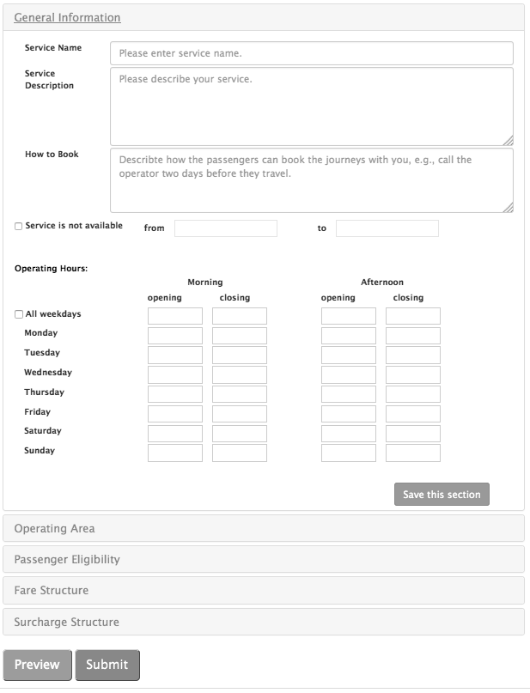

Figure 1: General information of a service

3.2 Operating Area
One of the discretionary constraints that operators/designers frequently assign to their services is the catchment or operating area. Catchment area boundaries stipulate a region within which a given service operates. This means eligible passengers within those boundaries can be picked up and/or dropped off. We use the term ‘eligible’ to suggest that there could be other constraints such as passenger type which an operator might consider in order to determine whether a passenger can use a service or not (the next sub-system deals with passenger eligibility issues). Figure 2 shows the operating area sub-system of the FITS visualisation tool. Using the FITS tool, the operating area of a service can be drawn as a polygon and the accompanying data entered into the sub-system. In order to estimate potential levels of demand for a service in a given operating area, the FITS visualisation tool employs the ray method to check if the origin or destination postcode is within the catchment area of a service (Shimrat, 1962). This is reasonable since the operating area of a service is captured as a polygon.

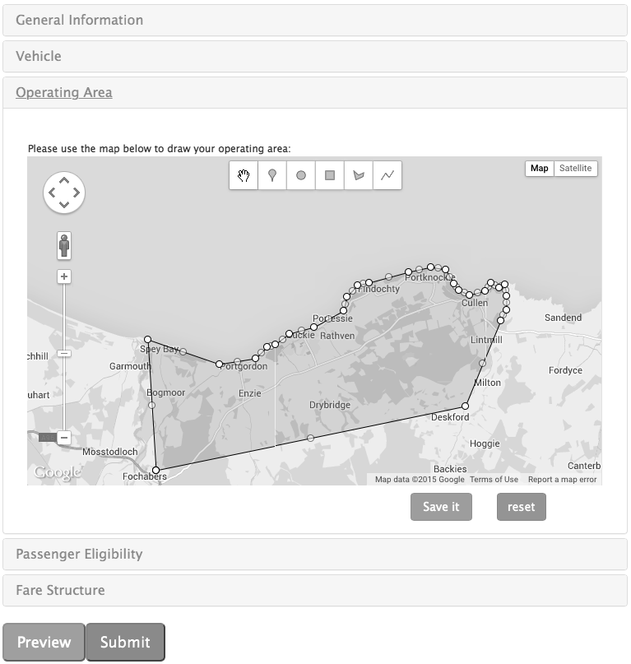

Figure 2: Operating area of a service

3.3 Passenger Eligibility
The passenger eligibility sub-system allows planners/designers to specify the categories of passengers that are eligible for a given service. If a service is open to all categories of users then there are no restrictions in terms of the age, mobility status and the journey purpose of passengers. Figure 3 shows a screenshot of the passenger eligibility sub-system.

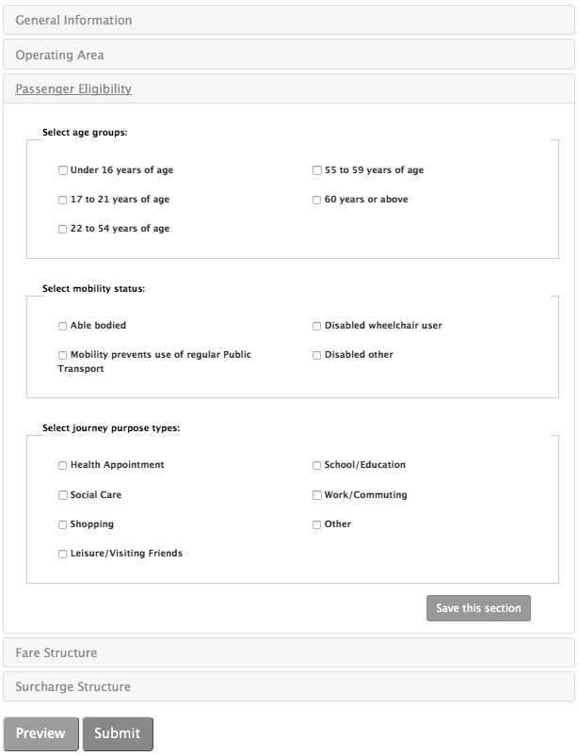

Figure 3: Passenger eligibility for a service

3.4 The Fare Structure
This sub-system details the fare regime for a given service and specifies discounts and concessionary travel for qualifying individuals. The fare structure information consists of the following:
- Whether the service charges fares or not.
- Fares within mileage bands.
- Return fare multiplier.
- Percentage discounts for concessionary cardholders (e.g., over 60’s, disabled and under 16s).
- Whether escorts are charged a fare or not.
- Whether the service charges for dead mileage and the location for this to be calculated from.

The fare information held in this sub-system applies for journeys within the specified service constraints. In other words, it assumes that the journey will be made within the operating boundary and that the passengers are within the specified categories. If any of the service constraints are relaxed to accommodate additional passengers then a surcharge may apply (see Section 3.5 for more details about surcharges that may apply).

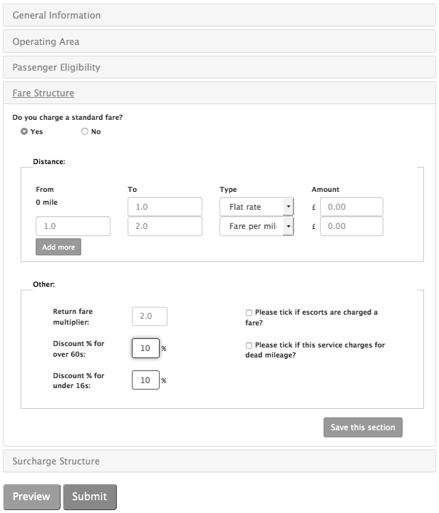

Figure 4: Fare structure of a service

3.5 The Surcharge Structure
It is usually the case that certain legislative frameworks and regulations may place a number of restrictions on services, which must not be violated by operators if a service is to remain legitimate and reputable. However, a transport planner/designer may decide to relax/tweak certain constraints to test various ‘what if?’ scenarios in order to accommodate more passengers. The surcharge structure sub-system specifies information regarding how such additional capacity would impact on the existing service. Importantly, designers/planners can specify the level of compensation that would be required to make such relaxations/additional capacity worthwhile for the service provider. We use the term ‘surcharge’ to denote the compensation that an operator expects for relaxing certain discretionary constraints. These surcharges are paid by the passengers or could be paid in the form of a per-trip subsidy from local authorities and/or other agencies. Some of the information captured in this sub-system includes:

- Penalty surcharges for operating outside defined operating area (in distance bands).
- Penalty surcharges for operating outside defined operating hours (in time bands).
- Penalty surcharges for carrying passenger types that are different from those categories that they set out to carry.

It is worth noting that each of these relaxations/surcharges is optional in that the designer/planner has the choice of keeping the same service constraints. However, should the designer/planner wish to redesign a service to enable it to deliver more efficient transport services to passengers then the FITS visualisation tool can support the process.

3.6 Putting It All Together
The FITS visualisation tool exploits simulation using computational mechanisms, population data (for postcode density, age distribution of the population in an area, etc.), and other open source or available data (e.g. annual outpatient appointment data) to attempt to predict the potential effect of shifting boundaries of different operating constraints. The tool, powered by a virtual marketplace that was built using intelligent autonomous agent technology, allows passengers and operators to interact as passengers seeking shared transport options are connected to suppliers who wish to offer transport services. On one hand, passengers can set their preferences regarding how they value travel time, money and number of vehicle changes relative to each other. These pieces of information are utilised to ensure that transport options are tailored to the needs of the passenger. On the other hand, operators can specify their service constraints including fare structure, operating areas, operating times and eligibility criteria (e.g. age restrictions or certain mobility status). Operators can also set the level of penalty surcharges that they would require to consider operating outside of their specified constraints. In this way, they are able to not only set the penalty surcharges but also the extent to which they are willing to go outside of existing constraints when some of the constraints are not satisfied by passenger journey requests. This allows transport operators the option of relaxing constraints in a way that meets their target and is acceptable to them. Relaxing constraints gives the potential for more passenger demands to be met, and much more than that it allows operators and planners to make informed decisions on service constraints and appropriate boundaries when designing transport services.

In designing or redesigning a service, the FITS tool may be deployed to interrogate the operating requirements and constraints that have been specified for the service as well as data sources available to the tool at the time (e.g. annual outpatient appointment, household survey, population data, postcode distribution and mobility profile of the area covered by the service) in an attempt to estimate potential demand based on current travel patterns and travel demand statistics. Put simply, FITS addresses the challenge of making the most out of existing services through constraint relaxation. The next section details a trial of the FITS tool in a transport to health scenario in North-East Scotland.

4 Case Studies – Aberdeenshire and Morayshire Examples
As a trial, the FITS visualisation tool is being applied to estimate transport to health demands that could be covered by the different flexible transport services in the Morayshire and Aberdeenshire areas of North East Scotland. These areas are largely rural and are characterised by low-demand, limited and infrequent fixed-route public transport, with many stand-alone FTS provided by community transport organisations, health sector funded organisations or Local Authority departments involved in social care. These flexible transport providers receive large public subsidies and are largely uncoordinated and poorly promoted. Transport authorities, local councils, providers and government agencies are keen on increasing the returns on investment in the provision of transport services; hence, the desire to explore ways of redesigning existing services or introducing new ones that will be robust and efficient.

4.1 Demand Generator
The FITS visualisation tool has been trialled offline with transport operator data as well as a set of passenger trip demands. A simulated demand generator was used to produce a set of passenger demands to reflect potential daily health-related trip demands. The generation of the trips is based on annual outpatient appointment data from each of nine districts (electoral wards) to and from five hospitals in the North-West Aberdeenshire and Morayshire area. Figure 5 is an illustration of the five hospital locations and ward boundaries for each of the nine wards. The area of the wards in Figure 5 is 2530 km² and population is approx. 100,000 with a density of 39 persons/km². For international comparison this is an area equivalent to that of the country of Luxembourg.

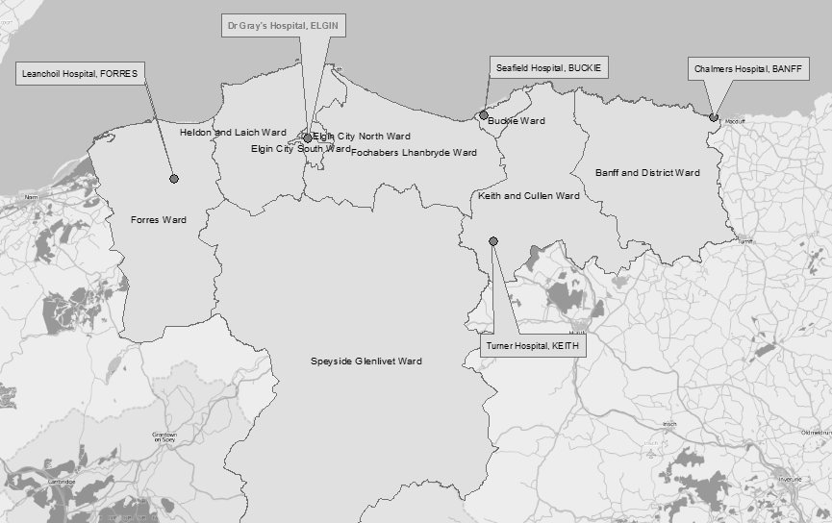
Source: QGIS Development Team, 2009. QGIS Geographic Information System. Open Source Geospatial Foundation. URL http://qgis.osgeo.org
Figure 5: Map showing the districts (electoral wards) and hospital locations used in the FITS offline simulation
In the case study dataset 107,120 outpatient appointments at the five hospitals (depicted in Figure 5) originate from the nine districts annually, which yields 214,240 annual trips (covering journeys to and from the hospital). This averages at 4,120 trips per week for all travel modes including private car which is a lower bound. Table 1 outlines the distribution of journeys by mode of travel to attend hospital and other health appointments in Scotland between 2008 and 2012.

Table 1: Distribution of journeys to attend health appointments in Scotland
Travel Mode | Car Driver | Car Passenger | Walk | Taxi | Public Transport + Other
Proportion | 41.9% | 22.2% | 13.9% | 4.7% | 17.3%
Source: Scottish Household Survey (2008-2012)

Table 1 shows that 78% of hospital and other health appointments in Scotland are accessed by foot or as a car passenger or driver, and only 22% are accessed by bus, taxi or other public transport services. The distribution contained in Table 1 relates to hospital and other health appointments including GP surgery visits, and covers the whole of Scotland. As such the distances involved in attending GP surgeries in urban areas will tend to be shorter than for the hospital only appointments in the generally rural area of our study area. For the purpose of calibrating FITS we take a very conservative estimate that 3% fewer people will walk to hospital appointments in rural areas and a similarly higher proportion will access by Public Transport and Taxi (i.e. 3% higher giving a total of 25%) in our simulation. Considering these slight adjustments, the estimated weekly journeys by taxi, bus or other public transport to outpatient appointments in the study area comes to 1030 trips per week (i.e. 25% of 4120). The distribution of passenger pick-up points within each ward was randomly selected from the full set of postcodes in each ward (giving a reasonable representation of the spatial distribution of population across the ward and each postcode providing a good proxy for the location of the patient’s address). It is worth noting that simulated passenger age was added to the postcode dataset for each ward based on patient age profiles for outpatient appointments and simulated mobility status was added based on simulated age. Therefore the selection of a postcode provides the simulated origin address, passenger age and mobility status.

4.2 Shifting Operating Boundaries
A catchment area within which an operator provides FTS is represented as a polygon. An estimate of hospital and health related trips generated from that area per week were simulated from real trip demands in the study area (as detailed in Section 4.1) and operating constraints of the operator (including passenger eligibility criteria, operating time, surcharge structure, etc.) were determined. The FITS tool was used to estimate the number of trips from the generated demands that would satisfy individual operator’s constraints.

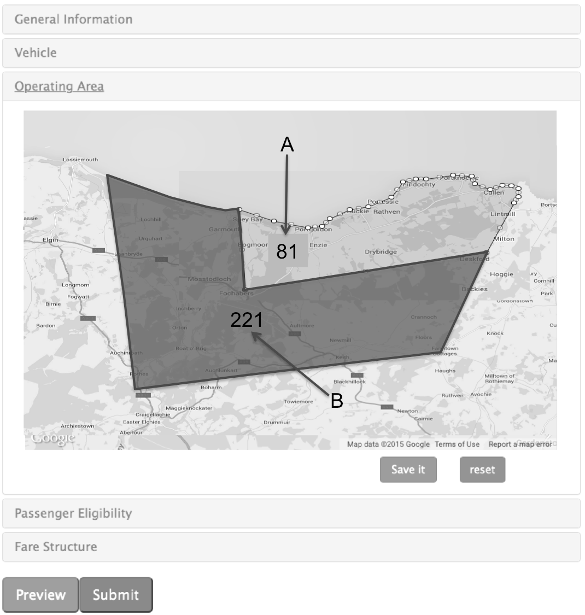

Figure 6: Operating area of M for Moray – Buckie Bus Service
The FITS tool treats each trip as originating from a point on a map, which means that the ray method (Shimrat, 1962) could be employed to see if that point falls within the polygon, and thereafter apply distributed constraint satisfaction mechanism to determine whether or not a given trip request meets the criteria for a given service (Yokoo & Hirayama, 2000). In other words, if the originating address of a passenger’s trip request falls within the polygon and the passenger satisfies all other criteria then that passenger could be considered as a potential passenger on that service. In this way, a transport operator or planner can adjust the boundaries of service constraints and see the effect of such adjustments on the number of potential passenger demands.

4.3 Preliminary Results
The FITS tool was used to investigate eight FTS covering the study area. However, for the sake of brevity the preliminary results presented in this section focuses on just one of the services. The service name is “M for Moray – Buckie Bus Service”. This service is designed to transport anyone living within the specified catchment area that is unable to access regular public transport (e.g. disabled persons or those living above an acceptable walking distance from their nearest suitable regular bus stop) irrespective of their age and journey purpose. The service is available from Monday to Friday between 9.00am and 2.30pm. The catchment area for the service is depicted in Figure 6 as the area covered by the polygon labelled “A”. Out of the estimated 1030 weekly trips to hospital by bus and taxi in the nine districts shown in Figure 5, 115 arise within the operating area of the M for Moray Buckie Bus Service. The FITS tool was used to compute the potential travel demand that could be met using different combinations of the existing service constraints of M for Moray – Buckie Bus Service in the Buckie Ward. The results are shown in Table 2:

Table 2: Potential Trip Demand using the Existing Constraints specified by M for Moray – Buckie Bus Service
Description | Potential Trip Demands per week
Within the operating area and within the service operating time | 81
Within the operating area but either pickup or drop off time or both falls outside the service operating time | 34
Total | 115

In order to showcase the level of support that the FITS tool can provide to planners when designing or redesigning services, the operating area boundaries of “M for Moray – Buckie Bus Service” were adjusted in a number of directions and by different amounts and the effects were recorded. Table 4 illustrates the potential levels of demand that could be attained as well as the operating time relaxations that may be required to fulfil those additional trips. Understandably, each journey request that requires the operator to relax one or more constraints in its service description attracts a surcharge because the operator incurs additional cost by accepting such a request. Using the surcharge structure provided by transport operators, planners can estimate the potential costs/savings of taking on any additional trip requests that relaxing their service constraints may yield. In the simulation, surcharges for constraint relaxations by “M for Moray – Buckie Bus Service” were set as illustrated in Table 3, taking account of where additional demand might be located. So, in row 1 of Table 4 where relaxing the operating boundary up to 5 miles to the South and East of the existing operating area is simulated, the ‘surcharge to cover area’ is only £1.30 because the potential additional demand was only 1.3 miles outside the existing operating area and the surcharge specified is £1 per mile up to 10 miles.

Table 3: Surcharge Structure for M for Moray – Buckie Bus Service
Operating outside usual area |  | Operating outside usual times |  |  | Relaxing passenger eligibility
Up to 10 miles | Above 10 miles | 0.5 hours earlier or later | 1 hour earlier or later | 1.5 hours earlier or later | Not Applicable: The service is open to all
£1.00 per mile | Not acceptable: can only relax up to 10 miles | £4.50 | £9.00 | £13.5 | £0

Table 4: Effect of Shifting Operating Area & Time for “M for Moray – Buckie Bus Service”
Relax Operating Area | Directions | Potential Additional Demand (per week) | Surcharge to cover Area  (per week) | Relax Operating Time by 0.5 hours | Relax Operating Time by 1 hour | Surcharge to extend Operating Time | Total Surcharge  (per week)
Up to 5 miles | South & East | 1 | 1.30 | 1 | 0 | 4.5 | 5.8
Up to 5 miles | South & West | 0 | 0 | 0 | 0 | 0 | 0
Up to 5 miles | North & East | 0 | 0 | 0 | 0 | 0 | 0
Up to 5 miles | North & West | 0 | 0 | 0 | 0 | 0 | 0
Up to 7.5 miles | South & East | 5 | 25.90 | 5 | 0 | 22.50 | 48.40
Up to 7.5 miles | South & West | 13 | 87.70 | 13 | 0 | 58.50 | 146.20
Up to 7.5 miles | North & East | 0 | 0 | 0 | 0 | 0 | 0
Up to 7.5 miles | North & West | 0 | 0 | 0 | 0 | 0 | 0
Up to 9 miles | South & East | 21 | 168.30 | 16 | 5 | 117.00 | 285.30
Up to 9 miles | South & West | 214 | 1876.90 | 206 | 8 | 999.00 | 2875.90
Up to 9 miles | North & East | 7 | 62.30 | 4 | 3 | 45 | 107.30
Up to 9 miles | North & West | 9 | 80.10 | 9 | 0 | 45 | 120.60
Up to 10 miles | South & East | 27 | 226.50 | 19 | 8 | 157.50 | 384.00
Up to 10 miles | South & West | 221 | 1944.00 | 210 | 11 | 1044.00 | 2988.00
Up to 10 miles | North & East | 7 | 62.30 | 4 | 3 | 45 | 107.30
Up to 10 miles | North & West | 9 | 80.10 | 9 | 0 | 45 | 120.60

5 Discussion and Conclusions
In the previous section, results that demonstrated the potential support that the FITS tool could provide to transport operators and planners was presented. For example, the potential level of demand that could be met as a result of shifting operating constraints (i.e. operating area, operating time, and passenger eligibility). Importantly, by combining the additional passenger trip demands discovered using the FITS tool and the surcharge structure, operators can compute the additional cost that would be incurred and such information could aid planning and decision-making (e.g., setting of fares, frequency of trips, estimating expected revenue, etc). Using existing service constraints for one of the transport services (i.e. M for Moray – Buckie Bus Service) showed that the potential level of demand for the service was 81 trips per week out of 115 estimated. This means that a substantial number of passenger trips would have to be made using Taxis (i.e. 34 trips) because there is no suitable FTS operating within that area and/or at that time. This assumption is not unrealistic since this level of taxi use is consistent with the estimated use of taxis in the study area based on the Scottish Household Survey data detailed in Table 1.

These 34 passenger trip demands were the baseline trip demands before constraint relaxation was carried out as the service was being redesigned (i.e. with the possibility of flexible bus services relaxing constraints in return for payment of a surcharge). This enabled some (and in some cases, all) of the originally unmet passenger trip demands to have suitable travel options using the redesigned M for Moray – Buckie Bus Service. In each of these cases there is a potential saving if the overall fare charged by the flexible bus operator (including the penalty surcharges) is cheaper than the equivalent current taxi fare (calculated using £2.40 flag drop plus £1.80 per mile). These potential savings were the taxi fare that would be paid minus the total fare that would be paid to the flexible bus operator. While the beneficiary of these savings may be the private individual if they are prepared and able to meet the high costs of a taxi trip, in most cases it will be the local authority or health board that meets the majority of the taxi cost on behalf of the passenger. Thus the FITS tool offers a support tool which enables flexibility in diverting a proportion of this funding to suitable FTS operators to undertake the trips currently being made by taxi. This can result in savings in local authority and NHS spend on taxis while at the same time provide a valuable revenue stream (the surcharges detailed in Table 4) to the flexible transport providers.

Table 4 shows the potential level of demand rose by 214 trips if the operating time is relaxed by 0.5 hours most times (and 1 hour occasionally) and if the operating area is expanded up to 9 miles to the South and West respectively. Conversely, relaxing the operating time by 1 hour and expanding the operating area up to 9 miles to the South and East respectively generated only 21 additional trips. The level of support offered by FITS is invaluable when planning transport especially if it involves investing in infrastructure and so on. Using FITS, service operators can specify the extent to which they are prepared to relax their core service constraints and when, where and who they are prepared to carry as well as allowing operators to stipulate the financial compensation (within legislative boundaries) they would require to make these relaxations. This provides a mechanism by which FTS operators (including community transport providers) can generate additional revenues for accommodating transport to health passengers who otherwise would need to be carried by taxi.

Over time, if shifting demands suggest a different core service provision then the FITS tool can be used to estimate potential demand based on specified constraints (as our preliminary results have shown). With improved knowledge of the spatio-temporal distribution of health and social care related demands which the system captures (through data on unmet trip requests and requests requiring additional subsidy payments) the commissioners of transport services can ensure the core services evolve to incorporate changing health and social care demands, thereby keeping the additional subsidy payments within manageable levels. Part of the savings in taxi costs identified above for local authorities and NHS boards could be used to fund more patient transport to reduce the number of ‘Did Not Attends’ (DNAs). There is little research on what proportion of these are attributable to transport issues, but figures ranging from 20% (Patient and Client Council & the Consumer Council, 2013) up to 69% (Countryside Agency, 2004) in more rural areas have been reported. With each DNA estimated to cost the NHS in Scotland approx. £112 (Audit Scotland, 2011), reducing these numbers by provision of more extensive FTS coverage which better matches demands could result in considerable savings in public spending.

In conclusion, this chapter has presented a novel visualisation tool, which aims to support planners and service designers to design transport services in rural and low-demand settings. The tool computes potential demand levels based on the service constraints specified by planners/operators. Furthermore, the tool presents a user-friendly and flexible interface to edit/adjust service constraints as required and observe the effect that those changes could have on demand levels, costs and associated revenues (fares and subsidies). The FITS visualisation tool was used to simulate the design/redesign of services in the study area of Aberdeenshire and Morayshire, and showed useful statistics that could aid decision-making in such settings.

Acknowledgements
This research was supported by the Research Councils UK Digital Economy programme award (reference: EP/G066051/1) to the dot.rural Digital Economy Hub, at the University of Aberdeen.

References
Audit Scotland. (2011).Transport for Health and Social Care. Retrieved from http://www.audit-scotland.gov.uk/docs/health/2011/nr_110804_transport_health.pdf

Brake, J., Mulley, C., Nelson, J. D., & Wright. S. (2007). Key lessons learned from recent experience with flexible transport services. Transport Policy, 14(6), 458-466.

Brake, J., Nelson, J. D., & Wright, S. (2004). Demand responsive transport: Towards the emergence of a new market segment. Journal of Transport Geography, 12, 323-337.

Community Transport Association. (2012). State of the sector report for Scotland 2012. Retrieved from http://www.ctauk.org/UserFiles/Documents/In%20Your%20Area/Scotland/State%20of%20the%20Sector%20Scotland%202012.pdf

Countryside Agency. (2004). The Benefits of Providing Transport to Health-Care in Rural Areas, Final Report To The Countryside Agency, prepared by CAG Consultants and the TAS Partnership Ltd.

Department for Transport. (2009). Providing Transport in Partnership – a guide for health agencies and local authorities. Retrieved from http://www.gov.scot/Resource/Doc/935/0085701.pdf

Emele, C. D., Oren, N., Zeng, C., Wright, S., Velaga, N., Nelson, J., Norman, T. J., & Farrington, J. (2013). Agent-driven variable pricing in flexible rural transport services. In J. M. Corchado., J. Bajo., J. Kozlak., P. Pawlewski., J. M. Molina., V. Julian., R. A. Silveira., R. Unland & S. Giroux (Eds.) Highlights on practical applications of agents and multi-agent systems, communications in computer and information science (p. 365 & pp. 24-35). Berlin, Heidelberg: Springer.

Ferber, J. (1999). Multi-agent systems: An introduction to distributed artificial intelligence. New York: Addison Wesley Longman.

Finn, B. (2012). Towards large-scale flexible transport services: A practical perspective from the domain of paratransit. Research in Transportation Business and Management, 3, 39-49.

Gallotti, R., & Barthelemy, M. (2015). The multilayer temporal network of public transport in Great Britain. Scientific Data, 2(140056), 1-8. ​doi: 10.1038/sdata.2014.56

Laws, R., Enoch, M., Ison, S., & S. Potter. (2009). Demand responsive transport: A review of schemes in England and Wales. Journal of Public Transportation, 12, 19-37.

Miller, H. J., & Shaw, S. L. (2001). Geographic information systems for transportation: Principles and applications. New York: Oxford University Press.

Mulley, C., & Daniels, R. (2012). Quantifying the role of a flexible transport service in reducing the accessibility gap in low density areas: A case-study in north-west Sydney. Research in Transportation Business and Management, 3, 12-23.

Mulley, C., Nelson, J. D, Teal, R., Wright, S., & Daniels, R. (2012). Barriers to implementing flexible transport services: An international comparison of the experiences in Australia, Europe and USA. Research in Transportation Business and Management, 3, 3-11.

Nelson, J. D., Wright, S., Masson, B., Ambrosino, G., & Naniopoulos. A. (2010). Recent developments in flexible transport services. Research in Transportation Economics, 29, 243-248.

Nielsen, G., Lind, G., Mulley, C., Nelson, J. D., & Tegnér, G. (2005) Network planning for high quality public transport in small and medium sized cities. HiTrans Best Practice Guide 2, HiTrans. Retrieved from http://www.civitas.no/assets/hitrans2publictransportplanningthenetworks.
pdf

Patient and Client Council & the Consumer Council. (2013). Transport Issues in Accessing Health and Social Care Services. The Patient and Client Council & the Consumer Council, Northern Ireland. Retrieved from http://www.consumercouncil.org.uk/filestore/documents/TRANSPORT_ISSUES_IN_ACCESSING_HEALTH_AND_SOCIAL_CARE_SERVICES_REPORT_FINAL.pdf

Preston J. M., & Raje, F. (2007). Accessibility, mobility and transport-related social exclusion. Journal of Transport Geography, 15(3), 151-160.

Ribeiro, J. T., Rijo, R., & Leal, A. (2012). Fast automatic schematics for public transport spider maps. Procedia Technology, 5, 659-669.

Shimrat, M. (1962) Algorithm 112: Position of point relative to polygon. Communications of the ACM, 5 (8), 434.

Yokoo, M., & Hirayama, K. (2000). Algorithms for distributed constraint satisfaction: A review. Autonomous Agents and Multi-Agent Systems, 3(2), 198-212.

