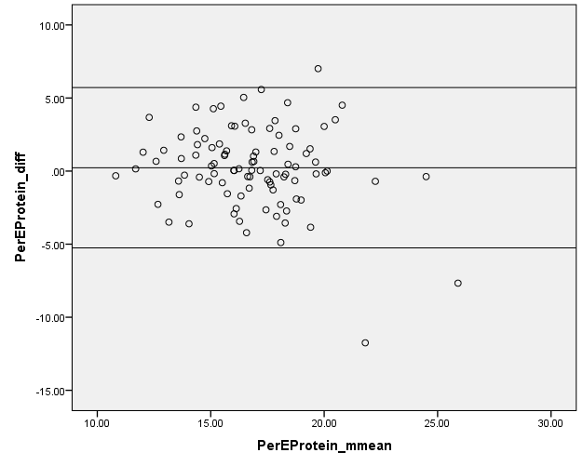
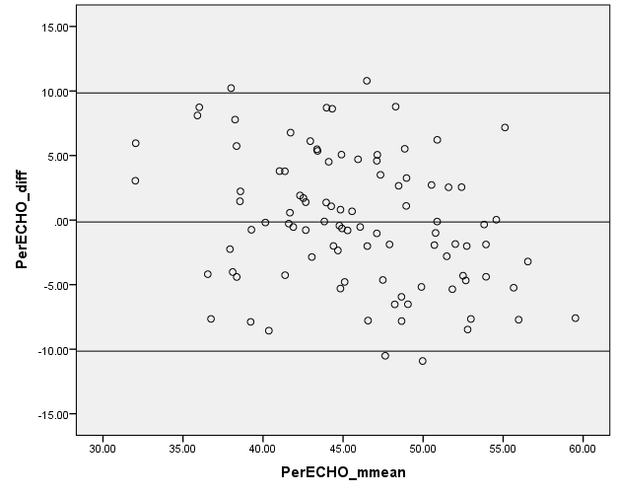
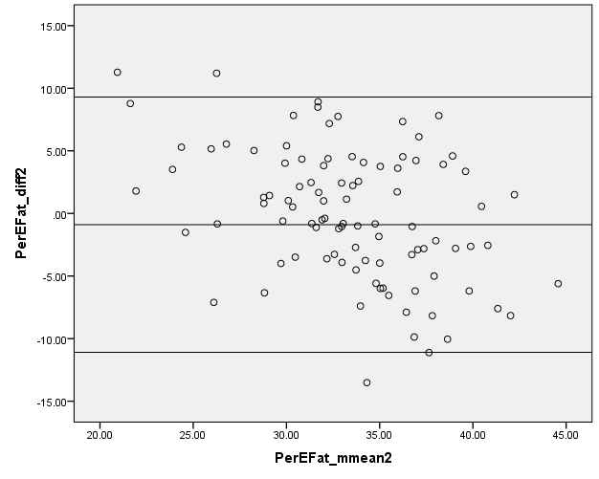

Figure 1. Bland Altman plots to assess relative agreement for percentage energy from protein, carbohydrates and fat between the SCG FFQ and food diary.

