Comparison between Mixed Binary classification and Voting Techniques for Active User Authentication using Mouse Dynamics
Alnour Ahmed Khalifa⁺, Mutasim Adil Hassan⁺, Tarig Ahmed Khalid⁺ and Hassan Hamdoun*
⁺Electrical Engineering Department, University of Khartoum
{ alnour.ahmed@gmail.com , motasim.taha@yahoo.com ,t.a.khalid@ieee.org }
*School of Natural and Computing Sciences, University of Aberdeen, Kings’ College, Aberdeen, UK, AB24 3BU
hassan.hamdoun@abdn.ac.uk

Abstract—The rapid proliferation of computing processing power has facilitated a rise in the adoption of computers in various aspects of human lives. From education to shopping and other everyday activities to critical applications in finance, banking and, recently, degree awarding online education. Several approaches for user authentication based on Behavioral Biometrics (BB) were suggested in order to identify unique signature/footprint for improved matching accuracy for genuine users and flagging for abnormal behaviors from intruders. In this paper we present a comparison between two classification algorithms for identifying users’ behavior using mouse dynamics. The algorithms are based on support vector machines (SVM) classifier allowing for direct comparison between different authentication-based metrics. The voting techniques show False Acceptance Rate (FAR) and noticeably small learning time; making it more suitable for incorporation within different authentication applications.

Index Terms: active authentication, mouse dynamics, pattern recognition, machine learning, support vector machines.

Introduction
Conventional authentication techniques rely on static approaches using passwords for single time check with no further identity validation after authorization. They are simple and effective if the access to computer systems occurs in one place and during specific time period in a secure environment [1]. Behavioral Biometrics (BB) performs users’ identification based on the behavioral patterns that the user exhibits when interacting with the computer. Research approaches building on BB concepts aims to find cost and time efficient tools and techniques in order strengthen computer security and data integrity at various points in the Human Computer Interaction (HCI) ecosystem, e.g. [2] [3] [4] [5]. However, there is still need for improved resilience of those techniques given the rising use of e-learning and e-education applications requiring improved user identification accuracy and verification time [6] [7] Also in banking systems
[8]. Issues such as users forgetting their authentication details, remaining logged on, credentials stolen are easy ways for intruders to gain lawful access to the system.
Behavioral Biometrics, contain inherent user characteristics of physiological features, offer unique advantages over other

approaches. Firstly, they can be collected without causing the users’ any inconvenience and hence not affecting the user experience (UX) negatively. Secondly, No. extra hardware is needed to capture them, resulting in reduced cost of the overall system [9]. BB also monitors users’ behavior continuously, offering increased resilience to intruder’s attacks. Computer BB can be implemented using keystroke keyboard dynamic [10] or mouse dynamics [11]. Keyboard dynamics are based on analyzing the typing rhythm of the user which makes them affected by the keyboard layout structure resulting in differing users’ behavior for different keyboard types. Mouse dynamics, on the other hand, are platform independent and hence offer one-to-one mapping to users’ behavior. Both mouse and keyboard dynamic are needed for example in systems with a combination of command line and graphical interfaces [3] [9].
This paper investigates two BB-based approaches for user classification; one is based on SVM and the other on a weighted voting technique. Performance comparisons are conducted for False Acceptance Rate (FAR), authentication time required and False Rejection Rate (FRR). Result indicates the superiority of the voting techniques in the FAR ,FRR and Generalization Factor (GF) performance measures. The inherent ability to combine results from different classifiers works well to the advantage of the voting technique. The rest of the paper is structured as follows: Related work is covered in Section II. The Behavioural Biometric authentication system based on two authentication techniques is presented in Section III. Section presents the results of the performance comparison. Finally Section V concludes the paper.

Behavioural biometrics
The need for authentication is important when a computing resource needs to be protected from manipulation, access and or to provide user’s privacy assurances. Traditional solutions include access control which can either be physical: sieges, doors, locks, CCTV cameras, etc or virtual using passwords, keys, Pins, finger-prints, etc. The authentication process consists of i) presentations of credentials by the unknown entity, ii) verification of credentials and ii) Authentication/prevention of access to the system.
Biometrics is a promising approach for authenticating who the user is beyond traditional passwords and PINs. Biometrics use inherent characteristics of human beings (Eye iris, fingerprint, voice, behavior, face, etc.) and hence are inherently unique to every human and can’t be stolen. Two types of biometrics exist, physiological: physical characteristics (finger prints, iris, etc) and behavioral. Physiological biometrics offer high reliability compared to traditional access control but suffer from the fact that it is done only single time, opening the door for intruders to retain access if users’ leave sessions active. They also incur additional cost in special hardware (e.g. finger print and iris scanners). BB address the above two issues by making the authentication process continuous while relying on available computer hardware (mouse and keyboard). BB can qualify the behavior traits exhibited by the user and use the resulting feature profiles to verify the user identity. Verification is perfume continuously via direct comparison to the feature profiles extracted.

Related Work
Behavioral re-authentication systems were first introduced
by Denning in 1985 [12]. Since then different approaches for studying the problem have been proposed with varying experimental setups and conclusions. It is not until recently, with the emerging data mining algorithms, that methods for establishing a performance comparative framework between those techniques are investigated [13]. Various approaches in the literature have differed in the size of the collected data per user, number of samples, method of collecting data, number of users, environment conditions (controlled or non-controlled) and the choice of classification method. Moreover, several performance metrics are utilized for efficiency evaluations including FAR, FRR, verification time and Equal Error Rates (ERR) [13].
Gamboa and Fred developed a behavioral biometric technique based on pointing device (mouse) [14] in order to improve web login forms. The authors used an online memory game with a numerical virtual keyboard for data collection. In such setup, users interact with the mouse providing data organized by event ID and document object model (DOM) object ID. Parzen density estimation and an unimodal distribution are used for the statistical analysis. Data is recorded from 50 users over duration of 10 hours each. They recorded as ERR of 12.5% for 10 pin digits and 6.25% for 16 pin digits.
Pusara and Brodley investigated a user re-verification system based on mouse movements [4]. It relies on monitoring the user behavior after the login and comparing it to the learned behavior. Upon any mismatch, an alarm is invoked to the admin asking for user’s re-authentication. Dataset was collected from web-pages usage by volunteer student users consisting of mouse clicks, double clicks and non-client (NC) moves. From the data features extracted, a model was built for each user using the decision tree classifier as a supervised learning algorithm. Features extracted were the distance, speed and angle between points, either consecutive or separated by $k$ points; in addition to categorization of events: NC move, wheel movement, click and double click creating a total of 63 features. Their approach yielded FAR of 0.46% and FRR of 1.75%. Though, the performance measures are good; this approach is not scalable in open systems with large number of users as the complexity of supervised learning algorithm increases.
Ahmed and Traore studied mouse dynamics for user interaction with a graphical user interface [4]. Again different data was collected corresponding to mouse movements: “from point to point”, “drag and drop” and “point and click followed by a click”. The traveled distance in pixels, movement speed, Movement direction and silence periods formed the dataset. A lightweight software module at client is used to send the data to the server for analysis. The studied features included histogramic ‘measured frequency for discrete events’ and non-histogramic and are analyzed using neural networks. Discrimination between users is performed using a confidence ratio (CR) that uses the output of the neural net to measure the similarity between the monitored behavior and the stored signature for the user. This approach has the advantage of the variety of features extracted and it was well implemented but suffers from a long verification time of about 2000 moves.
Yoon and Kim improved the work by Ahmed and Traore utilizing the same classes of actions: move, drag and drop, point and click [15]. Features extracted were the double clicking speed, acceleration per direction, movement velocity per traveled distance per defined action and distribution of double click speed. The Naïve Base unsupervised learning algorithm is used for data analysis resulting in unique pattern for each user.
Zheng, Paloski, and Wang developed a mouse based verification system using only angle based metrics and curvature features [16]. Features extracted were the direction, curvature angle and curvature distance. Unsupervised learning utilizing support vector machines (SVM) is used for users classification resulting in both FRR and FAR was about 1.3% for a continuous 20 mouse clicks in a free mouse movement. Also the features extracted are platform dependent unlike distance or location histograms. A summary of various BB authentication techniques and their performance is summarized in Table 1.
Table 1: Performance of Behavioral Biometrics authentication techniques
Technique | Experiment setup/advantages | FAR  (%) | FRR  (%) | Verification time (moves) | ERR  (%)
Statistical analysis [2] | 50 users over 10 hours | - | - | - | 12.5  & 6.25%
Supervised learning [3] | Efficient but relies on large data per user | 0.46 | 1.75 | - | -
Neural networks [4] | Efficient but slow | - | - | 2000
Unsupervised learning[5] | Unique user Patten identified | - | - | - | -
SVM-based | Unsupervised learning | 1.3 | 1.3 | 20 | -

Propsed Behavioral Biometric Authentication Systems

The Concept
The concept relies on user’s usage characteristics as a metric for classification via building user’s profile from mouse usage data. We aim to provide insights into the tradeoff between accuracy and verification time for the authentication process and hence employ both SVM and voting technique for users’ classification. In both cases, data is first reduced to more abstracted features which are then fed to SVM or voting techniques for classification.
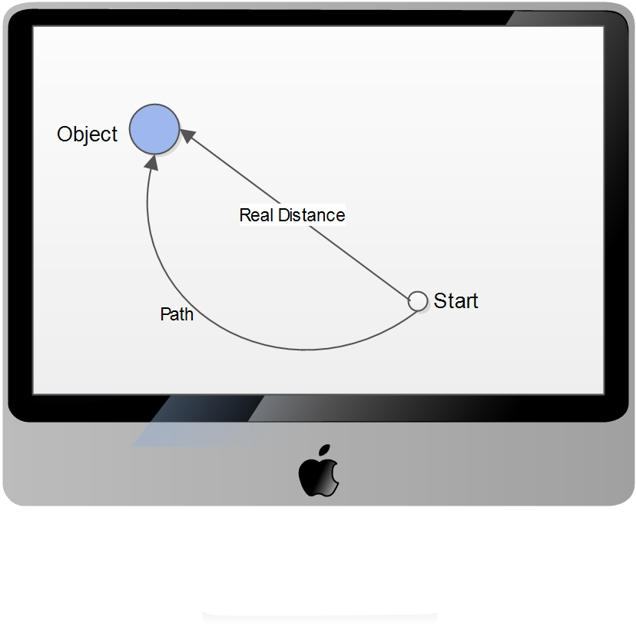
SVMs supervised learning technique used for classifying data points. Two types of classifications are possible: Linear or Binary classification or Non-linear or Multi-class classification. SVM helps maximizes the margin between the hyper-plane separating different classes of data.
In this paper, we employ a) mixed binary classification collecting data from both legitimate and intruders’ data and come up with a model that classify legitimate users in comparison to any type of user, b) voting system collecting data from legitimate users as well as intruders and classify users using weights calculation based on the implementation of a stacked regression method. Performance comparison between the two classification techniques is performed with the view to being able to generalize for the unseen intruder’s data. This is different to previous approaches in the literature summarized in Table 1. As it offers a general model that works both for positive and negative classes in a mouse dynamics authentication system. The generalization is measured using generalization factor that is defined in the results section.

b) The Implementation

1) Feature Extraction and Data Preprocessing
The raw mouse data consists of thousands of mouse points. Each point contains x, y coordinates and timestamp in addition to the event type (click, double click, mouse move, etc.). The raw data, taken from [17], is modified resulting in high abstracted features as follows [16]:
- The ratio between the real distance a person takes to go to a clickable object and the direct distance to that object (shown in Fig.1)
- Time spent before clicking the object
- The click type itself (right click, left click, double click) taking into consideration whether the action is done on client area or NC area.
- The speed
The dataset used consisted of 28 users each has 40 sessions [3] and the duration of the session is 40 minutes. The collected data is divided into training and learning parts. Training part is used to fit the model while the testing part is used to measure the accuracy and generalization factor of the fitted model.

Fig.1: Real distance to direct distance ratio for clicking an object

Datasets
Three datasets are used for performance comparisons. Dataset 1 is online available dataset provided by the authors of [16]. It consists of 28 users, each one have 30 sessions at least and each session is about 30 minutes.
Dataset 2 is also an online dataset provided upon request collected by authors of [18], [19]. It contains data about 48 users.
Dataset 3 (the authors own dataset) collected by students at University of Khartoum, Khartoum, Sudan. It contains 28 users. The average collected data is 10 hours for each user. All three data were collected under free use of computers.

Data classification Model

1)Mixed Binary Classification
The classifier is built using two equal parts of the dataset. The first part was generated from the legitimate user and the second part was generated from the others (intruders). For a give sample size $S$ and $N$ intruders, the classifier uses $S$ samples from the legitimate users and $S/N$ from each illegal user. A specific user’s data is taken from the user’s available data randomly. Some users’ data was not used in fitting these classes in order test the model ability to generalize for the case of intruders outside our dataset.
Following this an SVM classifier with radial basis function is applied to fit the data. A grid search algorithm is used to estimate the values of SVM hyper-parameters. The number of input samples is varied and the accuracy is measured. It is noted that the accuracy increases with the number of input samples but at the expense of higher training time. Also different number of samples has been used for testing purposes. Although increasing the number of samples decreases FAR and FRR, it also increases the verification time. The rule of thumb is one sample equating to one click and it takes about 45 seconds for the user to click an object on average.

2)Voting Technique
The legitimate user has been a trained verses N intruder, which results in $N$ classifier [16]. N is determined by the number of available users in the dataset minus the legitimate users and the unseen intruders used for measuring GF. For example if we have 26 users in our dataset and we want to check GF for 9 intruders then N will be 16. To predict a new sample we test verses all classifiers. Then the outputs of these classifiers are summed up and compared with a threshold value to determine whether the sample is positive or negative. An equal weight is used as it turned out to provide the best results.
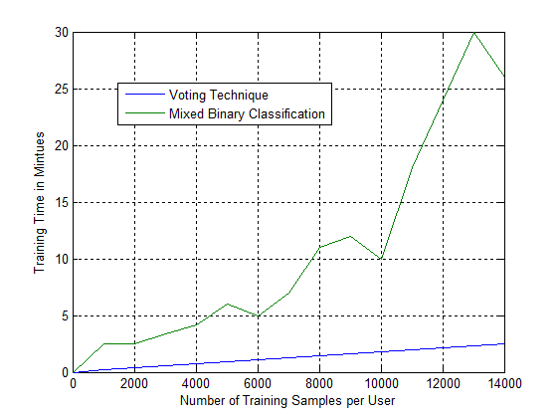
The threshold value $TH$ is chosen to be the value that maximizes the training accuracy as follows:

Step1: The test set is divided into positive data set $P_{set}$ and negative data set$N_{set}$.

Step2: For each sample $S_{pi}$ in positive test set and $S_{ni}$ negative test set a predicted value is by all classifiers, then values are added up to get a predicted positive value$PP_{i}$ and predicted negative value$PN_{i}$ i.e. :
$PP_{i}= \sum_{i=1}^{N}{C_{i}(S_{pi})}$ (1)
$PN_{i}= \sum_{i=1}^{N}{C_{i}(S_{ni})}$

Step3: Define the predicted positive set ${PP}_{set}$ to contain all ${PP}_{i}$ values and predicted negative set ${PN}_{set}$ to contains all ${PN}_{i}$ values.
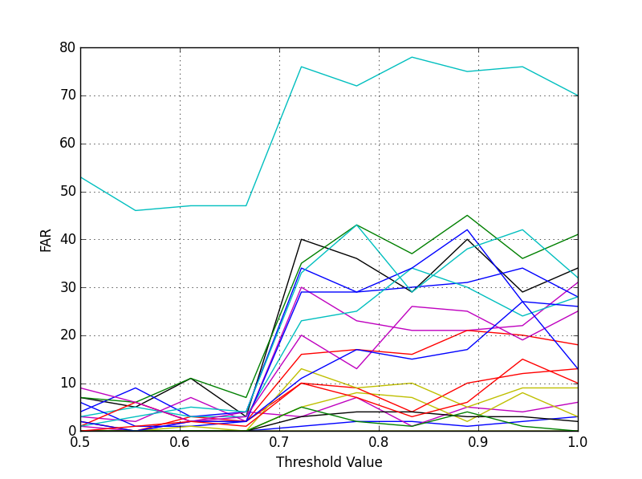
Step4: Define $N_{p}$ to be the number of values in ${PP}_{set}$ $≥$ $TH$, $N_{n}$ number of values in ${PN}_{set}$ < $TH.$

Step5: Choose $TH$ from (${PN}_{set}∪ {PP}_{set})$ that maximizes the value $\frac{N_{p}+Nn}{N_{p}*N_{n}}$ .

results
In order to quantify the performance and cost benefit of the two techniques, the time duration needed for each against the number of training samples is calculated and is shown in Fig.2. The average learning time for the SVM techniques using 14000 samples is about 25 minutes while it is only 2.5 minutes for the voting techniques. Time is measured in a PC with core i5 processor and 4 GB RAM. It is noted that the verification time is linearly proportional to the number of clicks. The verification time has been calculated by getting the average time of clicks’ number. Time for one click was found to be about 0.9 minutes on the dataset 1.
Fig.3: FAR vs. Threshold Value for different users, different colors indicate different users
The FRR and FAR have been recorded using different threshold values. Threshold in this context is the percentage of samples that are classified correct compared with the testing window (number of samples used at the testing process). For example if we take 10 samples for the testing window then threshold 0.6 means we need at least 6 samples to be classified positive to consider the user as legitimate user. Fig3. Shows the FAR variation with the threshold value for different number of users. We note the noticeable change in FAR and wide range it can take. Similar variations, not shown here, are observed for the FRR across various number of users.
Comparison of the results of SVM and voting techniques are presented in Fig. 4 (for FAR), Fig. 5 (for FRR).
Generalization Factor (GF) is defined as the FAR of the unseen intruder users and can be written as:

$GF= \frac{Number of rejected unseen intruders}{Total Number of unseen intruders}$ (2)

However, high value of GF is not always good indicator for the system accuracy. Corresponding FRR to each GF should be considered. A simple system that output always -1 (labels
Fig.2: Average learning time in minutes vs. number of training samples for the two classification techniques
any user as intruder without checking his data) has GF = 100% and FRR = 100%. These results are obtained assuming the threshold is in the range [0.55, 0.61, 0.67, 0.72, 0.78]) for the mixed binary classification technique.

Perfomrnace Comparisons across different datasets
Here we present results for dataset 1, 2 and 3 highlighting some insights into the performance of the two classification techniques across the datasets. It is important to note that the datasets differ in the features and hence we employed feature abstraction to arrive at a common set of features for comparison.
Dataset 1 and 3 were abstracted into the form of Dataset 3(Authors’ own dataset). The features used for comparisons are:
- $Type of Action$ (1: Mouse Move 2: Silence 3: Point Click 4: Drag drop)
- $Traveled Distance in pixels$
- $Elapsed Time$ (in seconds)
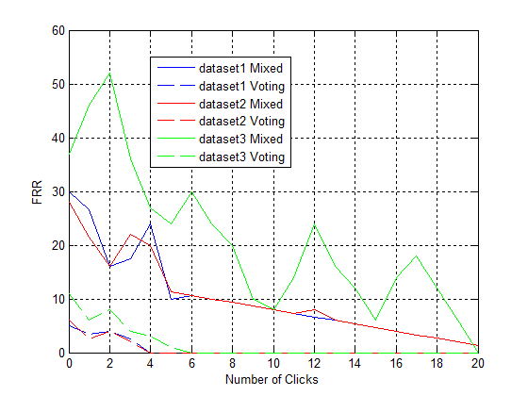
- $Direction of Movement$ (1 to 8) (actions performed within 45-degree intervals clockwise).
Dataset 2 was already abstracted to these features so Dataset 1 and 3 were abstracted from their raw format to these features, which put the three datasets on the same format to enable performance comparisons.
The abstraction for Dataset 1 and 3 is performed as follows:
- $Type of Action$
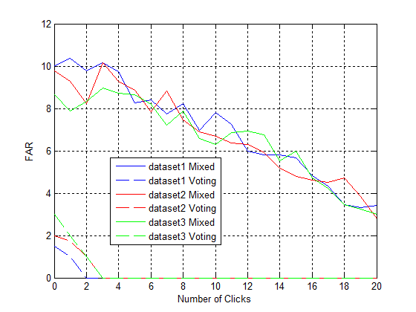
Mouse move and point click are available directly in mouse raw data, silence is generated when the user stops for a specific time without movement (we take it to be 15 seconds) and drag drop event is generated when a mouse down event occurs, followed by a series of mouse movement and ends by a mouse up event.
Fig.4: FRR vs. Number of Clicks for the two techniques across the three datasets

- $Elapsed Time$
Time is calculated directly by taking the difference in timestamps values and then dividing it by 1000 to get the time in seconds.

- T$ravelled Distance$
Distance between any two points is the Euclidean distance between these points.

- $Direction of Movement$
To calculate direction between two points $(x1,y1)$ and $(x2,y2)$ , we first calculate the angle between them to be:
Fig.5: FAR vs. Number of Clicks for the two techniques across the three datasets
$angle =arctan\left(\frac{y2-y1}{x2-x1}\right)$ (3)
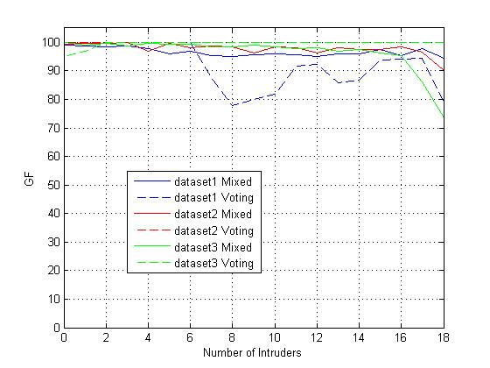
Then we use signs of$(y2-y1$) and ($x2-x1)$ to calculate the exact value of $angle$ in the range$[0 , 2π]$. After that direction is calculated as follows:

$direction=round\left(\frac{angle}{\frac{2π}{7}}\right)+1$ (4)

This will make direction to be in the range [1, 8], which is similar to dataset 2.

Fig. 4, 5, 6 provide a comparison between results generated from the three datasets in terms of FRR, FAR and GF for the two techniques, respectively. The average result of the two methods is show in the y axis. Fig.6 shows the relationship between GF and the number of unseen intruders for the three datasets.
Fig.6: GF vs. Number of Clicks for the two techniques across the three datasets
The voting technique results in lower FAR than the Mixed-binary classification techniques across all the three datasets. In fact the FAR values are quite similar across the datasets and decrease as the Number of User’s click increase. . The FRR exhibit the same trend with the voting technique again offering lower FRR than the mixed-binary classification technique. The GF performance results trends are mostly higher for the voting techniques across all three datasets; confirming again its advantages.

conclusion
Performance comparisons between Mixed-Binary and voting classification techniques for identifying users’ behavior using mouse dynamics is presented in this paper. The comparisons is performed for FAR (false positives wrt the detection of intruders) and FRR (false negatives wrt to the detection of legitimate users) as well as newly introduced Generalization Factor (GF) measure to account for classification techniques ability to accurately detect intruders when presented with a mixed dataset (positive and negative classes). The voting technique showed noticeably small verification time and higher GF making it suitable for active authentication systems used in various commerce and educational applications. This trend holds when applying the techniques on three different datasets, two from the literature and one is the authors’ own dataset. The versatility of the two techniques and performance advantage gains from the voting technique is promising for further work around the implementation of applications based on active-authentication based systems.

References
[1] | "Authentication”,February,2014. 2015. http://searchsecurity.techtarget.com/definition/  authentication.
[2] | I. T. Ahmed Awad E. Ahmed, "Mouse Dynamics,"  in Behavioral Biometrics for Human Identification:  Intelligent Applications. http://www4.ncsu.edu/~tyu/pubs/asiaccs11-jorgensen.pdf
[3] | I. W. M. S. O. Issa Traore, "Combining Mouse and  Keystroke Dynamics Biometrics for RiskBased  Authentication in Web Environments".
[4] | C. E. B. Maja Pusara, "User Re-Authentication via  Mouse Movements. http://csis.pace.edu/ctappert/cs692-13spring/projects/mouse-pusara.pdf.
[5] | BehavioSec,"BehavioSec," http://www.behaviosec.com/.
[6] | R. M. Karen Paullet, "Verifying User Identities  in Distance Learning Courses: Do We Know Who Is  Sitting And Submitting Behind The Screen?". Issues in  Information Systems . 2014, Vol. 15 Issue 1, p370-379.
[7] | J. S. Monaco, "Behavioral biometric verification of  student identity in online course assessment  and authentication of authors in literary works,"  Arlington, 2013.
[8] | BehvioSec, "Danske Bank deploys BehavioSec’s  Behavioral Biometrics Technology," BehavioSec,  2014. http://www.behaviosec.com/danske-bank-  deploys-behaviosec/.
[9] | P. V. C. Rohan V. Ponkshe, "Keystroke and Mouse  Dynamics: A Review on Behavioral Biometrics,"  International Journal of Computer Science and Mobile  Computing, p. 1, 2015.
[10] | "Keystroke Dynamics," February 2014.  Available:  https://en.wikipedia.org/wiki/Keystroke_dynamics.
[11] | Ahmed, A.A.E.; Traore, I., "A New Biometric  Technology Based on Mouse Dynamics," Dependable  and Secure Computing, IEEE Transactions on , vol.4,  no.3, pp.165,179, July-Sept. 2007.  doi: 10.1109/TDSC.2007.70207
[12] | P. N. Dorothy Denning, "Requirements and Model  for real-time Intrusion Detection Expert System," SRI  international , California, 1985.
[13] | B. H. R. G. M. P. C. R. Fouad Cherifi, "Performance  Evaluation Of Behavioral Biometric Systems," 13  May 2014. https://hal.archives-ouvertes.fr/hal-00990311
[14] | F. H. Hugo Gamboa, "A Behavioural Biometric System  Based on Human Computer Interaction.” http://www.lx.it.pt/~afred/anawebit/articles/  AFredSPIE2004.pdf.
[15] | D. D. K. Chee-Hyung Yoon, “User Authentication  Based On Behavioral Mouse Dynamics Biometrics”,  Stanford University,2005. Available Online: http://cs229.stanford.edu/proj2005/YoonKim-UserAuthenticationBasedOnBehavioralMouse  DynamicsBiometrics.pdf
[16] | A. P. H. W. Nan Zheng, “An Efficient User  Verification System via Mouse Movements”, Available  Online: http://www.cs.wm.edu/%7Ehnw/paper/ccs11.pdf
[17] | Chao Shen; Zhongmin Cai; Xiaohong Guan, "Continuous authentication for mouse dynamics: A pattern-growth  approach," Dependable Systems and Networks (DSN),2012.  42nd Annual IEEE/IFIP International Conference  on , vol., no., pp.1,12, 25-28 June 2012
[18] | Ahmed A.A.E, and I. Traore Dynamics, "A New  Biometrics Technology based on Mouse," IEEE  Transactions on Dependable and Secure Computing,  vol. 4, pp. 165-179, July-September 2007.
[19] | Y. Nakkabi, I. Traore,A. A. E Ahmed,  "Improving Mouse Dynamics Biometric Performance  using Variance Reduction with Separate Extractors,"  IEEETransactions on Systems, Man and Cybernetics—  Part A: Systems and Humans,, vol. 40, 2010.
[20] | J. STEFANOWSKI, Multiple classifiers, 2008.
[21] | Z. J. a. T. Yu, "On Mouse Dynamics as a Behavioral  Biometric for Authentication," in ACM Symposium on  Information, Computer and Communications Security. 2011
[22] | Yu Zhong; Deng, Y.; Jain, A.K., "Keystroke dynamics  for user authentication," Computer Vision and Pattern  Recognition Workshops (CVPRW), 2012 IEEE  Computer Society Conference on , vol., pp.117,123, 16-21  June 2012.

